

SALON BOOKING AND MANAGEMENT SYSTEM

**___________________**

An IT Capstone Project

Presented to

The Faculty of the Computer Studies

ACLC COLLEGE

Mandaue City

**___________________**

In Partial Fulfillment

of the Requirements for the Degree

Bachelor of Science in Information Technology

**___________________**

By

Jhenylyn M. Butawan

Sept 2022

**APPROVAL SHEET**

In partial fulfillment of the requirements for the degree, Bachelor of Science in Information Technology, this Capstone Project entitled “***SALON BOOKING AND MANAGEMENT SYSTEM***”, has been prepared by ***Jhenylyn M. Butawan* .**

**DONALD M. FRANCISCO, MSIT**

IT Adviser

Approved by the Committee on Oral Examination with a grade of _____________.

**DONALD FRANCISCO,MSIT**

Panelist 1

**ROY IMPERIAL, MSIT**

College DEAN / School Director

Accepted in partial Fulfillment of the requirements for the degree, BACHELOR OF SCIENCE IN INFORMATION TECHNOLOGY (BSIT).

**ROY IMPERIAL, MSIT**

College Dean / School Director  
ACLC College  
Maguikay, Mandaue City

Date of Oral Examination  
Sept 03, 2022

**Dedication**

This study is dedicated to our beloved parents, who have been our source of inspiration and gave us strength when we thought of giving up, who continually provide their moral, spiritual, emotional, and financial support.

To our brothers, sisters, relatives, mentors, friends, and classmates who shared their words of advice and encouragement to finish this study. And lastly, we dedicated this book to the almighty God, thank you for the guidance, strength, power of mind, protection and skills and for giving us a healthy. All of these, we offer to you.

***Acknowledgements***

To Jesus Christ, our Lord and Savior, for giving the wisdom strength and knowledge in exploring things, for the guidance in helping all the trials that we encountered and for giving determination to pursue our study, and make this study possible.

We would like to indicate our earnest gratitude to our I.T Capstone adviser Mr. Donald M. Francisco for continuous support in our study, patience, enthusiasm and for sharing his knowledge of what he has learned.

Our sincere thanks also to our School Director Mr. Roy L. Imperial for given us approval for our project proposal and for given us the opportunity to show our skills and capabilities. Without his utmost ideas we would be able to develop this project.

Above ground, to our beloved family that given us trust, undying motivation and most important for providing the financial income in conducting this study despite of the pandemic crisis. Thank you.

**Abstract**

**Title : Salon Booking And Management System**

**Proponents : Jhenylyn M. Butawan**

**Degree : Bachelor of Science in Information Technology**

**School : AMA Computer Learning Center**

**Adviser : Mr. Donald M. Francisco**

This Salon Booking and Management System highlights the capability to boost the market of any salon businesses. This is because having online booking with search engine optimisation (SEO) ease and solve the problem like low customer interaction as it aims to optimise search rankings and click-through rates from search engines results pages.It has a search place google map plugin to search nearby beauty salons and to directly get the salon name and address.

The overall design of the system is responsive and mobile friendly since users tend to use mobile devices. The project was designed to help small salon businesses to engage more customers online and to automate the manual data processing. On this way, there are possibility to give effective quality services through this application. If we love to beautify ourselves through all salon services then there should be a way to emphasize the beauty of technology in every salons.

The developer on this project conducted a lot of survey and interviews in different areas just to be able to get the information about salon business process flow. The developer itself conducted different kinds of testing like functionality, load , and security testing in order to deliver the system as what was expected.

**Table of Contents**

Pages

Title Page i

Approval Sheet ii

Dedication iii

Acknowledgements iv

Abstract vi

Table of Contents viii

List of Figures xix

List of table’s xii

**CHAPTER I – INTRODUCTION 1**

Statement of the Problem 5

Purpose/Objective of the Study 10

Significance of the Study 12

Scope and Limitation 14

Conceptual Framework 19

Review of Related Literature 20

**CHAPTER II – METHODS 25**

Research Design 45

Description of the Respondents 47

Research Instruments 49

Data Collection or Data Gathering Procedure 58

**CHAPTER III – RESULTS 60**

Data Presentation 60

Data Interpretation 62

Data Analysis 63

**CHAPTER IV – DISCUSSION 65**

Summary 66

Conclusion 70

Recommendations 73

References 74

Appendices 76

Biographical Sketch 157

**List of Figures**

Figure 1:  *Show the concept of queuing 19*

*Figure 2. Long queue Process 26*

*Figure 3. Long queue can be pissed-off 27*

*Figure 4. Paperless queuing doesn’t exist 27*

*Figure 5. Implementing queues 28*

*Figure 6. . Shows both payment and inquiry is applied 28*

*Figure 7. Paper is used in queuing 29*

*Figure 8. Agree to use smartphone 29*

*Figure 9. Shows that mobile application is*

*not used in queuing 30*

*Figure 10. Improvement of queue process 30*

*Figure 11. Utilizing paperless queuing 31*

*Figure 12. The Process Flow of the system 34*

*Figure 13. The Functionality of the system 35*

*Figure 14. The Features of the system 35*

*Figure 15. The Originality of the system 36*

*Figure 16. The users Interface of the system 36*

*Figure 17. The students reaction about the system 37*

*Figure 18. Comment and suggestion of the system 38*

*Figure 19. Show the 25 respondent answer the survey 47*

*Figure 20. Show the 25 respondent answer the survey 48*

*Figure 21. Process flow of the system 57*

*Figure 22. Generate IP Address to the user 134*

*Figure 23. Select Queue transactions 134*

*Figure 24. Users select continue to queue if not a PWD, Senior Citizen or Pregnant Women 135*

*Figure 25. Users dashboard to know the*

*The queuing transactions 135*

*Figure 26. Orange button that represents if the user is on waiting call 136*

*Figure 27. Green button represents if the user is on queue 136*

*Figure 28. Red button represent if the user is on the recall 137*

*Figure 29. Click yellow sign button for PWD, Senior Citizen or Pregnant Women 137*

*Figure 30. Dashboard for PWD, Senior Citizen or Pregnant Women, Uppercase P represent for Priority Lane 138*

*Figure 31. Orange button represent if the user is on waiting call for PWD, Senior Citizen or Pregnant Women 138*

*Figure 32. Green button represent if the user is on queue call for PWD, Senior Citizen or Pregnant Women 139*

*Figure 33. Red button represent if the user is on recall for PWD, Senior Citizen or Pregnant Women 139*

*Figure 34. Click to Log-in 140*

*Figure 35. Cashier Log-in 140*

*Figure 36. Cashier Homepage 141*

*Figure 37. Cashier Button Call 141*

*Figure 38. Cashier Queue transaction Call 142*

*Figure 39. User call on wait 142*

*Figure 40. Cashier is calling a queue to a user 143*

*Figure 41. User is on queue to cashier 143*

*Figure 42. Cashier queues on transaction to the users 144*

*Figure 43. Cashier queue a user’s on the monitor 144*

*Figure 44. Cashier Add limit to the queue 145*

*Figure 45. Limit queue is display 145*

*Figure 46. Limit is display to the monitor 146*

*Figure 47. Queue limit exceed 146*

*Figure 48. Add Announcement 147*

*Figure 49. Add Announcement table is display 147*

*Figure 50. Display announcement to the monitor 148*

*Figure 51. Recall the queue 148*

*Figure 52. User queue is recall 149*

*Figure 53. Cashier sign-out 149*

*Figure 54. Click to Log-in 150*

*Figure 55. Admin Log-in 150*

*Figure 56. Admin Homepage 151*

*Figure 57. Announcement Button 151*

*Figure 58. Add Announcement display 152*

*Figure 59. Add Announcement display on the monitor 152*

*Figure 60. Reset display button 153*

*Figure 61. Add Limit display button 153*

*Figure 62. Add limit is display 154*

*Figure 63. Add limit is display in the monitor 154*

*Figure 64. Add Cashier button 155*

*Figure 65. Add Cashier Log-in is display 155*

*Figure 66. Admin Sign-out 156*

**List of Tables**

Table 1. Pre-Survey Result (Q1) 32

Table 2. Pre-Survey Result (Q2) 32

Table 3. Pre-Survey Result (Q3) 32

Table 4. Pre-Survey Result (Q4) 32

Table 5. Pre-Survey Result (Q5) 32

Table 6. Pre-Survey Result (Q6) 33

Table 7. Pre-Survey Result (Q7) 33

Table 8. Pre-Survey Result (Q8) 33

Table 9. Pre-Survey Result (Q9) 33

Table 10. Pre-Survey Result (Q10) 33

Table 11. Post- Survey Result (Q1 39

Table 12. Post- Survey Result (Q2) 39

Table 13. Post- Survey Result (Q3) 39

Table 14. Post- Survey Result (Q4) 40

Table 15. Post- Survey Result (Q5) 40

Table 16. Hardware Specification for Web & Mobile

Application Development 51

Table 17. Software Specification for Web & Mobile

Application Development 52

Table 18. Hardware Specification for Arduino

Development 52

Table 19. Software Specification for Arduino

Development 53

Table 20. Hardware Specification for PQS

Paperless Queuing System 53

Table 21. Software Specification for PQS

Paperless Queuing System 54

Table 22. Hardware Specification for Admin

Development 54

Table 23. Software Specification for Admin

**CHAPTER I – INTRODUCTION**

One of the advantages of having the Salon Finder and management Booking System is to help Salon business can accept bookings 24/7, so the customer doesn’t have to wait until the next day. It also helps the customer to find other suitable salons. The objective of this application is to locate the nearest Salons along with the city and to make appointments right away.

There are three intended users: First, The Users/Customers who can book and inquire to any Salons. Second would be the Salon owners, who will manage all the admin management app. Third, the Super Admin can have full access to the database side and can handle all the activation to any application users.The software developer handles the Super Administrator, we allows the clients to choose from standard domains like .com, .net, .org, .info, .biz and etc, to help simplify their address for our customers. Also, We will set up the booking system. Each app has same functionality but with a unique web design.

It also saves time since app users can process all requests by statuses. It is a perfect solution for all users to make appointments on the go as they can install the app on their android Phones. It can increase the efficiency of all operations. It reduces the amount of administrative work that Salons owners might have to adjust staff responsibilities. This application is very user friendly and will become a best friend for all beauty lovers out there. So, now we have heard how technology helps us to bring our life so instant.

**Statement of the Problem**

Some service-based Salon businesses have implemented online applications to increase the revenues on their business that will automate the manual processing procedures. Since we are indulging with the technologies, so we want some changes that solve the problems with so many beauty salons out there today. One of the main problems that Salon owners faced is how to gain more customers or getting new clients. The best way to have more clients is to have an online Salon booking website that has been optimized for Google and other major search engines. This application can find any Salons, so If someone searches for the nearest Salon, so all registered Salon is going to be on the list. Many people are interested in beauty but some of us may not have the opportunity to go to the salon to make an appointment. Second, time is important for every client, they want instant so if they want to ask about time and date availability then this application is the best to serve them and give gratification to every client who wants to make appointments on the go. Third, is the paper works or the manual procedure of keeping the records. This application has designed to help Salons automate the data processing and without any hassle, because this is not just a user friendly but also an on the go app. The application is accessible for any latest version of Android Phones.

**GENERAL PROBLEM**

Small business salons needs help to attract more customers. The solution is to give them the services like a web site that enables the customer to book themselves on the go.

**SPECIFIC PROBLEM**

**Time Availability**

* What is the significant of time on this salon app?
* To let customer book the available time and to give flexibility.
* How important is the salon app when it comes to time?
* It gives a lot of options to which date and time to go to salon.
* What makes salon app faster?
* The system was made of vue javascript framework with firebase realtime database, so this is expectedly will return the data in realtime manner. The salon owners who handled the admin side will get the requests in realtime.

**Customer is waiting**

* How this app solves the Waiting customers inside salon?
* The salon owner who handled the admin side can view and manage the availability of staffs so the management itself can deal with other services to those customer who intentionally wants to wait.

**Booking process**

* How the booking process is done to other salon business transactions?
* The booking process is done when the customer wants to avail the services offered by the salons. The transaction will be through online via web or mobile devices. The pending request will be approved once the customer showed up according to the booked date and time. The cancellation policy should be defined at the home page of the web app.

**Salon Vacancy**

* + What if the salon was fully booked?

The best feature that will answer this problem is to let customer use the salon nearby me which is part of the system capability to search other salons and the nearest one. The customer can check the available date and time from the desired salons.

**OBJECTIVES**

**GENERAL OBJECTIVES**

The objective of this project is to provide a system, which will manage the booking process and time availability.

**SPECIFIC OBJECTIVES**

* + To help customer finds the nearest salons.
  + To provide automated way of booking process and to manage the time availability of staffs.
  + To enhance the market of the salon services through posting rewards and promos.

**Purpose/Objective of the Study**

To develop an application that can help Salon Businesses to have fast data processing and achieve more customers as their salon will be visible on the search engine.To provide a solution to the problem in searching available Salons and get direction via Google Map.

To help Users make an appointment on the go as they can install the app on their android Phones. To help the customer to find a beauty salon that can satisfy them, as this application will show all the registered salons together with all necessary details.To help speed up the process of beauty salon.To automate the manual reservation of salon.To standardized the reservation system with the customers.To reduce the amount of time to and effort consume.Provide user account and password for security of stored files. Lastly, To reduce their expenses in making reservation.

**Significance of the Study**

A Salon Finder & management booking system can save you time, money, and energy. So these studies help us arrive at the ideal solution for salon business owners. How the system help salons improve and grow? Every Salon has different answers. Some may have difficulties engaging and retaining customers. Others have been struggled with keeping the clients, since they may not return because appointments never start on time as stylists spend too long with previous customers. So, implementing software for Salons can be an important tool to cope with the challenges. As the product features to solve the main problem on every Salon like online booking, find near Salons and Manage the business on the go as they can access the app through the latest version of android phones.

 Implementing the software is a lifetime investment for every Salon Business owners as this software can help to get more customers through (SEO) Search engine optimization process that will boost the accountability and consistency of the customers to get into your Salon Website. Also, It is the most hassle-free app, designed for all registered users to manage the system anytime by themselves as long as they have an internet connection along the way.

**Scope and Limitation**

**General Scope**

The scope and limitations of this study rely upon the functionalities of this application. Users must have an internet connection so they can use the app. There are three intended users: First, The Users/Customers who can book and inquire to any Salons. The second would be the Salon owners, who manage all the admin management app. Third, the Super Admin can have full access to the database side and can handle all the activation to any application user. In this case, these salons can be visible on the app search engine.

**Scope**

**Super Administrator**

Super Admin has a login account.

Super Admin can update the information of the registered Salon owners.

Super Admin can activate/deactivate salons.

Super Admin can delete request of the Salon owners.

Super Admin can view all pending request of the Salon owners.

Super Admin can be able to logout the account.

Super Admin can be able to disable/delete user accounts and reset password and sent email notification through Firebase authentication.

**Community (Admin User)**

Registered Salon App Users (Owners)

Admin User has a login account.

Admin User’s Website will have the Search engine optimization.

Admin User can view all status of booking request.

Admin User can cancel pending booking request if customer confirmed the cancellation.

Admin User can approve booking request.

Admin User can add request for walk-In.

Admin User can add, update and delete services by category.

Admin User can Archived booking request that has been approved.

Admin User can be able to logout.

**Non-Registered Users**

Non-Registered User can view the Salon direction, time availability and some information.

Non-Registered User can search suitable Salons.

Non-Registered User can make appointments per day.

Non-Registered User can view and book services.

**Limitation**

**The limitations of this application are:**

Not applicable in iOS

Community account users can’t change anything on the app because of the reliability/ security issues.

Online payments are not acceptable.

This application can’t be access offline.

**Conceptual Framework**

The process flow of the system is to demonstrate how it works to all users. It conceptualized the importance of having an online salon application. Nowadays, People prefer to market products and services online. In this case, we have introduced this software for all Salon owners as this helps all Salon businesses to be known, to improve and grow their Salon. This app can help Salon owners approved all customer's requests, manage all bookings and services on the go. Additionally, All users can have full access to mobile and web apps.

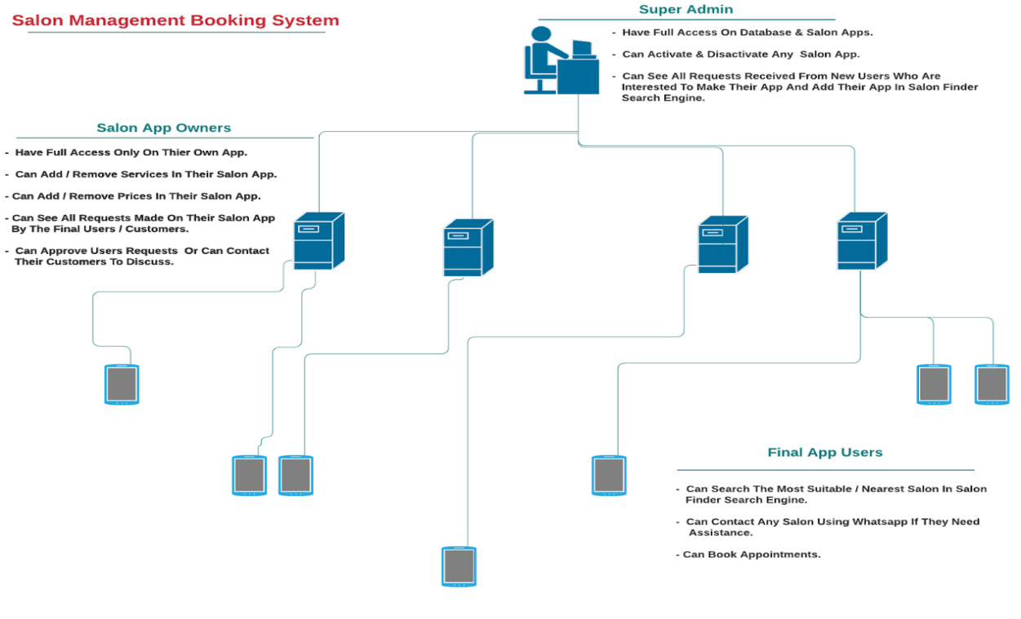*Figure 1. Show the concept of the booking system*

**Review of Related Literature**

**Theoretical Background**

In order to develop further and understand the study, the researchers made use of different reading materials and other references such as books, past thesis, web articles both foreign and local related to salon booking system. It also serves as a guide to the researchers to achieve their target objectives.

Technology, Is a way to automate all manual processing. Beauty salons needs to upgrade or change the manual methodology of data processing to save time.

**Related Literature**

In 1976 defines computers based information systems as structured systems that rely on computer hardware and software technology to collect, process, and store and distribute information. Information systems are employed to support decision making and control in business. Information systems can also be used to analyse problems, visualize complex subjects, and create new products. Input, processing and output are the three activities in an information system that produces the information a business needs.Advancements of software and using the internet to maintain and monitor their e-commerce. In the application of the informative systems, the salon reservation system is one of the used systems.

The literature review deals with the many topics and the researches that would help to understand Salon Finder and Salon Booking and Management System. The main objective of this literature review is to analyze the related work to this project also mechanisms used in previous studies. The following proposed system aims to develop a simple website for facilitating the reservation process at the salon. The system provides an easy way for searching nearest Salon, make an appointment and check available days, inserting the customer's information, getting details when need information about a specific customer, also making a reservation for services online. The management system can be accessed through android Phones, that users can add, update, delete the salon services. Enables the admin user to approve, cancel, and archive all the bookings information.

This chapter reviews the existing system and techniques related to Salon Finder and Salon Booking and Management System. Also deals with the topics and the researches that would help to understand and use of Reservation System for beauty salon. Without an online booking system, you will have to rely on phone calls and go to the salon only to make reservations. Clearly, an online booking system and Salon finder is necessary and required nowadays as we still defend ourselves to prevent the spread of the Pandemic Covid-19 in 2020, that is why we would like to point out the benefits every good online booking system should bring you as it works 24/7.

2.3 Beauty Salon

Beauty salons have proven to be a recession-proof industry across United States. Although sales had declined from 2008 highs due to the Great Recession, they remain robust with long term positive forecast. Even though during recessions, consumers tend to be more price conscious, spending continues to go increase. With rising per capital incomes across the United States since 2015, beauty salons are booming with the industry generating $56.2 billion in the United States.

Hair care is the largest segment with 86,000 locations. Skin care is expected to have revenue of almost $11 billion by 2018. This growth is being driven in part by a generally increasing awareness of the importance of skin care among American woman, but also specifically due to an increase in the market for men. The market is distributed widely across America, with a concentration in the Northeast and Midwest. There is also a growing trend in boutique salons popping up and leveraging online marketing to gain customers and compete with the franchise chains. The US Labour Department estimates employment in the United States will increase 20% between 2008–2014, with greatest employment growth from skin care specialists.This is a time of world-wide competition; all of the worlds are competing with each other’s using absolute and advanced technological features. The most common example of innovation is in information technology and communication.  
(Source: https://en.wikipedia.org/wiki/Beauty_salon#Industry

**CHAPTER II – METHODS**

This chapter will define the methods used in research to conduct the study of the Salon Finder and Booking Management System. The proposed system has gone through the procedures like costing, hardware specification, pre-survey result, post surveys chapter will define the methods used in research to conduct the study of Salon Finder, and Booking Management System. These methods help the researchers to utilize suggestions to develop the system successfully. The researchers conducted quantitative surveys in which the respondent (Salon Customers, Friends, etc.) fill up forms using google form surveys and qualitative surveys, asking the respondent (Salon Owners) verbal questions. The researcher compares the system to the current Salon booking system on the internet. These are the salon booking systems that have been used by developed outside the country.

**Pre-Survey Questions and Result**

When a salon is closed, do you prefer to book online?

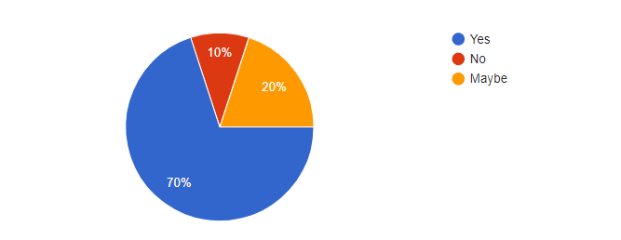 This part of the survey conclude that 70% of the customer preferred to book online while 20% preferred to book online or walk in and 10% does not want to book online. Above All, Booking online gets the higher percentage since nowadays we need to consider the safety and hassle free services.

*Figure 2. Pre-survey(Q1)*

Before making a booking, Do you like to check the services offered directly on the website?

This part of the system conclude that 90% of the customer wants to see the price of the services before making an appointment. This is to check if the prices greatly affect the customer’s decision when choosing a Beauty Salon.

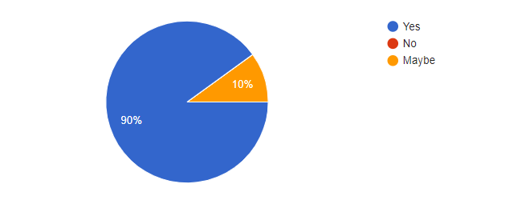

*Figure 3. Pre-survey(Q2)*

Do you want to see first the upcoming deals and promotions before choosing a booking date?

This part of the system conclude that customer wants to know the promotions of the Beauty Salon.

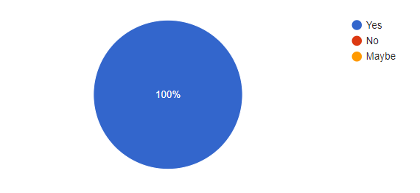

*Figure 4. Pre-survey(Q3)*

Is it helpful for you to display on the website, the reviews & testimonials, before and after pictures of past work before choosing a salon?

This part of the survey stated that 90% of the customer really wants to know the reviews and testimonials before choosing a Beauty Salon.

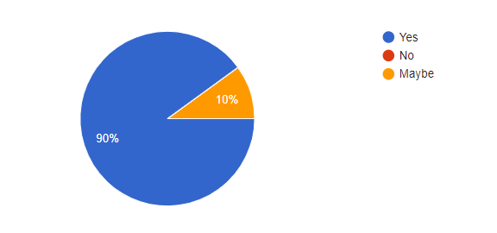

*Figure 5. Pre-survey(Q4)*

Is it helpful for you to include a detailed description of treatments & services displayed on the website?

This part of the survey suggested to include the services description so the customer will have idea about the services offered.

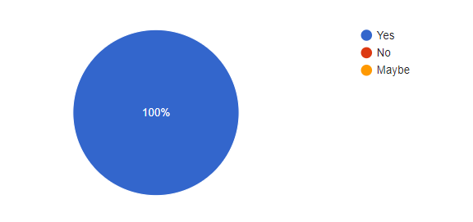

*Figure 6. Pre-survey(Q5)*

Do you also want to know the information on products used or for sale at the salon? This part of the survey concluded that 90% of the customer wants to know the products used in the Salon.

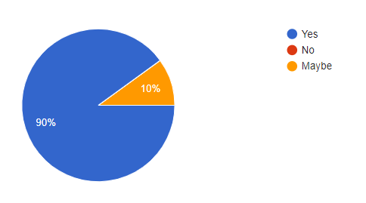

*Figure 7. Pre-survey(Q6)*

Which of these two features are most important to you on the salon/barber/spa website? This part of the survey stated that the products for sale online and having a blog and news about the latest trends are both important for the customer.

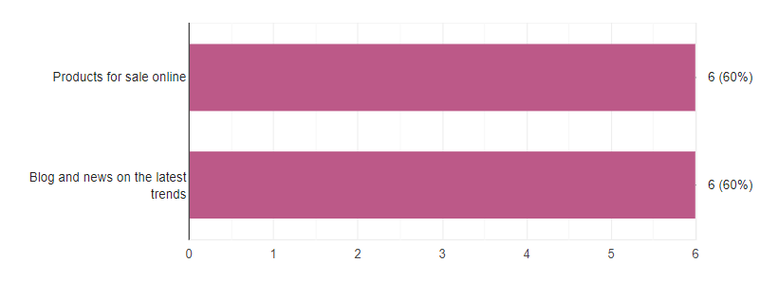

*Figure 8. Pre-survey(Q7)*

This software can help to search available Salons and get directions via Google Map. Do you like the concept of the Software?

This part of the survey concluded that the customer like the concept of searching available salons and will give a specific direction to go to that Beauty Salon.

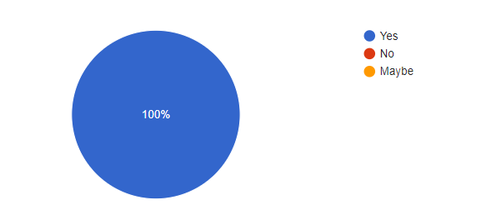

*Figure 9. Pre-survey(Q8)*

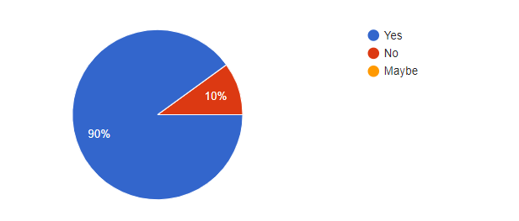Do you like to check other salons on the same website after checking one salon you visited online? This part of the survey stated that out of 100% there was 90% who says that he/she wants a system that can check another salon in just one website.

*Figure 10. Pre-survey(Q9)*

Is it helpful for you to use a website that can find the nearest salon and display the location and prominently displayed the salon opening hours?

This part of the survey stated that having a software that can easily find a nearest salon together with display of the important details before booking is helpful for them.

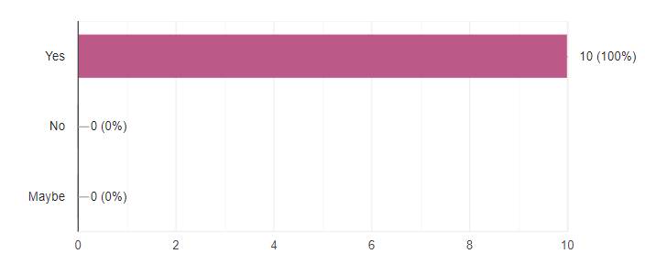

*Figure 11. Pre-survey(Q10)*

**Pre-Survey Result**

|  |  |  |  |  |
| --- | --- | --- | --- | --- |
| Questions | No. of respondent | Percentage | | |
| 1. When a salon is closed, do you prefer to book online? | 25 | Yes | No | Sometimes |
| 68% | 4% | 28% |

*Table 1. Pre-Survey Result (Q1)*

|  |  |  |  |  |
| --- | --- | --- | --- | --- |
| Questions | No. of respondent | Percentage | | |
| 2. Before making a booking, Do you like to check the services offered directly on the website? | 25 | Yes | No | Maybe |
| 70% | 10% | 20% |

*Table 2. Pre-Survey Result (Q2)*

|  |  |  |  |  |
| --- | --- | --- | --- | --- |
| Questions | No. of respondent | Percentage | | |
| 3.Do you want to see first the upcoming deals and promotions before choosing a booking date? | 25 | Yes | No | Maybe |
| 90% | 10% | N/A |

*Table 3. Pre-Survey Result (Q3)*

|  |  |  |  |  |
| --- | --- | --- | --- | --- |
| Questions | No. of respondent | Percentage | | |
| 4. Is it helpful for you to display on the website, the reviews & testimonials, before and after pictures of past work before choosing a salon? | 25 | Yes | No | Maybe |
| 90% | N/A | 10% |

*Table 4. Pre-Survey Result (Q4)*

|  |  |  |  |  |
| --- | --- | --- | --- | --- |
| Questions | No. of respondent | Percentage | | |
| 5. Is it helpful for you to include a detailed description of treatments & services displayed on the website? | 25 | Yes | No | Maybe |
| 100% | N/A | N/A |

*Table 5. Pre-Survey Result (Q5)*

|  |  |  |  |  |
| --- | --- | --- | --- | --- |
| Questions | No. of respondent | Percentage | | |
| 6. Do you also want to know the information on products used or for sale at the salon? | 25 | Yes | No | Maybe |
| 90% | N/A | 10% |

*Table 6. Pre-Survey Result (Q6)*

|  |  |  |  |
| --- | --- | --- | --- |
| Questions | No. of respondent | Percentage | |
| 7. Do you like to check other salons on the same website after checking one salon you visited online? | 25 | Yes | No |
| 90% | 10% |

*Table 7. Pre-Survey Result (Q7)*

|  |  |  |  |
| --- | --- | --- | --- |
| Questions | No. of respondent | Percentage | |
| 8. Which of these two features are most important to you on the salon/barber/spa website? | 25 | Products for sale online | Blog and news on the latesttrends |
| 60% | 60% |

*Table 8. Pre-Survey Result (Q8)*

|  |  |  |  |  |
| --- | --- | --- | --- | --- |
| Questions | No. of respondent | Percentage | | |
| 9. This software can help to search available Salons and get directions via Google Map. Do you like the concept of the Software? | 25 | Yes | No | Maybe |
| 100% | N/A | N/A |

*Table 9. Pre-Survey Result (Q9)*

|  |  |  |  |  |
| --- | --- | --- | --- | --- |
| Questions | No. of respondent | Percentage | | |
| 10. Is it helpful to use a website that can find the nearest salon and display the location and prominently displayed the salon opening hours? | 25 | Yes | No | Maybe |
| 100% | N/A | N/A |

*Table 10. Pre-Survey Result (Q10)*

**Post Survey**

The survey used google form for quantitative respond of the respondent which is the students.

How often do you at least go to the salon?

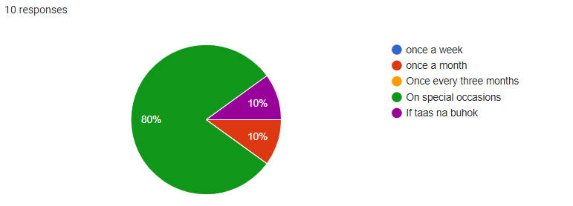

*Figure 12. Post-survey(Q1)*

Do you make reservations before going to the salon?

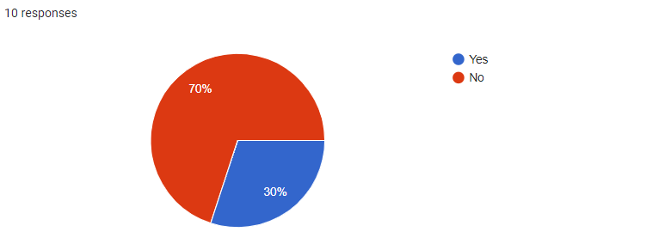

*Figure 13. Post-survey(Q2)*

What are the most common problems that you face when you go to the salon?

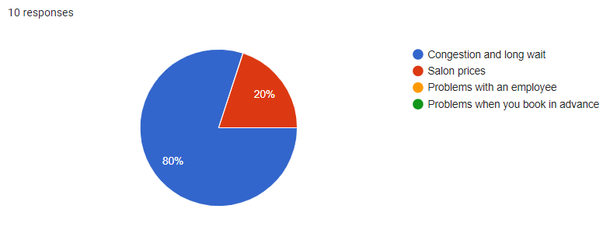

*Figure 14. Post-survey(Q3)*

.What are the factors that greatly affect your decision when choosing a beauty Salon?

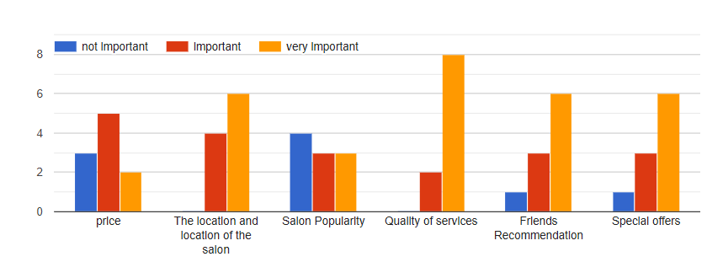

*Figure 15. Post-survey(Q4)*

What are the ways that you go to search for a beauty salon?

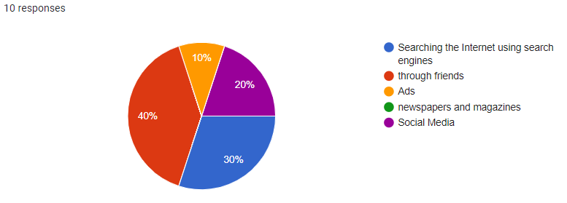

*Figure 16. Post-survey(Q5)*

Do you prefer to book appointments through the mobile application?

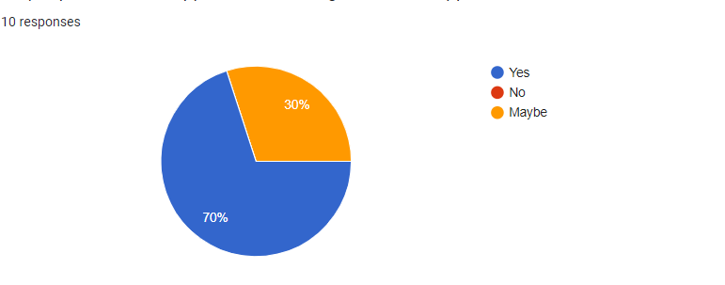

*Figure 17. Post-survey(Q6)*

Do you want to know all the salons around you and near you and know the services you provide and learn about others' experience?

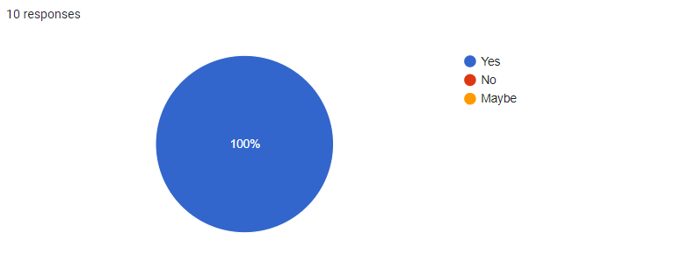

*Figure 18. Post-survey(Q7)*

What OS do you prefer for the application?

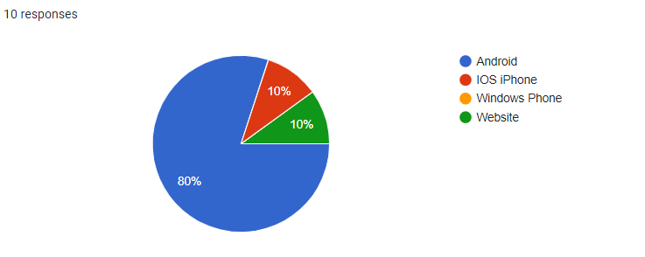

*Figure 19. Post-survey(Q8)*

Do you have any suggestions on our project?

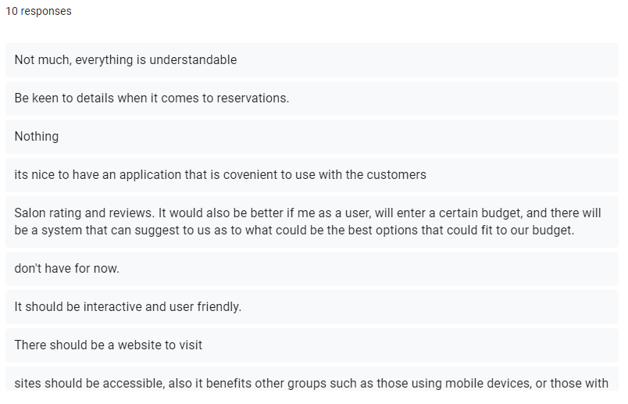

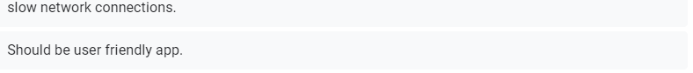

*Figure 20. Post-survey(Q9)*

**Post-Survey Result**

|  |  |  |  |  |  |  |
| --- | --- | --- | --- | --- | --- | --- |
| Questions | No. of respondent | Percentage | | | | |
| 1.How often do you at least go to the salon? | 10 | once a week | once a month | Once every three months | On special occasions | Other: |
| 0(0%) | 0(0%) | 1(10%) | 8(80%) | 1(10%) |

*Table 11. Post- Survey Result (Q1)*

|  |  |  |  |
| --- | --- | --- | --- |
| Questions | No. of respondent | Percentage | |
| 2. Do you make reservations before going to the salon? | 10 | Yes | No |
| 3(30%) | 7(70%) |

*Table 12. Post- Survey Result (Q2)*

|  |  |  |  |  |  |
| --- | --- | --- | --- | --- | --- |
| Questions | No. of respondent | Percentage | | | |
| 3.What are the common problems you face when you go to salon? | 10 | Congestion and long wait | Salon prices | Problems with an employee | Problems when you book in advance |
| 8(80%) | 2(20%) | 0(0%) | 0(0%) |

*Table 13. Post- Survey Result (Q3)*

|  |  |  |  |  |  |
| --- | --- | --- | --- | --- | --- |
| Questions | No. of respondent | Salon Factors | Percentage | | |
| 2. What are the ways that you go to search for a beauty salon? | 10 |  | Important | not important | Very important |
| price | 5(50%) | 3(30%) | 2(20%) |
| The location and location of the salon | 4(40%) | 0(0%) | 6(60%) |
| Salon Popularity | 3(30%) | 4(40%) | 3(30%) |
| Quality of services | 2(20%) | 0(0%) | 8(80%) |
| Special offers | 3(30%) | 1(10%) | 6(60%) |

*Table 14. Post- Survey Result (Q4)*

|  |  |  |  |  |  |  |
| --- | --- | --- | --- | --- | --- | --- |
| Questions | No. of respondent | Percentage | | | | |
| 2. What are the ways that you go to search for a beauty salon? | 10 | Searching the Internet using search engines | through friends | Ads | newspapers and magazines | Social Media |
| 3(30%) | 4(40%) | 1(10%) | 0(0%) | 2(20%) |

*Table 15. Post- Survey Result (Q5)*

|  |  |  |  |  |
| --- | --- | --- | --- | --- |
| Questions | No. of respondent | Percentage | | |
| Do you prefer to book appointments through the mobile application? | 10 | Yes | No | Maybe |
| 770%) | 0(0%) | 3(30%) |

*T Table 16. Post- Survey Result (Q6)*

|  |  |  |  |  |
| --- | --- | --- | --- | --- |
| Questions | No. of respondent | Percentage | | |
| Do you prefer to book through the mobile application? | 10 | Yes | No | Maybe |
| 10(100%) | 0(0%) | 0(0%) |

*Table 17. Post- Survey Result (Q7)*

|  |  |  |  |  |  |
| --- | --- | --- | --- | --- | --- |
| Questions | No. of respondent | Percentage | | | |
| What OS do you prefer for the application? | 10 | Android | IOS iPhone | Windows Phone | Website |
| 8(80%) | 1(10%) | 0(0%) | 1(10%) |

*Table 18. Post- Survey Result (Q8)*

These explain the overall suggestions and enhancements for Salon Finder and Booking Management System.

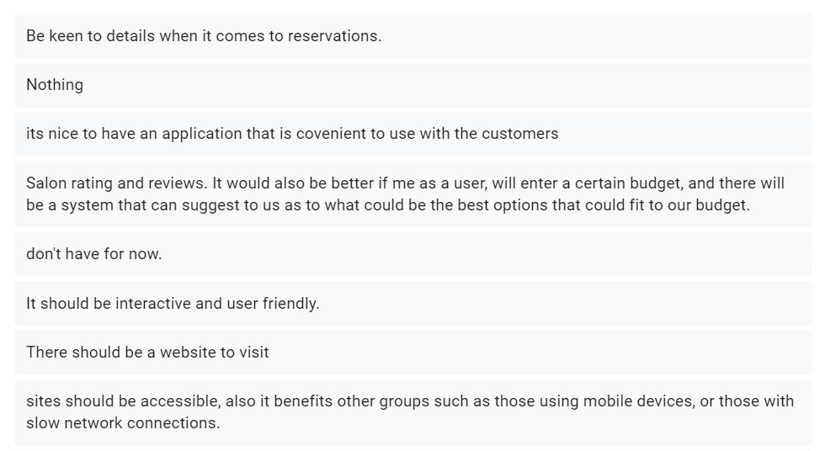

*Figure 21. Post-survey Result(Q9)*

**Salon Owner Survey**

The Salon owner of J4 Beauty Salon and Spa shared a necessary feedback to the questions stated below:

1.What are the challenges your salon is facing?

Answer:

Facing difficulty in engaging and retaining clients.Also,having problems in driving sales.But I was not struggling in managing my employees and their appointments.

Do you think that having a functionality to book appointments online, access the software through a mobile application, manage clients and their records,market the salon services and the products, manage the employees and send personalized emails and messages to clients can be a good spa and salon software?

Answer:

Yes, I think this Software can resolve the challenges that my business had been facing right now since on this pandemic time, we need to conduct a wise way to gain customers.

Do you think it is good to have a system like Salon Finder and Salon Booking Management System?

Answer:

Yes, I think this can help my business.

Do your staff who would normally spend time on the phone talking to customers and scheduling appointments?

Answer:

Yes, it consume a lot of time since the customer wants to know some details about the service and they can’t visualize it because it’s via phone call.

Do you think it is good idea to have a time table for your staff in various services?If not, then please let us know the reasons.

Answer:

No, the time that the services will take matters on what type of hair structure and concerns does the customer had. So, I will not recommend to include a time table on each services on the website.

**Research Design**

This chapter defines the research used methods to enhance the system requirements. Google Forms helps the researchers to conduct the study of Salon Finder and Booking Management System.The researcher explains how the data and information in google forms in order to address the research objectives and questions was collected, presented and analyzed. The researcher wants to know the opinions of the respondents specifically about the functionalities of the system. The data for this particular research was collected using survey and questionnaires by the help of Google Forms.

An online booking system is necessary and required nowadays that is why we would like to point out the benefits of good online booking system that would give us an easy transactions.An online booking system works all the time. This gives freedom to potential customers to book services anytime they want and maximizes sales because the user’s working hours is not limited. In fact studies show that a 24/7 online reservation system greatly increases the number of bookings.It saves a lot of time and effort.

The system should be able to run for all PCs with an operating systems that supports Windows 7 & up-to-date windows and running the Salon App in a single salon environment.  . This is for a single stand-alone PC salon configuration or for a salon with a Local Area Network (LAN) configuration.Internet access allows you to connect to servers and a high speed internet connection is recommended. A single network switch , Wi-Fi with high bandwidth, or router is required if setting up a LAN.

**Description of the Respondents**

A total of 10 friends were the respondents of the study. They are described according to their demographic profile such gender as (male and female) and educational degree (Information Technology, Education, Social Studies).In this study, the accessible population comprised all the Information Technology Students in ACLC College Of Mandaue. Most of them have had technical experience in web development and therefore, they are in the best position to furnish the researcher with the information needed to answer the research question of this study.These survey was created through the use of google form.

These are the respondents (student and guardians) for Pre-Survey.

|  |  |
| --- | --- |
| **Timestamp** | **Email Address** |
| 12/8/2020 18:30:08 | catarata.angelica47@gmail.com |
| 12/8/2020 18:30:18 | jmdonnu@gmail.com |
| 12/8/2020 18:37:44 | cesartajanlangit143@gmail.com |
| 12/8/2020 18:48:02 | villarmenterigie@gmail.com |
| 12/8/2020 18:49:36 | Antonjllamado@gmail.com |
| 12/8/2020 19:35:54 | adolfojohnkenneth@gmail.com |
| 12/8/2020 19:47:50 | sarmadikram4@gmail.com |
| 12/8/2020 19:48:57 | subarunakajima64@gmail.com |
| 12/9/2020 8:09:36 | aclc.jadc@gmail.com |
| 12/9/2020 10:46:04 | maria.rovilet233@gmail.com |

*Table 19. Pre- Survey Respondents*

These are the respondents (student and guardians) for Post-Survey.

|  |  |
| --- | --- |
| **Timestamp** | **Email Address** |
| 2/13/2021 6:51:02 | subarunakajima64@gmail.com |
| 2/13/2021 8:28:18 | ireneoarcenaljr@gmail.com |
| 2/13/2021 14:09:03 | eizelpanda@gmail.com |
| 2/13/2021 14:34:56 | 123glyndonrosco@gmail.com |
| 2/13/2021 18:12:25 | act.jzka@gmail.com |
| 2/23/2021 11:14:31 | asskicker09876@gmail.com |
| 3/27/2021 14:57:19 | jhenyangbutawan@gmail.com |
| 3/27/2021 15:00:39 | erich_wan@yahoo.com |
| 3/27/2021 15:04:41 | shelamae@shopify.com |
| 3/27/2021 15:06:05 | gemma123@gmail.com |

*Table 20. Pre- Survey Respondents*

**Research Instruments**

The researcher designed an interview as one of the data collection of this study. The interview questions were aimed at eliciting relevant information concerning the problems .A questionnaire in Google Forms designed by the researcher titled ”Pre-Survey and Post-Survey Questions for Salon Finder and Booking Management System.” was used in the study. The content of the instrument was based on the findings of the interview conducted with the IT students in ACLC College of Mandaue and the salon owner of J4 Beauty Salon & Spa at 429 Babang II Rd, Cordova, Cebu.These are the instrument of the SFBMS(Salon Finder and Booking Management System):

**COMPONENT**

**Android Phone**

It is a component to be used for mobile application for Salon owners. Customers can use android phones to book the services since the website has been designed to be responsive website. This means that the Salon Finder and Booking Management System can be viewed on any Android phones as long as the device runs a chrome browser.

**Personal Computer**

It is the component to be used for all users to access the full website.

**Wi-Fi**

It is a component to be used to have internet connection.This should be able to support the number of devices you plan to connect in one store.  
 **USER INTERFACE APPLICATION**

* **Mobile Application**

It is an application where the salon owners can access the salon management system.

* **Web page Application**

It is an application where the booking transaction takes place. The users can use the system in 24/7 online through web application platform.

**Hardware Specification**

**Development**

|  |  |
| --- | --- |
| **Hardware Specification for Web/Desktop/Mobile App Development** | |
| **PC** | |
| Processor | Intel Core i5-6500 (2.4 GHz, 3MB L3 Cache) |
| Memory | 4 GB DDR4 Memory |
| Storage | 240 GB M.2 2280 Solid State Drive |
| Display | 14" LCD w/ 1366x768 px resolution |
| Battery | Lithium Ion (Li-Ion) 2800 mAh |
| Communication | WLAN: IEEE 802.11ac / LAN: Gigabit Ethernet |
| **Wi-Fi Router** | |
| Type | Wi-Fi access point, Local Network, Mobile Wifi |
| Wireless Standard | 802.11n, frequency 2.4 / 5 GHz |
| Protection Information | WEP, WPA, WPA2, 802.1x |
| **Mobile Phone** | |
| Processor | MediaTek MT6750 Octa Core |
| Memory | 16GB ROM, 2 GB RAM |
| Display | Touch screen1080x2160 Resolution(5.70) |
| Battery | Non-removable Li-Ion 4130 mAh battery |
| Communication | WLAN: Wi-Fi 802.11 b/g/n, Wi-Fi Direct, hotspot |

*Table 21. Hardware Specification for Web & Mobile App Development*

|  |  |
| --- | --- |
| **Software Specification for Web/Desktop/Mobile App Development** | |
| **PC** | |
| OS | Windows 10 |
| Languages | Vue JS, Firebase , Apache 2 |
| Frameworks, | Node.js, Vue-Router, IP Address, WebSocket |
| IDE's & Tools | Visual Studio Code, Notepad |
| Browsers | Google Chrome |

*Table 22. Software Specification for Web & Mobile App Development*

**Deployment**

|  |  |
| --- | --- |
| **Hardware Specification for Web/Desktop/Mobile App Development** | |
| **PC** | |
| Processor | Intel Core i5-6500 (2.4 GHz, 3MB L3 Cache) |
| Memory | 4 GB DDR4 Memory |
| Storage | 240 GB M.2 2280 Solid State Drive |
| Display | 14" LCD w/ 1366x768 px resolution |
| Battery | Lithium Ion (Li-Ion) 2800 mAh |
| Communication | WLAN: IEEE 802.11ac / LAN: Gigabit Ethernet |
| **Wi-Fi Router** | |
| Type | Wi-Fi access point, Local Network, Mobile Wifi |
| Wireless Standard | 802.11n, frequency 2.4 / 5 GHz |
| Protection Information | WEP, WPA, WPA2, 802.1x |
| **Mobile Phone** | |
| Processor | MediaTek MT6750 Octa Core |
| Memory | 16GB ROM, 2 GB RAM |
| Display | Touch screen1080x2160 Resolution(5.70) |
| Battery | Non-removable Li-Ion 4130 mAh battery |
| Communication | WLAN: Wi-Fi 802.11 b/g/n, Wi-Fi Direct, hotspot |

*Table 23. Hardware Specification for Salon App System*

|  |  |
| --- | --- |
| **Hardware Specification for Web and Mobile** | |
| **PC** | |
| Processor | Intel Core i5-6500 (2.4 GHz, 3MB L3 Cache) |
| Memory | 4 GB DDR4 Memory |
| Storage | 240 GB M.2 2280 Solid State Drive |
| Display | 14" LCD w/ 1366x768 px resolution |
| Battery | Lithium Ion (Li-Ion) 2800 mAh |
| Communication | WLAN: IEEE 802.11ac / LAN: Gigabit Ethernet |
| **Mobile Phone** | |
| Processor | MediaTek MT6750 Octa Core |
| Memory | 16GB ROM, 2 GB RAM |
| Display | Touch screen1080x2160 Resolution(5.70) |
| Battery | Non-removable Li-Ion 4130 mAh battery |
| Communication | WLAN: Wi-Fi 802.11 b/g/n, Wi-Fi Direct, hotspot |

*Table 24. Hardware Specification for Admin Development*

|  |  |
| --- | --- |
| **Software Specification** | |
| **Android Platform** | |
| Operating System | Android 8.0 (Oreo) |
| Software | IP Address Link |
| **Desktop Platform** | |
| Operating System | Windows 8.1 |
| Software | IP Address Link |
| **Web Platform** | |
| Operating System | Windows 8.1 |
| Browser | Google Chrome |

*Table 22. Hardware Specification for Admin Development*

*Table 25. Software Specification for Admin Development*

|  |  |  |  |
| --- | --- | --- | --- |
| **Development: Hardware** | | | |
| **Functional Hardware** | **Qty** | **Price** | **Total Cost** |
|  |  |  |  |
| Sd Card 16Gb w/ OS | 1 | 750.00 | 750.00 |
| HDMI Cable 1.3 meter | 1 | 250.00 | 250.00 |
| Keyboard | 1 | 450.00 | 450.00 |
|  |  |  |  |
| **Total Functional Hardware Cost** | | | **₱ 1450.00** |
|  | | |  |
| **Non-Functional Hardware** |  | | **Total Cost** |
| Devant LED Monitor | ₱ 10,000.00 |
| Lenovo Laptop Series i5 | 24,000.00 |
| Asus Phone version 8.0 | 12.000.00 |
| Ethernet | 0.00 |
|  |  |
| **Total Non-Functional Hardware Cost** | | | **₱ 46,000.00** |
| **Total Hardware Cost** | | | **₱ 49.000.00** |
| **Development: Software** | | |  |
| **Software** |  | | **Total Cost** |
| Google Chrome | ₱ 0.00 |
| Visual Studio Code | 0.00 |
| IP Address Link | 0.00 |
| Raspian OS | 0.00 |
| Php 7 | 0.00 |
| Mariadb |  | | 0.00 |
| Apache2 |  | | 0.00 |
| Notepad |  | |  |
| **Total Software Cost** | | | **₱0.00** |
|  | | |  |
| **Deployment: Hardware** | | |  |
| **Functional Hardware** | **Qty** | **Price** | **Total Cost** |
|  |  |  |  |
| Sd Card 16Gb | 1 | 650.00 | 650.00 |
| HDMI Cable 1.3 meter | 1 | 250.00 | 250.00 |
|  |  |  |  |
|  |  |  |  |
| **Total Functional Hardware Cost** | | | **₱ 900.00** |
|  | | |  |
| **Non-Functional Hardware** |  | | **Total Cost** |
| Samsung Tablet | ₱ 5,000.00 |
| Ethernet | 0.00 |
|  |  |
| **Total Non-Functional Hardware Cost** | | | **₱ 5,000.00** |
| **Total Hardware Cost** | | | **₱ 8,845.00** |

**Costing**

*Table 26. Costing for Development*

**Flowchart**

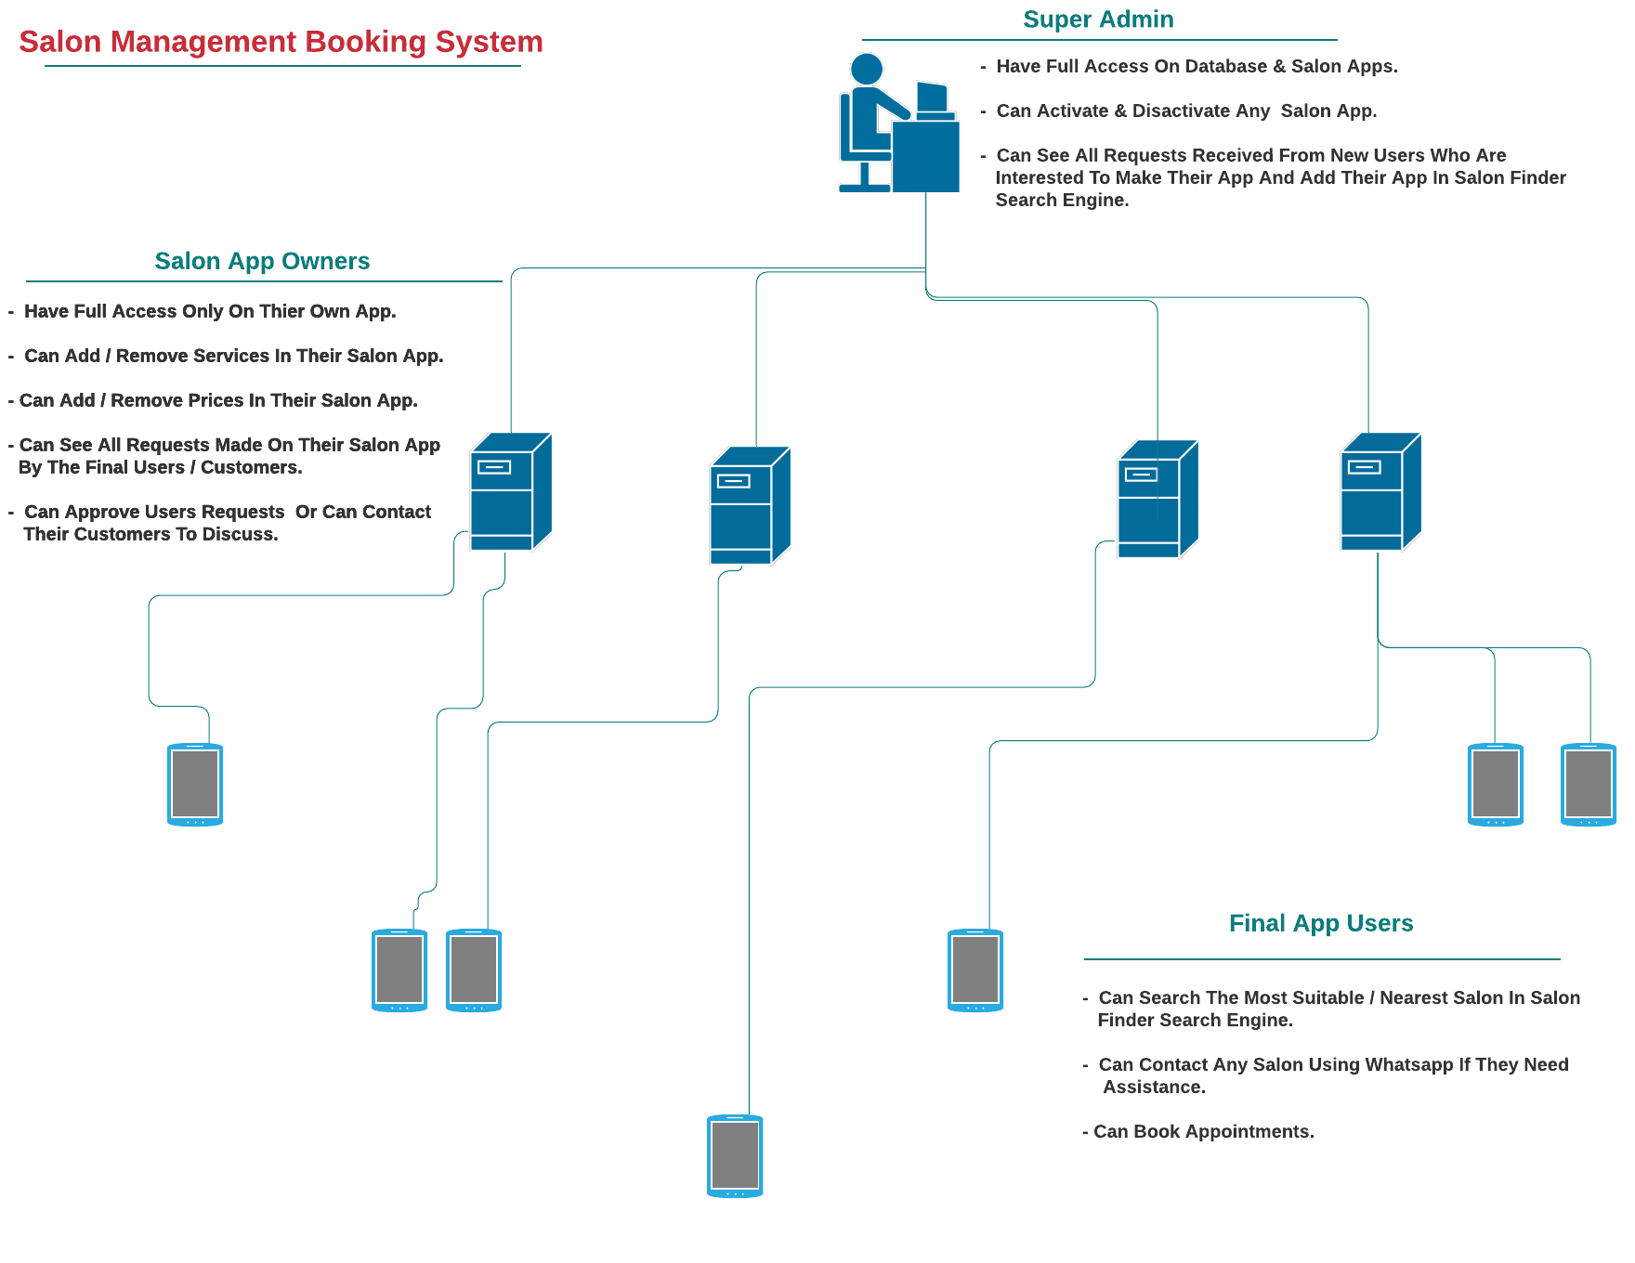

*Figure 22. Process Flow of the System*

**Data Collection or Data Gathering Procedure**

The survey was conducted by the researcher via Google Forms and Face to Face interview of the Salon Owner. Using Google Forms as a tool for data gathering is a modern methodology of data collection that use of Internet based research. This would mean receiving the respondents response via e-mail on which that would take them to a secure web-site to fill in a questionnaire. This type of research is often quicker and less detailed. Some disadvantages of this method include the exclusion of people who do not have a computer or are unable to access a computer. Along with the Face -to -face interview of the Salon Owner have a distinct advantage, and helps the researcher to establish bond with potential participants and therefore gain cooperation.These interviews yield highest response rates in survey research. They also allow the researcher to clarify answers and when appropriate, seek follow-up information.

**CHAPTER III – RESULTS**

**Data Presentation**

Data presentation is defined as the process of using various graphical formats to visually represent the relationship between two or more data sets so that an informed decision can be made based on them. It gives objectives to the entire development of the Salon Finder and Salon Booking Management System. For data gathering, a questionnaire survey through Google Forms was conducted. The survey comprises of 10 sets of question. The survey was then distributed to 25 respondents for pre-survey purposes and 10 respondents for the post-survey. The respondents are the IT students of ACLC College of Mandaue and Salon lovers. The survey shows the important features that needs to consider in order to build a high standard Salon Booking and Management Software. In Post survey, there 10 respondents who answers the question through the use of google form. The survey comprises of 10 questions. The surveys explain that the result of the systems usability, functionality and feasibility are well integrated to the system.

For the Salon Owners, the researchers use verbal questions for the interview about the system. According to the Salon Owners, the Salon App is very useful and helpful for them, as they said that this will boost their business and avoid crowded people and to implement physical distancing.

The detailed data with corresponding insights from the salon owners and IT students gives so much impact to build the system successfully.

**Data Interpretation**

The Salon App survey gives a wonderful interpretation to assemble the overall functionality of the Salon App. There are many Salon App on the market and it is good to know what we are paying for the services. Will the software boost the Salon business? Does it help to automate all the tasks? The quality of the system matters the most. As we aimed to avoid paperless, crowded, long waiting at Salon and how to boost business online. These are the following main challenges that we need to cope and solved. Salon Booking and Management System is the right place for the Salon Owners who aimed success. Per Survey, the respondents have shared a lot of insights on what they like about Salon App. As a result, the survey was conducted through online and it seems like people wants to have a Salon App that can book and cater all the managerial task, access the salon services into the internet. In general, the Salon Booking and Management System was developed and designed as per the result of the survey.

**Data Analysis**

For Data analysis we use qualitative analysis to assess the development of the system. It includes questions that were stated via google forms and interviews which provides a new perspective on the system’s competitive advantage. Gathering opinions from respondents on the value they see in the Salon App and the services it offered to prospective clients. Often this perception differs from what was assumed. Using google forms to write respondent's feedback about the Salon App and to guide future Salon Businesses, gives a clearer picture of why respondents like the system. Google Forms automate the analysis of the survey. This is the tool that where opinion counts easily since it has automated graphical result and check it by percentage. In this way, the researchers easily analyzed the dominant opinions and suggestions regarding what they experienced and how the app will gonna help those concerns.

**CHAPTER IV – DISCUSSION**

The results of the survey that has been conducted by the researchers makes the project more effective. The aim of the Salon Booking Management System is to automate the Salon transactions. This can allow the users or the customers to set the desired date of appointment with the salon and to record the personal details of customers as well as the transaction details. Convert the manual process of salon management into an online platform with a mobile app support.

**Summary**

Salon Booking Management System is digital solutions, such as online booking and appointment scheduling reduce admin, optimize availability and give ultimate flexibility and convenience to clients. In chapter 1, it explains the advantages of having the Salon Finder and management Booking System. That the system integrate an instant online booking directly to the salon's results page on Google Search or Google Maps. Its main goal is to Stop missing out on potential customer

In chapter 2, the researchers needed a method to support and analyze the data. These are the pre-survey, post survey, personal questions to the staff about the salon system that some salon businesses doesn’t have. The costing of the system, the hardware and software specification, the respondent survey and result. The researchers needed this method to gather specific data and alignment to the system. The integration and functionality of the system is a must, these are combine quantitative and qualitative materials to develop the system. The method help the researchers to surpass the misconception of the system. These will prove that methods are the way to provide the main purpose of the study due to the respondent who are being true by answering the questions given by the researchers.

In chapter 3, which is the result of the chapter 2 methods in which the progress of the chapter 2 answers the result in chapter 3. The graph will show how useful and innovative the paperless queuing system is. The results gather from the chapter 3 is fact and justified by the chapter 2.

In a way that the result will prove how the system is develop slowly and mold by the respondent response. And also the staff of the school helps a lot to cooperate the said matter. These are the evidence that the researchers will hold and apply these sooner.

In chapter 4, the summary of all the chapters from 1 to 4 is applied. The recommendations and conclude for the users, staffs, administrator, researcher’s and future researchers that will deploy the system is the way of data gathering to support the project. The researcher’s data is reliable to make this project achieved successfully. The project was well tested by the researcher. It was tested using automation tool for fast an reliable bug results. The project is designed for mobile and web platform. It could be a game changer to any salon businesses.

**Conclusion**

The researcher conclude that this type of Salon booking and management system can maximize reservations and faster way of transaction. This is helpful for any kind of queue transaction for a better solution. Online booking means you capture more potential business because reservations and information are always available.The development of system will be using the INTRODUCTION METHOD RESULT AND DISCUSSION (IMRAD) method. By evaluating the process of Salon booking and management system, this system could help promote the loyal customers to pre-book their next appointment for when the salon business plan to be open again  due to COVID-19. This system helps salon staff to check the wait list of the customer. A wait list can give you a sense of just how many clients are eager to return, when, and for which services. You can also get a sense of which staff members are in highest demand to start building your schedule. This is especially helpful as you may need to have your team work in shifts.

The GUI of this system is so responsive and attractive design. The design of the system creates awesome impressions and attracts more visitors.

**Recommendation**

Everything can be customize to the brand look and feel. This project will be first implemented to the selected salon shop located in Cordova, Cebu, Philippines.

The salon owners who wants to request will be having all default features and free to request a functionality that the system not covered yet. Any recommendation about the system will be highly appreciated as the researcher aimed to get the best salon solutions.

**References**

**Web Resources**

**Docs, Guides, and Codes**

* <https://vee-validate.logaretm.com/v2/guide/getting-started.html#usage>
* <https://vuejs.org/guide/essentials/event-handling.html#event-modifiers>
* <https://vuejs.org/guide/quick-start.html#without-build-tools>
* <https://www.javascripttutorial.net/javascript-array-filter/>
* <https://youbiquity.co.uk/articles/content-hub/how-to-add-your-sitemap-to-your-robots-txt-file/>
* <https://codehasbug.com/javascript/disable-specific-date-in-jquery-datepicker/>
* <https://stackoverflow.com/questions/28702851/storing-a-function-call-inside-an-array>
* <https://stackoverflow.com/questions/62957810/how-to-update-multiple-level-data-on-firebase>
* <https://stackoverflow.com/questions/57611582/how-to-delete-user-with-vue-js-firebase-uid>
* <https://softauthor.com/firebase-javascript-crud-web-app-add-update-delete/>
* <https://ss64.com/vb/syntax-getdate.html>
* <https://www.koderhq.com/tutorial/vue/function-method/#function>
* https://designkojo.com/make-items-editable-vuejs-using-v-if-v-model-directives

**Appendices**

**Pre-Implementation Survey**

When a salon is closed, do you prefer to book online? *

Yes

No

Maybe

Before making a booking, Do you like to check the services offered directly on the website?

Yes

No

Maybe

Do you want to see first the upcoming deals and promotions before choosing a booking date? *

Yes

No

Maybe

Is it helpful for you to display on the website, the reviews & testimonials, before and after pictures of past work before choosing a salon?

Yes

No

Maybe

Is it helpful for you to include a detailed description of treatments & services displayed on the website?

Yes

No

Maybe

Do you also want to know the information on products used or for sale at the salon?

Yes

No

Maybe

Do you like to check other salons on the same website after checking one salon you visited online?

Yes

No

Maybe

Which of these two features are most important to you on the salon/barber/spa website?

Products for sale online

Blog and news on the latest trends

This software can help to search available Salons and get directions via Google Map. Do you like the concept of the Software? *

Yes

No

Maybe

Is it helpful for you to use a website that can find the nearest salon and display the location and prominently displayed the salon opening hours? *

Yes

No

Maybe

**Post-Implementation Survey**

How often do you at least go to the salon? *

once a week

once a month

Once every three months

On special occasions

Do you make reservations before going to the salon?

Yes

No

What are the most common problems that you face when you go to the salon? *

Congestion and long wait

Salon prices

Problems with an employee

Problems when you book in advance

What are the factors that greatly affect your decision when choosing a beauty Salon? *

not important

important

very important

price

The location and location of the salon

Salon Popularity

Quality of services

Friends Recommendation

Special offers

price

The location and location of the salon

Salon Popularity

Quality of services

Friends Recommendation

Special offers

What are the ways that you go to search for a beauty salon? *

Searching the Internet using search engines

through friends

Ads

newspapers and magazines

Social Media

Do you prefer to book appointments through the mobile application? *

Yes

No

Maybe

Do you want to know all the salons around you and near you and know the services you provide and learn about others' experience? *

Yes

No

Maybe

What OS do you prefer for the application? *

Android

IOS iPhone

Windows Phone

Do you have any suggestions on our project? *

**Customer Page Codes**

**Index.html**

<!DOCTYPE html>

<html lang="en">

<head>

    <meta charset="UTF-8"  name="jheny-salon">

    <meta name="viewport" content="width=device-width, initial-scale=1.0">

    <title>JhenyLyn Salon</title>

    <!--Import Google Icon Font-->

    <link href="https://fonts.googleapis.com/icon?family=Material+Icons|Material+Icons+Two+Tone" rel="stylesheet">

    <link href="css/animate.css" rel="stylesheet">

    <!-- Compiled and minified CSS -->

    <link rel="stylesheet" href="https://cdnjs.cloudflare.com/ajax/libs/materialize/1.0.0/css/materialize.min.css">

    <link href="css/style.css" rel="stylesheet">

    <link rel="stylesheet" type="text/css" href="css/gallery.css" />

    <!-- Compiled and minified JavaScript -->

    <script src="https://cdnjs.cloudflare.com/ajax/libs/materialize/1.0.0/js/materialize.min.js"></script>

    <script src="https://cdnjs.cloudflare.com/ajax/libs/axios/0.19.2/axios.min.js"></script>

    <script src="js/vue.js"></script>

    <script src="https://cdnjs.cloudflare.com/ajax/libs/vue-resource/1.5.1/vue-resource.min.js"></script>

    <script src="js/priceList.js"></script>

    <script src="js/booking.js"></script>

</head>

<body>

    <div id="main">

<!-------------------

        NAVBAR

-------------------->

          <nav>

            <div class="nav-wrapper">

              <a href="#" class="brand-logo center">JhenyLyn Salon</a>

              <a href="#" data-target="slide-out" class="sidenav-trigger left show-on-large">

                <a href="#" data-target="slide-out" id="hide"  @click="animationsCon = true" class="sidenav-trigger left show-on-large btn-floating btn-large cyan pulse" style="

                display: inline-table;

                position: absolute;

                margin-top: 30px;

                background-color: #cc64ff;">

                <i class="material-icons">menu</i></a>

              </a>

              <ul id="nav-mobile" class="left hide-on-med-and-down">

              </ul>

            </div>

          </nav>

<!-------------------

      SIDENAV

-------------------->

        <ul id="slide-out" class="sidenav">

            <li>

            <div class="user-view">

              <div class="background">

                <img src="img/bg.jpeg">

              </div>

              <a href="#user"><img v-if="animationsCon" class="circle animated rotateIn" src="img/logo.jpg"></a>

              <a href="#email"><span v-if="animationsCon" class="white-text email animated fadeInRight">jhenyangbutawan@gmail.com</span></a>

            </div></li>

            <li v-for="link in links">

              <a @click="changeContent" href="javascript:;" :id="link.id" v-if="animationsCon" class="waves-effect links animated fadeInLeft scale-transition">

                <i  class="material-icons-two-tone">{{ link.icon }}</i>

                {{ link.title }}

              </a>

            </li>

            <li>

              <a id="linkfive" href="https://reservation-system-69ff9.web.app/app/app/index.html"  v-if="animationsCon" class="waves-effect links animated fadeInLeft" target="_blank">

               <i class="material-icons">directions</i>

                Nearby Salons

              </a>

            </li>

            <li>

              <a id="linkhome"  v-if="animationsCon"  @click="home" class="waves-effect links animated fadeInLeft" >

               <i class="material-icons">home</i>

                Home

              </a>

            </li>

<!----Button For Closing The SideNav-->

            <span><a @click="animationsCon = false" class="sidenav-close" href="javascript:;"></a></span>

          </ul>

          <section class="content">

            <booking :id="links[0].id"> </booking>

            <pricelist :id="links[1].id"></pricelist>

          </section>

                  <div class="slider scale-transition">

                    <ul class="slides scale-transition">

                    <li>

                        <img class="img-responsive"  src="slider/carousel_files/1.jpg" alt="jheny-salon"> <!-- random image -->

                        <div class="caption center-align scale-transition">

                        <h1>Welcome Beauties</h1>

                        <h1 class="light grey-text text-lighten-3">Avail {{ currentMonth }} Promos </h1>

                        </div>

                    </li>

                    <li>

                        <img class="img-responsive"  src="slider/carousel_files/2.jpg" alt="jheny-salon"> <!-- random image -->

                        <div class="caption left-align scale-transition">

                        <h1>Affordable Hair Packages</h1>

                        </div>

                    </li>

                    <li>

                        <img class="img-responsive" src="slider/carousel_files/3.jpg" alt="jheny-salon"> <!-- random image -->

                        <div class="caption right-align scale-transition">

                        <h1>Exciting Discounts</h1>

                        <h1 class="light grey-text text-lighten-3">On Selected Services</h1>

                        </div>

                    </li>

                    <li>

                        <img class="img-responsive"  src="slider/carousel_files/4.jpg" alt="jheny-salon"> <!-- random image -->

                        <div class="caption center-align scale-transition">

                        <h1>Book Now!</h1>

                        <h1 class="light grey-text text-lighten-3">Open at 9 am to 5 pm</h1>

                        </div>

                    </li>

                    </ul>

                    </div>

                    <div class="parallax-container">

                      <div class="parallax"></div>

                    </div>

                    <div class="section white">

                      <div class="row container">

                        <div class="container policy">

                          <h2>

                          Cancellation Policy

                           </h2>

                           <h4>

                           We retains the right to cancel any appointment after 15 minutes of the service start time if you are 15+ minutes late.

                           Any appointment that is cancelled within a 24 hour period will not be charged.

                           We will contact the customer before the date booked.

                           </h4>

                          </div>

                      </div>

                    </div>

                    <div class="parallax-container">

                      <div class="parallax"></div>

                    </div>

                      <div class="container">

                        <h2>Hair Style Trends</h2>

                        <input class="gallery__select" type="radio" name="gallery-select" id="0" checked="checked"/>

                        <input class="gallery__select" type="radio" name="gallery-select" id="1"/>

                        <input class="gallery__select" type="radio" name="gallery-select" id="2"/>

                        <input class="gallery__select" type="radio" name="gallery-select" id="3"/>

                        <input class="gallery__select" type="radio" name="gallery-select" id="4"/>

                        <input class="gallery__select" type="radio" name="gallery-select" id="5"/>

                        <input class="gallery__select" type="radio" name="gallery-select" id="6"/>

                        <input class="gallery__select" type="radio" name="gallery-select" id="7"/>

                        <input class="gallery__select" type="radio" name="gallery-select" id="8"/>

                        <input class="gallery__select" type="radio" name="gallery-select" id="9"/>

                        <input class="gallery__select" type="radio" name="gallery-select" id="10"/>

                        <input class="gallery__select" type="radio" name="gallery-select" id="11"/>

                        <input class="gallery__select" type="radio" name="gallery-select" id="12"/>

                        <div class="gallery">

                          <div class="gallery__filler"></div>

                          <div class="gallery__filler"></div>

                          <label  class="gallery__item" for="0" >

                           <img title="TOUSLED LOB" src="https://purewows3.imgix.net/images/articles/2018_05/tousled_lob_kendall_jenner35.jpg?auto=format,compress&cs=strip" alt="Something random"/>

                          </label>

                          <label  class="gallery__item" for="1">   <img  title="BUTTERFLY HAIRCUT" src="https://purewows3.imgix.net/images/articles/2022_03/best-haircuts-for-women-butterfly-haircut.jpg?auto=format,compress&cs=strip" alt="Something random"/></label>

                          <label   class="gallery__item" for="2"> <img   title="OCTOPUS HAIRCUT" src="https://purewows3.imgix.net/images/articles/2022_03/best-haircuts-for-women-octopus-haircut.jpg?auto=format,compress&cs=strip" alt="Something random"/></label>

                          <label   class="gallery__item" for="3"> <img  title="AIR BANGS" src="https://purewows3.imgix.net/images/articles/2022_03/best-haircuts-for-women-air-bangs.jpg?auto=format,compress&cs=strip" alt="Something random"/></label>

                          <label   class="gallery__item" for="4"> <img  title="THE POWER BOB" src="https://purewows3.imgix.net/images/articles/2022_03/best-haircuts-for-women-power-bob.jpg?auto=format,compress&cs=strip" alt="Something random"/></label>

                          <label   class="gallery__item" for="5"> <img  title="THE SHULLET" src="https://purewows3.imgix.net/images/articles/2022_03/best-haircuts-for-women-the-shullet.jpg?auto=format,compress&cs=strip" alt="Something random"/></label>

                          <label   class="gallery__item" for="6"> <img  title="LONG PIXIE" src="https://purewows3.imgix.net/images/articles/2021_02/best-haircuts-for-women-long-pixie.jpg?auto=format,compress&cs=strip" alt="Something random"/></label>

                          <label   class="gallery__item" for="7"> <img  title="SMOOTH LOB" src="https://purewows3.imgix.net/images/articles/2018_05/smooth_lob_haircut_mila_kunis6.jpg?auto=format,compress&cs=strip" alt="Something random"/></label>

                          <label   class="gallery__item" for="8"> <img  title="CURTAIN BANGS"  src="https://purewows3.imgix.net/images/articles/2021_02/best-haircuts-for-women-curtain_bangs.jpg?auto=format,compress&cs=strip" alt="Something random"/></label>

                          <label   class="gallery__item" for="9"> <img  title="A-LINE LOB" src="https://purewows3.imgix.net/images/articles/2018_05/aimee_song.jpg?auto=format,compress&cs=strip" alt="Something random"/></label>

                          <label   class="gallery__item" for="10" > <img  title="ASYMMETRICAL BOB" src="https://purewows3.imgix.net/images/articles/2018_05/asymmetrical_bob_rose_byrne23.jpg?auto=format,compress&cs=strip" alt="Something random"/></label>

                          <label   class="gallery__item" for="11"> <img title="LAYERED WITH CURTAIN BANGS" src="https://purewows3.imgix.net/images/articles/2018_05/layered_hair_with_curtain_bangs_jennifer_garner26.jpg?auto=format,compress&cs=strip" alt="Something random"/></label>

                          <label   class="gallery__item" for="12"> <img title="CURLY BANGS" src="https://purewows3.imgix.net/images/articles/2018_05/curly_bangs_zendaya34.jpg?auto=format,compress&cs=strip" alt="Something random"/></label>

                        </div>

                      </div>

       </div>

       <footer>

        <div class="section white">

          <div class="row container">

            <div class="container">

              <h2>Contact Us</h2>

              <div class="slider contact">

                <h4><i class="material-icons-two-tone">phone</i><a  href="tel:+63-932-660-1641" >+63-932-660-1641</a></h4><hr class="hrhr">

                <h4><i class="material-icons-two-tone">alternate_email</i><a href="mailto:jhenyangbutawan@gmail.com" >jhenyanbutawan@gmail.com</a></h4><hr class="hrhr">

                <h4><i class="material-icons-two-tone">location_city</i>Mandaue City, Cebu, Philippines</h4><hr class="hrhr">

              </div>

                    <h2>Locate Us</h2>

                    <div class="slider contact">

                        <!--Google map-->

                        <div style="width: 100%;margin-bottom: 140px;"><iframe width="100%" height="600" frameborder="0" scrolling="no" marginheight="0" marginwidth="0" src="https://maps.google.com/maps?width=100%25&amp;height=600&amp;hl=en&amp;q=Mandaue%20City%20Cebu+(Jheny%20Salon)&amp;t=h&amp;z=14&amp;ie=UTF8&amp;iwloc=B&amp;output=embed"><a href="https://www.gps.ie/wearable-gps/">wearable trackers</a></iframe></div>

                        <!--Google Maps-->

                  </div>

             </div>

          </div>

        </div>

      </footer>

<script>

    document.addEventListener('DOMContentLoaded', function() {

    var elems = document.querySelectorAll('.sidenav');

    var instances = M.Sidenav.init(elems, {});

    var elems1 = document.querySelectorAll('.slider');

    var instances = M.Slider.init(elems1);

  });

var app = new Vue({

      el : '#main',

    data :

     {

      currentMonth : '',

      animationsCon : false,

              links : [

                            {title : "Booking", icon : "alarm", id : "linkone"},

                            {title : "Services", icon : "attach_money",id : "linktwo"},

                      ],

     },

    methods :

     {

     home(){

      location.reload();

     },

        changeContent(event)

         {

          // Close The NavBar

          document.getElementsByClassName('sidenav-close')[0].click();

          // Hide All The Components & Showing Only The Selected Component

          clickedOption = event.srcElement.id;

          componentsToHide = document.getElementsByClassName('component');

            for(let x = 0; x < componentsToHide.length; x++)

                {

                  componentsToHide[x].style.display = "none";

                }

          document.getElementsByClassName(clickedOption)[0].style.display = "block";

          var element = document.getElementsByClassName("slider")[0];

            element.setAttribute("class", "scale-out");

          document.getElementsByClassName("slides")[0].style.display ='none';

          document.getElementsByClassName('container policy')[0].style.display ='none';

          document.getElementsByClassName('gallery')[0].style.display='none';

          document.querySelectorAll('.contact.slider')[0].style.display = 'none';

          document.querySelectorAll('.contact.slider')[1].style.display = 'none';

          document.querySelectorAll('.section.white')[0].style.display= 'none';

          document.querySelectorAll('.section.white')[1].style.display= 'none';

          document.getElementsByTagName('h2')[1].innerHTML=null;

          document.getElementsByTagName('h2')[2].innerHTML=null;

          document.getElementsByTagName('h2')[3].innerHTML=null;

          document.getElementsByTagName('h2')[4].innerHTML=null;

          document.getElementsByTagName('h2')[5].innerHTML=null;

         },

     },

    created()

    {

      // Fetching Date From Firebase

      this.$http.get("https://reservation-system-69ff9.firebaseio.com/whyus.json").then(function(data)

      {

        this.about = data.body;

      });

      const localDate = new Date();

      const months = [

        'January',

        'February',

        'March',

        'April',

        'May',

        'June',

        'July',

        'August',

        'September',

        'October',

        'November',

        'December',

      ];

      let currentMonth = months[localDate.getMonth()];

      this.currentMonth= currentMonth;

      console.log(currentMonth);

    }

});

</script>

</body>

</html>

**booking.js**

Vue.component('booking',

 {

    props : ["id"],

 template : `<div :class="'animated fadeInRight component booking ' + id">

              <h1 v-show="afterSubmit" class="animated bounceIn">We Have Received Your Request Successfully !</h1>

              <a  v-show="afterSubmit" @click="reset()" class="waves-effect waves-light btn">Book Another Appointment</a>

              <span class="notifications first-noti animated shake">Please, Select A Date Before Selecting Time</span>

              <span class="notifications second-noti animated shake">Please, Select A Date Before Submitting Request</span>

              <span class="notifications third-noti animated shake">Please, Select Time Before Submitting Request</span>

              <span class="notifications last-noti animated shake">Please, Write Your Name Before Submitting Request</span>

              <span class="notifications number-noti animated shake">Please, Write Your Contact Number Before Submitting Request</span>

              <span class="notifications fulllast-noti animated shake">Please, Select At Least One Service</span>

<!--Services-->

              <h1 v-if="!afterSubmit" style="margin-top:200px;" class="animated bounceIn select-services">Select Services</h1>

              <div v-if="!afterSubmit" class="service-main-container">

                <div class="animated zoomIn main-service" v-for="cat in categories">

                  <h1 class="cat-title">{{ cat }}</h1>

                   <div class="service-info" v-for="(service,index) in services" v-if="cat == service.category">

                      <label>

                        <input v-model="totalPay" :value=discountedPrice(service)  @click="getService(service.unique)" type="checkbox" class="filled-in">

                        <span class="service-info"> {{ service.name }} : php {{ service.price }} with {{ service.discount }} % off<br> Price:php {{ discountedPrice(service) }} </span>

                      </label>

                        <input v-model="selectedServices" :value="service.name"  type="checkbox" class="filled-in" :id="service.unique">

                      <hr class="cont-sep">

                   </div>

                </div>

              </div>

              <br><br>

<hr v-if="!afterSubmit" class="cont-sep">

<!--Services-->

              <div v-show="!afterSubmit">

              <span v-show="!afterSubmit" class="total-pay">{{ totalPay | somma }}</span>

                <form v-on:submit.prevent>

                  <div class="input-field col s6">

                   <input id="last_name" type="text" class="validate" v-model="customerName" required>

                   <label for="last_name" class="customerinfo">Your Name</label>

                  </div>

                  <div class="input-field col s6">

                  <input id="phone"  type="number" class="validate" v-model="customerNumber" required>

                  <label for="phone" class="customerinfo">Your Contact Number</label>

                 </div>

                 <input @click="changeDate" type="text" style="z-index: 1003; display: block; opacity: 1; top: 4%; transform: scaleX(1) scaleY(1);" class="datepicker" v-model.lazy="Schedule" placeholder="Pick A Date" required>

                 <div class="select-time"  @click="[checkDate($event), pasttime($event)]">See Available Time:</div>

                 <select  class="browser-default time" v-show="dateSelected == 'selected'">

                  <option value="">Select Time</option>

                  <option v-check v-for="time in allTime" :value="time">{{ time }}</option>

                 </select>

                 <hr>

                 <button @click="post" class="btn waves-effect waves-light" type="submit" name="action">

                 <i class="material-icons right">send</i>

                 Submit

                 </button>

                </form>

              </div>

 </div>`,

  data()

   {

       return {

             afterSubmit : false,

                 Schedule: "",

            customerName : "",

          customerNumber : "",

            dateSelected : 'notselected',

                   total : '',

                    date : '',

              bookedTime : [],

                 allTime : [9,10,11,12,13,14,15,16,17],

          validationName : false,

        validationNumber : false,

          validationDate : false,

          validationTime : false,

       validationService : false,

                services : [],

              categories : [],

                totalPay : [],

        selectedServices : []

             }

   },

  methods :

    {

      discountedPrice(service) {

        return service.price - (service.price *(service.discount)/100)

      },

      pasttime(){

        //validate current time

              //check if input date is equal to todays date

        var datesalon = document.getElementsByClassName('datepicker')[0].value;

        var day = new Date(datesalon).toLocaleDateString();

        console.log(day);

     // today get current date

          var today = new Date().toLocaleDateString();

          console.log(today);

     // if day today

          if (day ==  today){

            let num = [9,10,11,12,13,14,15,16,17];

            var dt = new Date();

            var ht= dt.getHours();

            var nht= Number(ht);

            console.log(nht);

            let timeleft = [];

            for (let i = 0; i < num.length; i++) {

                if (num[i] > nht) {

                        timeleft.push(num[i]);

                        setTimeout(() => {

                          var sub_array1 = [];

                          for (var i=0; i< timeleft.length; i++){

                          var nametext = timeleft[i];

                              sub_array1.push(nametext);

                          };

                          var options = {

                              timeString: sub_array1,

                            }

                            var string = JSON.stringify(options);

                            var newString = string.replace('{"timeString":[','');

                            var elemString = newString.replace(']}','');

                            document.querySelectorAll('.select-time')[0].innerHTML = "See Available Time for: "+ elemString + "... Thank You!";

                        }, 1000);

                }else if (nht >= 17){

                        document.querySelectorAll('.select-time')[0].innerHTML = "No Available Time ";

                        this.allTime=[];

                }else if (nht <= 9){

                        this.allTime = [9,10,11,12,13,14,15,16,17];

                } else{

                  false;

                }

            }

          }else{

                this.allTime = [9,10,11,12,13,14,15,16,17];

                document.querySelectorAll('.select-time')[0].innerHTML = "See Available Time: ";

          }

              },

             checkDate()

                 {

                   let date = document.getElementsByClassName('datepicker')[0].value;

                   this.date = date;

                    if(this.date)

                     {

                       this.dateSelected = 'selected';

                       // Fetching All Existing Bookings To Check The Available Time

                       this.$http.get('https://reservation-system-69ff9.firebaseio.com/jheny-salon/appointmentReadable.json').then(function(data)

                         {

                               this.bookedTime = [];

                               let savedData = Object.values(data.body);

                               for(let x = 0; x < savedData.length; x++)

                                  {

                       // If The Date Is Same In The Existing Bookings Then Store All Booked Hours For That Date In bookedTime Array

                                      if(savedData[x].date == this.date)

                                        {

                                          this.bookedTime.push(parseInt(savedData[x].time));

                                          let checker = (arr, target) => target.every(v => arr.includes(v));

                                          let checktime = checker(this.bookedTime,this.allTime );

                                              if (checktime == true){

                                              document.querySelectorAll('.select-time')[0].innerHTML = "No Available Time ";

                                              }else {

                                                document.querySelectorAll('.select-time')[0].innerHTML = "See Available Time: ";

                                              }

                                        }

                                  }

                         });

                     }

                     else

                     {

                       this.notification('first-noti');

                     }

                 },

            changeDate()

                 {

                    this.dateSelected = "notselected";

                    this.date ='';

                    document.querySelectorAll('.select-time')[0].innerHTML = "See Available Time: ";

                 },

             post()

               {

                let total = document.getElementsByClassName('total-pay')[0].textContent;

                 let time = document.getElementsByClassName('time')[0].value;

                 this.checkDate();

                 (!this.date) ? this.notification('second-noti') : this.validationDate = true;

                 (!time) ? this.notification('third-noti') : this.validationTime = true;

                 (!this.customerName) ? this.notification('last-noti') : this.validationName = true;

                 (!this.customerNumber) ? this.notification('number-noti') : this.validationNumber = true;

                 (this.selectedServices.length < 1) ? this.notification('fulllast-noti') : this.validationService = true;

                  if(this.validationDate == true & this.validationName == true & this.validationTime == true & this.validationService == true & this.validationNumber == true)

                    {

                      this.$http.post('https://reservation-system-69ff9.firebaseio.com/jheny-salon/appointments.json',

                      {

                                 "type" : "appointment",

                         "customerName" : this.customerName,

                        "customerNmber" : "tel:"+this.customerNumber,

                                 "date" : this.date,

                                 "time" : time,

                               "status" : "pending",

                             "services" : this.selectedServices,

                                "total" : total

                      }).then(function(data)

                        {

                            this.$http.post('https://reservation-system-69ff9.firebaseio.com/jheny-salon/appointmentReadable.json',

                                          {

                                                     "date" : this.date,

                                                     "time" : time,

                                          }).then(function(data)

                                            {

                                                this.afterSubmit = true;

                                            });

                        });

                    }

               },

            fetcher()

             {

                 // Fetching Data From FireBase

                 this.$http.get('https://reservation-system-69ff9.firebaseio.com/jheny-salon/services.json').then(function(data)

                  {

                       return data.json();

                  }).then(function(data)

                  {

                        let requests = [];

                      for(let key in data)

                       {

                           data[key].unique = key; // Adding the property (unique) in every object & assigning the value of objects,key

                           requests.push(data[key]);

                         (this.categories.includes(data[key].category)) ? false : this.categories.push(data[key].category);

                       }

                       this.services = requests;

                  });

             },

            notification(element)

                 {

                   document.getElementsByClassName(element)[0].style.display = "block";

                     setTimeout(function()

                       {

                         document.getElementsByClassName(element)[0].style.display = "none";

                       },5000)

                 },

            getService(val)

                 {

                     document.getElementById(val).click();

                 },

            reset()

                 {

                 let yes=   confirm("Book another appointment?");

                 if (yes == true){

                  this.afterSubmit = false;

                  this.customerName = "";

                this.customerNumber = "";

                      this.Schedule = '',

                          this.date = '',

                  this.dateSelected = 'notselected';

                    this.bookedTime = [];

                       this.allTime = [9,10,11,12,13,14,15,16,17];

                this.validationName = false;

              this.validationNumber = false;

                this.validationDate = false;

                this.validationTime = false;

             this.validationService = false;

                      this.totalPay = [];

              this.selectedServices = [] ;

                 }else{

                  window.location.reload();

                 }

                 },

    },

   created()

    {

        this.fetcher();

        document.getElementsByClassName('container')[0].style.display = "none";

        this.changeDate();

    }

 });

// I'll Create A Custom Directive To Filter The Hours

Vue.directive('check',

{

  update(el,binding,vnode)

    {

            let time = parseInt(el.innerHTML);

           let check = vnode.context.bookedTime.includes(time); // This Will Return Boolean True or False

      let realString = el.innerHTML.replace(" Not Available","");

        console.log(time);

        console.log(this.bookedTime);

        if(check)

          {

             el.disabled = true;

             el.style.color = "red";

             el.innerHTML = realString + " Not Available";

          }

        else

          {

            el.disabled = false;

            el.style.color = "green";

            el.style.fontSize = "1.2rem";

            el.innerHTML = realString;

          }

    }

});

Vue.filter('somma',function(val)

          {

            return val.reduce(function(a, b){ return parseInt(a) + parseInt(b); }, 0);

          });

 document.addEventListener('DOMContentLoaded', function() {

  var elems = document.querySelectorAll('.datepicker');

  // I Want To Limit The Date, So The Customers Cannot Select A Past Day

  var instances = M.Datepicker.init(elems, {minDate : new Date()});

});

**pricelist.js**

Vue.component('pricelist',

 {

    props : ["id"],

    template : `<div :class="'animated fadeInRight component pricelist ' + id">

                      <div style="margin-top:150px;" class="service-main-container">

                        <div class="animated zoomIn main-service" v-for="cat in categories">

                          <h1 class="cat-title">{{ cat }}</h1>

                           <div class="service-info" v-for="service in services" v-if="cat == service.category">

                             {{ service.name }} : php {{ service.price }}

                              <hr class="cont-sep">

                           </div>

                        </div>

                      </div>

                </div>`,

    data()

      {

          return {

                   services : [],

                   categories : []

                 }

      },

    methods :

     {

        fetcher()

         {

             // Fetching Data From FireBase

             this.$http.get('https://reservation-system-69ff9.firebaseio.com/jheny-salon/services.json').then(function(data)

              {

                   return data.json();

              }).then(function(data)

              {

                    let requests = [];

                  for(let key in data)

                   {

                       data[key].unique = key; // Adding the property (unique) in every object & assigning the value of objects,key

                       requests.push(data[key]);

                     (this.categories.includes(data[key].category)) ? false : this.categories.push(data[key].category);

                   }

                   this.services = requests;

              });

         }

    },

   created()

    {

        this.fetcher();

    }

});

**Admin Page Codes**

**auth.js**

var uid = "";

var rest = "";

firebase.auth().onAuthStateChanged(function(user) {

  if (user) {

    // User is signed in.

    var displayName = user.displayName;

    var email = user.email;

    var emailVerified = user.emailVerified;

    var photoURL = user.photoURL;

    var isAnonymous = user.isAnonymous;

    uid = user.uid;

    var providerData = user.providerData;

    user.getIdToken().then(function(data) {

    rest = data;

    });

  } else {

    window.location = "https://reservation-system-69ff9.web.app/jheny-salon/login-box-concept/index.html";

  }

});

**admin.js**

<!DOCTYPE html>

<html lang="en">

<head>

    <meta charset="UTF-8">

    <meta name="viewport" content="width=device-width, initial-scale=1.0">

    <link rel="stylesheet" href="css/animate.css">

    <link rel="stylesheet" href="css/styleAdmin.css">

    <link rel="stylesheet" href="css/style.css">

    <!--Import Google Icon Font-->

    <link href="https://fonts.googleapis.com/icon?family=Material+Icons|Material+Icons+Two+Tone" rel="stylesheet">

    <!-- Compiled and minified CSS -->

    <link rel="stylesheet" href="https://cdnjs.cloudflare.com/ajax/libs/materialize/1.0.0/css/materialize.min.css">

    <!-- Compiled and minified JavaScript -->

    <script src="https://cdnjs.cloudflare.com/ajax/libs/materialize/1.0.0/js/materialize.min.js"></script>

    <!-- Vue JS -->

    <script src="js/vue.js"></script>

    <script src="libs/vue.js"></script>

    <script src="libs/vue3-touch-events.js"></script>

    <!-- Vue Resource -->

    <script src="https://cdnjs.cloudflare.com/ajax/libs/vue-resource/1.5.1/vue-resource.min.js"></script>

    <!-- The core Firebase JS SDK is always required and must be listed first -->

    <script src="https://www.gstatic.com/firebasejs/7.14.0/firebase-app.js"></script>

    <script src="https://www.gstatic.com/firebasejs/7.14.0/firebase-auth.js"></script>

    <script src="https://www.gstatic.com/firebasejs/7.14.0/firebase-database.js"></script>

      <!-- jsdelivr cdn -->

    <script src="https://cdn.jsdelivr.net/npm/vee-validate@<3.0.0/dist/vee-validate.js"></script>

   <!-- unpkg -->

   <script src="https://unpkg.com/vee-validate@<3.0.0"></script>

    <script src="//cdn.jsdelivr.net/npm/sweetalert2@11"></script>

    <!-- include the script -->

    <script src="https://unpkg.com/sweetalert/dist/sweetalert.min.js"></script>

    <script src="https://unpkg.com/vue-draggable@1.0.9/lib/vue-draggable.js"></script>

    <script src="js/changepass.js"></script>

    <script src="js/adminorders.js"></script>

    <script src="js/services.js"></script>

    <script src="js/walkIn.js"></script>

    <script src="js/whyUs.js"></script>

    <title>JhenyLyn Salon</title>

</head>

<body>

    <div id="main">

<!-------------------

        NAVBAR

-------------------->

          <nav style="overflow: hidden;">

            <div class="nav-wrapper">

              <a href="#" class="brand-logo center">JhenyLyn Salon</a>

              <a href="#" data-target="slide-out" class="sidenav-trigger left show-on-large">

                <i id="hide" @click="animationsCon = true" class="btnn material-icons">menu</i>

              </a>

              <ul id="nav-mobile" class="left hide-on-med-and-down">

              </ul>

            </div>

          </nav>

<!-------------------

      SIDENAV

-------------------->

        <ul id="slide-out" class="sidenav">

            <li>

            <div class="user-view">

              <div class="background">

                <img src="img/bg.jpeg">

              </div>

              <a href="#user"><img v-if="animationsCon" class="circle animated rotateIn" src="img/logo.jpg"></a>

              <br><br>

            </div></li>

            <li v-for="link in links">

              <a @click="changeContent" href="javascript:;" :id="link.id" v-if="animationsCon"  class="waves-effect links animated fadeInLeft">

               <i  class="material-icons-two-tone" >{{ link.icon }}</i>

                {{ link.title }}

              </a>

            </li>

<!----Button For Closing The SideNav-->

            <span><a @click="animationsCon = false" class="sidenav-close" href="javascript:;"></a></span>

          </ul>

       <section class="content">

        <br>

          <services    :id="links[0].id"></services>

          <adminorders :id="links[1].id"></adminorders>

          <walkin      :id="links[2].id"> </walkin>

          <changepass  :id="links[3].id"></changepass>

           <whyus      :id="links[4].id"></whyus>

       </section>

    </div>

    <br>

    <iframe src="https://www.standalonedeveloper.eu/jheny/jheny-salon/slider/carousel.html" width="100%" height="300px" scrolling="no" style="border:none;"></iframe>

    <script src="js/firebase.js"></script>

    <script src="js/auth.js"></script>

<script>

    document.addEventListener('DOMContentLoaded', function() {

    var elems = document.querySelectorAll('.sidenav');

    var instances = M.Sidenav.init(elems, {});

  });

var app = new Vue({

      el : '#main',

    data :

     {

      animationsCon : false,

              links : [

                            {title : "Services", icon : "attach_money",id : "linkone"},

                            {title : "Bookings", icon : "alarm",id : "linktwo"},

                            {title : "Walk-In", icon : "directions_walk",id : "linkthree"},

                            {title : "Set Password", icon : "password",id : "linkfive"},

                            {title : "Stylist", icon : "assignment_ind",id : "app"},

                            {title : "Logout", icon : "exit_to_app",id : "linkfour"}

                      ],

     },

    methods :

     {

        changeContent(event)

         {

          // Close The NavBar

          document.getElementsByClassName('sidenav-close')[0].click();

          // Hide All The Components & Showing Only The Selected Component

          clickedOption = event.srcElement.id;

          if (clickedOption == "linkfour"){

            let confirmationOut = confirm('Would you like to logout?')

              if (confirmationOut == true){

                firebase.auth().signOut();

                console.log('User signed out!');

              }else{

                  false;

              }

          }else{

            false;

          }

          componentsToHide = document.getElementsByClassName('component');

            for(let x = 0; x < componentsToHide.length; x++)

                {

                  componentsToHide[x].style.display = "none";

                }

          document.getElementsByClassName(clickedOption)[0].style.display = "block";

         },

     },

    created()

    {

    },

});

</script>

</body>

</html>

**adminorders.js**

Vue.component('adminorders',

{

       props : ["id"],

    template : `<div :class="'animated fadeInRight component ' + id">

    <!--Scheduled Today Requests-->

    <h1 class="service-cats">Today</h1>

                  <div class="mosque-main-container">

                  <div class="animated zoomIn main-mosque" v-for="bk in bookings" v-if=" bk.date === searchdate  && bk.status == 'pending' && bk.type == 'appointment'">

                      <div class="contratto-info">Name : {{ bk.customerName }}</div>

                      <span class="material-icons cont-icon">account_circle</span>

                      <hr class="cont-sep">

                      <br>

                      <div class="contratto-info">Date : {{ bk.date }}</div>

                      <span class="material-icons cont-icon">today</span>

                      <hr class="cont-sep">

                      <br>

                      <div :class="bk.status +' contratto-info'">status : {{ bk.status }}</div>

                      <span :class="bk.status +' material-icons cont-icon'">rule</span>

                      <hr class="cont-sep">

                      <br>

                      <div class="contratto-info"><h5>Time : {{ bk.time }}</h5></div>

                      <span class="material-icons cont-icon">schedule</span>

                      <hr class="cont-sep">

                      <br>

                      <div class="contratto-info"><a target="_blank" :href="bk.customerNmber">{{ bk.customerNmber }}</a></div>

                      <span class="material-icons cont-icon">call</span>

                      <hr class="cont-sep">

                      <br>

                      <div class="contratto-info servi" v-for="serv in bk.services">

                        <span v-for="sN in services" v-if="serv == sN.name">

                         {{ sN.name }} : php {{ sN.price }}  with {{ sN.discount }} % off

                        </span>

                      </div>

                      <i :class="bk.unique+'total sert'">{{ bk.total }} </i>

                      <hr class="cont-sep">

                      <br>

                      <label @click="changeStatus(bk.unique,'approved')" class="toapprove status-options">Approve</label>

                      <label @click="changeStatus(bk.unique,'cancelled')" class="tocancel status-options">Cancel</label>

                    </div>

                  </div>

    <!--Pending Requests-->

                  <h1 class="service-cats">All Pending Requests</h1>

                  <div class="mosque-main-container">

                    <div class="animated zoomIn main-mosque" v-for="bk in bookings" v-if="bk.date !== searchdate  && bk.status == 'pending' && bk.type == 'appointment'">

                      <div class="contratto-info">Name : {{ bk.customerName }}</div>

                      <span class="material-icons cont-icon">account_circle</span>

                      <hr class="cont-sep">

                      <br>

                      <div class="contratto-info">Date : {{ bk.date }}</div>

                      <span class="material-icons cont-icon">today</span>

                      <hr class="cont-sep">

                      <br>

                      <div :class="bk.status +' contratto-info'">status : {{ bk.status }}</div>

                      <span :class="bk.status +' material-icons cont-icon'">rule</span>

                      <hr class="cont-sep">

                      <br>

                      <div class="contratto-info">Time : {{ bk.time }}</div>

                      <span class="material-icons cont-icon">schedule</span>

                      <hr class="cont-sep">

                      <br>

                      <div class="contratto-info"><a target="_blank" :href="bk.customerNmber">{{ bk.customerNmber }}</a></div>

                      <span class="material-icons cont-icon">call</span>

                      <hr class="cont-sep">

                      <br>

                      <div class="contratto-info servi" v-for="serv in bk.services">

                        <span v-for="sN in services" v-if="serv == sN.name">

                         {{ sN.name }} : php {{ sN.price }}  with {{ sN.discount }} % off

                        </span>

                      </div>

                      <i :class="bk.unique+'total sert'">{{ bk.total }} </i>

                      <hr class="cont-sep">

                      <br>

                      <label @click="changeStatus(bk.unique,'approved')" class="toapprove status-options">Approve</label>

                      <label @click="changeStatus(bk.unique,'cancelled')" class="tocancel status-options">Cancel</label>

                    </div>

                  </div>

<!--Approved Requests-->

                  <br><br>

                  <h1 class="service-cats">Approved Requests</h1>

                  <div class="mosque-main-container">

                    <div class="animated zoomIn main-mosque" v-for="bk in bookings" v-if="bk.status == 'approved'">

                      <div class="contratto-info">Name : {{ bk.customerName }}</div>

                      <span class="material-icons cont-icon">account_circle</span>

                      <hr class="cont-sep">

                      <br>

                      <div class="contratto-info">Date : {{ bk.date }}</div>

                      <span class="material-icons cont-icon">today</span>

                      <hr class="cont-sep">

                      <br>

                      <div :class="bk.status +' contratto-info'">status : {{ bk.status }}</div>

                      <span :class="bk.status +' material-icons cont-icon'">rule</span>

                      <hr class="cont-sep">

                      <br>

                      <div class="contratto-info">Time : {{ bk.time }}</div>

                      <span class="material-icons cont-icon">schedule</span>

                      <hr class="cont-sep">

                      <br>

                      <div class="contratto-info">Contact Number : {{ bk.customerNmber }}</div>

                      <span class="material-icons cont-icon">call</span>

                      <hr class="cont-sep">

                      <br>

                      <div class="contratto-info servi" v-for="serv in bk.services">

                        <span v-for="sN in services" v-if="serv == sN.name">

                        {{ sN.name }} : php {{ sN.price }}  with {{ sN.discount }} % off

                        <i :class="bk.unique" style="visibility:hidden;">{{ sN.price }}</i>

                        </span>

                      </div>

                      <i :class="bk.unique+'total sert'">{{ bk.total }} </i>

                      <hr class="cont-sep">

                      <br>

                      <label @click="changeStatus(bk.unique,'archived')" class="toarchive status-options">Archive</label>

                    </div>

                  </div>

 <!--Walk-In-->

                  <br><br>

                  <h1 class="service-cats">Walk-In</h1>

                  <div class="mosque-main-container">

                    <div class="animated zoomIn main-mosque" v-for="bk in bookings" v-if="bk.status == 'serving' && bk.type == 'walkin'">

                      <div class="contratto-info">Name : {{ bk.customerName }}</div>

                      <span class="material-icons cont-icon">account_circle</span>

                      <hr class="cont-sep">

                      <br>

                      <div :class="bk.status +' contratto-info'">status : {{ bk.status }}</div>

                      <span :class="bk.status +' material-icons cont-icon'">rule</span>

                      <hr class="cont-sep">

                      <br>

                      <div class="contratto-info">{{ bk.time}}</div>

                      <span class="material-icons cont-icon">schedule</span>

                      <hr class="cont-sep">

                      <br>

                      <div class="contratto-info">{{ bk.customerNmber }}</div>

                      <span class="material-icons cont-icon">call</span>

                      <hr class="cont-sep">

                      <br>

                      <div class="contratto-info servi" v-for="serv in bk.services">

                        <span v-for="sN in services" v-if="serv == sN.name">

                        {{ sN.name }} : php {{ sN.price }}  with {{ sN.discount }} % off

                        <i :class="bk.unique" style="visibility:hidden;">{{ sN.price }}</i>

                        </span>

                      </div>

                      <i :class="bk.unique+'total sert'">{{ bk.total }} </i>

                      <hr class="cont-sep">

                      <br>

                      <label @click="changeStatus(bk.unique,'archived')" class="toarchive status-options">Archive</label>

                    </div>

                  </div>

<!--Archived Requests-->

                  <br><br>

                  <h1 class="service-cats">Archived Requests</h1>

                  <div class="mosque-main-container">

                    <div class="animated zoomIn main-mosque" v-for="bk in bookings" v-if="bk.status == 'archived'">

                      <div class="contratto-info">Name : {{ bk.customerName }}</div>

                      <span class="material-icons cont-icon">account_circle</span>

                      <hr class="cont-sep">

                      <br>

                      <div class="contratto-info">Date : {{ bk.date }}</div>

                      <span class="material-icons cont-icon">today</span>

                      <hr class="cont-sep">

                      <br>

                      <div :class="bk.status +' contratto-info'">status : {{ bk.status }}</div>

                      <span :class="bk.status +' material-icons cont-icon'">rule</span>

                      <hr class="cont-sep">

                      <br>

                      <div class="contratto-info">Time : {{ bk.time }}</div>

                      <span class="material-icons cont-icon">schedule</span>

                      <hr class="cont-sep">

                      <br>

                      <div class="contratto-info">{{ bk.customerNmber }}</div>

                      <span class="material-icons cont-icon">call</span>

                      <hr class="cont-sep">

                      <br>

                      <div class="contratto-info servi" v-for="serv in bk.services">

                        <span v-for="sN in services" v-if="serv == sN.name">

                        {{ sN.name }} : php {{ sN.price }}  with {{ sN.discount }} % off

                        <i :class="bk.unique" style="visibility:hidden;">{{ sN.price }}</i>

                        </span>

                      </div>

                      <i :class="bk.unique+'total sert'">{{ bk.total }} </i>

                    </div>

                  </div>

                  <br><br>

<!--Cancelled Requests-->

                  <h1 class="service-cats">Cancelled Requests</h1>

                  <div class="mosque-main-container">

                    <div class="animated zoomIn main-mosque" v-for="bk in bookings" v-if="bk.status == 'cancelled'">

                      <div class="contratto-info">Name : {{ bk.customerName }}</div>

                      <span class="material-icons cont-icon">account_circle</span>

                      <hr class="cont-sep">

                      <br>

                      <div class="contratto-info">Date : {{ bk.date }}</div>

                      <span class="material-icons cont-icon">today</span>

                      <hr class="cont-sep">

                      <br>

                      <div :class="bk.status +' contratto-info'">status : {{ bk.status }}</div>

                      <span :class="bk.status +' material-icons cont-icon'">rule</span>

                      <hr class="cont-sep">

                      <br>

                      <div class="contratto-info">Time : {{ bk.time }}</div>

                      <span class="material-icons cont-icon">schedule</span>

                      <hr class="cont-sep">

                      <br>

                      <div class="contratto-info">{{ bk.customerNmber }}</div>

                      <span class="material-icons cont-icon">call</span>

                      <hr class="cont-sep">

                      <br>

                      <div class="contratto-info servi" v-for="serv in bk.services">

                        <span v-for="sN in services" v-if="serv == sN.name">

                        {{ sN.name }} : php {{ sN.price }}  with {{ sN.discount }} % off

                        <i :class="bk.unique" style="visibility:hidden;"> {{ sN.price }} </i>

                        </span>

                      </div>

                      <i :class="bk.unique+'total sert'">{{ bk.total }} </i>

                      <hr class="cont-sep">

                      <br>

                      <label @click="eliminate" :data-id="bk.unique" class="tocancel status-options">Delete</label>

                    </div>

                  </div>

               </div>`,

    data()

      {

          return {

                     searchdate : "",

                       bookings : [],

                       services : [],

                   statusUpdate : ""

                 }

      },

    methods :

     {

        fetcher()

         {

             // Fetching Data From FireBase

             this.$http.get('https://reservation-system-69ff9.firebaseio.com/jheny-salon/appointments.json?auth='+rest).then(function(data)

              {

                  return data.json();

              }).then(function(data)

              {

                  let requests = [];

                  for(let key in data)

                   {

                       data[key].unique = key; // Adding the property (unique) in every object & assigning the value of objects,key

                       requests.push(data[key]);

                   }

                   this.bookings = requests;

              });

         },

        Sfetcher()

         {

             // Fetching Data From FireBase

             this.$http.get('https://reservation-system-69ff9.firebaseio.com/jheny-salon/services.json').then(function(data)

              {

                   return data.json();

              }).then(function(data)

              {

                    let requests = [];

                  for(let key in data)

                   {

                       data[key].unique = key; // Adding the property (unique) in every object & assigning the value of objects,key

                       requests.push(data[key]);

                   }

                   this.services = requests;

              });

         },

        makeTotal()

         {

             for(let x in this.bookings)

             {

                 let unique = this.bookings[x].unique;

                 let ele = document.getElementsByClassName(unique);

                 let sum = 0;

                   for(let y in ele)

                     {

                         var v = document.getElementsByClassName(unique)[y].innerHTML;

                         var newP =  v - (v *(sN.discount)/100)

                         (newP != undefined) ? sum = parseInt(sum) + parseInt(newP ) : false ;

                     }

                    document.getElementsByClassName(unique+"total")[0].innerHTML = sum;

             }

         },

        changeStatus(id,status)

             {

               let confirmation = confirm(`Are You Sure You Want To Change The Status To ${status} Of This Request`);

                  if(confirmation == true)

                   {

                       let ff = () => this.fetcher();

                       this.$http.patch('https://reservation-system-69ff9.firebaseio.com/jheny-salon/appointments/'+id+'.json?'+rest,

                             {

                                 "status" : status

                             }).then(function(data)

                                      {

                                          ff();

                                      });

                   }

                  else

                   {

                     return false;

                   }

             },

             eliminate(e)

             {

                let unique = e.srcElement.dataset.id;

                let confirmation = confirm('Are You Sure You Want To Delete This Record?');

                  if(confirmation == true)

                   {

                        this.$http.delete("https://reservation-system-69ff9.firebaseio.com/jheny-salon/appointments/"+unique+".json?"+rest).then(function(data)

                         {

                             this.fetcher();

                         });

                   }

                  else

                   {

                     return false;

                   }

             },

    },

   created()

    {

        this.Sfetcher();

        let ff = () => this.fetcher();

        setTimeout(function()

                  {

                      ff();

                  },2000);

                  var today = new Date().toDateString()

                  let d = new Date(today);

                  let ye = new Intl.DateTimeFormat('en', { year: 'numeric' }).format(d);

                  let mo = new Intl.DateTimeFormat('en', { month: 'short' }).format(d);

                  let da = new Intl.DateTimeFormat('en', { day: '2-digit' }).format(d);

                  let searchdate1 = (`${mo} ${da}, ${ye}`).toString();

                  console.log(searchdate1);

                  this.searchdate = searchdate1;

    }

});

**services.js**

Vue.component('services',

{

       props : ["id"],

    template : `<div :class="'animated fadeInRight component ' + id">

                  <div class="add-option" @click="openAdd()">Add Services</div>

                  <div id="add" class="animated fadeIn" v-show="open">

                  <br><br><br>

                  <div class="row">

                  <div class="col s12">

                    <div class="row">

                      <div class="input-field col s12">

                        <i class="material-icons prefix">search</i>

                        <input @click="autocom" type="text"  v-model="selected" placeholder="Search Category" id="autocomplete-input" class="autocomplete" @change="switchSelect($event)">

                        <label v-if="sentSuccess" id="valid" for="autocomplete-input">  {{selected}} has been selected</label>

                      </div>

                    </div>

                  </div>

                 </div>

                      <div class="service-info"><input type="text"  class="in" v-model="selected" placeholder="Name of Category" required>

                      </div>

                      <div class="service-info"><input type="text"  class="in" v-model="serv[1]" placeholder="Name of Service" required></div>

                      <div class="service-info"><input  type="text" pattern="/^-?\d+\.?\d*$/"  :maxlength="pricemax" class="in" v-model="serv[2]" placeholder="Price of Service" required></div>

                      <div class="service-info"><input  type="text" pattern="/^-\d+\.?\d*$/"  :maxlength = "discmax" class="in" v-model="serv[3]" placeholder="Discount" required></div>

                      <br>

                      <button @click="addService" style="margin:0 auto; display:block;" name="action" class="btn waves-effect waves-light center">

                        <i class="material-icons right">send</i>

                        Add Service

                      </button>

                      <div id="closeme" @click="openAdd()">X</div>

                  </div>

                  <br><br><br><br><br><br>

                      <div class="service-main-container" v-show="!open">

                        <div class="animated zoomIn main-service" v-for="cat in categories">

                          <h1 class="cat-title">{{ cat }}</h1>

                           <div class="service-info" v-for="service in services" v-if="cat == service.category"  v-on:click.self="$set(service, 'edit',!service.edit)" >

                           {{ service.name }} : php {{ service.price }} with {{ service.discount }} % off

                             <div v-if="service.edit"  class="name"  >

                             <ul>

                                <li>

                                  <div class="focusable-test" tabindex="0">

                                  <input  id="Name" style="text-align:center;background:rgba(0,0,0,0.7);color:white;"  rows="4" cols="50" v-model="service.name"  required>

                                  </div>

                                </li>

                                <li>

                                  <div class="focusable-test" tabindex="1" >

                                  <input id="price" style="text-align:center;background:rgba(0,0,0,0.7);color:white;"  rows="4" cols="50" v-model="service.price" required>

                                  </div>

                                </li>

                                <li>

                                  <div class="focusable-test" tabindex="2" >

                                  <input id="discount" style="text-align:center;background:rgba(0,0,0,0.7);color:white;"  rows="4" cols="50" v-model="service.discount" required>

                                  </div>

                                </li>

                             </ul>

                              <button @click="saveedit" :data-id="service.unique" >Save</button>

                              </div>

                              <span @click="eliminate" id="closeme" :data-id="service.unique" style="

                               color: white;

                               font-size: 1.9rem;

                               margin-left: 20px;

                               padding: 20px;">X

                               </span>

                              <hr class="cont-sep">

                           </div>

                        </div>

                      </div>

               </div>`,

    data()

      {

          return {

                   services : [],

                 categories : [],

                       open : false,

                        edit: false,

                sentSuccess : false,

                     selected: '',

                       serv : [],

                       pricemax : 12,

                       discmax: 2

                 }

      },

    methods :

     {

      closeedit(e)

      {

            setTimeout(() => {

              this.edit = false;

            }, 1000);

            e.stopPropagation();

      },

      saveedit(e)

      {

           this.edit = false;

           let key       =   e.srcElement.dataset.id;

           let Name      =   document.querySelector('#Name').value;

           let price     =   document.querySelector('#price').value;

           let discount     =   document.querySelector('#discount').value;

           let confirmation = confirm(`Are you sure to save the changes?`);

           if(confirmation == true)

            {

              this.$http.patch('https://reservation-system-69ff9.firebaseio.com/jheny-salon/services/'+key+'.json?auth='+rest,

              {

                  name  :  Name,

                  price :  price,

               discount :  discount

                }).then(function(data)

                {

                this.fetcher();

                 });

                      }

                    else

                      {

                        return false;

                      }

      },

      switchSelect(event) {

          this.selected = event.target.value;

          setTimeout(() => {

            this.sentSuccess =  true;

            setTimeout(() => {

              this.sentSuccess =  false;

            }, 8000);

          }, 3000);

      },

        openAdd()

         {

              this.open = !this.open;

         },

        addService()

         {

            if(this.selected.length > 0 &  this.serv[1].length != 0  &  this.serv[2].length != 0 &  this.serv[3].length != 0)

              {

                    let cat = this.selected.toLowerCase().trim();

                    this.$http.post('https://reservation-system-69ff9.firebaseio.com/jheny-salon/services/.json?'+rest,

                                   {

                                    "category" : cat,

                                        "name" : this.serv[1],

                                       "price" : this.serv[2],

                                    "discount" : this.serv[3],

                                   }).then(function(data)

                                   {

                                     this.open = !this.open;

                                     this.selected = "";

                                     this.serv[1] = "";

                                     this.serv[2] = "";

                                     this.serv[3] = "";

                                     this.fetcher();

                                   });

                                    setTimeout(() => {

                                      document.querySelectorAll('.service-info input')[0].value = null;

                                    }, 8000);

              }

         },

        fetcher()

         {

             // Fetching Data From FireBase

             this.$http.get('https://reservation-system-69ff9.firebaseio.com/jheny-salon/services.json').then(function(data)

              {

                   return data.json();

              }).then(function(data)

              {

                    let requests = [];

                  for(let key in data)

                   {

                       data[key].unique = key; // Adding the property (unique) in every object & assigning the value of objects,key

                       requests.push(data[key]);

                     (this.categories.includes(data[key].category)) ? false : this.categories.push(data[key].category);

                   }

                   this.services = requests;

              });

         },

        eliminate(e)

         {

            let unique = e.srcElement.dataset.id;

            let confirmation = confirm('Are You Sure You Want To Delete This Service!');

              if(confirmation == true)

               {

                    this.$http.delete("https://reservation-system-69ff9.firebaseio.com/jheny-salon/services/"+unique+".json?"+rest).then(function(data)

                     {

                         this.fetcher();

                     });

               }

              else

               {

                 return false;

               }

         },

        autocom(){

            var elems = document.querySelectorAll('.autocomplete');

            var x = document.querySelectorAll('.cat-title')

            var sub_array = [];

            var super_array = [];

            for (var i=0; i<x.length; i++){

            var nametext = x[i].innerHTML;

            sub_array.push(nametext);

            super_array.push(sub_array.slice(0));

            };

            var data = {};

            for (const key of sub_array) {

                  data[key] = null;

            }

            var options = {

              data: data,

            }

            var instances = M.Autocomplete.init(elems,options);

             console.log(instances);

            //document.querySelectorAll('.service-info input')[0].value =  selected;

        },

    },

   created()

    {

        this.fetcher();

        this.autocom();

    },

});

**walkin.js**

Vue.component('walkin',

 {

    props : ["id"],

 template : `<div :class="'animated fadeInRight component walkin ' + id">

              <h1 v-show="afterSubmit" class="animated bounceIn">We Have Received Your Request Successfully !</h1>

              <a  v-show="afterSubmit" @click="reset()" class="waves-effect waves-light btn">Add Another Walk-In</a>

              <span class="notifications first-noti animated shake">Please, Select A Date Before Selecting Time</span>

              <span class="notifications second-noti animated shake">Please, Select A Date Before Submitting Request</span>

              <span class="notifications third-noti animated shake">Sorry, Can't Book A Time Request </span>

              <span class="notifications last-noti animated shake">Please, Write Your Name Before Submitting Request</span>

              <span class="notifications number-noti animated shake">Please, Write Your Contact Number Before Submitting Request</span>

              <span class="notifications fulllast-noti animated shake">Please, Select At Least One Service</span>

<!--Services-->

              <h1 v-if="!afterSubmit" style="margin-top:200px;" class="animated bounceIn select-services">Select Services</h1>

              <div v-if="!afterSubmit" class="service-main-container">

                <div class="animated zoomIn main-service" v-for="cat in categories">

                  <h1 class="cat-title">{{ cat }}</h1>

                   <div class="service-info" v-for="(service,index) in services" v-if="cat == service.category">

                      <label>

                        <input v-model="totalPay" :value=discountedPrice(service)  @click="getService(service.unique)" type="checkbox" class="filled-in">

                        <span class="service-info"> {{ service.name }} : php {{ service.price }} with {{ service.discount }} % off <br>Price: php {{ discountedPrice(service) }} </span>

                      </label>

                        <input v-model="selectedServices" :value="service.name"  type="checkbox" class="filled-in" :id="service.unique">

                      <hr class="cont-sep">

                   </div>

                </div>

              </div>

              <br><br>

<hr v-if="!afterSubmit" class="cont-sep">

<!--Services-->

              <div v-show="!afterSubmit">

              <span v-show="!afterSubmit" class="total-pay">{{ totalPay | somma }} </span>

                <form v-on:submit.prevent>

                  <div class="input-field col s6">

                   <input id="last_name" type="text" class="validate" v-model="customerName" required>

                   <label for="last_name" class="customerinfo">Your Name</label>

                  </div>

                  <div class="input-field col s6">

                  <input id="phone"  type="number" class="validate" v-model="customerNumber" required>

                  <label for="phone" class="customerinfo">Your Contact Number</label>

                 </div>

                 <br><br>

                 <button @click="post" class="btn waves-effect waves-light" type="submit" name="action">

                 <i class="material-icons right">send</i>

                 Submit

                 </button>

                </form>

                <hr class="cont-sep">

                <h5>Check Bookings</h5>

                <h5>Note: Please select date first</h5>

                <br>

                 <input @change="changeDate($event)" type="text" style="z-index: 1003; display: block; opacity: 1; top: 4%; transform: scaleX(1) scaleY(1);" class="datepicker" v-model.lazy="Schedule" placeholder="Pick A Date" required>

                 <div class="select-time"  @click="[checkDate($event), pasttime($event)]">See Available Time:</div>

                 <select  class="browser-default time" v-show="dateSelected == 'selected'">

                  <option value="">Click To See Bookings</option>

                  <option  v-check v-for="time in allTime" :value="time" >{{ time }}</option>

                 </select>

                 <hr>

              </div>

 </div>`,

  data()

   {

       return {

             afterSubmit : false,

                 Schedule: "",

            customerName : "",

          customerNumber : "",

            dateSelected : 'notselected',

                   total : '',

                    date : '',

              bookedTime : [],

                 allTime : [9,10,11,12,13,14,15,16,17],

          validationName : false,

        validationNumber : false,

          validationDate : false,

          validationTime : false,

       validationService : false,

                services : [],

              categories : [],

                totalPay : [],

        selectedServices : [],

             }

   },

  methods :

    {

      discountedPrice(service) {

        return service.price - (service.price *(service.discount)/100);

      },

      pasttime(){

        //validate current time

              //check if input date is equal to todays date

        var datesalon = document.getElementsByClassName('datepicker')[0].value;

        var day = new Date(datesalon).toLocaleDateString();

        console.log(day);

     // today get current date

          var today = new Date().toLocaleDateString();

          console.log(today);

          if (day ==  today){

            let num = [9,10,11,12,13,14,15,16,17];

            var dt = new Date();

            var ht= dt.getHours();

            var nht= Number(ht);

            let timeleft = [];

            for (let i = 0; i < num.length; i++) {

                if (num[i] > nht) {

                    timeleft.push(num[i]);

                    setTimeout(() => {

                      var sub_array1 = [];

                      for (var i=0; i< timeleft.length; i++){

                      var nametext = timeleft[i];

                          sub_array1.push(nametext);

                      };

                      var options = {

                          timeString: sub_array1,

                        }

                        var string = JSON.stringify(options);

                        var newString = string.replace('{"timeString":[','');

                        var elemString = newString.replace(']}','');

                        document.querySelectorAll('.select-time')[0].innerHTML = "See Available Time for: "+ elemString + "... Thank You!";

                     }, 1000);

                }else if (nht >= 17){

                  document.querySelectorAll('.select-time')[0].innerHTML = "No Available Time ";

                }else{

                  false;

                }

            }

          }else{

                document.querySelectorAll('.select-time')[0].innerHTML = "See Available Time: ";

          }

              },

             checkDate()

                 {

                   let date = document.getElementsByClassName('datepicker')[0].value;

                   this.date = date;

                    if(this.date)

                     {

                       this.dateSelected = 'selected';

                       // Fetching All Existing Bookings To Check The Available Time

                       this.$http.get('https://reservation-system-69ff9.firebaseio.com/jheny-salon/appointmentReadable.json').then(function(data)

                         {

                               this.bookedTime = [];

                               let savedData = Object.values(data.body);

                               for(let x = 0; x < savedData.length; x++)

                                  {

                       // If The Date Is Same In The Existing Bookings Then Store All Booked Hours For That Date In bookedTime Array

                                      if(savedData[x].date == this.date)

                                        {

                                          this.bookedTime.push(parseInt(savedData[x].time));

                                          let checker = (arr, target) => target.every(v => arr.includes(v));

                                          let checktime = checker(this.bookedTime,this.allTime );

                                              if (checktime == true){

                                              document.querySelectorAll('.select-time')[0].innerHTML = "No Available Time ";

                                              }else {

                                                document.querySelectorAll('.select-time')[0].innerHTML = "See Available Time: ";

                                              }

                                        }

                                  }

                         });

                     }

                     else

                     {

                       this.notification('first-noti');

                     }

                 },

            changeDate()

                 {

                    this.dateSelected = "notselected";

                    this.date ='';

                    document.querySelectorAll('.select-time')[0].innerHTML = "See Available Time: ";

                 },

             post()

               {

                let total = document.getElementsByClassName('total-pay')[0].textContent;

                var todaytime = new Date().toLocaleString();

                var time_result = todaytime.toString();

                 (!this.customerName) ? this.notification('last-noti') : this.validationName = true;

                 (!this.customerNumber) ? this.notification('number-noti') : this.validationNumber = true;

                 (this.selectedServices.length < 1) ? this.notification('fulllast-noti') : this.validationService = true;

                  if(this.validationName == true & this.validationService == true & this.validationNumber == true)

                    {

                      this.$http.post('https://reservation-system-69ff9.firebaseio.com/jheny-salon/appointments.json',

                      {

                                 "type" : "walkin",

                         "customerName" : this.customerName,

                        "customerNmber" : this.customerNumber,

                                 "time" : time_result,

                               "status" : "serving",

                             "services" : this.selectedServices,

                                "total" : total

                      }).then(function(data)

                                            {

                                                this.afterSubmit = true;

                                            });

                    }

               },

            fetcher()

             {

                 // Fetching Data From FireBase

                 this.$http.get('https://reservation-system-69ff9.firebaseio.com/jheny-salon/services.json').then(function(data)

                  {

                       return data.json();

                  }).then(function(data)

                  {

                        let requests = [];

                      for(let key in data)

                       {

                           data[key].unique = key; // Adding the property (unique) in every object & assigning the value of objects,key

                           requests.push(data[key]);

                         (this.categories.includes(data[key].category)) ? false : this.categories.push(data[key].category);

                       }

                       this.services = requests;

                  });

             },

            notification(element)

                 {

                   document.getElementsByClassName(element)[0].style.display = "block";

                     setTimeout(function()

                       {

                         document.getElementsByClassName(element)[0].style.display = "none";

                       },5000)

                 },

            getService(val)

                 {

                     document.getElementById(val).click();

                 },

            reset()

                 {

                  this.afterSubmit = false;

                  this.customerName = "";

                this.customerNumber = "";

                      this.Schedule = '',

                          this.date = '',

                  this.dateSelected = 'notselected';

                    this.bookedTime = [];

                       this.allTime = [9,10,11,12,13,14,15,16,17];

                this.validationName = false;

              this.validationNumber = false;

                this.validationDate = false;

                this.validationTime = false;

             this.validationService = false;

                      this.totalPay = [];

              this.selectedServices = [] ;

                 },

    },

   created()

    {

        this.fetcher();

        this.changeDate();

    }

 });

// I'll Create A Custom Directive To Filter The Hours

Vue.directive('check',

{

  update(el,binding,vnode)

    {

            let time = parseInt(el.innerHTML);

           let check = vnode.context.bookedTime.includes(time); // This Will Return Boolean True or False

      let realString = el.innerHTML.replace(" Not Available","");

        if(check)

          {

             el.disabled = true;

             el.style.color = "red";

             el.innerHTML = realString + " Not Available";

          }

        else

          {

            el.disabled = true;

            el.style.color = "green";

            el.style.fontSize = "1.2rem";

            el.innerHTML = realString;

          }

    }

});

Vue.filter('somma',function(val)

          {

            return val.reduce(function(a, b){ return parseInt(a) + parseInt(b); }, 0);

          });

 document.addEventListener('DOMContentLoaded', function() {

  var elems = document.querySelectorAll('.datepicker');

  // I Want To Limit The Date, So The Customers Cannot Select A Past Day

  var instances = M.Datepicker.init(elems, {minDate : new Date()});

});

**changepass.js**

Vue.component('changepass',

{

  props : ["id"],

    template : `<div :class="'animated fadeInRight component ' + id">

                <div class="add-option">Set Password</div>

                <br><br>

                <div id="add" class="animated fadeIn">

                    <div class="service-info">

                     <input type="text" class="in" v-model="currentPassword" placeholder="Old Password"  required>

                    </div>

                    <div class="service-info">

                     <input type="password" class="in" v-model="newPassword" placeholder="New Password" required>

                    </div>

                    <br>

                    <button  @click="onChangePasswordPress" id="change" style="margin:0 auto; display:block;" name="action" class="btn waves-effect waves-light center">

                      <i class="material-icons right">send</i>

                      Change Password

                    </button>

                </div>

               </div>`,

               data()

               {

                  return {

                      currentPassword: "",

                      newPassword: ""

                         }

               },

             methods :

               {

                reauthenticate(currentPassword){

                  var user = firebase.auth().currentUser;

                  var cred = firebase.auth.EmailAuthProvider.credential(user.email,currentPassword);

                  return user.reauthenticateWithCredential(cred);

                },

                      // Changes user's password...

                      onChangePasswordPress(){

                        this.reauthenticate(this.currentPassword).then(() => {

                          const user = firebase.auth().currentUser;

                          user.updatePassword(this.newPassword).then(() => {

                            // Update successful.

                            alert("Updated password is:"+" "+this.newPassword)

                          }).catch((error) => {

                            // An error ocurred

                            var errorCode = error.code;

                            var errorMessage = error.message;

                                 alert(errorMessage);

                               console.log(errorCode);

                            console.log(errorMessage);

                            // ...

                          });

                        });

                      }

                    },

            created()

               {

              this.reauthenticate();

              this.onChangePasswordPress();

               }

         });

}

**staff.js**

Vue.use(VueDraggable.default);

Vue.component('whyus',

{

       props : ["id"],

    template : `<div :class="'animated fadeInRight component whyus ' + id">

    <div class="add-option" @click="openAdd()">Add Stylist</div>

    <div id="add" class="animated fadeIn" v-show="open">

    <br><br><br>

        <div class="service-info"><input type="text"  class="in" v-model="selected" placeholder="Stylist Name" required>

        </div>

        <div class="service-info"><input type="text"  class="in" v-model="skill[1]" placeholder="Skills" required></div>

        <br>

        <button @click="addStylist" style="margin:0 auto; display:block;" name="action" class="btn waves-effect waves-light center">

          <i class="material-icons right">send</i>

          Add Stylist

        </button>

        <div id="closeme" @click="openAdd()">X</div>

    </div>

    <br><br><br><br><br><br>

        <div class="service-main-container" v-show="!open">

        <div class="drag-wrapper">

        <h2 class="cat-title drag-wrapper">Available</h2>

        <h2 class="cat-title drag-wrapper">Not Available</h2>

        </div>

         <div v-drag-and-drop:options="options" class="drag-wrapper">

                      <ul>

                            <li v-touch:swipe="onSwipeItem" class="animated zoomIn main-service" v-for="styling in staff" :data-id="styling.unique">

                                  <h1 class="cat-title">{{ styling.stylistName }} </h1>

                                     <h2> {{ styling.name }}</h2>

                            </li>

                      </ul>

                      <ul>

                      </ul>

             </div>

       <br><br><br><br>

        <!-------------------------------------------

        Getting staff From FireBase

 -------------------------------------------->

 <br><br><h1 style="text-align:center;background:rgba(0,0,0,0.7);color:white;padding:20px;">Manage Staff</h1>

 <table class="pending"">

 <thead>

     <tr>

         <th>Stylist Name</th>

         <th>Services</th>

         <th>Update</th>

         <th>Delete</th>

     </tr>

 </thead>

 <tbody>

     <tr v-for="(salon,index) in staff">

         <td class="salon.stylistName" v-if="!salon.edit" v-on:click="$set(salon, 'edit', !salon.edit)">

         {{ salon.stylistName }}

             <td v-if="salon.edit" class="stylistName">

                <input id="stylistName" style="text-align:center;background:rgba(0,0,0,0.7);color:white;"  rows="4" cols="50" v-model="salon.stylistName" v-bind:stylistName = "stylistName" >

                </input>

                </td>

               </td>

         <td class="salon.name" v-if="!salon.edit" v-on:click="$set(salon, 'edit', !salon.edit)">

         {{ salon.name }}

              <td v-if="salon.edit" class="name">

              <input id="name" style="text-align:center;background:rgba(0,0,0,0.7);color:white;"  rows="4" cols="50" v-model="salon.name" v-bind:name = "name" >

              </input>

              </td>

             </td>

           <td class="update" v-on:click="$set(salon, 'edit', !salon.edit)">

              <a href="javascript:;"><i v-if ="!salon.edit"  class="btnn material-icons">edit</i></a>

              <a @click="saveedit" href="javascript:;"><i :data-id=salon.unique v-if="salon.edit"  class="btnn material-icons">save</i></a>

           </td>

           <td class="delete">

               <a @click="eliminate"  href="javascript:;"><i :data-id="salon.unique" class="btnn material-icons">delete</i></a>

           </td>

     </tr>

 </tbody>

</table>

<br><br><br>

         </div>

   </div>`,

                data() {

                  const componentInstance = this;

                  return {

                     staffdata : "",

                         staff : [],

                    categories : [],

                          open : false,

                           edit: false,

                   sentSuccess : false,

                        selected: '',

                        skill : [],

                    options: {

                       dropzoneSelector: 'ul',

                       draggableSelector: 'li',

                       showDropzoneAreas: true,

                       multipleDropzonesItemsDraggingEnabled: true,

                       onDrop(event) {

                        console.log(event);

                        componentInstance.someDummyMethod();

                       },

                       onDragstart(event) {

                       // event.stop();

                       },

                      onDragend(event) {

                        // if you need to stop d&d

                        // event.stop();

                        console.log('drag');

                        // you can call component methods, just don't forget

                        // that here `this` will not reference component scope,

                        // so out from this returned data object make reference

                        // to component instance

                        // to detect if draggable element is dropped out

                        if (!event.droptarget) {

                          console.log('event is dropped out');

                        }

                      }

                    }

                  }

                },

                methods: {

                  someDummyMethod() {

                    let num =  document.querySelectorAll("ul")[2].querySelectorAll("li")

                    localStorage.setItem("num",num);

                      var sub_array1 = [];

                    for (var i=0; i< num.length; i++){

                    var nametext = num[i].innerText;

                        sub_array1.push(nametext.replace(/(\r\n|\r|\n)/g, ':'));

                    };

                    var options = {

                        staffData: sub_array1,

                      }

                      var string     = JSON.stringify(options);

                      var newString  = string.replace('{"staffData":["', ' ')

                      var newString1 = newString.replace('"]}', ' ')

                      var newString2 = newString1.split('","').join('');

                      console.log(newString2);

                       this.staffdata =newString2;

                  },

                  closeedit(e)

                  {

                        setTimeout(() => {

                          this.edit = false;

                        }, 1000);

                        e.stopPropagation();

                  },

                  saveedit(e)

                  {

                       this.edit = false;

                       let key       =   e.srcElement.dataset.id;

                       let StName      = document.querySelector('#stylistName').value;

                       let Name      =   document.querySelector('#name').value;

                       let confirmation = confirm(`Are you sure to save the changes?`);

                       if(confirmation == true)

                        {

                          this.$http.patch('https://reservation-system-69ff9.firebaseio.com/jheny-salon/staff/'+key+'.json?auth='+rest,

                          {

                            "stylistName": StName,

                              "name"  :  Name

                            }).then(function(data)

                            {

                            this.fetcher();

                             });

                                  }

                                else

                                  {

                                    return false;

                                  }

                  },

                  switchSelect(event) {

                      this.selected = event.target.value;

                      setTimeout(() => {

                        this.sentSuccess =  true;

                        setTimeout(() => {

                          this.sentSuccess =  false;

                        }, 8000);

                      }, 3000);

                  },

                    openAdd()

                     {

                          this.open = !this.open;

                     },

                    addStylist()

                     {

                        if(this.selected.length > 0 &  this.skill[1].length != 0 )

                          {

                                let styling = this.selected.toLowerCase().trim();

                                this.$http.post('https://reservation-system-69ff9.firebaseio.com/jheny-salon/staff.json?'+rest,

                                               {

                                                "stylistName" : styling,

                                                    "name" : this.skill[1],

                                               }).then(function(data)

                                               {

                                                 this.open = !this.open;

                                                 this.selected = "";

                                                 this.skill[1] = "";

                                                 this.fetcher();

                                               });

                          }

                     },

                    fetcher()

                     {

                         // Fetching Data From FireBase

                         this.$http.get('https://reservation-system-69ff9.firebaseio.com/jheny-salon/staff.json').then(function(data)

                          {

                               return data.json();

                          }).then(function(data)

                          {

                                let requests = [];

                              for(let key in data)

                               {

                                   data[key].unique = key; // Adding the property (unique) in every object & assigning the value of objects,key

                                   requests.push(data[key]);

                                 (this.categories.includes(data[key].category)) ? false : this.categories.push(data[key].category);

                               }

                               this.staff = requests;

                          });

                     },

                    eliminate(e)

                     {

                        let unique = e.srcElement.dataset.id;

                        let confirmation = confirm('Are You Sure You Want To Delete This Service!');

                          if(confirmation == true)

                           {

                                this.$http.delete("https://reservation-system-69ff9.firebaseio.com/jheny-salon/staff/"+unique+".json?"+rest).then(function(data)

                                 {

                                     this.fetcher();

                                 });

                           }

                          else

                           {

                             return false;

                           }

                     },

                },

                created()

                {

                    this.fetcher();

                },

 });

 document.addEventListener('DOMContentLoaded', function() {

  document.addEventListener("touchstart", () => {}, true);

});

**vue.js**

/*!

* Vue.js v2.6.11

* (c) 2014-2019 Evan You

* Released under the MIT License.

*/

(function (global, factory) {

typeof exports === 'object' && typeof module !== 'undefined' ? module.exports = factory() :

typeof define === 'function' && define.amd ? define(factory) :

(global = global || self, global.Vue = factory());

}(this, function () { 'use strict';

/* */

var emptyObject = Object.freeze({});

// These helpers produce better VM code in JS engines due to their

// explicitness and function inlining.

function isUndef (v) {

return v === undefined || v === null

}

function isDef (v) {

return v !== undefined && v !== null

}

function isTrue (v) {

return v === true

}

function isFalse (v) {

return v === false

}

/**

* Check if value is primitive.

*/

function isPrimitive (value) {

return (

typeof value === 'string' ||

typeof value === 'number' ||

// $flow-disable-line

typeof value === 'symbol' ||

typeof value === 'boolean'

)

}

/**

* Quick object check - this is primarily used to tell

* Objects from primitive values when we know the value

* is a JSON-compliant type.

*/

function isObject (obj) {

return obj !== null && typeof obj === 'object'

}

/**

* Get the raw type string of a value, e.g., [object Object].

*/

var _toString = Object.prototype.toString;

function toRawType (value) {

return _toString.call(value).slice(8, -1)

}

/**

* Strict object type check. Only returns true

* for plain JavaScript objects.

*/

function isPlainObject (obj) {

return _toString.call(obj) === '[object Object]'

}

function isRegExp (v) {

return _toString.call(v) === '[object RegExp]'

}

/**

* Check if val is a valid array index.

*/

function isValidArrayIndex (val) {

var n = parseFloat(String(val));

return n >= 0 && Math.floor(n) === n && isFinite(val)

}

function isPromise (val) {

return (

isDef(val) &&

typeof val.then === 'function' &&

typeof val.catch === 'function'

)

}

/**

* Convert a value to a string that is actually rendered.

*/

function toString (val) {

return val == null

? ''

: Array.isArray(val) || (isPlainObject(val) && val.toString === _toString)

? JSON.stringify(val, null, 2)

: String(val)

}

/**

* Convert an input value to a number for persistence.

* If the conversion fails, return original string.

*/

function toNumber (val) {

var n = parseFloat(val);

return isNaN(n) ? val : n

}

/**

* Make a map and return a function for checking if a key

* is in that map.

*/

function makeMap (

str,

expectsLowerCase

) {

var map = Object.create(null);

var list = str.split(',');

for (var i = 0; i < list.length; i++) {

map[list[i]] = true;

}

return expectsLowerCase

? function (val) { return map[val.toLowerCase()]; }

: function (val) { return map[val]; }

}

/**

* Check if a tag is a built-in tag.

*/

var isBuiltInTag = makeMap('slot,component', true);

/**

* Check if an attribute is a reserved attribute.

*/

var isReservedAttribute = makeMap('key,ref,slot,slot-scope,is');

/**

* Remove an item from an array.

*/

function remove (arr, item) {

if (arr.length) {

var index = arr.indexOf(item);

if (index > -1) {

return arr.splice(index, 1)

}

}

}

/**

* Check whether an object has the property.

*/

var hasOwnProperty = Object.prototype.hasOwnProperty;

function hasOwn (obj, key) {

return hasOwnProperty.call(obj, key)

}

/**

* Create a cached version of a pure function.

*/

function cached (fn) {

var cache = Object.create(null);

return (function cachedFn (str) {

var hit = cache[str];

return hit || (cache[str] = fn(str))

})

}

/**

* Camelize a hyphen-delimited string.

*/

var camelizeRE = /-(\w)/g;

var camelize = cached(function (str) {

return str.replace(camelizeRE, function (_, c) { return c ? c.toUpperCase() : ''; })

});

/**

* Capitalize a string.

*/

var capitalize = cached(function (str) {

return str.charAt(0).toUpperCase() + str.slice(1)

});

/**

* Hyphenate a camelCase string.

*/

var hyphenateRE = /\B([A-Z])/g;

var hyphenate = cached(function (str) {

return str.replace(hyphenateRE, '-$1').toLowerCase()

});

/**

* Simple bind polyfill for environments that do not support it,

* e.g., PhantomJS 1.x. Technically, we don't need this anymore

* since native bind is now performant enough in most browsers.

* But removing it would mean breaking code that was able to run in

* PhantomJS 1.x, so this must be kept for backward compatibility.

*/

/* istanbul ignore next */

function polyfillBind (fn, ctx) {

function boundFn (a) {

var l = arguments.length;

return l

? l > 1

? fn.apply(ctx, arguments)

: fn.call(ctx, a)

: fn.call(ctx)

}

boundFn._length = fn.length;

return boundFn

}

function nativeBind (fn, ctx) {

return fn.bind(ctx)

}

var bind = Function.prototype.bind

? nativeBind

: polyfillBind;

/**

* Convert an Array-like object to a real Array.

*/

function toArray (list, start) {

start = start || 0;

var i = list.length - start;

var ret = new Array(i);

while (i--) {

ret[i] = list[i + start];

}

return ret

}

/**

* Mix properties into target object.

*/

function extend (to, _from) {

for (var key in _from) {

to[key] = _from[key];

}

return to

}

/**

* Merge an Array of Objects into a single Object.

*/

function toObject (arr) {

var res = {};

for (var i = 0; i < arr.length; i++) {

if (arr[i]) {

extend(res, arr[i]);

}

}

return res

}

/* eslint-disable no-unused-vars */

/**

* Perform no operation.

* Stubbing args to make Flow happy without leaving useless transpiled code

* with ...rest (https://flow.org/blog/2017/05/07/Strict-Function-Call-Arity/).

*/

function noop (a, b, c) {}

/**

* Always return false.

*/

var no = function (a, b, c) { return false; };

/* eslint-enable no-unused-vars */

/**

* Return the same value.

*/

var identity = function (_) { return _; };

/**

* Generate a string containing static keys from compiler modules.

*/

function genStaticKeys (modules) {

return modules.reduce(function (keys, m) {

return keys.concat(m.staticKeys || [])

}, []).join(',')

}

/**

* Check if two values are loosely equal - that is,

* if they are plain objects, do they have the same shape?

*/

function looseEqual (a, b) {

if (a === b) { return true }

var isObjectA = isObject(a);

var isObjectB = isObject(b);

if (isObjectA && isObjectB) {

try {

var isArrayA = Array.isArray(a);

var isArrayB = Array.isArray(b);

if (isArrayA && isArrayB) {

return a.length === b.length && a.every(function (e, i) {

return looseEqual(e, b[i])

})

} else if (a instanceof Date && b instanceof Date) {

return a.getTime() === b.getTime()

} else if (!isArrayA && !isArrayB) {

var keysA = Object.keys(a);

var keysB = Object.keys(b);

return keysA.length === keysB.length && keysA.every(function (key) {

return looseEqual(a[key], b[key])

})

} else {

/* istanbul ignore next */

return false

}

} catch (e) {

/* istanbul ignore next */

return false

}

} else if (!isObjectA && !isObjectB) {

return String(a) === String(b)

} else {

return false

}

}

/**

* Return the first index at which a loosely equal value can be

* found in the array (if value is a plain object, the array must

* contain an object of the same shape), or -1 if it is not present.

*/

function looseIndexOf (arr, val) {

for (var i = 0; i < arr.length; i++) {

if (looseEqual(arr[i], val)) { return i }

}

return -1

}

/**

* Ensure a function is called only once.

*/

function once (fn) {

var called = false;

return function () {

if (!called) {

called = true;

fn.apply(this, arguments);

}

}

}

var SSR_ATTR = 'data-server-rendered';

var ASSET_TYPES = [

'component',

'directive',

'filter'

];

var LIFECYCLE_HOOKS = [

'beforeCreate',

'created',

'beforeMount',

'mounted',

'beforeUpdate',

'updated',

'beforeDestroy',

'destroyed',

'activated',

'deactivated',

'errorCaptured',

'serverPrefetch'

];

/* */

var config = ({

/**

* Option merge strategies (used in core/util/options)

*/

// $flow-disable-line

optionMergeStrategies: Object.create(null),

/**

* Whether to suppress warnings.

*/

silent: false,

/**

* Show production mode tip message on boot?

*/

productionTip: "development" !== 'production',

/**

* Whether to enable devtools

*/

devtools: "development" !== 'production',

/**

* Whether to record perf

*/

performance: false,

/**

* Error handler for watcher errors

*/

errorHandler: null,

/**

* Warn handler for watcher warns

*/

warnHandler: null,

/**

* Ignore certain custom elements

*/

ignoredElements: [],

/**

* Custom user key aliases for v-on

*/

// $flow-disable-line

keyCodes: Object.create(null),

/**

* Check if a tag is reserved so that it cannot be registered as a

* component. This is platform-dependent and may be overwritten.

*/

isReservedTag: no,

/**

* Check if an attribute is reserved so that it cannot be used as a component

* prop. This is platform-dependent and may be overwritten.

*/

isReservedAttr: no,

/**

* Check if a tag is an unknown element.

* Platform-dependent.

*/

isUnknownElement: no,

/**

* Get the namespace of an element

*/

getTagNamespace: noop,

/**

* Parse the real tag name for the specific platform.

*/

parsePlatformTagName: identity,

/**

* Check if an attribute must be bound using property, e.g. value

* Platform-dependent.

*/

mustUseProp: no,

/**

* Perform updates asynchronously. Intended to be used by Vue Test Utils

* This will significantly reduce performance if set to false.

*/

async: true,

/**

* Exposed for legacy reasons

*/

_lifecycleHooks: LIFECYCLE_HOOKS

});

/* */

/**

* unicode letters used for parsing html tags, component names and property paths.

* using https://www.w3.org/TR/html53/semantics-scripting.html#potentialcustomelementname

* skipping \u10000-\uEFFFF due to it freezing up PhantomJS

*/

var unicodeRegExp = /a-zA-Z\u00B7\u00C0-\u00D6\u00D8-\u00F6\u00F8-\u037D\u037F-\u1FFF\u200C-\u200D\u203F-\u2040\u2070-\u218F\u2C00-\u2FEF\u3001-\uD7FF\uF900-\uFDCF\uFDF0-\uFFFD/;

/**

* Check if a string starts with $ or _

*/

function isReserved (str) {

var c = (str + '').charCodeAt(0);

return c === 0x24 || c === 0x5F

}

/**

* Define a property.

*/

function def (obj, key, val, enumerable) {

Object.defineProperty(obj, key, {

value: val,

enumerable: !!enumerable,

writable: true,

configurable: true

});

}

/**

* Parse simple path.

*/

var bailRE = new RegExp(("[^" + (unicodeRegExp.source) + ".$_\\d]"));

function parsePath (path) {

if (bailRE.test(path)) {

return

}

var segments = path.split('.');

return function (obj) {

for (var i = 0; i < segments.length; i++) {

if (!obj) { return }

obj = obj[segments[i]];

}

return obj

}

}

/* */

// can we use __proto__?

var hasProto = '__proto__' in {};

// Browser environment sniffing

var inBrowser = typeof window !== 'undefined';

var inWeex = typeof WXEnvironment !== 'undefined' && !!WXEnvironment.platform;

var weexPlatform = inWeex && WXEnvironment.platform.toLowerCase();

var UA = inBrowser && window.navigator.userAgent.toLowerCase();

var isIE = UA && /msie|trident/.test(UA);

var isIE9 = UA && UA.indexOf('msie 9.0') > 0;

var isEdge = UA && UA.indexOf('edge/') > 0;

var isAndroid = (UA && UA.indexOf('android') > 0) || (weexPlatform === 'android');

var isIOS = (UA && /iphone|ipad|ipod|ios/.test(UA)) || (weexPlatform === 'ios');

var isChrome = UA && /chrome\/\d+/.test(UA) && !isEdge;

var isPhantomJS = UA && /phantomjs/.test(UA);

var isFF = UA && UA.match(/firefox\/(\d+)/);

// Firefox has a "watch" function on Object.prototype...

var nativeWatch = ({}).watch;

var supportsPassive = false;

if (inBrowser) {

try {

var opts = {};

Object.defineProperty(opts, 'passive', ({

get: function get () {

/* istanbul ignore next */

supportsPassive = true;

}

})); // https://github.com/facebook/flow/issues/285

window.addEventListener('test-passive', null, opts);

} catch (e) {}

}

// this needs to be lazy-evaled because vue may be required before

// vue-server-renderer can set VUE_ENV

var _isServer;

var isServerRendering = function () {

if (_isServer === undefined) {

/* istanbul ignore if */

if (!inBrowser && !inWeex && typeof global !== 'undefined') {

// detect presence of vue-server-renderer and avoid

// Webpack shimming the process

_isServer = global['process'] && global['process'].env.VUE_ENV === 'server';

} else {

_isServer = false;

}

}

return _isServer

};

// detect devtools

var devtools = inBrowser && window.__VUE_DEVTOOLS_GLOBAL_HOOK__;

/* istanbul ignore next */

function isNative (Ctor) {

return typeof Ctor === 'function' && /native code/.test(Ctor.toString())

}

var hasSymbol =

typeof Symbol !== 'undefined' && isNative(Symbol) &&

typeof Reflect !== 'undefined' && isNative(Reflect.ownKeys);

var _Set;

/* istanbul ignore if */ // $flow-disable-line

if (typeof Set !== 'undefined' && isNative(Set)) {

// use native Set when available.

_Set = Set;

} else {

// a non-standard Set polyfill that only works with primitive keys.

_Set = /*@__PURE__*/(function () {

function Set () {

this.set = Object.create(null);

}

Set.prototype.has = function has (key) {

return this.set[key] === true

};

Set.prototype.add = function add (key) {

this.set[key] = true;

};

Set.prototype.clear = function clear () {

this.set = Object.create(null);

};

return Set;

}());

}

/* */

var warn = noop;

var tip = noop;

var generateComponentTrace = (noop); // work around flow check

var formatComponentName = (noop);

{

var hasConsole = typeof console !== 'undefined';

var classifyRE = /(?:^|[-_])(\w)/g;

var classify = function (str) { return str

.replace(classifyRE, function (c) { return c.toUpperCase(); })

.replace(/[-_]/g, ''); };

warn = function (msg, vm) {

var trace = vm ? generateComponentTrace(vm) : '';

if (config.warnHandler) {

config.warnHandler.call(null, msg, vm, trace);

} else if (hasConsole && (!config.silent)) {

console.error(("[Vue warn]: " + msg + trace));

}

};

tip = function (msg, vm) {

if (hasConsole && (!config.silent)) {

console.warn("[Vue tip]: " + msg + (

vm ? generateComponentTrace(vm) : ''

));

}

};

formatComponentName = function (vm, includeFile) {

if (vm.$root === vm) {

return '<Root>'

}

var options = typeof vm === 'function' && vm.cid != null

? vm.options

: vm._isVue

? vm.$options || vm.constructor.options

: vm;

var name = options.name || options._componentTag;

var file = options.__file;

if (!name && file) {

var match = file.match(/([^/\\]+)\.vue$/);

name = match && match[1];

}

return (

(name ? ("<" + (classify(name)) + ">") : "<Anonymous>") +

(file && includeFile !== false ? (" at " + file) : '')

)

};

var repeat = function (str, n) {

var res = '';

while (n) {

if (n % 2 === 1) { res += str; }

if (n > 1) { str += str; }

n >>= 1;

}

return res

};

generateComponentTrace = function (vm) {

if (vm._isVue && vm.$parent) {

var tree = [];

var currentRecursiveSequence = 0;

while (vm) {

if (tree.length > 0) {

var last = tree[tree.length - 1];

if (last.constructor === vm.constructor) {

currentRecursiveSequence++;

vm = vm.$parent;

continue

} else if (currentRecursiveSequence > 0) {

tree[tree.length - 1] = [last, currentRecursiveSequence];

currentRecursiveSequence = 0;

}

}

tree.push(vm);

vm = vm.$parent;

}

return '\n\nfound in\n\n' + tree

.map(function (vm, i) { return ("" + (i === 0 ? '---> ' : repeat(' ', 5 + i * 2)) + (Array.isArray(vm)

? ((formatComponentName(vm[0])) + "... (" + (vm[1]) + " recursive calls)")

: formatComponentName(vm))); })

.join('\n')

} else {

return ("\n\n(found in " + (formatComponentName(vm)) + ")")

}

};

}

/* */

var uid = 0;

/**

* A dep is an observable that can have multiple

* directives subscribing to it.

*/

var Dep = function Dep () {

this.id = uid++;

this.subs = [];

};

Dep.prototype.addSub = function addSub (sub) {

this.subs.push(sub);

};

Dep.prototype.removeSub = function removeSub (sub) {

remove(this.subs, sub);

};

Dep.prototype.depend = function depend () {

if (Dep.target) {

Dep.target.addDep(this);

}

};

Dep.prototype.notify = function notify () {

// stabilize the subscriber list first

var subs = this.subs.slice();

if (!config.async) {

// subs aren't sorted in scheduler if not running async

// we need to sort them now to make sure they fire in correct

// order

subs.sort(function (a, b) { return a.id - b.id; });

}

for (var i = 0, l = subs.length; i < l; i++) {

subs[i].update();

}

};

// The current target watcher being evaluated.

// This is globally unique because only one watcher

// can be evaluated at a time.

Dep.target = null;

var targetStack = [];

function pushTarget (target) {

targetStack.push(target);

Dep.target = target;

}

function popTarget () {

targetStack.pop();

Dep.target = targetStack[targetStack.length - 1];

}

/* */

var VNode = function VNode (

tag,

data,

children,

text,

elm,

context,

componentOptions,

asyncFactory

) {

this.tag = tag;

this.data = data;

this.children = children;

this.text = text;

this.elm = elm;

this.ns = undefined;

this.context = context;

this.fnContext = undefined;

this.fnOptions = undefined;

this.fnScopeId = undefined;

this.key = data && data.key;

this.componentOptions = componentOptions;

this.componentInstance = undefined;

this.parent = undefined;

this.raw = false;

this.isStatic = false;

this.isRootInsert = true;

this.isComment = false;

this.isCloned = false;

this.isOnce = false;

this.asyncFactory = asyncFactory;

this.asyncMeta = undefined;

this.isAsyncPlaceholder = false;

};

var prototypeAccessors = { child: { configurable: true } };

// DEPRECATED: alias for componentInstance for backwards compat.

/* istanbul ignore next */

prototypeAccessors.child.get = function () {

return this.componentInstance

};

Object.defineProperties( VNode.prototype, prototypeAccessors );

var createEmptyVNode = function (text) {

if ( text === void 0 ) text = '';

var node = new VNode();

node.text = text;

node.isComment = true;

return node

};

function createTextVNode (val) {

return new VNode(undefined, undefined, undefined, String(val))

}

// optimized shallow clone

// used for static nodes and slot nodes because they may be reused across

// multiple renders, cloning them avoids errors when DOM manipulations rely

// on their elm reference.

function cloneVNode (vnode) {

var cloned = new VNode(

vnode.tag,

vnode.data,

// #7975

// clone children array to avoid mutating original in case of cloning

// a child.

vnode.children && vnode.children.slice(),

vnode.text,

vnode.elm,

vnode.context,

vnode.componentOptions,

vnode.asyncFactory

);

cloned.ns = vnode.ns;

cloned.isStatic = vnode.isStatic;

cloned.key = vnode.key;

cloned.isComment = vnode.isComment;

cloned.fnContext = vnode.fnContext;

cloned.fnOptions = vnode.fnOptions;

cloned.fnScopeId = vnode.fnScopeId;

cloned.asyncMeta = vnode.asyncMeta;

cloned.isCloned = true;

return cloned

}

/*

* not type checking this file because flow doesn't play well with

* dynamically accessing methods on Array prototype

*/

var arrayProto = Array.prototype;

var arrayMethods = Object.create(arrayProto);

var methodsToPatch = [

'push',

'pop',

'shift',

'unshift',

'splice',

'sort',

'reverse'

];

/**

* Intercept mutating methods and emit events

*/

methodsToPatch.forEach(function (method) {

// cache original method

var original = arrayProto[method];

def(arrayMethods, method, function mutator () {

var args = [], len = arguments.length;

while ( len-- ) args[ len ] = arguments[ len ];

var result = original.apply(this, args);

var ob = this.__ob__;

var inserted;

switch (method) {

case 'push':

case 'unshift':

inserted = args;

break

case 'splice':

inserted = args.slice(2);

break

}

if (inserted) { ob.observeArray(inserted); }

// notify change

ob.dep.notify();

return result

});

});

/* */

var arrayKeys = Object.getOwnPropertyNames(arrayMethods);

/**

* In some cases we may want to disable observation inside a component's

* update computation.

*/

var shouldObserve = true;

function toggleObserving (value) {

shouldObserve = value;

}

/**

* Observer class that is attached to each observed

* object. Once attached, the observer converts the target

* object's property keys into getter/setters that

* collect dependencies and dispatch updates.

*/

var Observer = function Observer (value) {

this.value = value;

this.dep = new Dep();

this.vmCount = 0;

def(value, '__ob__', this);

if (Array.isArray(value)) {

if (hasProto) {

protoAugment(value, arrayMethods);

} else {

copyAugment(value, arrayMethods, arrayKeys);

}

this.observeArray(value);

} else {

this.walk(value);

}

};

/**

* Walk through all properties and convert them into

* getter/setters. This method should only be called when

* value type is Object.

*/

Observer.prototype.walk = function walk (obj) {

var keys = Object.keys(obj);

for (var i = 0; i < keys.length; i++) {

defineReactive$$1(obj, keys[i]);

}

};

/**

* Observe a list of Array items.

*/

Observer.prototype.observeArray = function observeArray (items) {

for (var i = 0, l = items.length; i < l; i++) {

observe(items[i]);

}

};

// helpers

/**

* Augment a target Object or Array by intercepting

* the prototype chain using __proto__

*/

function protoAugment (target, src) {

/* eslint-disable no-proto */

target.__proto__ = src;

/* eslint-enable no-proto */

}

/**

* Augment a target Object or Array by defining

* hidden properties.

*/

/* istanbul ignore next */

function copyAugment (target, src, keys) {

for (var i = 0, l = keys.length; i < l; i++) {

var key = keys[i];

def(target, key, src[key]);

}

}

/**

* Attempt to create an observer instance for a value,

* returns the new observer if successfully observed,

* or the existing observer if the value already has one.

*/

function observe (value, asRootData) {

if (!isObject(value) || value instanceof VNode) {

return

}

var ob;

if (hasOwn(value, '__ob__') && value.__ob__ instanceof Observer) {

ob = value.__ob__;

} else if (

shouldObserve &&

!isServerRendering() &&

(Array.isArray(value) || isPlainObject(value)) &&

Object.isExtensible(value) &&

!value._isVue

) {

ob = new Observer(value);

}

if (asRootData && ob) {

ob.vmCount++;

}

return ob

}

/**

* Define a reactive property on an Object.

*/

function defineReactive$$1 (

obj,

key,

val,

customSetter,

shallow

) {

var dep = new Dep();

var property = Object.getOwnPropertyDescriptor(obj, key);

if (property && property.configurable === false) {

return

}

// cater for pre-defined getter/setters

var getter = property && property.get;

var setter = property && property.set;

if ((!getter || setter) && arguments.length === 2) {

val = obj[key];

}

var childOb = !shallow && observe(val);

Object.defineProperty(obj, key, {

enumerable: true,

configurable: true,

get: function reactiveGetter () {

var value = getter ? getter.call(obj) : val;

if (Dep.target) {

dep.depend();

if (childOb) {

childOb.dep.depend();

if (Array.isArray(value)) {

dependArray(value);

}

}

}

return value

},

set: function reactiveSetter (newVal) {

var value = getter ? getter.call(obj) : val;

/* eslint-disable no-self-compare */

if (newVal === value || (newVal !== newVal && value !== value)) {

return

}

/* eslint-enable no-self-compare */

if (customSetter) {

customSetter();

}

// #7981: for accessor properties without setter

if (getter && !setter) { return }

if (setter) {

setter.call(obj, newVal);

} else {

val = newVal;

}

childOb = !shallow && observe(newVal);

dep.notify();

}

});

}

/**

* Set a property on an object. Adds the new property and

* triggers change notification if the property doesn't

* already exist.

*/

function set (target, key, val) {

if (isUndef(target) || isPrimitive(target)

) {

warn(("Cannot set reactive property on undefined, null, or primitive value: " + ((target))));

}

if (Array.isArray(target) && isValidArrayIndex(key)) {

target.length = Math.max(target.length, key);

target.splice(key, 1, val);

return val

}

if (key in target && !(key in Object.prototype)) {

target[key] = val;

return val

}

var ob = (target).__ob__;

if (target._isVue || (ob && ob.vmCount)) {

warn(

'Avoid adding reactive properties to a Vue instance or its root $data ' +

'at runtime - declare it upfront in the data option.'

);

return val

}

if (!ob) {

target[key] = val;

return val

}

defineReactive$$1(ob.value, key, val);

ob.dep.notify();

return val

}

/**

* Delete a property and trigger change if necessary.

*/

function del (target, key) {

if (isUndef(target) || isPrimitive(target)

) {

warn(("Cannot delete reactive property on undefined, null, or primitive value: " + ((target))));

}

if (Array.isArray(target) && isValidArrayIndex(key)) {

target.splice(key, 1);

return

}

var ob = (target).__ob__;

if (target._isVue || (ob && ob.vmCount)) {

warn(

'Avoid deleting properties on a Vue instance or its root $data ' +

'- just set it to null.'

);

return

}

if (!hasOwn(target, key)) {

return

}

delete target[key];

if (!ob) {

return

}

ob.dep.notify();

}

/**

* Collect dependencies on array elements when the array is touched, since

* we cannot intercept array element access like property getters.

*/

function dependArray (value) {

for (var e = (void 0), i = 0, l = value.length; i < l; i++) {

e = value[i];

e && e.__ob__ && e.__ob__.dep.depend();

if (Array.isArray(e)) {

dependArray(e);

}

}

}

/* */

/**

* Option overwriting strategies are functions that handle

* how to merge a parent option value and a child option

* value into the final value.

*/

var strats = config.optionMergeStrategies;

/**

* Options with restrictions

*/

{

strats.el = strats.propsData = function (parent, child, vm, key) {

if (!vm) {

warn(

"option \"" + key + "\" can only be used during instance " +

'creation with the `new` keyword.'

);

}

return defaultStrat(parent, child)

};

}

/**

* Helper that recursively merges two data objects together.

*/

function mergeData (to, from) {

if (!from) { return to }

var key, toVal, fromVal;

var keys = hasSymbol

? Reflect.ownKeys(from)

: Object.keys(from);

for (var i = 0; i < keys.length; i++) {

key = keys[i];

// in case the object is already observed...

if (key === '__ob__') { continue }

toVal = to[key];

fromVal = from[key];

if (!hasOwn(to, key)) {

set(to, key, fromVal);

} else if (

toVal !== fromVal &&

isPlainObject(toVal) &&

isPlainObject(fromVal)

) {

mergeData(toVal, fromVal);

}

}

return to

}

/**

* Data

*/

function mergeDataOrFn (

parentVal,

childVal,

vm

) {

if (!vm) {

// in a Vue.extend merge, both should be functions

if (!childVal) {

return parentVal

}

if (!parentVal) {

return childVal

}

// when parentVal & childVal are both present,

// we need to return a function that returns the

// merged result of both functions... no need to

// check if parentVal is a function here because

// it has to be a function to pass previous merges.

return function mergedDataFn () {

return mergeData(

typeof childVal === 'function' ? childVal.call(this, this) : childVal,

typeof parentVal === 'function' ? parentVal.call(this, this) : parentVal

)

}

} else {

return function mergedInstanceDataFn () {

// instance merge

var instanceData = typeof childVal === 'function'

? childVal.call(vm, vm)

: childVal;

var defaultData = typeof parentVal === 'function'

? parentVal.call(vm, vm)

: parentVal;

if (instanceData) {

return mergeData(instanceData, defaultData)

} else {

return defaultData

}

}

}

}

strats.data = function (

parentVal,

childVal,

vm

) {

if (!vm) {

if (childVal && typeof childVal !== 'function') {

warn(

'The "data" option should be a function ' +

'that returns a per-instance value in component ' +

'definitions.',

vm

);

return parentVal

}

return mergeDataOrFn(parentVal, childVal)

}

return mergeDataOrFn(parentVal, childVal, vm)

};

/**

* Hooks and props are merged as arrays.

*/

function mergeHook (

parentVal,

childVal

) {

var res = childVal

? parentVal

? parentVal.concat(childVal)

: Array.isArray(childVal)

? childVal

: [childVal]

: parentVal;

return res

? dedupeHooks(res)

: res

}

function dedupeHooks (hooks) {

var res = [];

for (var i = 0; i < hooks.length; i++) {

if (res.indexOf(hooks[i]) === -1) {

res.push(hooks[i]);

}

}

return res

}

LIFECYCLE_HOOKS.forEach(function (hook) {

strats[hook] = mergeHook;

});

/**

* Assets

*

* When a vm is present (instance creation), we need to do

* a three-way merge between constructor options, instance

* options and parent options.

*/

function mergeAssets (

parentVal,

childVal,

vm,

key

) {

var res = Object.create(parentVal || null);

if (childVal) {

assertObjectType(key, childVal, vm);

return extend(res, childVal)

} else {

return res

}

}

ASSET_TYPES.forEach(function (type) {

strats[type + 's'] = mergeAssets;

});

/**

* Watchers.

*

* Watchers hashes should not overwrite one

* another, so we merge them as arrays.

*/

strats.watch = function (

parentVal,

childVal,

vm,

key

) {

// work around Firefox's Object.prototype.watch...

if (parentVal === nativeWatch) { parentVal = undefined; }

if (childVal === nativeWatch) { childVal = undefined; }

/* istanbul ignore if */

if (!childVal) { return Object.create(parentVal || null) }

{

assertObjectType(key, childVal, vm);

}

if (!parentVal) { return childVal }

var ret = {};

extend(ret, parentVal);

for (var key$1 in childVal) {

var parent = ret[key$1];

var child = childVal[key$1];

if (parent && !Array.isArray(parent)) {

parent = [parent];

}

ret[key$1] = parent

? parent.concat(child)

: Array.isArray(child) ? child : [child];

}

return ret

};

/**

* Other object hashes.

*/

strats.props =

strats.methods =

strats.inject =

strats.computed = function (

parentVal,

childVal,

vm,

key

) {

if (childVal && "development" !== 'production') {

assertObjectType(key, childVal, vm);

}

if (!parentVal) { return childVal }

var ret = Object.create(null);

extend(ret, parentVal);

if (childVal) { extend(ret, childVal); }

return ret

};

strats.provide = mergeDataOrFn;

/**

* Default strategy.

*/

var defaultStrat = function (parentVal, childVal) {

return childVal === undefined

? parentVal

: childVal

};

/**

* Validate component names

*/

function checkComponents (options) {

for (var key in options.components) {

validateComponentName(key);

}

}

function validateComponentName (name) {

if (!new RegExp(("^[a-zA-Z][\\-\\.0-9_" + (unicodeRegExp.source) + "]*$")).test(name)) {

warn(

'Invalid component name: "' + name + '". Component names ' +

'should conform to valid custom element name in html5 specification.'

);

}

if (isBuiltInTag(name) || config.isReservedTag(name)) {

warn(

'Do not use built-in or reserved HTML elements as component ' +

'id: ' + name

);

}

}

/**

* Ensure all props option syntax are normalized into the

* Object-based format.

*/

function normalizeProps (options, vm) {

var props = options.props;

if (!props) { return }

var res = {};

var i, val, name;

if (Array.isArray(props)) {

i = props.length;

while (i--) {

val = props[i];

if (typeof val === 'string') {

name = camelize(val);

res[name] = { type: null };

} else {

warn('props must be strings when using array syntax.');

}

}

} else if (isPlainObject(props)) {

for (var key in props) {

val = props[key];

name = camelize(key);

res[name] = isPlainObject(val)

? val

: { type: val };

}

} else {

warn(

"Invalid value for option \"props\": expected an Array or an Object, " +

"but got " + (toRawType(props)) + ".",

vm

);

}

options.props = res;

}

/**

* Normalize all injections into Object-based format

*/

function normalizeInject (options, vm) {

var inject = options.inject;

if (!inject) { return }

var normalized = options.inject = {};

if (Array.isArray(inject)) {

for (var i = 0; i < inject.length; i++) {

normalized[inject[i]] = { from: inject[i] };

}

} else if (isPlainObject(inject)) {

for (var key in inject) {

var val = inject[key];

normalized[key] = isPlainObject(val)

? extend({ from: key }, val)

: { from: val };

}

} else {

warn(

"Invalid value for option \"inject\": expected an Array or an Object, " +

"but got " + (toRawType(inject)) + ".",

vm

);

}

}

/**

* Normalize raw function directives into object format.

*/

function normalizeDirectives (options) {

var dirs = options.directives;

if (dirs) {

for (var key in dirs) {

var def$$1 = dirs[key];

if (typeof def$$1 === 'function') {

dirs[key] = { bind: def$$1, update: def$$1 };

}

}

}

}

function assertObjectType (name, value, vm) {

if (!isPlainObject(value)) {

warn(

"Invalid value for option \"" + name + "\": expected an Object, " +

"but got " + (toRawType(value)) + ".",

vm

);

}

}

/**

* Merge two option objects into a new one.

* Core utility used in both instantiation and inheritance.

*/

function mergeOptions (

parent,

child,

vm

) {

{

checkComponents(child);

}

if (typeof child === 'function') {

child = child.options;

}

normalizeProps(child, vm);

normalizeInject(child, vm);

normalizeDirectives(child);

// Apply extends and mixins on the child options,

// but only if it is a raw options object that isn't

// the result of another mergeOptions call.

// Only merged options has the _base property.

if (!child._base) {

if (child.extends) {

parent = mergeOptions(parent, child.extends, vm);

}

if (child.mixins) {

for (var i = 0, l = child.mixins.length; i < l; i++) {

parent = mergeOptions(parent, child.mixins[i], vm);

}

}

}

var options = {};

var key;

for (key in parent) {

mergeField(key);

}

for (key in child) {

if (!hasOwn(parent, key)) {

mergeField(key);

}

}

function mergeField (key) {

var strat = strats[key] || defaultStrat;

options[key] = strat(parent[key], child[key], vm, key);

}

return options

}

/**

* Resolve an asset.

* This function is used because child instances need access

* to assets defined in its ancestor chain.

*/

function resolveAsset (

options,

type,

id,

warnMissing

) {

/* istanbul ignore if */

if (typeof id !== 'string') {

return

}

var assets = options[type];

// check local registration variations first

if (hasOwn(assets, id)) { return assets[id] }

var camelizedId = camelize(id);

if (hasOwn(assets, camelizedId)) { return assets[camelizedId] }

var PascalCaseId = capitalize(camelizedId);

if (hasOwn(assets, PascalCaseId)) { return assets[PascalCaseId] }

// fallback to prototype chain

var res = assets[id] || assets[camelizedId] || assets[PascalCaseId];

if (warnMissing && !res) {

warn(

'Failed to resolve ' + type.slice(0, -1) + ': ' + id,

options

);

}

return res

}

/* */

function validateProp (

key,

propOptions,

propsData,

vm

) {

var prop = propOptions[key];

var absent = !hasOwn(propsData, key);

var value = propsData[key];

// boolean casting

var booleanIndex = getTypeIndex(Boolean, prop.type);

if (booleanIndex > -1) {

if (absent && !hasOwn(prop, 'default')) {

value = false;

} else if (value === '' || value === hyphenate(key)) {

// only cast empty string / same name to boolean if

// boolean has higher priority

var stringIndex = getTypeIndex(String, prop.type);

if (stringIndex < 0 || booleanIndex < stringIndex) {

value = true;

}

}

}

// check default value

if (value === undefined) {

value = getPropDefaultValue(vm, prop, key);

// since the default value is a fresh copy,

// make sure to observe it.

var prevShouldObserve = shouldObserve;

toggleObserving(true);

observe(value);

toggleObserving(prevShouldObserve);

}

{

assertProp(prop, key, value, vm, absent);

}

return value

}

/**

* Get the default value of a prop.

*/

function getPropDefaultValue (vm, prop, key) {

// no default, return undefined

if (!hasOwn(prop, 'default')) {

return undefined

}

var def = prop.default;

// warn against non-factory defaults for Object & Array

if (isObject(def)) {

warn(

'Invalid default value for prop "' + key + '": ' +

'Props with type Object/Array must use a factory function ' +

'to return the default value.',

vm

);

}

// the raw prop value was also undefined from previous render,

// return previous default value to avoid unnecessary watcher trigger

if (vm && vm.$options.propsData &&

vm.$options.propsData[key] === undefined &&

vm._props[key] !== undefined

) {

return vm._props[key]

}

// call factory function for non-Function types

// a value is Function if its prototype is function even across different execution context

return typeof def === 'function' && getType(prop.type) !== 'Function'

? def.call(vm)

: def

}

/**

* Assert whether a prop is valid.

*/

function assertProp (

prop,

name,

value,

vm,

absent

) {

if (prop.required && absent) {

warn(

'Missing required prop: "' + name + '"',

vm

);

return

}

if (value == null && !prop.required) {

return

}

var type = prop.type;

var valid = !type || type === true;

var expectedTypes = [];

if (type) {

if (!Array.isArray(type)) {

type = [type];

}

for (var i = 0; i < type.length && !valid; i++) {

var assertedType = assertType(value, type[i]);

expectedTypes.push(assertedType.expectedType || '');

valid = assertedType.valid;

}

}

if (!valid) {

warn(

getInvalidTypeMessage(name, value, expectedTypes),

vm

);

return

}

var validator = prop.validator;

if (validator) {

if (!validator(value)) {

warn(

'Invalid prop: custom validator check failed for prop "' + name + '".',

vm

);

}

}

}

var simpleCheckRE = /^(String|Number|Boolean|Function|Symbol)$/;

function assertType (value, type) {

var valid;

var expectedType = getType(type);

if (simpleCheckRE.test(expectedType)) {

var t = typeof value;

valid = t === expectedType.toLowerCase();

// for primitive wrapper objects

if (!valid && t === 'object') {

valid = value instanceof type;

}

} else if (expectedType === 'Object') {

valid = isPlainObject(value);

} else if (expectedType === 'Array') {

valid = Array.isArray(value);

} else {

valid = value instanceof type;

}

return {

valid: valid,

expectedType: expectedType

}

}

/**

* Use function string name to check built-in types,

* because a simple equality check will fail when running

* across different vms / iframes.

*/

function getType (fn) {

var match = fn && fn.toString().match(/^\s*function (\w+)/);

return match ? match[1] : ''

}

function isSameType (a, b) {

return getType(a) === getType(b)

}

function getTypeIndex (type, expectedTypes) {

if (!Array.isArray(expectedTypes)) {

return isSameType(expectedTypes, type) ? 0 : -1

}

for (var i = 0, len = expectedTypes.length; i < len; i++) {

if (isSameType(expectedTypes[i], type)) {

return i

}

}

return -1

}

function getInvalidTypeMessage (name, value, expectedTypes) {

var message = "Invalid prop: type check failed for prop \"" + name + "\"." +

" Expected " + (expectedTypes.map(capitalize).join(', '));

var expectedType = expectedTypes[0];

var receivedType = toRawType(value);

var expectedValue = styleValue(value, expectedType);

var receivedValue = styleValue(value, receivedType);

// check if we need to specify expected value

if (expectedTypes.length === 1 &&

isExplicable(expectedType) &&

!isBoolean(expectedType, receivedType)) {

message += " with value " + expectedValue;

}

message += ", got " + receivedType + " ";

// check if we need to specify received value

if (isExplicable(receivedType)) {

message += "with value " + receivedValue + ".";

}

return message

}

function styleValue (value, type) {

if (type === 'String') {

return ("\"" + value + "\"")

} else if (type === 'Number') {

return ("" + (Number(value)))

} else {

return ("" + value)

}

}

function isExplicable (value) {

var explicitTypes = ['string', 'number', 'boolean'];

return explicitTypes.some(function (elem) { return value.toLowerCase() === elem; })

}

function isBoolean () {

var args = [], len = arguments.length;

while ( len-- ) args[ len ] = arguments[ len ];

return args.some(function (elem) { return elem.toLowerCase() === 'boolean'; })

}

/* */

function handleError (err, vm, info) {

// Deactivate deps tracking while processing error handler to avoid possible infinite rendering.

// See: https://github.com/vuejs/vuex/issues/1505

pushTarget();

try {

if (vm) {

var cur = vm;

while ((cur = cur.$parent)) {

var hooks = cur.$options.errorCaptured;

if (hooks) {

for (var i = 0; i < hooks.length; i++) {

try {

var capture = hooks[i].call(cur, err, vm, info) === false;

if (capture) { return }

} catch (e) {

globalHandleError(e, cur, 'errorCaptured hook');

}

}

}

}

}

globalHandleError(err, vm, info);

} finally {

popTarget();

}

}

function invokeWithErrorHandling (

handler,

context,

args,

vm,

info

) {

var res;

try {

res = args ? handler.apply(context, args) : handler.call(context);

if (res && !res._isVue && isPromise(res) && !res._handled) {

res.catch(function (e) { return handleError(e, vm, info + " (Promise/async)"); });

// issue #9511

// avoid catch triggering multiple times when nested calls

res._handled = true;

}

} catch (e) {

handleError(e, vm, info);

}

return res

}

function globalHandleError (err, vm, info) {

if (config.errorHandler) {

try {

return config.errorHandler.call(null, err, vm, info)

} catch (e) {

// if the user intentionally throws the original error in the handler,

// do not log it twice

if (e !== err) {

logError(e, null, 'config.errorHandler');

}

}

}

logError(err, vm, info);

}

function logError (err, vm, info) {

{

warn(("Error in " + info + ": \"" + (err.toString()) + "\""), vm);

}

/* istanbul ignore else */

if ((inBrowser || inWeex) && typeof console !== 'undefined') {

console.error(err);

} else {

throw err

}

}

/* */

var isUsingMicroTask = false;

var callbacks = [];

var pending = false;

function flushCallbacks () {

pending = false;

var copies = callbacks.slice(0);

callbacks.length = 0;

for (var i = 0; i < copies.length; i++) {

copies[i]();

}

}

// Here we have async deferring wrappers using microtasks.

// In 2.5 we used (macro) tasks (in combination with microtasks).

// However, it has subtle problems when state is changed right before repaint

// (e.g. #6813, out-in transitions).

// Also, using (macro) tasks in event handler would cause some weird behaviors

// that cannot be circumvented (e.g. #7109, #7153, #7546, #7834, #8109).

// So we now use microtasks everywhere, again.

// A major drawback of this tradeoff is that there are some scenarios

// where microtasks have too high a priority and fire in between supposedly

// sequential events (e.g. #4521, #6690, which have workarounds)

// or even between bubbling of the same event (#6566).

var timerFunc;

// The nextTick behavior leverages the microtask queue, which can be accessed

// via either native Promise.then or MutationObserver.

// MutationObserver has wider support, however it is seriously bugged in

// UIWebView in iOS >= 9.3.3 when triggered in touch event handlers. It

// completely stops working after triggering a few times... so, if native

// Promise is available, we will use it:

/* istanbul ignore next, $flow-disable-line */

if (typeof Promise !== 'undefined' && isNative(Promise)) {

var p = Promise.resolve();

timerFunc = function () {

p.then(flushCallbacks);

// In problematic UIWebViews, Promise.then doesn't completely break, but

// it can get stuck in a weird state where callbacks are pushed into the

// microtask queue but the queue isn't being flushed, until the browser

// needs to do some other work, e.g. handle a timer. Therefore we can

// "force" the microtask queue to be flushed by adding an empty timer.

if (isIOS) { setTimeout(noop); }

};

isUsingMicroTask = true;

} else if (!isIE && typeof MutationObserver !== 'undefined' && (

isNative(MutationObserver) ||

// PhantomJS and iOS 7.x

MutationObserver.toString() === '[object MutationObserverConstructor]'

)) {

// Use MutationObserver where native Promise is not available,

// e.g. PhantomJS, iOS7, Android 4.4

// (#6466 MutationObserver is unreliable in IE11)

var counter = 1;

var observer = new MutationObserver(flushCallbacks);

var textNode = document.createTextNode(String(counter));

observer.observe(textNode, {

characterData: true

});

timerFunc = function () {

counter = (counter + 1) % 2;

textNode.data = String(counter);

};

isUsingMicroTask = true;

} else if (typeof setImmediate !== 'undefined' && isNative(setImmediate)) {

// Fallback to setImmediate.

// Technically it leverages the (macro) task queue,

// but it is still a better choice than setTimeout.

timerFunc = function () {

setImmediate(flushCallbacks);

};

} else {

// Fallback to setTimeout.

timerFunc = function () {

setTimeout(flushCallbacks, 0);

};

}

function nextTick (cb, ctx) {

var _resolve;

callbacks.push(function () {

if (cb) {

try {

cb.call(ctx);

} catch (e) {

handleError(e, ctx, 'nextTick');

}

} else if (_resolve) {

_resolve(ctx);

}

});

if (!pending) {

pending = true;

timerFunc();

}

// $flow-disable-line

if (!cb && typeof Promise !== 'undefined') {

return new Promise(function (resolve) {

_resolve = resolve;

})

}

}

/* */

var mark;

var measure;

{

var perf = inBrowser && window.performance;

/* istanbul ignore if */

if (

perf &&

perf.mark &&

perf.measure &&

perf.clearMarks &&

perf.clearMeasures

) {

mark = function (tag) { return perf.mark(tag); };

measure = function (name, startTag, endTag) {

perf.measure(name, startTag, endTag);

perf.clearMarks(startTag);

perf.clearMarks(endTag);

// perf.clearMeasures(name)

};

}

}

/* not type checking this file because flow doesn't play well with Proxy */

var initProxy;

{

var allowedGlobals = makeMap(

'Infinity,undefined,NaN,isFinite,isNaN,' +

'parseFloat,parseInt,decodeURI,decodeURIComponent,encodeURI,encodeURIComponent,' +

'Math,Number,Date,Array,Object,Boolean,String,RegExp,Map,Set,JSON,Intl,' +

'require' // for Webpack/Browserify

);

var warnNonPresent = function (target, key) {

warn(

"Property or method \"" + key + "\" is not defined on the instance but " +

'referenced during render. Make sure that this property is reactive, ' +

'either in the data option, or for class-based components, by ' +

'initializing the property. ' +

'See: https://vuejs.org/v2/guide/reactivity.html#Declaring-Reactive-Properties.',

target

);

};

var warnReservedPrefix = function (target, key) {

warn(

"Property \"" + key + "\" must be accessed with \"$data." + key + "\" because " +

'properties starting with "$" or "_" are not proxied in the Vue instance to ' +

'prevent conflicts with Vue internals. ' +

'See: https://vuejs.org/v2/api/#data',

target

);

};

var hasProxy =

typeof Proxy !== 'undefined' && isNative(Proxy);

if (hasProxy) {

var isBuiltInModifier = makeMap('stop,prevent,self,ctrl,shift,alt,meta,exact');

config.keyCodes = new Proxy(config.keyCodes, {

set: function set (target, key, value) {

if (isBuiltInModifier(key)) {

warn(("Avoid overwriting built-in modifier in config.keyCodes: ." + key));

return false

} else {

target[key] = value;

return true

}

}

});

}

var hasHandler = {

has: function has (target, key) {

var has = key in target;

var isAllowed = allowedGlobals(key) ||

(typeof key === 'string' && key.charAt(0) === '_' && !(key in target.$data));

if (!has && !isAllowed) {

if (key in target.$data) { warnReservedPrefix(target, key); }

else { warnNonPresent(target, key); }

}

return has || !isAllowed

}

};

var getHandler = {

get: function get (target, key) {

if (typeof key === 'string' && !(key in target)) {

if (key in target.$data) { warnReservedPrefix(target, key); }

else { warnNonPresent(target, key); }

}

return target[key]

}

};

initProxy = function initProxy (vm) {

if (hasProxy) {

// determine which proxy handler to use

var options = vm.$options;

var handlers = options.render && options.render._withStripped

? getHandler

: hasHandler;

vm._renderProxy = new Proxy(vm, handlers);

} else {

vm._renderProxy = vm;

}

};

}

/* */

var seenObjects = new _Set();

/**

* Recursively traverse an object to evoke all converted

* getters, so that every nested property inside the object

* is collected as a "deep" dependency.

*/

function traverse (val) {

_traverse(val, seenObjects);

seenObjects.clear();

}

function _traverse (val, seen) {

var i, keys;

var isA = Array.isArray(val);

if ((!isA && !isObject(val)) || Object.isFrozen(val) || val instanceof VNode) {

return

}

if (val.__ob__) {

var depId = val.__ob__.dep.id;

if (seen.has(depId)) {

return

}

seen.add(depId);

}

if (isA) {

i = val.length;

while (i--) { _traverse(val[i], seen); }

} else {

keys = Object.keys(val);

i = keys.length;

while (i--) { _traverse(val[keys[i]], seen); }

}

}

/* */

var normalizeEvent = cached(function (name) {

var passive = name.charAt(0) === '&';

name = passive ? name.slice(1) : name;

var once$$1 = name.charAt(0) === '~'; // Prefixed last, checked first

name = once$$1 ? name.slice(1) : name;

var capture = name.charAt(0) === '!';

name = capture ? name.slice(1) : name;

return {

name: name,

once: once$$1,

capture: capture,

passive: passive

}

});

function createFnInvoker (fns, vm) {

function invoker () {

var arguments$1 = arguments;

var fns = invoker.fns;

if (Array.isArray(fns)) {

var cloned = fns.slice();

for (var i = 0; i < cloned.length; i++) {

invokeWithErrorHandling(cloned[i], null, arguments$1, vm, "v-on handler");

}

} else {

// return handler return value for single handlers

return invokeWithErrorHandling(fns, null, arguments, vm, "v-on handler")

}

}

invoker.fns = fns;

return invoker

}

function updateListeners (

on,

oldOn,

add,

remove$$1,

createOnceHandler,

vm

) {

var name, def$$1, cur, old, event;

for (name in on) {

def$$1 = cur = on[name];

old = oldOn[name];

event = normalizeEvent(name);

if (isUndef(cur)) {

warn(

"Invalid handler for event \"" + (event.name) + "\": got " + String(cur),

vm

);

} else if (isUndef(old)) {

if (isUndef(cur.fns)) {

cur = on[name] = createFnInvoker(cur, vm);

}

if (isTrue(event.once)) {

cur = on[name] = createOnceHandler(event.name, cur, event.capture);

}

add(event.name, cur, event.capture, event.passive, event.params);

} else if (cur !== old) {

old.fns = cur;

on[name] = old;

}

}

for (name in oldOn) {

if (isUndef(on[name])) {

event = normalizeEvent(name);

remove$$1(event.name, oldOn[name], event.capture);

}

}

}

/* */

function mergeVNodeHook (def, hookKey, hook) {

if (def instanceof VNode) {

def = def.data.hook || (def.data.hook = {});

}

var invoker;

var oldHook = def[hookKey];

function wrappedHook () {

hook.apply(this, arguments);

// important: remove merged hook to ensure it's called only once

// and prevent memory leak

remove(invoker.fns, wrappedHook);

}

if (isUndef(oldHook)) {

// no existing hook

invoker = createFnInvoker([wrappedHook]);

} else {

/* istanbul ignore if */

if (isDef(oldHook.fns) && isTrue(oldHook.merged)) {

// already a merged invoker

invoker = oldHook;

invoker.fns.push(wrappedHook);

} else {

// existing plain hook

invoker = createFnInvoker([oldHook, wrappedHook]);

}

}

invoker.merged = true;

def[hookKey] = invoker;

}

/* */

function extractPropsFromVNodeData (

data,

Ctor,

tag

) {

// we are only extracting raw values here.

// validation and default values are handled in the child

// component itself.

var propOptions = Ctor.options.props;

if (isUndef(propOptions)) {

return

}

var res = {};

var attrs = data.attrs;

var props = data.props;

if (isDef(attrs) || isDef(props)) {

for (var key in propOptions) {

var altKey = hyphenate(key);

{

var keyInLowerCase = key.toLowerCase();

if (

key !== keyInLowerCase &&

attrs && hasOwn(attrs, keyInLowerCase)

) {

tip(

"Prop \"" + keyInLowerCase + "\" is passed to component " +

(formatComponentName(tag || Ctor)) + ", but the declared prop name is" +

" \"" + key + "\". " +

"Note that HTML attributes are case-insensitive and camelCased " +

"props need to use their kebab-case equivalents when using in-DOM " +

"templates. You should probably use \"" + altKey + "\" instead of \"" + key + "\"."

);

}

}

checkProp(res, props, key, altKey, true) ||

checkProp(res, attrs, key, altKey, false);

}

}

return res

}

function checkProp (

res,

hash,

key,

altKey,

preserve

) {

if (isDef(hash)) {

if (hasOwn(hash, key)) {

res[key] = hash[key];

if (!preserve) {

delete hash[key];

}

return true

} else if (hasOwn(hash, altKey)) {

res[key] = hash[altKey];

if (!preserve) {

delete hash[altKey];

}

return true

}

}

return false

}

/* */

// The template compiler attempts to minimize the need for normalization by

// statically analyzing the template at compile time.

//

// For plain HTML markup, normalization can be completely skipped because the

// generated render function is guaranteed to return Array<VNode>. There are

// two cases where extra normalization is needed:

// 1. When the children contains components - because a functional component

// may return an Array instead of a single root. In this case, just a simple

// normalization is needed - if any child is an Array, we flatten the whole

// thing with Array.prototype.concat. It is guaranteed to be only 1-level deep

// because functional components already normalize their own children.

function simpleNormalizeChildren (children) {

for (var i = 0; i < children.length; i++) {

if (Array.isArray(children[i])) {

return Array.prototype.concat.apply([], children)

}

}

return children

}

// 2. When the children contains constructs that always generated nested Arrays,

// e.g. <template>, <slot>, v-for, or when the children is provided by user

// with hand-written render functions / JSX. In such cases a full normalization

// is needed to cater to all possible types of children values.

function normalizeChildren (children) {

return isPrimitive(children)

? [createTextVNode(children)]

: Array.isArray(children)

? normalizeArrayChildren(children)

: undefined

}

function isTextNode (node) {

return isDef(node) && isDef(node.text) && isFalse(node.isComment)

}

function normalizeArrayChildren (children, nestedIndex) {

var res = [];

var i, c, lastIndex, last;

for (i = 0; i < children.length; i++) {

c = children[i];

if (isUndef(c) || typeof c === 'boolean') { continue }

lastIndex = res.length - 1;

last = res[lastIndex];

// nested

if (Array.isArray(c)) {

if (c.length > 0) {

c = normalizeArrayChildren(c, ((nestedIndex || '') + "_" + i));

// merge adjacent text nodes

if (isTextNode(c[0]) && isTextNode(last)) {

res[lastIndex] = createTextVNode(last.text + (c[0]).text);

c.shift();

}

res.push.apply(res, c);

}

} else if (isPrimitive(c)) {

if (isTextNode(last)) {

// merge adjacent text nodes

// this is necessary for SSR hydration because text nodes are

// essentially merged when rendered to HTML strings

res[lastIndex] = createTextVNode(last.text + c);

} else if (c !== '') {

// convert primitive to vnode

res.push(createTextVNode(c));

}

} else {

if (isTextNode(c) && isTextNode(last)) {

// merge adjacent text nodes

res[lastIndex] = createTextVNode(last.text + c.text);

} else {

// default key for nested array children (likely generated by v-for)

if (isTrue(children._isVList) &&

isDef(c.tag) &&

isUndef(c.key) &&

isDef(nestedIndex)) {

c.key = "__vlist" + nestedIndex + "_" + i + "__";

}

res.push(c);

}

}

}

return res

}

/* */

function initProvide (vm) {

var provide = vm.$options.provide;

if (provide) {

vm._provided = typeof provide === 'function'

? provide.call(vm)

: provide;

}

}

function initInjections (vm) {

var result = resolveInject(vm.$options.inject, vm);

if (result) {

toggleObserving(false);

Object.keys(result).forEach(function (key) {

/* istanbul ignore else */

{

defineReactive$$1(vm, key, result[key], function () {

warn(

"Avoid mutating an injected value directly since the changes will be " +

"overwritten whenever the provided component re-renders. " +

"injection being mutated: \"" + key + "\"",

vm

);

});

}

});

toggleObserving(true);

}

}

function resolveInject (inject, vm) {

if (inject) {

// inject is :any because flow is not smart enough to figure out cached

var result = Object.create(null);

var keys = hasSymbol

? Reflect.ownKeys(inject)

: Object.keys(inject);

for (var i = 0; i < keys.length; i++) {

var key = keys[i];

// #6574 in case the inject object is observed...

if (key === '__ob__') { continue }

var provideKey = inject[key].from;

var source = vm;

while (source) {

if (source._provided && hasOwn(source._provided, provideKey)) {

result[key] = source._provided[provideKey];

break

}

source = source.$parent;

}

if (!source) {

if ('default' in inject[key]) {

var provideDefault = inject[key].default;

result[key] = typeof provideDefault === 'function'

? provideDefault.call(vm)

: provideDefault;

} else {

warn(("Injection \"" + key + "\" not found"), vm);

}

}

}

return result

}

}

/* */

/**

* Runtime helper for resolving raw children VNodes into a slot object.

*/

function resolveSlots (

children,

context

) {

if (!children || !children.length) {

return {}

}

var slots = {};

for (var i = 0, l = children.length; i < l; i++) {

var child = children[i];

var data = child.data;

// remove slot attribute if the node is resolved as a Vue slot node

if (data && data.attrs && data.attrs.slot) {

delete data.attrs.slot;

}

// named slots should only be respected if the vnode was rendered in the

// same context.

if ((child.context === context || child.fnContext === context) &&

data && data.slot != null

) {

var name = data.slot;

var slot = (slots[name] || (slots[name] = []));

if (child.tag === 'template') {

slot.push.apply(slot, child.children || []);

} else {

slot.push(child);

}

} else {

(slots.default || (slots.default = [])).push(child);

}

}

// ignore slots that contains only whitespace

for (var name$1 in slots) {

if (slots[name$1].every(isWhitespace)) {

delete slots[name$1];

}

}

return slots

}

function isWhitespace (node) {

return (node.isComment && !node.asyncFactory) || node.text === ' '

}

/* */

function normalizeScopedSlots (

slots,

normalSlots,

prevSlots

) {

var res;

var hasNormalSlots = Object.keys(normalSlots).length > 0;

var isStable = slots ? !!slots.$stable : !hasNormalSlots;

var key = slots && slots.$key;

if (!slots) {

res = {};

} else if (slots._normalized) {

// fast path 1: child component re-render only, parent did not change

return slots._normalized

} else if (

isStable &&

prevSlots &&

prevSlots !== emptyObject &&

key === prevSlots.$key &&

!hasNormalSlots &&

!prevSlots.$hasNormal

) {

// fast path 2: stable scoped slots w/ no normal slots to proxy,

// only need to normalize once

return prevSlots

} else {

res = {};

for (var key$1 in slots) {

if (slots[key$1] && key$1[0] !== '$') {

res[key$1] = normalizeScopedSlot(normalSlots, key$1, slots[key$1]);

}

}

}

// expose normal slots on scopedSlots

for (var key$2 in normalSlots) {

if (!(key$2 in res)) {

res[key$2] = proxyNormalSlot(normalSlots, key$2);

}

}

// avoriaz seems to mock a non-extensible $scopedSlots object

// and when that is passed down this would cause an error

if (slots && Object.isExtensible(slots)) {

(slots)._normalized = res;

}

def(res, '$stable', isStable);

def(res, '$key', key);

def(res, '$hasNormal', hasNormalSlots);

return res

}

function normalizeScopedSlot(normalSlots, key, fn) {

var normalized = function () {

var res = arguments.length ? fn.apply(null, arguments) : fn({});

res = res && typeof res === 'object' && !Array.isArray(res)

? [res] // single vnode

: normalizeChildren(res);

return res && (

res.length === 0 ||

(res.length === 1 && res[0].isComment) // #9658

) ? undefined

: res

};

// this is a slot using the new v-slot syntax without scope. although it is

// compiled as a scoped slot, render fn users would expect it to be present

// on this.$slots because the usage is semantically a normal slot.

if (fn.proxy) {

Object.defineProperty(normalSlots, key, {

get: normalized,

enumerable: true,

configurable: true

});

}

return normalized

}

function proxyNormalSlot(slots, key) {

return function () { return slots[key]; }

}

/* */

/**

* Runtime helper for rendering v-for lists.

*/

function renderList (

val,

render

) {

var ret, i, l, keys, key;

if (Array.isArray(val) || typeof val === 'string') {

ret = new Array(val.length);

for (i = 0, l = val.length; i < l; i++) {

ret[i] = render(val[i], i);

}

} else if (typeof val === 'number') {

ret = new Array(val);

for (i = 0; i < val; i++) {

ret[i] = render(i + 1, i);

}

} else if (isObject(val)) {

if (hasSymbol && val[Symbol.iterator]) {

ret = [];

var iterator = val[Symbol.iterator]();

var result = iterator.next();

while (!result.done) {

ret.push(render(result.value, ret.length));

result = iterator.next();

}

} else {

keys = Object.keys(val);

ret = new Array(keys.length);

for (i = 0, l = keys.length; i < l; i++) {

key = keys[i];

ret[i] = render(val[key], key, i);

}

}

}

if (!isDef(ret)) {

ret = [];

}

(ret)._isVList = true;

return ret

}

/* */

/**

* Runtime helper for rendering <slot>

*/

function renderSlot (

name,

fallback,

props,

bindObject

) {

var scopedSlotFn = this.$scopedSlots[name];

var nodes;

if (scopedSlotFn) { // scoped slot

props = props || {};

if (bindObject) {

if (!isObject(bindObject)) {

warn(

'slot v-bind without argument expects an Object',

this

);

}

props = extend(extend({}, bindObject), props);

}

nodes = scopedSlotFn(props) || fallback;

} else {

nodes = this.$slots[name] || fallback;

}

var target = props && props.slot;

if (target) {

return this.$createElement('template', { slot: target }, nodes)

} else {

return nodes

}

}

/* */

/**

* Runtime helper for resolving filters

*/

function resolveFilter (id) {

return resolveAsset(this.$options, 'filters', id, true) || identity

}

/* */

function isKeyNotMatch (expect, actual) {

if (Array.isArray(expect)) {

return expect.indexOf(actual) === -1

} else {

return expect !== actual

}

}

/**

* Runtime helper for checking keyCodes from config.

* exposed as Vue.prototype._k

* passing in eventKeyName as last argument separately for backwards compat

*/

function checkKeyCodes (

eventKeyCode,

key,

builtInKeyCode,

eventKeyName,

builtInKeyName

) {

var mappedKeyCode = config.keyCodes[key] || builtInKeyCode;

if (builtInKeyName && eventKeyName && !config.keyCodes[key]) {

return isKeyNotMatch(builtInKeyName, eventKeyName)

} else if (mappedKeyCode) {

return isKeyNotMatch(mappedKeyCode, eventKeyCode)

} else if (eventKeyName) {

return hyphenate(eventKeyName) !== key

}

}

/* */

/**

* Runtime helper for merging v-bind="object" into a VNode's data.

*/

function bindObjectProps (

data,

tag,

value,

asProp,

isSync

) {

if (value) {

if (!isObject(value)) {

warn(

'v-bind without argument expects an Object or Array value',

this

);

} else {

if (Array.isArray(value)) {

value = toObject(value);

}

var hash;

var loop = function ( key ) {

if (

key === 'class' ||

key === 'style' ||

isReservedAttribute(key)

) {

hash = data;

} else {

var type = data.attrs && data.attrs.type;

hash = asProp || config.mustUseProp(tag, type, key)

? data.domProps || (data.domProps = {})

: data.attrs || (data.attrs = {});

}

var camelizedKey = camelize(key);

var hyphenatedKey = hyphenate(key);

if (!(camelizedKey in hash) && !(hyphenatedKey in hash)) {

hash[key] = value[key];

if (isSync) {

var on = data.on || (data.on = {});

on[("update:" + key)] = function ($event) {

value[key] = $event;

};

}

}

};

for (var key in value) loop( key );

}

}

return data

}

/* */

/**

* Runtime helper for rendering static trees.

*/

function renderStatic (

index,

isInFor

) {

var cached = this._staticTrees || (this._staticTrees = []);

var tree = cached[index];

// if has already-rendered static tree and not inside v-for,

// we can reuse the same tree.

if (tree && !isInFor) {

return tree

}

// otherwise, render a fresh tree.

tree = cached[index] = this.$options.staticRenderFns[index].call(

this._renderProxy,

null,

this // for render fns generated for functional component templates

);

markStatic(tree, ("__static__" + index), false);

return tree

}

/**

* Runtime helper for v-once.

* Effectively it means marking the node as static with a unique key.

*/

function markOnce (

tree,

index,

key

) {

markStatic(tree, ("__once__" + index + (key ? ("_" + key) : "")), true);

return tree

}

function markStatic (

tree,

key,

isOnce

) {

if (Array.isArray(tree)) {

for (var i = 0; i < tree.length; i++) {

if (tree[i] && typeof tree[i] !== 'string') {

markStaticNode(tree[i], (key + "_" + i), isOnce);

}

}

} else {

markStaticNode(tree, key, isOnce);

}

}

function markStaticNode (node, key, isOnce) {

node.isStatic = true;

node.key = key;

node.isOnce = isOnce;

}

/* */

function bindObjectListeners (data, value) {

if (value) {

if (!isPlainObject(value)) {

warn(

'v-on without argument expects an Object value',

this

);

} else {

var on = data.on = data.on ? extend({}, data.on) : {};

for (var key in value) {

var existing = on[key];

var ours = value[key];

on[key] = existing ? [].concat(existing, ours) : ours;

}

}

}

return data

}

/* */

function resolveScopedSlots (

fns, // see flow/vnode

res,

// the following are added in 2.6

hasDynamicKeys,

contentHashKey

) {

res = res || { $stable: !hasDynamicKeys };

for (var i = 0; i < fns.length; i++) {

var slot = fns[i];

if (Array.isArray(slot)) {

resolveScopedSlots(slot, res, hasDynamicKeys);

} else if (slot) {

// marker for reverse proxying v-slot without scope on this.$slots

if (slot.proxy) {

slot.fn.proxy = true;

}

res[slot.key] = slot.fn;

}

}

if (contentHashKey) {

(res).$key = contentHashKey;

}

return res

}

/* */

function bindDynamicKeys (baseObj, values) {

for (var i = 0; i < values.length; i += 2) {

var key = values[i];

if (typeof key === 'string' && key) {

baseObj[values[i]] = values[i + 1];

} else if (key !== '' && key !== null) {

// null is a special value for explicitly removing a binding

warn(

("Invalid value for dynamic directive argument (expected string or null): " + key),

this

);

}

}

return baseObj

}

// helper to dynamically append modifier runtime markers to event names.

// ensure only append when value is already string, otherwise it will be cast

// to string and cause the type check to miss.

function prependModifier (value, symbol) {

return typeof value === 'string' ? symbol + value : value

}

/* */

function installRenderHelpers (target) {

target._o = markOnce;

target._n = toNumber;

target._s = toString;

target._l = renderList;

target._t = renderSlot;

target._q = looseEqual;

target._i = looseIndexOf;

target._m = renderStatic;

target._f = resolveFilter;

target._k = checkKeyCodes;

target._b = bindObjectProps;

target._v = createTextVNode;

target._e = createEmptyVNode;

target._u = resolveScopedSlots;

target._g = bindObjectListeners;

target._d = bindDynamicKeys;

target._p = prependModifier;

}

/* */

function FunctionalRenderContext (

data,

props,

children,

parent,

Ctor

) {

var this$1 = this;

var options = Ctor.options;

// ensure the createElement function in functional components

// gets a unique context - this is necessary for correct named slot check

var contextVm;

if (hasOwn(parent, '_uid')) {

contextVm = Object.create(parent);

// $flow-disable-line

contextVm._original = parent;

} else {

// the context vm passed in is a functional context as well.

// in this case we want to make sure we are able to get a hold to the

// real context instance.

contextVm = parent;

// $flow-disable-line

parent = parent._original;

}

var isCompiled = isTrue(options._compiled);

var needNormalization = !isCompiled;

this.data = data;

this.props = props;

this.children = children;

this.parent = parent;

this.listeners = data.on || emptyObject;

this.injections = resolveInject(options.inject, parent);

this.slots = function () {

if (!this$1.$slots) {

normalizeScopedSlots(

data.scopedSlots,

this$1.$slots = resolveSlots(children, parent)

);

}

return this$1.$slots

};

Object.defineProperty(this, 'scopedSlots', ({

enumerable: true,

get: function get () {

return normalizeScopedSlots(data.scopedSlots, this.slots())

}

}));

// support for compiled functional template

if (isCompiled) {

// exposing $options for renderStatic()

this.$options = options;

// pre-resolve slots for renderSlot()

this.$slots = this.slots();

this.$scopedSlots = normalizeScopedSlots(data.scopedSlots, this.$slots);

}

if (options._scopeId) {

this._c = function (a, b, c, d) {

var vnode = createElement(contextVm, a, b, c, d, needNormalization);

if (vnode && !Array.isArray(vnode)) {

vnode.fnScopeId = options._scopeId;

vnode.fnContext = parent;

}

return vnode

};

} else {

this._c = function (a, b, c, d) { return createElement(contextVm, a, b, c, d, needNormalization); };

}

}

installRenderHelpers(FunctionalRenderContext.prototype);

function createFunctionalComponent (

Ctor,

propsData,

data,

contextVm,

children

) {

var options = Ctor.options;

var props = {};

var propOptions = options.props;

if (isDef(propOptions)) {

for (var key in propOptions) {

props[key] = validateProp(key, propOptions, propsData || emptyObject);

}

} else {

if (isDef(data.attrs)) { mergeProps(props, data.attrs); }

if (isDef(data.props)) { mergeProps(props, data.props); }

}

var renderContext = new FunctionalRenderContext(

data,

props,

children,

contextVm,

Ctor

);

var vnode = options.render.call(null, renderContext._c, renderContext);

if (vnode instanceof VNode) {

return cloneAndMarkFunctionalResult(vnode, data, renderContext.parent, options, renderContext)

} else if (Array.isArray(vnode)) {

var vnodes = normalizeChildren(vnode) || [];

var res = new Array(vnodes.length);

for (var i = 0; i < vnodes.length; i++) {

res[i] = cloneAndMarkFunctionalResult(vnodes[i], data, renderContext.parent, options, renderContext);

}

return res

}

}

function cloneAndMarkFunctionalResult (vnode, data, contextVm, options, renderContext) {

// #7817 clone node before setting fnContext, otherwise if the node is reused

// (e.g. it was from a cached normal slot) the fnContext causes named slots

// that should not be matched to match.

var clone = cloneVNode(vnode);

clone.fnContext = contextVm;

clone.fnOptions = options;

{

(clone.devtoolsMeta = clone.devtoolsMeta || {}).renderContext = renderContext;

}

if (data.slot) {

(clone.data || (clone.data = {})).slot = data.slot;

}

return clone

}

function mergeProps (to, from) {

for (var key in from) {

to[camelize(key)] = from[key];

}

}

/* */

/* */

/* */

/* */

// inline hooks to be invoked on component VNodes during patch

var componentVNodeHooks = {

init: function init (vnode, hydrating) {

if (

vnode.componentInstance &&

!vnode.componentInstance._isDestroyed &&

vnode.data.keepAlive

) {

// kept-alive components, treat as a patch

var mountedNode = vnode; // work around flow

componentVNodeHooks.prepatch(mountedNode, mountedNode);

} else {

var child = vnode.componentInstance = createComponentInstanceForVnode(

vnode,

activeInstance

);

child.$mount(hydrating ? vnode.elm : undefined, hydrating);

}

},

prepatch: function prepatch (oldVnode, vnode) {

var options = vnode.componentOptions;

var child = vnode.componentInstance = oldVnode.componentInstance;

updateChildComponent(

child,

options.propsData, // updated props

options.listeners, // updated listeners

vnode, // new parent vnode

options.children // new children

);

},

insert: function insert (vnode) {

var context = vnode.context;

var componentInstance = vnode.componentInstance;

if (!componentInstance._isMounted) {

componentInstance._isMounted = true;

callHook(componentInstance, 'mounted');

}

if (vnode.data.keepAlive) {

if (context._isMounted) {

// vue-router#1212

// During updates, a kept-alive component's child components may

// change, so directly walking the tree here may call activated hooks

// on incorrect children. Instead we push them into a queue which will

// be processed after the whole patch process ended.

queueActivatedComponent(componentInstance);

} else {

activateChildComponent(componentInstance, true /* direct */);

}

}

},

destroy: function destroy (vnode) {

var componentInstance = vnode.componentInstance;

if (!componentInstance._isDestroyed) {

if (!vnode.data.keepAlive) {

componentInstance.$destroy();

} else {

deactivateChildComponent(componentInstance, true /* direct */);

}

}

}

};

var hooksToMerge = Object.keys(componentVNodeHooks);

function createComponent (

Ctor,

data,

context,

children,

tag

) {

if (isUndef(Ctor)) {

return

}

var baseCtor = context.$options._base;

// plain options object: turn it into a constructor

if (isObject(Ctor)) {

Ctor = baseCtor.extend(Ctor);

}

// if at this stage it's not a constructor or an async component factory,

// reject.

if (typeof Ctor !== 'function') {

{

warn(("Invalid Component definition: " + (String(Ctor))), context);

}

return

}

// async component

var asyncFactory;

if (isUndef(Ctor.cid)) {

asyncFactory = Ctor;

Ctor = resolveAsyncComponent(asyncFactory, baseCtor);

if (Ctor === undefined) {

// return a placeholder node for async component, which is rendered

// as a comment node but preserves all the raw information for the node.

// the information will be used for async server-rendering and hydration.

return createAsyncPlaceholder(

asyncFactory,

data,

context,

children,

tag

)

}

}

data = data || {};

// resolve constructor options in case global mixins are applied after

// component constructor creation

resolveConstructorOptions(Ctor);

// transform component v-model data into props & events

if (isDef(data.model)) {

transformModel(Ctor.options, data);

}

// extract props

var propsData = extractPropsFromVNodeData(data, Ctor, tag);

// functional component

if (isTrue(Ctor.options.functional)) {

return createFunctionalComponent(Ctor, propsData, data, context, children)

}

// extract listeners, since these needs to be treated as

// child component listeners instead of DOM listeners

var listeners = data.on;

// replace with listeners with .native modifier

// so it gets processed during parent component patch.

data.on = data.nativeOn;

if (isTrue(Ctor.options.abstract)) {

// abstract components do not keep anything

// other than props & listeners & slot

// work around flow

var slot = data.slot;

data = {};

if (slot) {

data.slot = slot;

}

}

// install component management hooks onto the placeholder node

installComponentHooks(data);

// return a placeholder vnode

var name = Ctor.options.name || tag;

var vnode = new VNode(

("vue-component-" + (Ctor.cid) + (name ? ("-" + name) : '')),

data, undefined, undefined, undefined, context,

{ Ctor: Ctor, propsData: propsData, listeners: listeners, tag: tag, children: children },

asyncFactory

);

return vnode

}

function createComponentInstanceForVnode (

vnode, // we know it's MountedComponentVNode but flow doesn't

parent // activeInstance in lifecycle state

) {

var options = {

_isComponent: true,

_parentVnode: vnode,

parent: parent

};

// check inline-template render functions

var inlineTemplate = vnode.data.inlineTemplate;

if (isDef(inlineTemplate)) {

options.render = inlineTemplate.render;

options.staticRenderFns = inlineTemplate.staticRenderFns;

}

return new vnode.componentOptions.Ctor(options)

}

function installComponentHooks (data) {

var hooks = data.hook || (data.hook = {});

for (var i = 0; i < hooksToMerge.length; i++) {

var key = hooksToMerge[i];

var existing = hooks[key];

var toMerge = componentVNodeHooks[key];

if (existing !== toMerge && !(existing && existing._merged)) {

hooks[key] = existing ? mergeHook$1(toMerge, existing) : toMerge;

}

}

}

function mergeHook$1 (f1, f2) {

var merged = function (a, b) {

// flow complains about extra args which is why we use any

f1(a, b);

f2(a, b);

};

merged._merged = true;

return merged

}

// transform component v-model info (value and callback) into

// prop and event handler respectively.

function transformModel (options, data) {

var prop = (options.model && options.model.prop) || 'value';

var event = (options.model && options.model.event) || 'input'

;(data.attrs || (data.attrs = {}))[prop] = data.model.value;

var on = data.on || (data.on = {});

var existing = on[event];

var callback = data.model.callback;

if (isDef(existing)) {

if (

Array.isArray(existing)

? existing.indexOf(callback) === -1

: existing !== callback

) {

on[event] = [callback].concat(existing);

}

} else {

on[event] = callback;

}

}

/* */

var SIMPLE_NORMALIZE = 1;

var ALWAYS_NORMALIZE = 2;

// wrapper function for providing a more flexible interface

// without getting yelled at by flow

function createElement (

context,

tag,

data,

children,

normalizationType,

alwaysNormalize

) {

if (Array.isArray(data) || isPrimitive(data)) {

normalizationType = children;

children = data;

data = undefined;

}

if (isTrue(alwaysNormalize)) {

normalizationType = ALWAYS_NORMALIZE;

}

return _createElement(context, tag, data, children, normalizationType)

}

function _createElement (

context,

tag,

data,

children,

normalizationType

) {

if (isDef(data) && isDef((data).__ob__)) {

warn(

"Avoid using observed data object as vnode data: " + (JSON.stringify(data)) + "\n" +

'Always create fresh vnode data objects in each render!',

context

);

return createEmptyVNode()

}

// object syntax in v-bind

if (isDef(data) && isDef(data.is)) {

tag = data.is;

}

if (!tag) {

// in case of component :is set to falsy value

return createEmptyVNode()

}

// warn against non-primitive key

if (isDef(data) && isDef(data.key) && !isPrimitive(data.key)

) {

{

warn(

'Avoid using non-primitive value as key, ' +

'use string/number value instead.',

context

);

}

}

// support single function children as default scoped slot

if (Array.isArray(children) &&

typeof children[0] === 'function'

) {

data = data || {};

data.scopedSlots = { default: children[0] };

children.length = 0;

}

if (normalizationType === ALWAYS_NORMALIZE) {

children = normalizeChildren(children);

} else if (normalizationType === SIMPLE_NORMALIZE) {

children = simpleNormalizeChildren(children);

}

var vnode, ns;

if (typeof tag === 'string') {

var Ctor;

ns = (context.$vnode && context.$vnode.ns) || config.getTagNamespace(tag);

if (config.isReservedTag(tag)) {

// platform built-in elements

if (isDef(data) && isDef(data.nativeOn)) {

warn(

("The .native modifier for v-on is only valid on components but it was used on <" + tag + ">."),

context

);

}

vnode = new VNode(

config.parsePlatformTagName(tag), data, children,

undefined, undefined, context

);

} else if ((!data || !data.pre) && isDef(Ctor = resolveAsset(context.$options, 'components', tag))) {

// component

vnode = createComponent(Ctor, data, context, children, tag);

} else {

// unknown or unlisted namespaced elements

// check at runtime because it may get assigned a namespace when its

// parent normalizes children

vnode = new VNode(

tag, data, children,

undefined, undefined, context

);

}

} else {

// direct component options / constructor

vnode = createComponent(tag, data, context, children);

}

if (Array.isArray(vnode)) {

return vnode

} else if (isDef(vnode)) {

if (isDef(ns)) { applyNS(vnode, ns); }

if (isDef(data)) { registerDeepBindings(data); }

return vnode

} else {

return createEmptyVNode()

}

}

function applyNS (vnode, ns, force) {

vnode.ns = ns;

if (vnode.tag === 'foreignObject') {

// use default namespace inside foreignObject

ns = undefined;

force = true;

}

if (isDef(vnode.children)) {

for (var i = 0, l = vnode.children.length; i < l; i++) {

var child = vnode.children[i];

if (isDef(child.tag) && (

isUndef(child.ns) || (isTrue(force) && child.tag !== 'svg'))) {

applyNS(child, ns, force);

}

}

}

}

// ref #5318

// necessary to ensure parent re-render when deep bindings like :style and

// :class are used on slot nodes

function registerDeepBindings (data) {

if (isObject(data.style)) {

traverse(data.style);

}

if (isObject(data.class)) {

traverse(data.class);

}

}

/* */

function initRender (vm) {

vm._vnode = null; // the root of the child tree

vm._staticTrees = null; // v-once cached trees

var options = vm.$options;

var parentVnode = vm.$vnode = options._parentVnode; // the placeholder node in parent tree

var renderContext = parentVnode && parentVnode.context;

vm.$slots = resolveSlots(options._renderChildren, renderContext);

vm.$scopedSlots = emptyObject;

// bind the createElement fn to this instance

// so that we get proper render context inside it.

// args order: tag, data, children, normalizationType, alwaysNormalize

// internal version is used by render functions compiled from templates

vm._c = function (a, b, c, d) { return createElement(vm, a, b, c, d, false); };

// normalization is always applied for the public version, used in

// user-written render functions.

vm.$createElement = function (a, b, c, d) { return createElement(vm, a, b, c, d, true); };

// $attrs & $listeners are exposed for easier HOC creation.

// they need to be reactive so that HOCs using them are always updated

var parentData = parentVnode && parentVnode.data;

/* istanbul ignore else */

{

defineReactive$$1(vm, '$attrs', parentData && parentData.attrs || emptyObject, function () {

!isUpdatingChildComponent && warn("$attrs is readonly.", vm);

}, true);

defineReactive$$1(vm, '$listeners', options._parentListeners || emptyObject, function () {

!isUpdatingChildComponent && warn("$listeners is readonly.", vm);

}, true);

}

}

var currentRenderingInstance = null;

function renderMixin (Vue) {

// install runtime convenience helpers

installRenderHelpers(Vue.prototype);

Vue.prototype.$nextTick = function (fn) {

return nextTick(fn, this)

};

Vue.prototype._render = function () {

var vm = this;

var ref = vm.$options;

var render = ref.render;

var _parentVnode = ref._parentVnode;

if (_parentVnode) {

vm.$scopedSlots = normalizeScopedSlots(

_parentVnode.data.scopedSlots,

vm.$slots,

vm.$scopedSlots

);

}

// set parent vnode. this allows render functions to have access

// to the data on the placeholder node.

vm.$vnode = _parentVnode;

// render self

var vnode;

try {

// There's no need to maintain a stack because all render fns are called

// separately from one another. Nested component's render fns are called

// when parent component is patched.

currentRenderingInstance = vm;

vnode = render.call(vm._renderProxy, vm.$createElement);

} catch (e) {

handleError(e, vm, "render");

// return error render result,

// or previous vnode to prevent render error causing blank component

/* istanbul ignore else */

if (vm.$options.renderError) {

try {

vnode = vm.$options.renderError.call(vm._renderProxy, vm.$createElement, e);

} catch (e) {

handleError(e, vm, "renderError");

vnode = vm._vnode;

}

} else {

vnode = vm._vnode;

}

} finally {

currentRenderingInstance = null;

}

// if the returned array contains only a single node, allow it

if (Array.isArray(vnode) && vnode.length === 1) {

vnode = vnode[0];

}

// return empty vnode in case the render function errored out

if (!(vnode instanceof VNode)) {

if (Array.isArray(vnode)) {

warn(

'Multiple root nodes returned from render function. Render function ' +

'should return a single root node.',

vm

);

}

vnode = createEmptyVNode();

}

// set parent

vnode.parent = _parentVnode;

return vnode

};

}

/* */

function ensureCtor (comp, base) {

if (

comp.__esModule ||

(hasSymbol && comp[Symbol.toStringTag] === 'Module')

) {

comp = comp.default;

}

return isObject(comp)

? base.extend(comp)

: comp

}

function createAsyncPlaceholder (

factory,

data,

context,

children,

tag

) {

var node = createEmptyVNode();

node.asyncFactory = factory;

node.asyncMeta = { data: data, context: context, children: children, tag: tag };

return node

}

function resolveAsyncComponent (

factory,

baseCtor

) {

if (isTrue(factory.error) && isDef(factory.errorComp)) {

return factory.errorComp

}

if (isDef(factory.resolved)) {

return factory.resolved

}

var owner = currentRenderingInstance;

if (owner && isDef(factory.owners) && factory.owners.indexOf(owner) === -1) {

// already pending

factory.owners.push(owner);

}

if (isTrue(factory.loading) && isDef(factory.loadingComp)) {

return factory.loadingComp

}

if (owner && !isDef(factory.owners)) {

var owners = factory.owners = [owner];

var sync = true;

var timerLoading = null;

var timerTimeout = null

;(owner).$on('hook:destroyed', function () { return remove(owners, owner); });

var forceRender = function (renderCompleted) {

for (var i = 0, l = owners.length; i < l; i++) {

(owners[i]).$forceUpdate();

}

if (renderCompleted) {

owners.length = 0;

if (timerLoading !== null) {

clearTimeout(timerLoading);

timerLoading = null;

}

if (timerTimeout !== null) {

clearTimeout(timerTimeout);

timerTimeout = null;

}

}

};

var resolve = once(function (res) {

// cache resolved

factory.resolved = ensureCtor(res, baseCtor);

// invoke callbacks only if this is not a synchronous resolve

// (async resolves are shimmed as synchronous during SSR)

if (!sync) {

forceRender(true);

} else {

owners.length = 0;

}

});

var reject = once(function (reason) {

warn(

"Failed to resolve async component: " + (String(factory)) +

(reason ? ("\nReason: " + reason) : '')

);

if (isDef(factory.errorComp)) {

factory.error = true;

forceRender(true);

}

});

var res = factory(resolve, reject);

if (isObject(res)) {

if (isPromise(res)) {

// () => Promise

if (isUndef(factory.resolved)) {

res.then(resolve, reject);

}

} else if (isPromise(res.component)) {

res.component.then(resolve, reject);

if (isDef(res.error)) {

factory.errorComp = ensureCtor(res.error, baseCtor);

}

if (isDef(res.loading)) {

factory.loadingComp = ensureCtor(res.loading, baseCtor);

if (res.delay === 0) {

factory.loading = true;

} else {

timerLoading = setTimeout(function () {

timerLoading = null;

if (isUndef(factory.resolved) && isUndef(factory.error)) {

factory.loading = true;

forceRender(false);

}

}, res.delay || 200);

}

}

if (isDef(res.timeout)) {

timerTimeout = setTimeout(function () {

timerTimeout = null;

if (isUndef(factory.resolved)) {

reject(

"timeout (" + (res.timeout) + "ms)"

);

}

}, res.timeout);

}

}

}

sync = false;

// return in case resolved synchronously

return factory.loading

? factory.loadingComp

: factory.resolved

}

}

/* */

function isAsyncPlaceholder (node) {

return node.isComment && node.asyncFactory

}

/* */

function getFirstComponentChild (children) {

if (Array.isArray(children)) {

for (var i = 0; i < children.length; i++) {

var c = children[i];

if (isDef(c) && (isDef(c.componentOptions) || isAsyncPlaceholder(c))) {

return c

}

}

}

}

/* */

/* */

function initEvents (vm) {

vm._events = Object.create(null);

vm._hasHookEvent = false;

// init parent attached events

var listeners = vm.$options._parentListeners;

if (listeners) {

updateComponentListeners(vm, listeners);

}

}

var target;

function add (event, fn) {

target.$on(event, fn);

}

function remove$1 (event, fn) {

target.$off(event, fn);

}

function createOnceHandler (event, fn) {

var _target = target;

return function onceHandler () {

var res = fn.apply(null, arguments);

if (res !== null) {

_target.$off(event, onceHandler);

}

}

}

function updateComponentListeners (

vm,

listeners,

oldListeners

) {

target = vm;

updateListeners(listeners, oldListeners || {}, add, remove$1, createOnceHandler, vm);

target = undefined;

}

function eventsMixin (Vue) {

var hookRE = /^hook:/;

Vue.prototype.$on = function (event, fn) {

var vm = this;

if (Array.isArray(event)) {

for (var i = 0, l = event.length; i < l; i++) {

vm.$on(event[i], fn);

}

} else {

(vm._events[event] || (vm._events[event] = [])).push(fn);

// optimize hook:event cost by using a boolean flag marked at registration

// instead of a hash lookup

if (hookRE.test(event)) {

vm._hasHookEvent = true;

}

}

return vm

};

Vue.prototype.$once = function (event, fn) {

var vm = this;

function on () {

vm.$off(event, on);

fn.apply(vm, arguments);

}

on.fn = fn;

vm.$on(event, on);

return vm

};

Vue.prototype.$off = function (event, fn) {

var vm = this;

// all

if (!arguments.length) {

vm._events = Object.create(null);

return vm

}

// array of events

if (Array.isArray(event)) {

for (var i$1 = 0, l = event.length; i$1 < l; i$1++) {

vm.$off(event[i$1], fn);

}

return vm

}

// specific event

var cbs = vm._events[event];

if (!cbs) {

return vm

}

if (!fn) {

vm._events[event] = null;

return vm

}

// specific handler

var cb;

var i = cbs.length;

while (i--) {

cb = cbs[i];

if (cb === fn || cb.fn === fn) {

cbs.splice(i, 1);

break

}

}

return vm

};

Vue.prototype.$emit = function (event) {

var vm = this;

{

var lowerCaseEvent = event.toLowerCase();

if (lowerCaseEvent !== event && vm._events[lowerCaseEvent]) {

tip(

"Event \"" + lowerCaseEvent + "\" is emitted in component " +

(formatComponentName(vm)) + " but the handler is registered for \"" + event + "\". " +

"Note that HTML attributes are case-insensitive and you cannot use " +

"v-on to listen to camelCase events when using in-DOM templates. " +

"You should probably use \"" + (hyphenate(event)) + "\" instead of \"" + event + "\"."

);

}

}

var cbs = vm._events[event];

if (cbs) {

cbs = cbs.length > 1 ? toArray(cbs) : cbs;

var args = toArray(arguments, 1);

var info = "event handler for \"" + event + "\"";

for (var i = 0, l = cbs.length; i < l; i++) {

invokeWithErrorHandling(cbs[i], vm, args, vm, info);

}

}

return vm

};

}

/* */

var activeInstance = null;

var isUpdatingChildComponent = false;

function setActiveInstance(vm) {

var prevActiveInstance = activeInstance;

activeInstance = vm;

return function () {

activeInstance = prevActiveInstance;

}

}

function initLifecycle (vm) {

var options = vm.$options;

// locate first non-abstract parent

var parent = options.parent;

if (parent && !options.abstract) {

while (parent.$options.abstract && parent.$parent) {

parent = parent.$parent;

}

parent.$children.push(vm);

}

vm.$parent = parent;

vm.$root = parent ? parent.$root : vm;

vm.$children = [];

vm.$refs = {};

vm._watcher = null;

vm._inactive = null;

vm._directInactive = false;

vm._isMounted = false;

vm._isDestroyed = false;

vm._isBeingDestroyed = false;

}

function lifecycleMixin (Vue) {

Vue.prototype._update = function (vnode, hydrating) {

var vm = this;

var prevEl = vm.$el;

var prevVnode = vm._vnode;

var restoreActiveInstance = setActiveInstance(vm);

vm._vnode = vnode;

// Vue.prototype.__patch__ is injected in entry points

// based on the rendering backend used.

if (!prevVnode) {

// initial render

vm.$el = vm.__patch__(vm.$el, vnode, hydrating, false /* removeOnly */);

} else {

// updates

vm.$el = vm.__patch__(prevVnode, vnode);

}

restoreActiveInstance();

// update __vue__ reference

if (prevEl) {

prevEl.__vue__ = null;

}

if (vm.$el) {

vm.$el.__vue__ = vm;

}

// if parent is an HOC, update its $el as well

if (vm.$vnode && vm.$parent && vm.$vnode === vm.$parent._vnode) {

vm.$parent.$el = vm.$el;

}

// updated hook is called by the scheduler to ensure that children are

// updated in a parent's updated hook.

};

Vue.prototype.$forceUpdate = function () {

var vm = this;

if (vm._watcher) {

vm._watcher.update();

}

};

Vue.prototype.$destroy = function () {

var vm = this;

if (vm._isBeingDestroyed) {

return

}

callHook(vm, 'beforeDestroy');

vm._isBeingDestroyed = true;

// remove self from parent

var parent = vm.$parent;

if (parent && !parent._isBeingDestroyed && !vm.$options.abstract) {

remove(parent.$children, vm);

}

// teardown watchers

if (vm._watcher) {

vm._watcher.teardown();

}

var i = vm._watchers.length;

while (i--) {

vm._watchers[i].teardown();

}

// remove reference from data ob

// frozen object may not have observer.

if (vm._data.__ob__) {

vm._data.__ob__.vmCount--;

}

// call the last hook...

vm._isDestroyed = true;

// invoke destroy hooks on current rendered tree

vm.__patch__(vm._vnode, null);

// fire destroyed hook

callHook(vm, 'destroyed');

// turn off all instance listeners.

vm.$off();

// remove __vue__ reference

if (vm.$el) {

vm.$el.__vue__ = null;

}

// release circular reference (#6759)

if (vm.$vnode) {

vm.$vnode.parent = null;

}

};

}

function mountComponent (

vm,

el,

hydrating

) {

vm.$el = el;

if (!vm.$options.render) {

vm.$options.render = createEmptyVNode;

{

/* istanbul ignore if */

if ((vm.$options.template && vm.$options.template.charAt(0) !== '#') ||

vm.$options.el || el) {

warn(

'You are using the runtime-only build of Vue where the template ' +

'compiler is not available. Either pre-compile the templates into ' +

'render functions, or use the compiler-included build.',

vm

);

} else {

warn(

'Failed to mount component: template or render function not defined.',

vm

);

}

}

}

callHook(vm, 'beforeMount');

var updateComponent;

/* istanbul ignore if */

if (config.performance && mark) {

updateComponent = function () {

var name = vm._name;

var id = vm._uid;

var startTag = "vue-perf-start:" + id;

var endTag = "vue-perf-end:" + id;

mark(startTag);

var vnode = vm._render();

mark(endTag);

measure(("vue " + name + " render"), startTag, endTag);

mark(startTag);

vm._update(vnode, hydrating);

mark(endTag);

measure(("vue " + name + " patch"), startTag, endTag);

};

} else {

updateComponent = function () {

vm._update(vm._render(), hydrating);

};

}

// we set this to vm._watcher inside the watcher's constructor

// since the watcher's initial patch may call $forceUpdate (e.g. inside child

// component's mounted hook), which relies on vm._watcher being already defined

new Watcher(vm, updateComponent, noop, {

before: function before () {

if (vm._isMounted && !vm._isDestroyed) {

callHook(vm, 'beforeUpdate');

}

}

}, true /* isRenderWatcher */);

hydrating = false;

// manually mounted instance, call mounted on self

// mounted is called for render-created child components in its inserted hook

if (vm.$vnode == null) {

vm._isMounted = true;

callHook(vm, 'mounted');

}

return vm

}

function updateChildComponent (

vm,

propsData,

listeners,

parentVnode,

renderChildren

) {

{

isUpdatingChildComponent = true;

}

// determine whether component has slot children

// we need to do this before overwriting $options._renderChildren.

// check if there are dynamic scopedSlots (hand-written or compiled but with

// dynamic slot names). Static scoped slots compiled from template has the

// "$stable" marker.

var newScopedSlots = parentVnode.data.scopedSlots;

var oldScopedSlots = vm.$scopedSlots;

var hasDynamicScopedSlot = !!(

(newScopedSlots && !newScopedSlots.$stable) ||

(oldScopedSlots !== emptyObject && !oldScopedSlots.$stable) ||

(newScopedSlots && vm.$scopedSlots.$key !== newScopedSlots.$key)

);

// Any static slot children from the parent may have changed during parent's

// update. Dynamic scoped slots may also have changed. In such cases, a forced

// update is necessary to ensure correctness.

var needsForceUpdate = !!(

renderChildren || // has new static slots

vm.$options._renderChildren || // has old static slots

hasDynamicScopedSlot

);

vm.$options._parentVnode = parentVnode;

vm.$vnode = parentVnode; // update vm's placeholder node without re-render

if (vm._vnode) { // update child tree's parent

vm._vnode.parent = parentVnode;

}

vm.$options._renderChildren = renderChildren;

// update $attrs and $listeners hash

// these are also reactive so they may trigger child update if the child

// used them during render

vm.$attrs = parentVnode.data.attrs || emptyObject;

vm.$listeners = listeners || emptyObject;

// update props

if (propsData && vm.$options.props) {

toggleObserving(false);

var props = vm._props;

var propKeys = vm.$options._propKeys || [];

for (var i = 0; i < propKeys.length; i++) {

var key = propKeys[i];

var propOptions = vm.$options.props; // wtf flow?

props[key] = validateProp(key, propOptions, propsData, vm);

}

toggleObserving(true);

// keep a copy of raw propsData

vm.$options.propsData = propsData;

}

// update listeners

listeners = listeners || emptyObject;

var oldListeners = vm.$options._parentListeners;

vm.$options._parentListeners = listeners;

updateComponentListeners(vm, listeners, oldListeners);

// resolve slots + force update if has children

if (needsForceUpdate) {

vm.$slots = resolveSlots(renderChildren, parentVnode.context);

vm.$forceUpdate();

}

{

isUpdatingChildComponent = false;

}

}

function isInInactiveTree (vm) {

while (vm && (vm = vm.$parent)) {

if (vm._inactive) { return true }

}

return false

}

function activateChildComponent (vm, direct) {

if (direct) {

vm._directInactive = false;

if (isInInactiveTree(vm)) {

return

}

} else if (vm._directInactive) {

return

}

if (vm._inactive || vm._inactive === null) {

vm._inactive = false;

for (var i = 0; i < vm.$children.length; i++) {

activateChildComponent(vm.$children[i]);

}

callHook(vm, 'activated');

}

}

function deactivateChildComponent (vm, direct) {

if (direct) {

vm._directInactive = true;

if (isInInactiveTree(vm)) {

return

}

}

if (!vm._inactive) {

vm._inactive = true;

for (var i = 0; i < vm.$children.length; i++) {

deactivateChildComponent(vm.$children[i]);

}

callHook(vm, 'deactivated');

}

}

function callHook (vm, hook) {

// #7573 disable dep collection when invoking lifecycle hooks

pushTarget();

var handlers = vm.$options[hook];

var info = hook + " hook";

if (handlers) {

for (var i = 0, j = handlers.length; i < j; i++) {

invokeWithErrorHandling(handlers[i], vm, null, vm, info);

}

}

if (vm._hasHookEvent) {

vm.$emit('hook:' + hook);

}

popTarget();

}

/* */

var MAX_UPDATE_COUNT = 100;

var queue = [];

var activatedChildren = [];

var has = {};

var circular = {};

var waiting = false;

var flushing = false;

var index = 0;

/**

* Reset the scheduler's state.

*/

function resetSchedulerState () {

index = queue.length = activatedChildren.length = 0;

has = {};

{

circular = {};

}

waiting = flushing = false;

}

// Async edge case #6566 requires saving the timestamp when event listeners are

// attached. However, calling performance.now() has a perf overhead especially

// if the page has thousands of event listeners. Instead, we take a timestamp

// every time the scheduler flushes and use that for all event listeners

// attached during that flush.

var currentFlushTimestamp = 0;

// Async edge case fix requires storing an event listener's attach timestamp.

var getNow = Date.now;

// Determine what event timestamp the browser is using. Annoyingly, the

// timestamp can either be hi-res (relative to page load) or low-res

// (relative to UNIX epoch), so in order to compare time we have to use the

// same timestamp type when saving the flush timestamp.

// All IE versions use low-res event timestamps, and have problematic clock

// implementations (#9632)

if (inBrowser && !isIE) {

var performance = window.performance;

if (

performance &&

typeof performance.now === 'function' &&

getNow() > document.createEvent('Event').timeStamp

) {

// if the event timestamp, although evaluated AFTER the Date.now(), is

// smaller than it, it means the event is using a hi-res timestamp,

// and we need to use the hi-res version for event listener timestamps as

// well.

getNow = function () { return performance.now(); };

}

}

/**

* Flush both queues and run the watchers.

*/

function flushSchedulerQueue () {

currentFlushTimestamp = getNow();

flushing = true;

var watcher, id;

// Sort queue before flush.

// This ensures that:

// 1. Components are updated from parent to child. (because parent is always

// created before the child)

// 2. A component's user watchers are run before its render watcher (because

// user watchers are created before the render watcher)

// 3. If a component is destroyed during a parent component's watcher run,

// its watchers can be skipped.

queue.sort(function (a, b) { return a.id - b.id; });

// do not cache length because more watchers might be pushed

// as we run existing watchers

for (index = 0; index < queue.length; index++) {

watcher = queue[index];

if (watcher.before) {

watcher.before();

}

id = watcher.id;

has[id] = null;

watcher.run();

// in dev build, check and stop circular updates.

if (has[id] != null) {

circular[id] = (circular[id] || 0) + 1;

if (circular[id] > MAX_UPDATE_COUNT) {

warn(

'You may have an infinite update loop ' + (

watcher.user

? ("in watcher with expression \"" + (watcher.expression) + "\"")

: "in a component render function."

),

watcher.vm

);

break

}

}

}

// keep copies of post queues before resetting state

var activatedQueue = activatedChildren.slice();

var updatedQueue = queue.slice();

resetSchedulerState();

// call component updated and activated hooks

callActivatedHooks(activatedQueue);

callUpdatedHooks(updatedQueue);

// devtool hook

/* istanbul ignore if */

if (devtools && config.devtools) {

devtools.emit('flush');

}

}

function callUpdatedHooks (queue) {

var i = queue.length;

while (i--) {

var watcher = queue[i];

var vm = watcher.vm;

if (vm._watcher === watcher && vm._isMounted && !vm._isDestroyed) {

callHook(vm, 'updated');

}

}

}

/**

* Queue a kept-alive component that was activated during patch.

* The queue will be processed after the entire tree has been patched.

*/

function queueActivatedComponent (vm) {

// setting _inactive to false here so that a render function can

// rely on checking whether it's in an inactive tree (e.g. router-view)

vm._inactive = false;

activatedChildren.push(vm);

}

function callActivatedHooks (queue) {

for (var i = 0; i < queue.length; i++) {

queue[i]._inactive = true;

activateChildComponent(queue[i], true /* true */);

}

}

/**

* Push a watcher into the watcher queue.

* Jobs with duplicate IDs will be skipped unless it's

* pushed when the queue is being flushed.

*/

function queueWatcher (watcher) {

var id = watcher.id;

if (has[id] == null) {

has[id] = true;

if (!flushing) {

queue.push(watcher);

} else {

// if already flushing, splice the watcher based on its id

// if already past its id, it will be run next immediately.

var i = queue.length - 1;

while (i > index && queue[i].id > watcher.id) {

i--;

}

queue.splice(i + 1, 0, watcher);

}

// queue the flush

if (!waiting) {

waiting = true;

if (!config.async) {

flushSchedulerQueue();

return

}

nextTick(flushSchedulerQueue);

}

}

}

/* */

var uid$2 = 0;

/**

* A watcher parses an expression, collects dependencies,

* and fires callback when the expression value changes.

* This is used for both the $watch() api and directives.

*/

var Watcher = function Watcher (

vm,

expOrFn,

cb,

options,

isRenderWatcher

) {

this.vm = vm;

if (isRenderWatcher) {

vm._watcher = this;

}

vm._watchers.push(this);

// options

if (options) {

this.deep = !!options.deep;

this.user = !!options.user;

this.lazy = !!options.lazy;

this.sync = !!options.sync;

this.before = options.before;

} else {

this.deep = this.user = this.lazy = this.sync = false;

}

this.cb = cb;

this.id = ++uid$2; // uid for batching

this.active = true;

this.dirty = this.lazy; // for lazy watchers

this.deps = [];

this.newDeps = [];

this.depIds = new _Set();

this.newDepIds = new _Set();

this.expression = expOrFn.toString();

// parse expression for getter

if (typeof expOrFn === 'function') {

this.getter = expOrFn;

} else {

this.getter = parsePath(expOrFn);

if (!this.getter) {

this.getter = noop;

warn(

"Failed watching path: \"" + expOrFn + "\" " +

'Watcher only accepts simple dot-delimited paths. ' +

'For full control, use a function instead.',

vm

);

}

}

this.value = this.lazy

? undefined

: this.get();

};

/**

* Evaluate the getter, and re-collect dependencies.

*/

Watcher.prototype.get = function get () {

pushTarget(this);

var value;

var vm = this.vm;

try {

value = this.getter.call(vm, vm);

} catch (e) {

if (this.user) {

handleError(e, vm, ("getter for watcher \"" + (this.expression) + "\""));

} else {

throw e

}

} finally {

// "touch" every property so they are all tracked as

// dependencies for deep watching

if (this.deep) {

traverse(value);

}

popTarget();

this.cleanupDeps();

}

return value

};

/**

* Add a dependency to this directive.

*/

Watcher.prototype.addDep = function addDep (dep) {

var id = dep.id;

if (!this.newDepIds.has(id)) {

this.newDepIds.add(id);

this.newDeps.push(dep);

if (!this.depIds.has(id)) {

dep.addSub(this);

}

}

};

/**

* Clean up for dependency collection.

*/

Watcher.prototype.cleanupDeps = function cleanupDeps () {

var i = this.deps.length;

while (i--) {

var dep = this.deps[i];

if (!this.newDepIds.has(dep.id)) {

dep.removeSub(this);

}

}

var tmp = this.depIds;

this.depIds = this.newDepIds;

this.newDepIds = tmp;

this.newDepIds.clear();

tmp = this.deps;

this.deps = this.newDeps;

this.newDeps = tmp;

this.newDeps.length = 0;

};

/**

* Subscriber interface.

* Will be called when a dependency changes.

*/

Watcher.prototype.update = function update () {

/* istanbul ignore else */

if (this.lazy) {

this.dirty = true;

} else if (this.sync) {

this.run();

} else {

queueWatcher(this);

}

};

/**

* Scheduler job interface.

* Will be called by the scheduler.

*/

Watcher.prototype.run = function run () {

if (this.active) {

var value = this.get();

if (

value !== this.value ||

// Deep watchers and watchers on Object/Arrays should fire even

// when the value is the same, because the value may

// have mutated.

isObject(value) ||

this.deep

) {

// set new value

var oldValue = this.value;

this.value = value;

if (this.user) {

try {

this.cb.call(this.vm, value, oldValue);

} catch (e) {

handleError(e, this.vm, ("callback for watcher \"" + (this.expression) + "\""));

}

} else {

this.cb.call(this.vm, value, oldValue);

}

}

}

};

/**

* Evaluate the value of the watcher.

* This only gets called for lazy watchers.

*/

Watcher.prototype.evaluate = function evaluate () {

this.value = this.get();

this.dirty = false;

};

/**

* Depend on all deps collected by this watcher.

*/

Watcher.prototype.depend = function depend () {

var i = this.deps.length;

while (i--) {

this.deps[i].depend();

}

};

/**

* Remove self from all dependencies' subscriber list.

*/

Watcher.prototype.teardown = function teardown () {

if (this.active) {

// remove self from vm's watcher list

// this is a somewhat expensive operation so we skip it

// if the vm is being destroyed.

if (!this.vm._isBeingDestroyed) {

remove(this.vm._watchers, this);

}

var i = this.deps.length;

while (i--) {

this.deps[i].removeSub(this);

}

this.active = false;

}

};

/* */

var sharedPropertyDefinition = {

enumerable: true,

configurable: true,

get: noop,

set: noop

};

function proxy (target, sourceKey, key) {

sharedPropertyDefinition.get = function proxyGetter () {

return this[sourceKey][key]

};

sharedPropertyDefinition.set = function proxySetter (val) {

this[sourceKey][key] = val;

};

Object.defineProperty(target, key, sharedPropertyDefinition);

}

function initState (vm) {

vm._watchers = [];

var opts = vm.$options;

if (opts.props) { initProps(vm, opts.props); }

if (opts.methods) { initMethods(vm, opts.methods); }

if (opts.data) {

initData(vm);

} else {

observe(vm._data = {}, true /* asRootData */);

}

if (opts.computed) { initComputed(vm, opts.computed); }

if (opts.watch && opts.watch !== nativeWatch) {

initWatch(vm, opts.watch);

}

}

function initProps (vm, propsOptions) {

var propsData = vm.$options.propsData || {};

var props = vm._props = {};

// cache prop keys so that future props updates can iterate using Array

// instead of dynamic object key enumeration.

var keys = vm.$options._propKeys = [];

var isRoot = !vm.$parent;

// root instance props should be converted

if (!isRoot) {

toggleObserving(false);

}

var loop = function ( key ) {

keys.push(key);

var value = validateProp(key, propsOptions, propsData, vm);

/* istanbul ignore else */

{

var hyphenatedKey = hyphenate(key);

if (isReservedAttribute(hyphenatedKey) ||

config.isReservedAttr(hyphenatedKey)) {

warn(

("\"" + hyphenatedKey + "\" is a reserved attribute and cannot be used as component prop."),

vm

);

}

defineReactive$$1(props, key, value, function () {

if (!isRoot && !isUpdatingChildComponent) {

warn(

"Avoid mutating a prop directly since the value will be " +

"overwritten whenever the parent component re-renders. " +

"Instead, use a data or computed property based on the prop's " +

"value. Prop being mutated: \"" + key + "\"",

vm

);

}

});

}

// static props are already proxied on the component's prototype

// during Vue.extend(). We only need to proxy props defined at

// instantiation here.

if (!(key in vm)) {

proxy(vm, "_props", key);

}

};

for (var key in propsOptions) loop( key );

toggleObserving(true);

}

function initData (vm) {

var data = vm.$options.data;

data = vm._data = typeof data === 'function'

? getData(data, vm)

: data || {};

if (!isPlainObject(data)) {

data = {};

warn(

'data functions should return an object:\n' +

'https://vuejs.org/v2/guide/components.html#data-Must-Be-a-Function',

vm

);

}

// proxy data on instance

var keys = Object.keys(data);

var props = vm.$options.props;

var methods = vm.$options.methods;

var i = keys.length;

while (i--) {

var key = keys[i];

{

if (methods && hasOwn(methods, key)) {

warn(

("Method \"" + key + "\" has already been defined as a data property."),

vm

);

}

}

if (props && hasOwn(props, key)) {

warn(

"The data property \"" + key + "\" is already declared as a prop. " +

"Use prop default value instead.",

vm

);

} else if (!isReserved(key)) {

proxy(vm, "_data", key);

}

}

// observe data

observe(data, true /* asRootData */);

}

function getData (data, vm) {

// #7573 disable dep collection when invoking data getters

pushTarget();

try {

return data.call(vm, vm)

} catch (e) {

handleError(e, vm, "data()");

return {}

} finally {

popTarget();

}

}

var computedWatcherOptions = { lazy: true };

function initComputed (vm, computed) {

// $flow-disable-line

var watchers = vm._computedWatchers = Object.create(null);

// computed properties are just getters during SSR

var isSSR = isServerRendering();

for (var key in computed) {

var userDef = computed[key];

var getter = typeof userDef === 'function' ? userDef : userDef.get;

if (getter == null) {

warn(

("Getter is missing for computed property \"" + key + "\"."),

vm

);

}

if (!isSSR) {

// create internal watcher for the computed property.

watchers[key] = new Watcher(

vm,

getter || noop,

noop,

computedWatcherOptions

);

}

// component-defined computed properties are already defined on the

// component prototype. We only need to define computed properties defined

// at instantiation here.

if (!(key in vm)) {

defineComputed(vm, key, userDef);

} else {

if (key in vm.$data) {

warn(("The computed property \"" + key + "\" is already defined in data."), vm);

} else if (vm.$options.props && key in vm.$options.props) {

warn(("The computed property \"" + key + "\" is already defined as a prop."), vm);

}

}

}

}

function defineComputed (

target,

key,

userDef

) {

var shouldCache = !isServerRendering();

if (typeof userDef === 'function') {

sharedPropertyDefinition.get = shouldCache

? createComputedGetter(key)

: createGetterInvoker(userDef);

sharedPropertyDefinition.set = noop;

} else {

sharedPropertyDefinition.get = userDef.get

? shouldCache && userDef.cache !== false

? createComputedGetter(key)

: createGetterInvoker(userDef.get)

: noop;

sharedPropertyDefinition.set = userDef.set || noop;

}

if (sharedPropertyDefinition.set === noop) {

sharedPropertyDefinition.set = function () {

warn(

("Computed property \"" + key + "\" was assigned to but it has no setter."),

this

);

};

}

Object.defineProperty(target, key, sharedPropertyDefinition);

}

function createComputedGetter (key) {

return function computedGetter () {

var watcher = this._computedWatchers && this._computedWatchers[key];

if (watcher) {

if (watcher.dirty) {

watcher.evaluate();

}

if (Dep.target) {

watcher.depend();

}

return watcher.value

}

}

}

function createGetterInvoker(fn) {

return function computedGetter () {

return fn.call(this, this)

}

}

function initMethods (vm, methods) {

var props = vm.$options.props;

for (var key in methods) {

{

if (typeof methods[key] !== 'function') {

warn(

"Method \"" + key + "\" has type \"" + (typeof methods[key]) + "\" in the component definition. " +

"Did you reference the function correctly?",

vm

);

}

if (props && hasOwn(props, key)) {

warn(

("Method \"" + key + "\" has already been defined as a prop."),

vm

);

}

if ((key in vm) && isReserved(key)) {

warn(

"Method \"" + key + "\" conflicts with an existing Vue instance method. " +

"Avoid defining component methods that start with _ or $."

);

}

}

vm[key] = typeof methods[key] !== 'function' ? noop : bind(methods[key], vm);

}

}

function initWatch (vm, watch) {

for (var key in watch) {

var handler = watch[key];

if (Array.isArray(handler)) {

for (var i = 0; i < handler.length; i++) {

createWatcher(vm, key, handler[i]);

}

} else {

createWatcher(vm, key, handler);

}

}

}

function createWatcher (

vm,

expOrFn,

handler,

options

) {

if (isPlainObject(handler)) {

options = handler;

handler = handler.handler;

}

if (typeof handler === 'string') {

handler = vm[handler];

}

return vm.$watch(expOrFn, handler, options)

}

function stateMixin (Vue) {

// flow somehow has problems with directly declared definition object

// when using Object.defineProperty, so we have to procedurally build up

// the object here.

var dataDef = {};

dataDef.get = function () { return this._data };

var propsDef = {};

propsDef.get = function () { return this._props };

{

dataDef.set = function () {

warn(

'Avoid replacing instance root $data. ' +

'Use nested data properties instead.',

this

);

};

propsDef.set = function () {

warn("$props is readonly.", this);

};

}

Object.defineProperty(Vue.prototype, '$data', dataDef);

Object.defineProperty(Vue.prototype, '$props', propsDef);

Vue.prototype.$set = set;

Vue.prototype.$delete = del;

Vue.prototype.$watch = function (

expOrFn,

cb,

options

) {

var vm = this;

if (isPlainObject(cb)) {

return createWatcher(vm, expOrFn, cb, options)

}

options = options || {};

options.user = true;

var watcher = new Watcher(vm, expOrFn, cb, options);

if (options.immediate) {

try {

cb.call(vm, watcher.value);

} catch (error) {

handleError(error, vm, ("callback for immediate watcher \"" + (watcher.expression) + "\""));

}

}

return function unwatchFn () {

watcher.teardown();

}

};

}

/* */

var uid$3 = 0;

function initMixin (Vue) {

Vue.prototype._init = function (options) {

var vm = this;

// a uid

vm._uid = uid$3++;

var startTag, endTag;

/* istanbul ignore if */

if (config.performance && mark) {

startTag = "vue-perf-start:" + (vm._uid);

endTag = "vue-perf-end:" + (vm._uid);

mark(startTag);

}

// a flag to avoid this being observed

vm._isVue = true;

// merge options

if (options && options._isComponent) {

// optimize internal component instantiation

// since dynamic options merging is pretty slow, and none of the

// internal component options needs special treatment.

initInternalComponent(vm, options);

} else {

vm.$options = mergeOptions(

resolveConstructorOptions(vm.constructor),

options || {},

vm

);

}

/* istanbul ignore else */

{

initProxy(vm);

}

// expose real self

vm._self = vm;

initLifecycle(vm);

initEvents(vm);

initRender(vm);

callHook(vm, 'beforeCreate');

initInjections(vm); // resolve injections before data/props

initState(vm);

initProvide(vm); // resolve provide after data/props

callHook(vm, 'created');

/* istanbul ignore if */

if (config.performance && mark) {

vm._name = formatComponentName(vm, false);

mark(endTag);

measure(("vue " + (vm._name) + " init"), startTag, endTag);

}

if (vm.$options.el) {

vm.$mount(vm.$options.el);

}

};

}

function initInternalComponent (vm, options) {

var opts = vm.$options = Object.create(vm.constructor.options);

// doing this because it's faster than dynamic enumeration.

var parentVnode = options._parentVnode;

opts.parent = options.parent;

opts._parentVnode = parentVnode;

var vnodeComponentOptions = parentVnode.componentOptions;

opts.propsData = vnodeComponentOptions.propsData;

opts._parentListeners = vnodeComponentOptions.listeners;

opts._renderChildren = vnodeComponentOptions.children;

opts._componentTag = vnodeComponentOptions.tag;

if (options.render) {

opts.render = options.render;

opts.staticRenderFns = options.staticRenderFns;

}

}

function resolveConstructorOptions (Ctor) {

var options = Ctor.options;

if (Ctor.super) {

var superOptions = resolveConstructorOptions(Ctor.super);

var cachedSuperOptions = Ctor.superOptions;

if (superOptions !== cachedSuperOptions) {

// super option changed,

// need to resolve new options.

Ctor.superOptions = superOptions;

// check if there are any late-modified/attached options (#4976)

var modifiedOptions = resolveModifiedOptions(Ctor);

// update base extend options

if (modifiedOptions) {

extend(Ctor.extendOptions, modifiedOptions);

}

options = Ctor.options = mergeOptions(superOptions, Ctor.extendOptions);

if (options.name) {

options.components[options.name] = Ctor;

}

}

}

return options

}

function resolveModifiedOptions (Ctor) {

var modified;

var latest = Ctor.options;

var sealed = Ctor.sealedOptions;

for (var key in latest) {

if (latest[key] !== sealed[key]) {

if (!modified) { modified = {}; }

modified[key] = latest[key];

}

}

return modified

}

function Vue (options) {

if (!(this instanceof Vue)

) {

warn('Vue is a constructor and should be called with the `new` keyword');

}

this._init(options);

}

initMixin(Vue);

stateMixin(Vue);

eventsMixin(Vue);

lifecycleMixin(Vue);

renderMixin(Vue);

/* */

function initUse (Vue) {

Vue.use = function (plugin) {

var installedPlugins = (this._installedPlugins || (this._installedPlugins = []));

if (installedPlugins.indexOf(plugin) > -1) {

return this

}

// additional parameters

var args = toArray(arguments, 1);

args.unshift(this);

if (typeof plugin.install === 'function') {

plugin.install.apply(plugin, args);

} else if (typeof plugin === 'function') {

plugin.apply(null, args);

}

installedPlugins.push(plugin);

return this

};

}

/* */

function initMixin$1 (Vue) {

Vue.mixin = function (mixin) {

this.options = mergeOptions(this.options, mixin);

return this

};

}

/* */

function initExtend (Vue) {

/**

* Each instance constructor, including Vue, has a unique

* cid. This enables us to create wrapped "child

* constructors" for prototypal inheritance and cache them.

*/

Vue.cid = 0;

var cid = 1;

/**

* Class inheritance

*/

Vue.extend = function (extendOptions) {

extendOptions = extendOptions || {};

var Super = this;

var SuperId = Super.cid;

var cachedCtors = extendOptions._Ctor || (extendOptions._Ctor = {});

if (cachedCtors[SuperId]) {

return cachedCtors[SuperId]

}

var name = extendOptions.name || Super.options.name;

if (name) {

validateComponentName(name);

}

var Sub = function VueComponent (options) {

this._init(options);

};

Sub.prototype = Object.create(Super.prototype);

Sub.prototype.constructor = Sub;

Sub.cid = cid++;

Sub.options = mergeOptions(

Super.options,

extendOptions

);

Sub['super'] = Super;

// For props and computed properties, we define the proxy getters on

// the Vue instances at extension time, on the extended prototype. This

// avoids Object.defineProperty calls for each instance created.

if (Sub.options.props) {

initProps$1(Sub);

}

if (Sub.options.computed) {

initComputed$1(Sub);

}

// allow further extension/mixin/plugin usage

Sub.extend = Super.extend;

Sub.mixin = Super.mixin;

Sub.use = Super.use;

// create asset registers, so extended classes

// can have their private assets too.

ASSET_TYPES.forEach(function (type) {

Sub[type] = Super[type];

});

// enable recursive self-lookup

if (name) {

Sub.options.components[name] = Sub;

}

// keep a reference to the super options at extension time.

// later at instantiation we can check if Super's options have

// been updated.

Sub.superOptions = Super.options;

Sub.extendOptions = extendOptions;

Sub.sealedOptions = extend({}, Sub.options);

// cache constructor

cachedCtors[SuperId] = Sub;

return Sub

};

}

function initProps$1 (Comp) {

var props = Comp.options.props;

for (var key in props) {

proxy(Comp.prototype, "_props", key);

}

}

function initComputed$1 (Comp) {

var computed = Comp.options.computed;

for (var key in computed) {

defineComputed(Comp.prototype, key, computed[key]);

}

}

/* */

function initAssetRegisters (Vue) {

/**

* Create asset registration methods.

*/

ASSET_TYPES.forEach(function (type) {

Vue[type] = function (

id,

definition

) {

if (!definition) {

return this.options[type + 's'][id]

} else {

/* istanbul ignore if */

if (type === 'component') {

validateComponentName(id);

}

if (type === 'component' && isPlainObject(definition)) {

definition.name = definition.name || id;

definition = this.options._base.extend(definition);

}

if (type === 'directive' && typeof definition === 'function') {

definition = { bind: definition, update: definition };

}

this.options[type + 's'][id] = definition;

return definition

}

};

});

}

/* */

function getComponentName (opts) {

return opts && (opts.Ctor.options.name || opts.tag)

}

function matches (pattern, name) {

if (Array.isArray(pattern)) {

return pattern.indexOf(name) > -1

} else if (typeof pattern === 'string') {

return pattern.split(',').indexOf(name) > -1

} else if (isRegExp(pattern)) {

return pattern.test(name)

}

/* istanbul ignore next */

return false

}

function pruneCache (keepAliveInstance, filter) {

var cache = keepAliveInstance.cache;

var keys = keepAliveInstance.keys;

var _vnode = keepAliveInstance._vnode;

for (var key in cache) {

var cachedNode = cache[key];

if (cachedNode) {

var name = getComponentName(cachedNode.componentOptions);

if (name && !filter(name)) {

pruneCacheEntry(cache, key, keys, _vnode);

}

}

}

}

function pruneCacheEntry (

cache,

key,

keys,

current

) {

var cached$$1 = cache[key];

if (cached$$1 && (!current || cached$$1.tag !== current.tag)) {

cached$$1.componentInstance.$destroy();

}

cache[key] = null;

remove(keys, key);

}

var patternTypes = [String, RegExp, Array];

var KeepAlive = {

name: 'keep-alive',

abstract: true,

props: {

include: patternTypes,

exclude: patternTypes,

max: [String, Number]

},

created: function created () {

this.cache = Object.create(null);

this.keys = [];

},

destroyed: function destroyed () {

for (var key in this.cache) {

pruneCacheEntry(this.cache, key, this.keys);

}

},

mounted: function mounted () {

var this$1 = this;

this.$watch('include', function (val) {

pruneCache(this$1, function (name) { return matches(val, name); });

});

this.$watch('exclude', function (val) {

pruneCache(this$1, function (name) { return !matches(val, name); });

});

},

render: function render () {

var slot = this.$slots.default;

var vnode = getFirstComponentChild(slot);

var componentOptions = vnode && vnode.componentOptions;

if (componentOptions) {

// check pattern

var name = getComponentName(componentOptions);

var ref = this;

var include = ref.include;

var exclude = ref.exclude;

if (

// not included

(include && (!name || !matches(include, name))) ||

// excluded

(exclude && name && matches(exclude, name))

) {

return vnode

}

var ref$1 = this;

var cache = ref$1.cache;

var keys = ref$1.keys;

var key = vnode.key == null

// same constructor may get registered as different local components

// so cid alone is not enough (#3269)

? componentOptions.Ctor.cid + (componentOptions.tag ? ("::" + (componentOptions.tag)) : '')

: vnode.key;

if (cache[key]) {

vnode.componentInstance = cache[key].componentInstance;

// make current key freshest

remove(keys, key);

keys.push(key);

} else {

cache[key] = vnode;

keys.push(key);

// prune oldest entry

if (this.max && keys.length > parseInt(this.max)) {

pruneCacheEntry(cache, keys[0], keys, this._vnode);

}

}

vnode.data.keepAlive = true;

}

return vnode || (slot && slot[0])

}

};

var builtInComponents = {

KeepAlive: KeepAlive

};

/* */

function initGlobalAPI (Vue) {

// config

var configDef = {};

configDef.get = function () { return config; };

{

configDef.set = function () {

warn(

'Do not replace the Vue.config object, set individual fields instead.'

);

};

}

Object.defineProperty(Vue, 'config', configDef);

// exposed util methods.

// NOTE: these are not considered part of the public API - avoid relying on

// them unless you are aware of the risk.

Vue.util = {

warn: warn,

extend: extend,

mergeOptions: mergeOptions,

defineReactive: defineReactive$$1

};

Vue.set = set;

Vue.delete = del;

Vue.nextTick = nextTick;

// 2.6 explicit observable API

Vue.observable = function (obj) {

observe(obj);

return obj

};

Vue.options = Object.create(null);

ASSET_TYPES.forEach(function (type) {

Vue.options[type + 's'] = Object.create(null);

});

// this is used to identify the "base" constructor to extend all plain-object

// components with in Weex's multi-instance scenarios.

Vue.options._base = Vue;

extend(Vue.options.components, builtInComponents);

initUse(Vue);

initMixin$1(Vue);

initExtend(Vue);

initAssetRegisters(Vue);

}

initGlobalAPI(Vue);

Object.defineProperty(Vue.prototype, '$isServer', {

get: isServerRendering

});

Object.defineProperty(Vue.prototype, '$ssrContext', {

get: function get () {

/* istanbul ignore next */

return this.$vnode && this.$vnode.ssrContext

}

});

// expose FunctionalRenderContext for ssr runtime helper installation

Object.defineProperty(Vue, 'FunctionalRenderContext', {

value: FunctionalRenderContext

});

Vue.version = '2.6.11';

/* */

// these are reserved for web because they are directly compiled away

// during template compilation

var isReservedAttr = makeMap('style,class');

// attributes that should be using props for binding

var acceptValue = makeMap('input,textarea,option,select,progress');

var mustUseProp = function (tag, type, attr) {

return (

(attr === 'value' && acceptValue(tag)) && type !== 'button' ||

(attr === 'selected' && tag === 'option') ||

(attr === 'checked' && tag === 'input') ||

(attr === 'muted' && tag === 'video')

)

};

var isEnumeratedAttr = makeMap('contenteditable,draggable,spellcheck');

var isValidContentEditableValue = makeMap('events,caret,typing,plaintext-only');

var convertEnumeratedValue = function (key, value) {

return isFalsyAttrValue(value) || value === 'false'

? 'false'

// allow arbitrary string value for contenteditable

: key === 'contenteditable' && isValidContentEditableValue(value)

? value

: 'true'

};

var isBooleanAttr = makeMap(

'allowfullscreen,async,autofocus,autoplay,checked,compact,controls,declare,' +

'default,defaultchecked,defaultmuted,defaultselected,defer,disabled,' +

'enabled,formnovalidate,hidden,indeterminate,inert,ismap,itemscope,loop,multiple,' +

'muted,nohref,noresize,noshade,novalidate,nowrap,open,pauseonexit,readonly,' +

'required,reversed,scoped,seamless,selected,sortable,translate,' +

'truespeed,typemustmatch,visible'

);

var xlinkNS = 'http://www.w3.org/1999/xlink';

var isXlink = function (name) {

return name.charAt(5) === ':' && name.slice(0, 5) === 'xlink'

};

var getXlinkProp = function (name) {

return isXlink(name) ? name.slice(6, name.length) : ''

};

var isFalsyAttrValue = function (val) {

return val == null || val === false

};

/* */

function genClassForVnode (vnode) {

var data = vnode.data;

var parentNode = vnode;

var childNode = vnode;

while (isDef(childNode.componentInstance)) {

childNode = childNode.componentInstance._vnode;

if (childNode && childNode.data) {

data = mergeClassData(childNode.data, data);

}

}

while (isDef(parentNode = parentNode.parent)) {

if (parentNode && parentNode.data) {

data = mergeClassData(data, parentNode.data);

}

}

return renderClass(data.staticClass, data.class)

}

function mergeClassData (child, parent) {

return {

staticClass: concat(child.staticClass, parent.staticClass),

class: isDef(child.class)

? [child.class, parent.class]

: parent.class

}

}

function renderClass (

staticClass,

dynamicClass

) {

if (isDef(staticClass) || isDef(dynamicClass)) {

return concat(staticClass, stringifyClass(dynamicClass))

}

/* istanbul ignore next */

return ''

}

function concat (a, b) {

return a ? b ? (a + ' ' + b) : a : (b || '')

}

function stringifyClass (value) {

if (Array.isArray(value)) {

return stringifyArray(value)

}

if (isObject(value)) {

return stringifyObject(value)

}

if (typeof value === 'string') {

return value

}

/* istanbul ignore next */

return ''

}

function stringifyArray (value) {

var res = '';

var stringified;

for (var i = 0, l = value.length; i < l; i++) {

if (isDef(stringified = stringifyClass(value[i])) && stringified !== '') {

if (res) { res += ' '; }

res += stringified;

}

}

return res

}

function stringifyObject (value) {

var res = '';

for (var key in value) {

if (value[key]) {

if (res) { res += ' '; }

res += key;

}

}

return res

}

/* */

var namespaceMap = {

svg: 'http://www.w3.org/2000/svg',

math: 'http://www.w3.org/1998/Math/MathML'

};

var isHTMLTag = makeMap(

'html,body,base,head,link,meta,style,title,' +

'address,article,aside,footer,header,h1,h2,h3,h4,h5,h6,hgroup,nav,section,' +

'div,dd,dl,dt,figcaption,figure,picture,hr,img,li,main,ol,p,pre,ul,' +

'a,b,abbr,bdi,bdo,br,cite,code,data,dfn,em,i,kbd,mark,q,rp,rt,rtc,ruby,' +

's,samp,small,span,strong,sub,sup,time,u,var,wbr,area,audio,map,track,video,' +

'embed,object,param,source,canvas,script,noscript,del,ins,' +

'caption,col,colgroup,table,thead,tbody,td,th,tr,' +

'button,datalist,fieldset,form,input,label,legend,meter,optgroup,option,' +

'output,progress,select,textarea,' +

'details,dialog,menu,menuitem,summary,' +

'content,element,shadow,template,blockquote,iframe,tfoot'

);

// this map is intentionally selective, only covering SVG elements that may

// contain child elements.

var isSVG = makeMap(

'svg,animate,circle,clippath,cursor,defs,desc,ellipse,filter,font-face,' +

'foreignObject,g,glyph,image,line,marker,mask,missing-glyph,path,pattern,' +

'polygon,polyline,rect,switch,symbol,text,textpath,tspan,use,view',

true

);

var isPreTag = function (tag) { return tag === 'pre'; };

var isReservedTag = function (tag) {

return isHTMLTag(tag) || isSVG(tag)

};

function getTagNamespace (tag) {

if (isSVG(tag)) {

return 'svg'

}

// basic support for MathML

// note it doesn't support other MathML elements being component roots

if (tag === 'math') {

return 'math'

}

}

var unknownElementCache = Object.create(null);

function isUnknownElement (tag) {

/* istanbul ignore if */

if (!inBrowser) {

return true

}

if (isReservedTag(tag)) {

return false

}

tag = tag.toLowerCase();

/* istanbul ignore if */

if (unknownElementCache[tag] != null) {

return unknownElementCache[tag]

}

var el = document.createElement(tag);

if (tag.indexOf('-') > -1) {

// http://stackoverflow.com/a/28210364/1070244

return (unknownElementCache[tag] = (

el.constructor === window.HTMLUnknownElement ||

el.constructor === window.HTMLElement

))

} else {

return (unknownElementCache[tag] = /HTMLUnknownElement/.test(el.toString()))

}

}

var isTextInputType = makeMap('text,number,password,search,email,tel,url');

/* */

/**

* Query an element selector if it's not an element already.

*/

function query (el) {

if (typeof el === 'string') {

var selected = document.querySelector(el);

if (!selected) {

warn(

'Cannot find element: ' + el

);

return document.createElement('div')

}

return selected

} else {

return el

}

}

/* */

function createElement$1 (tagName, vnode) {

var elm = document.createElement(tagName);

if (tagName !== 'select') {

return elm

}

// false or null will remove the attribute but undefined will not

if (vnode.data && vnode.data.attrs && vnode.data.attrs.multiple !== undefined) {

elm.setAttribute('multiple', 'multiple');

}

return elm

}

function createElementNS (namespace, tagName) {

return document.createElementNS(namespaceMap[namespace], tagName)

}

function createTextNode (text) {

return document.createTextNode(text)

}

function createComment (text) {

return document.createComment(text)

}

function insertBefore (parentNode, newNode, referenceNode) {

parentNode.insertBefore(newNode, referenceNode);

}

function removeChild (node, child) {

node.removeChild(child);

}

function appendChild (node, child) {

node.appendChild(child);

}

function parentNode (node) {

return node.parentNode

}

function nextSibling (node) {

return node.nextSibling

}

function tagName (node) {

return node.tagName

}

function setTextContent (node, text) {

node.textContent = text;

}

function setStyleScope (node, scopeId) {

node.setAttribute(scopeId, '');

}

var nodeOps = /*#__PURE__*/Object.freeze({

createElement: createElement$1,

createElementNS: createElementNS,

createTextNode: createTextNode,

createComment: createComment,

insertBefore: insertBefore,

removeChild: removeChild,

appendChild: appendChild,

parentNode: parentNode,

nextSibling: nextSibling,

tagName: tagName,

setTextContent: setTextContent,

setStyleScope: setStyleScope

});

/* */

var ref = {

create: function create (_, vnode) {

registerRef(vnode);

},

update: function update (oldVnode, vnode) {

if (oldVnode.data.ref !== vnode.data.ref) {

registerRef(oldVnode, true);

registerRef(vnode);

}

},

destroy: function destroy (vnode) {

registerRef(vnode, true);

}

};

function registerRef (vnode, isRemoval) {

var key = vnode.data.ref;

if (!isDef(key)) { return }

var vm = vnode.context;

var ref = vnode.componentInstance || vnode.elm;

var refs = vm.$refs;

if (isRemoval) {

if (Array.isArray(refs[key])) {

remove(refs[key], ref);

} else if (refs[key] === ref) {

refs[key] = undefined;

}

} else {

if (vnode.data.refInFor) {

if (!Array.isArray(refs[key])) {

refs[key] = [ref];

} else if (refs[key].indexOf(ref) < 0) {

// $flow-disable-line

refs[key].push(ref);

}

} else {

refs[key] = ref;

}

}

}

/**

* Virtual DOM patching algorithm based on Snabbdom by

* Simon Friis Vindum (@paldepind)

* Licensed under the MIT License

* https://github.com/paldepind/snabbdom/blob/master/LICENSE

*

* modified by Evan You (@yyx990803)

*

* Not type-checking this because this file is perf-critical and the cost

* of making flow understand it is not worth it.

*/

var emptyNode = new VNode('', {}, []);

var hooks = ['create', 'activate', 'update', 'remove', 'destroy'];

function sameVnode (a, b) {

return (

a.key === b.key && (

(

a.tag === b.tag &&

a.isComment === b.isComment &&

isDef(a.data) === isDef(b.data) &&

sameInputType(a, b)

) || (

isTrue(a.isAsyncPlaceholder) &&

a.asyncFactory === b.asyncFactory &&

isUndef(b.asyncFactory.error)

)

)

)

}

function sameInputType (a, b) {

if (a.tag !== 'input') { return true }

var i;

var typeA = isDef(i = a.data) && isDef(i = i.attrs) && i.type;

var typeB = isDef(i = b.data) && isDef(i = i.attrs) && i.type;

return typeA === typeB || isTextInputType(typeA) && isTextInputType(typeB)

}

function createKeyToOldIdx (children, beginIdx, endIdx) {

var i, key;

var map = {};

for (i = beginIdx; i <= endIdx; ++i) {

key = children[i].key;

if (isDef(key)) { map[key] = i; }

}

return map

}

function createPatchFunction (backend) {

var i, j;

var cbs = {};

var modules = backend.modules;

var nodeOps = backend.nodeOps;

for (i = 0; i < hooks.length; ++i) {

cbs[hooks[i]] = [];

for (j = 0; j < modules.length; ++j) {

if (isDef(modules[j][hooks[i]])) {

cbs[hooks[i]].push(modules[j][hooks[i]]);

}

}

}

function emptyNodeAt (elm) {

return new VNode(nodeOps.tagName(elm).toLowerCase(), {}, [], undefined, elm)

}

function createRmCb (childElm, listeners) {

function remove$$1 () {

if (--remove$$1.listeners === 0) {

removeNode(childElm);

}

}

remove$$1.listeners = listeners;

return remove$$1

}

function removeNode (el) {

var parent = nodeOps.parentNode(el);

// element may have already been removed due to v-html / v-text

if (isDef(parent)) {

nodeOps.removeChild(parent, el);

}

}

function isUnknownElement$$1 (vnode, inVPre) {

return (

!inVPre &&

!vnode.ns &&

!(

config.ignoredElements.length &&

config.ignoredElements.some(function (ignore) {

return isRegExp(ignore)

? ignore.test(vnode.tag)

: ignore === vnode.tag

})

) &&

config.isUnknownElement(vnode.tag)

)

}

var creatingElmInVPre = 0;

function createElm (

vnode,

insertedVnodeQueue,

parentElm,

refElm,

nested,

ownerArray,

index

) {

if (isDef(vnode.elm) && isDef(ownerArray)) {

// This vnode was used in a previous render!

// now it's used as a new node, overwriting its elm would cause

// potential patch errors down the road when it's used as an insertion

// reference node. Instead, we clone the node on-demand before creating

// associated DOM element for it.

vnode = ownerArray[index] = cloneVNode(vnode);

}

vnode.isRootInsert = !nested; // for transition enter check

if (createComponent(vnode, insertedVnodeQueue, parentElm, refElm)) {

return

}

var data = vnode.data;

var children = vnode.children;

var tag = vnode.tag;

if (isDef(tag)) {

{

if (data && data.pre) {

creatingElmInVPre++;

}

if (isUnknownElement$$1(vnode, creatingElmInVPre)) {

warn(

'Unknown custom element: <' + tag + '> - did you ' +

'register the component correctly? For recursive components, ' +

'make sure to provide the "name" option.',

vnode.context

);

}

}

vnode.elm = vnode.ns

? nodeOps.createElementNS(vnode.ns, tag)

: nodeOps.createElement(tag, vnode);

setScope(vnode);

/* istanbul ignore if */

{

createChildren(vnode, children, insertedVnodeQueue);

if (isDef(data)) {

invokeCreateHooks(vnode, insertedVnodeQueue);

}

insert(parentElm, vnode.elm, refElm);

}

if (data && data.pre) {

creatingElmInVPre--;

}

} else if (isTrue(vnode.isComment)) {

vnode.elm = nodeOps.createComment(vnode.text);

insert(parentElm, vnode.elm, refElm);

} else {

vnode.elm = nodeOps.createTextNode(vnode.text);

insert(parentElm, vnode.elm, refElm);

}

}

function createComponent (vnode, insertedVnodeQueue, parentElm, refElm) {

var i = vnode.data;

if (isDef(i)) {

var isReactivated = isDef(vnode.componentInstance) && i.keepAlive;

if (isDef(i = i.hook) && isDef(i = i.init)) {

i(vnode, false /* hydrating */);

}

// after calling the init hook, if the vnode is a child component

// it should've created a child instance and mounted it. the child

// component also has set the placeholder vnode's elm.

// in that case we can just return the element and be done.

if (isDef(vnode.componentInstance)) {

initComponent(vnode, insertedVnodeQueue);

insert(parentElm, vnode.elm, refElm);

if (isTrue(isReactivated)) {

reactivateComponent(vnode, insertedVnodeQueue, parentElm, refElm);

}

return true

}

}

}

function initComponent (vnode, insertedVnodeQueue) {

if (isDef(vnode.data.pendingInsert)) {

insertedVnodeQueue.push.apply(insertedVnodeQueue, vnode.data.pendingInsert);

vnode.data.pendingInsert = null;

}

vnode.elm = vnode.componentInstance.$el;

if (isPatchable(vnode)) {

invokeCreateHooks(vnode, insertedVnodeQueue);

setScope(vnode);

} else {

// empty component root.

// skip all element-related modules except for ref (#3455)

registerRef(vnode);

// make sure to invoke the insert hook

insertedVnodeQueue.push(vnode);

}

}

function reactivateComponent (vnode, insertedVnodeQueue, parentElm, refElm) {

var i;

// hack for #4339: a reactivated component with inner transition

// does not trigger because the inner node's created hooks are not called

// again. It's not ideal to involve module-specific logic in here but

// there doesn't seem to be a better way to do it.

var innerNode = vnode;

while (innerNode.componentInstance) {

innerNode = innerNode.componentInstance._vnode;

if (isDef(i = innerNode.data) && isDef(i = i.transition)) {

for (i = 0; i < cbs.activate.length; ++i) {

cbs.activate[i](emptyNode, innerNode);

}

insertedVnodeQueue.push(innerNode);

break

}

}

// unlike a newly created component,

// a reactivated keep-alive component doesn't insert itself

insert(parentElm, vnode.elm, refElm);

}

function insert (parent, elm, ref$$1) {

if (isDef(parent)) {

if (isDef(ref$$1)) {

if (nodeOps.parentNode(ref$$1) === parent) {

nodeOps.insertBefore(parent, elm, ref$$1);

}

} else {

nodeOps.appendChild(parent, elm);

}

}

}

function createChildren (vnode, children, insertedVnodeQueue) {

if (Array.isArray(children)) {

{

checkDuplicateKeys(children);

}

for (var i = 0; i < children.length; ++i) {

createElm(children[i], insertedVnodeQueue, vnode.elm, null, true, children, i);

}

} else if (isPrimitive(vnode.text)) {

nodeOps.appendChild(vnode.elm, nodeOps.createTextNode(String(vnode.text)));

}

}

function isPatchable (vnode) {

while (vnode.componentInstance) {

vnode = vnode.componentInstance._vnode;

}

return isDef(vnode.tag)

}

function invokeCreateHooks (vnode, insertedVnodeQueue) {

for (var i$1 = 0; i$1 < cbs.create.length; ++i$1) {

cbs.create[i$1](emptyNode, vnode);

}

i = vnode.data.hook; // Reuse variable

if (isDef(i)) {

if (isDef(i.create)) { i.create(emptyNode, vnode); }

if (isDef(i.insert)) { insertedVnodeQueue.push(vnode); }

}

}

// set scope id attribute for scoped CSS.

// this is implemented as a special case to avoid the overhead

// of going through the normal attribute patching process.

function setScope (vnode) {

var i;

if (isDef(i = vnode.fnScopeId)) {

nodeOps.setStyleScope(vnode.elm, i);

} else {

var ancestor = vnode;

while (ancestor) {

if (isDef(i = ancestor.context) && isDef(i = i.$options._scopeId)) {

nodeOps.setStyleScope(vnode.elm, i);

}

ancestor = ancestor.parent;

}

}

// for slot content they should also get the scopeId from the host instance.

if (isDef(i = activeInstance) &&

i !== vnode.context &&

i !== vnode.fnContext &&

isDef(i = i.$options._scopeId)

) {

nodeOps.setStyleScope(vnode.elm, i);

}

}

function addVnodes (parentElm, refElm, vnodes, startIdx, endIdx, insertedVnodeQueue) {

for (; startIdx <= endIdx; ++startIdx) {

createElm(vnodes[startIdx], insertedVnodeQueue, parentElm, refElm, false, vnodes, startIdx);

}

}

function invokeDestroyHook (vnode) {

var i, j;

var data = vnode.data;

if (isDef(data)) {

if (isDef(i = data.hook) && isDef(i = i.destroy)) { i(vnode); }

for (i = 0; i < cbs.destroy.length; ++i) { cbs.destroy[i](vnode); }

}

if (isDef(i = vnode.children)) {

for (j = 0; j < vnode.children.length; ++j) {

invokeDestroyHook(vnode.children[j]);

}

}

}

function removeVnodes (vnodes, startIdx, endIdx) {

for (; startIdx <= endIdx; ++startIdx) {

var ch = vnodes[startIdx];

if (isDef(ch)) {

if (isDef(ch.tag)) {

removeAndInvokeRemoveHook(ch);

invokeDestroyHook(ch);

} else { // Text node

removeNode(ch.elm);

}

}

}

}

function removeAndInvokeRemoveHook (vnode, rm) {

if (isDef(rm) || isDef(vnode.data)) {

var i;

var listeners = cbs.remove.length + 1;

if (isDef(rm)) {

// we have a recursively passed down rm callback

// increase the listeners count

rm.listeners += listeners;

} else {

// directly removing

rm = createRmCb(vnode.elm, listeners);

}

// recursively invoke hooks on child component root node

if (isDef(i = vnode.componentInstance) && isDef(i = i._vnode) && isDef(i.data)) {

removeAndInvokeRemoveHook(i, rm);

}

for (i = 0; i < cbs.remove.length; ++i) {

cbs.remove[i](vnode, rm);

}

if (isDef(i = vnode.data.hook) && isDef(i = i.remove)) {

i(vnode, rm);

} else {

rm();

}

} else {

removeNode(vnode.elm);

}

}

function updateChildren (parentElm, oldCh, newCh, insertedVnodeQueue, removeOnly) {

var oldStartIdx = 0;

var newStartIdx = 0;

var oldEndIdx = oldCh.length - 1;

var oldStartVnode = oldCh[0];

var oldEndVnode = oldCh[oldEndIdx];

var newEndIdx = newCh.length - 1;

var newStartVnode = newCh[0];

var newEndVnode = newCh[newEndIdx];

var oldKeyToIdx, idxInOld, vnodeToMove, refElm;

// removeOnly is a special flag used only by <transition-group>

// to ensure removed elements stay in correct relative positions

// during leaving transitions

var canMove = !removeOnly;

{

checkDuplicateKeys(newCh);

}

while (oldStartIdx <= oldEndIdx && newStartIdx <= newEndIdx) {

if (isUndef(oldStartVnode)) {

oldStartVnode = oldCh[++oldStartIdx]; // Vnode has been moved left

} else if (isUndef(oldEndVnode)) {

oldEndVnode = oldCh[--oldEndIdx];

} else if (sameVnode(oldStartVnode, newStartVnode)) {

patchVnode(oldStartVnode, newStartVnode, insertedVnodeQueue, newCh, newStartIdx);

oldStartVnode = oldCh[++oldStartIdx];

newStartVnode = newCh[++newStartIdx];

} else if (sameVnode(oldEndVnode, newEndVnode)) {

patchVnode(oldEndVnode, newEndVnode, insertedVnodeQueue, newCh, newEndIdx);

oldEndVnode = oldCh[--oldEndIdx];

newEndVnode = newCh[--newEndIdx];

} else if (sameVnode(oldStartVnode, newEndVnode)) { // Vnode moved right

patchVnode(oldStartVnode, newEndVnode, insertedVnodeQueue, newCh, newEndIdx);

canMove && nodeOps.insertBefore(parentElm, oldStartVnode.elm, nodeOps.nextSibling(oldEndVnode.elm));

oldStartVnode = oldCh[++oldStartIdx];

newEndVnode = newCh[--newEndIdx];

} else if (sameVnode(oldEndVnode, newStartVnode)) { // Vnode moved left

patchVnode(oldEndVnode, newStartVnode, insertedVnodeQueue, newCh, newStartIdx);

canMove && nodeOps.insertBefore(parentElm, oldEndVnode.elm, oldStartVnode.elm);

oldEndVnode = oldCh[--oldEndIdx];

newStartVnode = newCh[++newStartIdx];

} else {

if (isUndef(oldKeyToIdx)) { oldKeyToIdx = createKeyToOldIdx(oldCh, oldStartIdx, oldEndIdx); }

idxInOld = isDef(newStartVnode.key)

? oldKeyToIdx[newStartVnode.key]

: findIdxInOld(newStartVnode, oldCh, oldStartIdx, oldEndIdx);

if (isUndef(idxInOld)) { // New element

createElm(newStartVnode, insertedVnodeQueue, parentElm, oldStartVnode.elm, false, newCh, newStartIdx);

} else {

vnodeToMove = oldCh[idxInOld];

if (sameVnode(vnodeToMove, newStartVnode)) {

patchVnode(vnodeToMove, newStartVnode, insertedVnodeQueue, newCh, newStartIdx);

oldCh[idxInOld] = undefined;

canMove && nodeOps.insertBefore(parentElm, vnodeToMove.elm, oldStartVnode.elm);

} else {

// same key but different element. treat as new element

createElm(newStartVnode, insertedVnodeQueue, parentElm, oldStartVnode.elm, false, newCh, newStartIdx);

}

}

newStartVnode = newCh[++newStartIdx];

}

}

if (oldStartIdx > oldEndIdx) {

refElm = isUndef(newCh[newEndIdx + 1]) ? null : newCh[newEndIdx + 1].elm;

addVnodes(parentElm, refElm, newCh, newStartIdx, newEndIdx, insertedVnodeQueue);

} else if (newStartIdx > newEndIdx) {

removeVnodes(oldCh, oldStartIdx, oldEndIdx);

}

}

function checkDuplicateKeys (children) {

var seenKeys = {};

for (var i = 0; i < children.length; i++) {

var vnode = children[i];

var key = vnode.key;

if (isDef(key)) {

if (seenKeys[key]) {

warn(

("Duplicate keys detected: '" + key + "'. This may cause an update error."),

vnode.context

);

} else {

seenKeys[key] = true;

}

}

}

}

function findIdxInOld (node, oldCh, start, end) {

for (var i = start; i < end; i++) {

var c = oldCh[i];

if (isDef(c) && sameVnode(node, c)) { return i }

}

}

function patchVnode (

oldVnode,

vnode,

insertedVnodeQueue,

ownerArray,

index,

removeOnly

) {

if (oldVnode === vnode) {

return

}

if (isDef(vnode.elm) && isDef(ownerArray)) {

// clone reused vnode

vnode = ownerArray[index] = cloneVNode(vnode);

}

var elm = vnode.elm = oldVnode.elm;

if (isTrue(oldVnode.isAsyncPlaceholder)) {

if (isDef(vnode.asyncFactory.resolved)) {

hydrate(oldVnode.elm, vnode, insertedVnodeQueue);

} else {

vnode.isAsyncPlaceholder = true;

}

return

}

// reuse element for static trees.

// note we only do this if the vnode is cloned -

// if the new node is not cloned it means the render functions have been

// reset by the hot-reload-api and we need to do a proper re-render.

if (isTrue(vnode.isStatic) &&

isTrue(oldVnode.isStatic) &&

vnode.key === oldVnode.key &&

(isTrue(vnode.isCloned) || isTrue(vnode.isOnce))

) {

vnode.componentInstance = oldVnode.componentInstance;

return

}

var i;

var data = vnode.data;

if (isDef(data) && isDef(i = data.hook) && isDef(i = i.prepatch)) {

i(oldVnode, vnode);

}

var oldCh = oldVnode.children;

var ch = vnode.children;

if (isDef(data) && isPatchable(vnode)) {

for (i = 0; i < cbs.update.length; ++i) { cbs.update[i](oldVnode, vnode); }

if (isDef(i = data.hook) && isDef(i = i.update)) { i(oldVnode, vnode); }

}

if (isUndef(vnode.text)) {

if (isDef(oldCh) && isDef(ch)) {

if (oldCh !== ch) { updateChildren(elm, oldCh, ch, insertedVnodeQueue, removeOnly); }

} else if (isDef(ch)) {

{

checkDuplicateKeys(ch);

}

if (isDef(oldVnode.text)) { nodeOps.setTextContent(elm, ''); }

addVnodes(elm, null, ch, 0, ch.length - 1, insertedVnodeQueue);

} else if (isDef(oldCh)) {

removeVnodes(oldCh, 0, oldCh.length - 1);

} else if (isDef(oldVnode.text)) {

nodeOps.setTextContent(elm, '');

}

} else if (oldVnode.text !== vnode.text) {

nodeOps.setTextContent(elm, vnode.text);

}

if (isDef(data)) {

if (isDef(i = data.hook) && isDef(i = i.postpatch)) { i(oldVnode, vnode); }

}

}

function invokeInsertHook (vnode, queue, initial) {

// delay insert hooks for component root nodes, invoke them after the

// element is really inserted

if (isTrue(initial) && isDef(vnode.parent)) {

vnode.parent.data.pendingInsert = queue;

} else {

for (var i = 0; i < queue.length; ++i) {

queue[i].data.hook.insert(queue[i]);

}

}

}

var hydrationBailed = false;

// list of modules that can skip create hook during hydration because they

// are already rendered on the client or has no need for initialization

// Note: style is excluded because it relies on initial clone for future

// deep updates (#7063).

var isRenderedModule = makeMap('attrs,class,staticClass,staticStyle,key');

// Note: this is a browser-only function so we can assume elms are DOM nodes.

function hydrate (elm, vnode, insertedVnodeQueue, inVPre) {

var i;

var tag = vnode.tag;

var data = vnode.data;

var children = vnode.children;

inVPre = inVPre || (data && data.pre);

vnode.elm = elm;

if (isTrue(vnode.isComment) && isDef(vnode.asyncFactory)) {

vnode.isAsyncPlaceholder = true;

return true

}

// assert node match

{

if (!assertNodeMatch(elm, vnode, inVPre)) {

return false

}

}

if (isDef(data)) {

if (isDef(i = data.hook) && isDef(i = i.init)) { i(vnode, true /* hydrating */); }

if (isDef(i = vnode.componentInstance)) {

// child component. it should have hydrated its own tree.

initComponent(vnode, insertedVnodeQueue);

return true

}

}

if (isDef(tag)) {

if (isDef(children)) {

// empty element, allow client to pick up and populate children

if (!elm.hasChildNodes()) {

createChildren(vnode, children, insertedVnodeQueue);

} else {

// v-html and domProps: innerHTML

if (isDef(i = data) && isDef(i = i.domProps) && isDef(i = i.innerHTML)) {

if (i !== elm.innerHTML) {

/* istanbul ignore if */

if (typeof console !== 'undefined' &&

!hydrationBailed

) {

hydrationBailed = true;

console.warn('Parent: ', elm);

console.warn('server innerHTML: ', i);

console.warn('client innerHTML: ', elm.innerHTML);

}

return false

}

} else {

// iterate and compare children lists

var childrenMatch = true;

var childNode = elm.firstChild;

for (var i$1 = 0; i$1 < children.length; i$1++) {

if (!childNode || !hydrate(childNode, children[i$1], insertedVnodeQueue, inVPre)) {

childrenMatch = false;

break

}

childNode = childNode.nextSibling;

}

// if childNode is not null, it means the actual childNodes list is

// longer than the virtual children list.

if (!childrenMatch || childNode) {

/* istanbul ignore if */

if (typeof console !== 'undefined' &&

!hydrationBailed

) {

hydrationBailed = true;

console.warn('Parent: ', elm);

console.warn('Mismatching childNodes vs. VNodes: ', elm.childNodes, children);

}

return false

}

}

}

}

if (isDef(data)) {

var fullInvoke = false;

for (var key in data) {

if (!isRenderedModule(key)) {

fullInvoke = true;

invokeCreateHooks(vnode, insertedVnodeQueue);

break

}

}

if (!fullInvoke && data['class']) {

// ensure collecting deps for deep class bindings for future updates

traverse(data['class']);

}

}

} else if (elm.data !== vnode.text) {

elm.data = vnode.text;

}

return true

}

function assertNodeMatch (node, vnode, inVPre) {

if (isDef(vnode.tag)) {

return vnode.tag.indexOf('vue-component') === 0 || (

!isUnknownElement$$1(vnode, inVPre) &&

vnode.tag.toLowerCase() === (node.tagName && node.tagName.toLowerCase())

)

} else {

return node.nodeType === (vnode.isComment ? 8 : 3)

}

}

return function patch (oldVnode, vnode, hydrating, removeOnly) {

if (isUndef(vnode)) {

if (isDef(oldVnode)) { invokeDestroyHook(oldVnode); }

return

}

var isInitialPatch = false;

var insertedVnodeQueue = [];

if (isUndef(oldVnode)) {

// empty mount (likely as component), create new root element

isInitialPatch = true;

createElm(vnode, insertedVnodeQueue);

} else {

var isRealElement = isDef(oldVnode.nodeType);

if (!isRealElement && sameVnode(oldVnode, vnode)) {

// patch existing root node

patchVnode(oldVnode, vnode, insertedVnodeQueue, null, null, removeOnly);

} else {

if (isRealElement) {

// mounting to a real element

// check if this is server-rendered content and if we can perform

// a successful hydration.

if (oldVnode.nodeType === 1 && oldVnode.hasAttribute(SSR_ATTR)) {

oldVnode.removeAttribute(SSR_ATTR);

hydrating = true;

}

if (isTrue(hydrating)) {

if (hydrate(oldVnode, vnode, insertedVnodeQueue)) {

invokeInsertHook(vnode, insertedVnodeQueue, true);

return oldVnode

} else {

warn(

'The client-side rendered virtual DOM tree is not matching ' +

'server-rendered content. This is likely caused by incorrect ' +

'HTML markup, for example nesting block-level elements inside ' +

'<p>, or missing <tbody>. Bailing hydration and performing ' +

'full client-side render.'

);

}

}

// either not server-rendered, or hydration failed.

// create an empty node and replace it

oldVnode = emptyNodeAt(oldVnode);

}

// replacing existing element

var oldElm = oldVnode.elm;

var parentElm = nodeOps.parentNode(oldElm);

// create new node

createElm(

vnode,

insertedVnodeQueue,

// extremely rare edge case: do not insert if old element is in a

// leaving transition. Only happens when combining transition +

// keep-alive + HOCs. (#4590)

oldElm._leaveCb ? null : parentElm,

nodeOps.nextSibling(oldElm)

);

// update parent placeholder node element, recursively

if (isDef(vnode.parent)) {

var ancestor = vnode.parent;

var patchable = isPatchable(vnode);

while (ancestor) {

for (var i = 0; i < cbs.destroy.length; ++i) {

cbs.destroy[i](ancestor);

}

ancestor.elm = vnode.elm;

if (patchable) {

for (var i$1 = 0; i$1 < cbs.create.length; ++i$1) {

cbs.create[i$1](emptyNode, ancestor);

}

// #6513

// invoke insert hooks that may have been merged by create hooks.

// e.g. for directives that uses the "inserted" hook.

var insert = ancestor.data.hook.insert;

if (insert.merged) {

// start at index 1 to avoid re-invoking component mounted hook

for (var i$2 = 1; i$2 < insert.fns.length; i$2++) {

insert.fns[i$2]();

}

}

} else {

registerRef(ancestor);

}

ancestor = ancestor.parent;

}

}

// destroy old node

if (isDef(parentElm)) {

removeVnodes([oldVnode], 0, 0);

} else if (isDef(oldVnode.tag)) {

invokeDestroyHook(oldVnode);

}

}

}

invokeInsertHook(vnode, insertedVnodeQueue, isInitialPatch);

return vnode.elm

}

}

/* */

var directives = {

create: updateDirectives,

update: updateDirectives,

destroy: function unbindDirectives (vnode) {

updateDirectives(vnode, emptyNode);

}

};

function updateDirectives (oldVnode, vnode) {

if (oldVnode.data.directives || vnode.data.directives) {

_update(oldVnode, vnode);

}

}

function _update (oldVnode, vnode) {

var isCreate = oldVnode === emptyNode;

var isDestroy = vnode === emptyNode;

var oldDirs = normalizeDirectives$1(oldVnode.data.directives, oldVnode.context);

var newDirs = normalizeDirectives$1(vnode.data.directives, vnode.context);

var dirsWithInsert = [];

var dirsWithPostpatch = [];

var key, oldDir, dir;

for (key in newDirs) {

oldDir = oldDirs[key];

dir = newDirs[key];

if (!oldDir) {

// new directive, bind

callHook$1(dir, 'bind', vnode, oldVnode);

if (dir.def && dir.def.inserted) {

dirsWithInsert.push(dir);

}

} else {

// existing directive, update

dir.oldValue = oldDir.value;

dir.oldArg = oldDir.arg;

callHook$1(dir, 'update', vnode, oldVnode);

if (dir.def && dir.def.componentUpdated) {

dirsWithPostpatch.push(dir);

}

}

}

if (dirsWithInsert.length) {

var callInsert = function () {

for (var i = 0; i < dirsWithInsert.length; i++) {

callHook$1(dirsWithInsert[i], 'inserted', vnode, oldVnode);

}

};

if (isCreate) {

mergeVNodeHook(vnode, 'insert', callInsert);

} else {

callInsert();

}

}

if (dirsWithPostpatch.length) {

mergeVNodeHook(vnode, 'postpatch', function () {

for (var i = 0; i < dirsWithPostpatch.length; i++) {

callHook$1(dirsWithPostpatch[i], 'componentUpdated', vnode, oldVnode);

}

});

}

if (!isCreate) {

for (key in oldDirs) {

if (!newDirs[key]) {

// no longer present, unbind

callHook$1(oldDirs[key], 'unbind', oldVnode, oldVnode, isDestroy);

}

}

}

}

var emptyModifiers = Object.create(null);

function normalizeDirectives$1 (

dirs,

vm

) {

var res = Object.create(null);

if (!dirs) {

// $flow-disable-line

return res

}

var i, dir;

for (i = 0; i < dirs.length; i++) {

dir = dirs[i];

if (!dir.modifiers) {

// $flow-disable-line

dir.modifiers = emptyModifiers;

}

res[getRawDirName(dir)] = dir;

dir.def = resolveAsset(vm.$options, 'directives', dir.name, true);

}

// $flow-disable-line

return res

}

function getRawDirName (dir) {

return dir.rawName || ((dir.name) + "." + (Object.keys(dir.modifiers || {}).join('.')))

}

function callHook$1 (dir, hook, vnode, oldVnode, isDestroy) {

var fn = dir.def && dir.def[hook];

if (fn) {

try {

fn(vnode.elm, dir, vnode, oldVnode, isDestroy);

} catch (e) {

handleError(e, vnode.context, ("directive " + (dir.name) + " " + hook + " hook"));

}

}

}

var baseModules = [

ref,

directives

];

/* */

function updateAttrs (oldVnode, vnode) {

var opts = vnode.componentOptions;

if (isDef(opts) && opts.Ctor.options.inheritAttrs === false) {

return

}

if (isUndef(oldVnode.data.attrs) && isUndef(vnode.data.attrs)) {

return

}

var key, cur, old;

var elm = vnode.elm;

var oldAttrs = oldVnode.data.attrs || {};

var attrs = vnode.data.attrs || {};

// clone observed objects, as the user probably wants to mutate it

if (isDef(attrs.__ob__)) {

attrs = vnode.data.attrs = extend({}, attrs);

}

for (key in attrs) {

cur = attrs[key];

old = oldAttrs[key];

if (old !== cur) {

setAttr(elm, key, cur);

}

}

// #4391: in IE9, setting type can reset value for input[type=radio]

// #6666: IE/Edge forces progress value down to 1 before setting a max

/* istanbul ignore if */

if ((isIE || isEdge) && attrs.value !== oldAttrs.value) {

setAttr(elm, 'value', attrs.value);

}

for (key in oldAttrs) {

if (isUndef(attrs[key])) {

if (isXlink(key)) {

elm.removeAttributeNS(xlinkNS, getXlinkProp(key));

} else if (!isEnumeratedAttr(key)) {

elm.removeAttribute(key);

}

}

}

}

function setAttr (el, key, value) {

if (el.tagName.indexOf('-') > -1) {

baseSetAttr(el, key, value);

} else if (isBooleanAttr(key)) {

// set attribute for blank value

// e.g. <option disabled>Select one</option>

if (isFalsyAttrValue(value)) {

el.removeAttribute(key);

} else {

// technically allowfullscreen is a boolean attribute for <iframe>,

// but Flash expects a value of "true" when used on <embed> tag

value = key === 'allowfullscreen' && el.tagName === 'EMBED'

? 'true'

: key;

el.setAttribute(key, value);

}

} else if (isEnumeratedAttr(key)) {

el.setAttribute(key, convertEnumeratedValue(key, value));

} else if (isXlink(key)) {

if (isFalsyAttrValue(value)) {

el.removeAttributeNS(xlinkNS, getXlinkProp(key));

} else {

el.setAttributeNS(xlinkNS, key, value);

}

} else {

baseSetAttr(el, key, value);

}

}

function baseSetAttr (el, key, value) {

if (isFalsyAttrValue(value)) {

el.removeAttribute(key);

} else {

// #7138: IE10 & 11 fires input event when setting placeholder on

// <textarea>... block the first input event and remove the blocker

// immediately.

/* istanbul ignore if */

if (

isIE && !isIE9 &&

el.tagName === 'TEXTAREA' &&

key === 'placeholder' && value !== '' && !el.__ieph

) {

var blocker = function (e) {

e.stopImmediatePropagation();

el.removeEventListener('input', blocker);

};

el.addEventListener('input', blocker);

// $flow-disable-line

el.__ieph = true; /* IE placeholder patched */

}

el.setAttribute(key, value);

}

}

var attrs = {

create: updateAttrs,

update: updateAttrs

};

/* */

function updateClass (oldVnode, vnode) {

var el = vnode.elm;

var data = vnode.data;

var oldData = oldVnode.data;

if (

isUndef(data.staticClass) &&

isUndef(data.class) && (

isUndef(oldData) || (

isUndef(oldData.staticClass) &&

isUndef(oldData.class)

)

)

) {

return

}

var cls = genClassForVnode(vnode);

// handle transition classes

var transitionClass = el._transitionClasses;

if (isDef(transitionClass)) {

cls = concat(cls, stringifyClass(transitionClass));

}

// set the class

if (cls !== el._prevClass) {

el.setAttribute('class', cls);

el._prevClass = cls;

}

}

var klass = {

create: updateClass,

update: updateClass

};

/* */

var validDivisionCharRE = /[\w).+\-_$\]]/;

function parseFilters (exp) {

var inSingle = false;

var inDouble = false;

var inTemplateString = false;

var inRegex = false;

var curly = 0;

var square = 0;

var paren = 0;

var lastFilterIndex = 0;

var c, prev, i, expression, filters;

for (i = 0; i < exp.length; i++) {

prev = c;

c = exp.charCodeAt(i);

if (inSingle) {

if (c === 0x27 && prev !== 0x5C) { inSingle = false; }

} else if (inDouble) {

if (c === 0x22 && prev !== 0x5C) { inDouble = false; }

} else if (inTemplateString) {

if (c === 0x60 && prev !== 0x5C) { inTemplateString = false; }

} else if (inRegex) {

if (c === 0x2f && prev !== 0x5C) { inRegex = false; }

} else if (

c === 0x7C && // pipe

exp.charCodeAt(i + 1) !== 0x7C &&

exp.charCodeAt(i - 1) !== 0x7C &&

!curly && !square && !paren

) {

if (expression === undefined) {

// first filter, end of expression

lastFilterIndex = i + 1;

expression = exp.slice(0, i).trim();

} else {

pushFilter();

}

} else {

switch (c) {

case 0x22: inDouble = true; break // "

case 0x27: inSingle = true; break // '

case 0x60: inTemplateString = true; break // `

case 0x28: paren++; break // (

case 0x29: paren--; break // )

case 0x5B: square++; break // [

case 0x5D: square--; break // ]

case 0x7B: curly++; break // {

case 0x7D: curly--; break // }

}

if (c === 0x2f) { // /

var j = i - 1;

var p = (void 0);

// find first non-whitespace prev char

for (; j >= 0; j--) {

p = exp.charAt(j);

if (p !== ' ') { break }

}

if (!p || !validDivisionCharRE.test(p)) {

inRegex = true;

}

}

}

}

if (expression === undefined) {

expression = exp.slice(0, i).trim();

} else if (lastFilterIndex !== 0) {

pushFilter();

}

function pushFilter () {

(filters || (filters = [])).push(exp.slice(lastFilterIndex, i).trim());

lastFilterIndex = i + 1;

}

if (filters) {

for (i = 0; i < filters.length; i++) {

expression = wrapFilter(expression, filters[i]);

}

}

return expression

}

function wrapFilter (exp, filter) {

var i = filter.indexOf('(');

if (i < 0) {

// _f: resolveFilter

return ("_f(\"" + filter + "\")(" + exp + ")")

} else {

var name = filter.slice(0, i);

var args = filter.slice(i + 1);

return ("_f(\"" + name + "\")(" + exp + (args !== ')' ? ',' + args : args))

}

}

/* */

/* eslint-disable no-unused-vars */

function baseWarn (msg, range) {

console.error(("[Vue compiler]: " + msg));

}

/* eslint-enable no-unused-vars */

function pluckModuleFunction (

modules,

key

) {

return modules

? modules.map(function (m) { return m[key]; }).filter(function (_) { return _; })

: []

}

function addProp (el, name, value, range, dynamic) {

(el.props || (el.props = [])).push(rangeSetItem({ name: name, value: value, dynamic: dynamic }, range));

el.plain = false;

}

function addAttr (el, name, value, range, dynamic) {

var attrs = dynamic

? (el.dynamicAttrs || (el.dynamicAttrs = []))

: (el.attrs || (el.attrs = []));

attrs.push(rangeSetItem({ name: name, value: value, dynamic: dynamic }, range));

el.plain = false;

}

// add a raw attr (use this in preTransforms)

function addRawAttr (el, name, value, range) {

el.attrsMap[name] = value;

el.attrsList.push(rangeSetItem({ name: name, value: value }, range));

}

function addDirective (

el,

name,

rawName,

value,

arg,

isDynamicArg,

modifiers,

range

) {

(el.directives || (el.directives = [])).push(rangeSetItem({

name: name,

rawName: rawName,

value: value,

arg: arg,

isDynamicArg: isDynamicArg,

modifiers: modifiers

}, range));

el.plain = false;

}

function prependModifierMarker (symbol, name, dynamic) {

return dynamic

? ("_p(" + name + ",\"" + symbol + "\")")

: symbol + name // mark the event as captured

}

function addHandler (

el,

name,

value,

modifiers,

important,

warn,

range,

dynamic

) {

modifiers = modifiers || emptyObject;

// warn prevent and passive modifier

/* istanbul ignore if */

if (

warn &&

modifiers.prevent && modifiers.passive

) {

warn(

'passive and prevent can\'t be used together. ' +

'Passive handler can\'t prevent default event.',

range

);

}

// normalize click.right and click.middle since they don't actually fire

// this is technically browser-specific, but at least for now browsers are

// the only target envs that have right/middle clicks.

if (modifiers.right) {

if (dynamic) {

name = "(" + name + ")==='click'?'contextmenu':(" + name + ")";

} else if (name === 'click') {

name = 'contextmenu';

delete modifiers.right;

}

} else if (modifiers.middle) {

if (dynamic) {

name = "(" + name + ")==='click'?'mouseup':(" + name + ")";

} else if (name === 'click') {

name = 'mouseup';

}

}

// check capture modifier

if (modifiers.capture) {

delete modifiers.capture;

name = prependModifierMarker('!', name, dynamic);

}

if (modifiers.once) {

delete modifiers.once;

name = prependModifierMarker('~', name, dynamic);

}

/* istanbul ignore if */

if (modifiers.passive) {

delete modifiers.passive;

name = prependModifierMarker('&', name, dynamic);

}

var events;

if (modifiers.native) {

delete modifiers.native;

events = el.nativeEvents || (el.nativeEvents = {});

} else {

events = el.events || (el.events = {});

}

var newHandler = rangeSetItem({ value: value.trim(), dynamic: dynamic }, range);

if (modifiers !== emptyObject) {

newHandler.modifiers = modifiers;

}

var handlers = events[name];

/* istanbul ignore if */

if (Array.isArray(handlers)) {

important ? handlers.unshift(newHandler) : handlers.push(newHandler);

} else if (handlers) {

events[name] = important ? [newHandler, handlers] : [handlers, newHandler];

} else {

events[name] = newHandler;

}

el.plain = false;

}

function getRawBindingAttr (

el,

name

) {

return el.rawAttrsMap[':' + name] ||

el.rawAttrsMap['v-bind:' + name] ||

el.rawAttrsMap[name]

}

function getBindingAttr (

el,

name,

getStatic

) {

var dynamicValue =

getAndRemoveAttr(el, ':' + name) ||

getAndRemoveAttr(el, 'v-bind:' + name);

if (dynamicValue != null) {

return parseFilters(dynamicValue)

} else if (getStatic !== false) {

var staticValue = getAndRemoveAttr(el, name);

if (staticValue != null) {

return JSON.stringify(staticValue)

}

}

}

// note: this only removes the attr from the Array (attrsList) so that it

// doesn't get processed by processAttrs.

// By default it does NOT remove it from the map (attrsMap) because the map is

// needed during codegen.

function getAndRemoveAttr (

el,

name,

removeFromMap

) {

var val;

if ((val = el.attrsMap[name]) != null) {

var list = el.attrsList;

for (var i = 0, l = list.length; i < l; i++) {

if (list[i].name === name) {

list.splice(i, 1);

break

}

}

}

if (removeFromMap) {

delete el.attrsMap[name];

}

return val

}

function getAndRemoveAttrByRegex (

el,

name

) {

var list = el.attrsList;

for (var i = 0, l = list.length; i < l; i++) {

var attr = list[i];

if (name.test(attr.name)) {

list.splice(i, 1);

return attr

}

}

}

function rangeSetItem (

item,

range

) {

if (range) {

if (range.start != null) {

item.start = range.start;

}

if (range.end != null) {

item.end = range.end;

}

}

return item

}

/* */

/**

* Cross-platform code generation for component v-model

*/

function genComponentModel (

el,

value,

modifiers

) {

var ref = modifiers || {};

var number = ref.number;

var trim = ref.trim;

var baseValueExpression = '$$v';

var valueExpression = baseValueExpression;

if (trim) {

valueExpression =

"(typeof " + baseValueExpression + " === 'string'" +

"? " + baseValueExpression + ".trim()" +

": " + baseValueExpression + ")";

}

if (number) {

valueExpression = "_n(" + valueExpression + ")";

}

var assignment = genAssignmentCode(value, valueExpression);

el.model = {

value: ("(" + value + ")"),

expression: JSON.stringify(value),

callback: ("function (" + baseValueExpression + ") {" + assignment + "}")

};

}

/**

* Cross-platform codegen helper for generating v-model value assignment code.

*/

function genAssignmentCode (

value,

assignment

) {

var res = parseModel(value);

if (res.key === null) {

return (value + "=" + assignment)

} else {

return ("$set(" + (res.exp) + ", " + (res.key) + ", " + assignment + ")")

}

}

/**

* Parse a v-model expression into a base path and a final key segment.

* Handles both dot-path and possible square brackets.

*

* Possible cases:

*

* - test

* - test[key]

* - test[test1[key]]

* - test["a"][key]

* - xxx.test[a[a].test1[key]]

* - test.xxx.a["asa"][test1[key]]

*

*/

var len, str, chr, index$1, expressionPos, expressionEndPos;

function parseModel (val) {

// Fix https://github.com/vuejs/vue/pull/7730

// allow v-model="obj.val " (trailing whitespace)

val = val.trim();

len = val.length;

if (val.indexOf('[') < 0 || val.lastIndexOf(']') < len - 1) {

index$1 = val.lastIndexOf('.');

if (index$1 > -1) {

return {

exp: val.slice(0, index$1),

key: '"' + val.slice(index$1 + 1) + '"'

}

} else {

return {

exp: val,

key: null

}

}

}

str = val;

index$1 = expressionPos = expressionEndPos = 0;

while (!eof()) {

chr = next();

/* istanbul ignore if */

if (isStringStart(chr)) {

parseString(chr);

} else if (chr === 0x5B) {

parseBracket(chr);

}

}

return {

exp: val.slice(0, expressionPos),

key: val.slice(expressionPos + 1, expressionEndPos)

}

}

function next () {

return str.charCodeAt(++index$1)

}

function eof () {

return index$1 >= len

}

function isStringStart (chr) {

return chr === 0x22 || chr === 0x27

}

function parseBracket (chr) {

var inBracket = 1;

expressionPos = index$1;

while (!eof()) {

chr = next();

if (isStringStart(chr)) {

parseString(chr);

continue

}

if (chr === 0x5B) { inBracket++; }

if (chr === 0x5D) { inBracket--; }

if (inBracket === 0) {

expressionEndPos = index$1;

break

}

}

}

function parseString (chr) {

var stringQuote = chr;

while (!eof()) {

chr = next();

if (chr === stringQuote) {

break

}

}

}

/* */

var warn$1;

// in some cases, the event used has to be determined at runtime

// so we used some reserved tokens during compile.

var RANGE_TOKEN = '__r';

var CHECKBOX_RADIO_TOKEN = '__c';

function model (

el,

dir,

_warn

) {

warn$1 = _warn;

var value = dir.value;

var modifiers = dir.modifiers;

var tag = el.tag;

var type = el.attrsMap.type;

{

// inputs with type="file" are read only and setting the input's

// value will throw an error.

if (tag === 'input' && type === 'file') {

warn$1(

"<" + (el.tag) + " v-model=\"" + value + "\" type=\"file\">:\n" +

"File inputs are read only. Use a v-on:change listener instead.",

el.rawAttrsMap['v-model']

);

}

}

if (el.component) {

genComponentModel(el, value, modifiers);

// component v-model doesn't need extra runtime

return false

} else if (tag === 'select') {

genSelect(el, value, modifiers);

} else if (tag === 'input' && type === 'checkbox') {

genCheckboxModel(el, value, modifiers);

} else if (tag === 'input' && type === 'radio') {

genRadioModel(el, value, modifiers);

} else if (tag === 'input' || tag === 'textarea') {

genDefaultModel(el, value, modifiers);

} else if (!config.isReservedTag(tag)) {

genComponentModel(el, value, modifiers);

// component v-model doesn't need extra runtime

return false

} else {

warn$1(

"<" + (el.tag) + " v-model=\"" + value + "\">: " +

"v-model is not supported on this element type. " +

'If you are working with contenteditable, it\'s recommended to ' +

'wrap a library dedicated for that purpose inside a custom component.',

el.rawAttrsMap['v-model']

);

}

// ensure runtime directive metadata

return true

}

function genCheckboxModel (

el,

value,

modifiers

) {

var number = modifiers && modifiers.number;

var valueBinding = getBindingAttr(el, 'value') || 'null';

var trueValueBinding = getBindingAttr(el, 'true-value') || 'true';

var falseValueBinding = getBindingAttr(el, 'false-value') || 'false';

addProp(el, 'checked',

"Array.isArray(" + value + ")" +

"?_i(" + value + "," + valueBinding + ")>-1" + (

trueValueBinding === 'true'

? (":(" + value + ")")

: (":_q(" + value + "," + trueValueBinding + ")")

)

);

addHandler(el, 'change',

"var $$a=" + value + "," +

'$$el=$event.target,' +

"$$c=$$el.checked?(" + trueValueBinding + "):(" + falseValueBinding + ");" +

'if(Array.isArray($$a)){' +

"var $$v=" + (number ? '_n(' + valueBinding + ')' : valueBinding) + "," +

'$$i=_i($$a,$$v);' +

"if($$el.checked){$$i<0&&(" + (genAssignmentCode(value, '$$a.concat([$$v])')) + ")}" +

"else{$$i>-1&&(" + (genAssignmentCode(value, '$$a.slice(0,$$i).concat($$a.slice($$i+1))')) + ")}" +

"}else{" + (genAssignmentCode(value, '$$c')) + "}",

null, true

);

}

function genRadioModel (

el,

value,

modifiers

) {

var number = modifiers && modifiers.number;

var valueBinding = getBindingAttr(el, 'value') || 'null';

valueBinding = number ? ("_n(" + valueBinding + ")") : valueBinding;

addProp(el, 'checked', ("_q(" + value + "," + valueBinding + ")"));

addHandler(el, 'change', genAssignmentCode(value, valueBinding), null, true);

}

function genSelect (

el,

value,

modifiers

) {

var number = modifiers && modifiers.number;

var selectedVal = "Array.prototype.filter" +

".call($event.target.options,function(o){return o.selected})" +

".map(function(o){var val = \"_value\" in o ? o._value : o.value;" +

"return " + (number ? '_n(val)' : 'val') + "})";

var assignment = '$event.target.multiple ? $$selectedVal : $$selectedVal[0]';

var code = "var $$selectedVal = " + selectedVal + ";";

code = code + " " + (genAssignmentCode(value, assignment));

addHandler(el, 'change', code, null, true);

}

function genDefaultModel (

el,

value,

modifiers

) {

var type = el.attrsMap.type;

// warn if v-bind:value conflicts with v-model

// except for inputs with v-bind:type

{

var value$1 = el.attrsMap['v-bind:value'] || el.attrsMap[':value'];

var typeBinding = el.attrsMap['v-bind:type'] || el.attrsMap[':type'];

if (value$1 && !typeBinding) {

var binding = el.attrsMap['v-bind:value'] ? 'v-bind:value' : ':value';

warn$1(

binding + "=\"" + value$1 + "\" conflicts with v-model on the same element " +

'because the latter already expands to a value binding internally',

el.rawAttrsMap[binding]

);

}

}

var ref = modifiers || {};

var lazy = ref.lazy;

var number = ref.number;

var trim = ref.trim;

var needCompositionGuard = !lazy && type !== 'range';

var event = lazy

? 'change'

: type === 'range'

? RANGE_TOKEN

: 'input';

var valueExpression = '$event.target.value';

if (trim) {

valueExpression = "$event.target.value.trim()";

}

if (number) {

valueExpression = "_n(" + valueExpression + ")";

}

var code = genAssignmentCode(value, valueExpression);

if (needCompositionGuard) {

code = "if($event.target.composing)return;" + code;

}

addProp(el, 'value', ("(" + value + ")"));

addHandler(el, event, code, null, true);

if (trim || number) {

addHandler(el, 'blur', '$forceUpdate()');

}

}

/* */

// normalize v-model event tokens that can only be determined at runtime.

// it's important to place the event as the first in the array because

// the whole point is ensuring the v-model callback gets called before

// user-attached handlers.

function normalizeEvents (on) {

/* istanbul ignore if */

if (isDef(on[RANGE_TOKEN])) {

// IE input[type=range] only supports `change` event

var event = isIE ? 'change' : 'input';

on[event] = [].concat(on[RANGE_TOKEN], on[event] || []);

delete on[RANGE_TOKEN];

}

// This was originally intended to fix #4521 but no longer necessary

// after 2.5. Keeping it for backwards compat with generated code from < 2.4

/* istanbul ignore if */

if (isDef(on[CHECKBOX_RADIO_TOKEN])) {

on.change = [].concat(on[CHECKBOX_RADIO_TOKEN], on.change || []);

delete on[CHECKBOX_RADIO_TOKEN];

}

}

var target$1;

function createOnceHandler$1 (event, handler, capture) {

var _target = target$1; // save current target element in closure

return function onceHandler () {

var res = handler.apply(null, arguments);

if (res !== null) {

remove$2(event, onceHandler, capture, _target);

}

}

}

// #9446: Firefox <= 53 (in particular, ESR 52) has incorrect Event.timeStamp

// implementation and does not fire microtasks in between event propagation, so

// safe to exclude.

var useMicrotaskFix = isUsingMicroTask && !(isFF && Number(isFF[1]) <= 53);

function add$1 (

name,

handler,

capture,

passive

) {

// async edge case #6566: inner click event triggers patch, event handler

// attached to outer element during patch, and triggered again. This

// happens because browsers fire microtask ticks between event propagation.

// the solution is simple: we save the timestamp when a handler is attached,

// and the handler would only fire if the event passed to it was fired

// AFTER it was attached.

if (useMicrotaskFix) {

var attachedTimestamp = currentFlushTimestamp;

var original = handler;

handler = original._wrapper = function (e) {

if (

// no bubbling, should always fire.

// this is just a safety net in case event.timeStamp is unreliable in

// certain weird environments...

e.target === e.currentTarget ||

// event is fired after handler attachment

e.timeStamp >= attachedTimestamp ||

// bail for environments that have buggy event.timeStamp implementations

// #9462 iOS 9 bug: event.timeStamp is 0 after history.pushState

// #9681 QtWebEngine event.timeStamp is negative value

e.timeStamp <= 0 ||

// #9448 bail if event is fired in another document in a multi-page

// electron/nw.js app, since event.timeStamp will be using a different

// starting reference

e.target.ownerDocument !== document

) {

return original.apply(this, arguments)

}

};

}

target$1.addEventListener(

name,

handler,

supportsPassive

? { capture: capture, passive: passive }

: capture

);

}

function remove$2 (

name,

handler,

capture,

_target

) {

(_target || target$1).removeEventListener(

name,

handler._wrapper || handler,

capture

);

}

function updateDOMListeners (oldVnode, vnode) {

if (isUndef(oldVnode.data.on) && isUndef(vnode.data.on)) {

return

}

var on = vnode.data.on || {};

var oldOn = oldVnode.data.on || {};

target$1 = vnode.elm;

normalizeEvents(on);

updateListeners(on, oldOn, add$1, remove$2, createOnceHandler$1, vnode.context);

target$1 = undefined;

}

var events = {

create: updateDOMListeners,

update: updateDOMListeners

};

/* */

var svgContainer;

function updateDOMProps (oldVnode, vnode) {

if (isUndef(oldVnode.data.domProps) && isUndef(vnode.data.domProps)) {

return

}

var key, cur;

var elm = vnode.elm;

var oldProps = oldVnode.data.domProps || {};

var props = vnode.data.domProps || {};

// clone observed objects, as the user probably wants to mutate it

if (isDef(props.__ob__)) {

props = vnode.data.domProps = extend({}, props);

}

for (key in oldProps) {

if (!(key in props)) {

elm[key] = '';

}

}

for (key in props) {

cur = props[key];

// ignore children if the node has textContent or innerHTML,

// as these will throw away existing DOM nodes and cause removal errors

// on subsequent patches (#3360)

if (key === 'textContent' || key === 'innerHTML') {

if (vnode.children) { vnode.children.length = 0; }

if (cur === oldProps[key]) { continue }

// #6601 work around Chrome version <= 55 bug where single textNode

// replaced by innerHTML/textContent retains its parentNode property

if (elm.childNodes.length === 1) {

elm.removeChild(elm.childNodes[0]);

}

}

if (key === 'value' && elm.tagName !== 'PROGRESS') {

// store value as _value as well since

// non-string values will be stringified

elm._value = cur;

// avoid resetting cursor position when value is the same

var strCur = isUndef(cur) ? '' : String(cur);

if (shouldUpdateValue(elm, strCur)) {

elm.value = strCur;

}

} else if (key === 'innerHTML' && isSVG(elm.tagName) && isUndef(elm.innerHTML)) {

// IE doesn't support innerHTML for SVG elements

svgContainer = svgContainer || document.createElement('div');

svgContainer.innerHTML = "<svg>" + cur + "</svg>";

var svg = svgContainer.firstChild;

while (elm.firstChild) {

elm.removeChild(elm.firstChild);

}

while (svg.firstChild) {

elm.appendChild(svg.firstChild);

}

} else if (

// skip the update if old and new VDOM state is the same.

// `value` is handled separately because the DOM value may be temporarily

// out of sync with VDOM state due to focus, composition and modifiers.

// This #4521 by skipping the unnecesarry `checked` update.

cur !== oldProps[key]

) {

// some property updates can throw

// e.g. `value` on <progress> w/ non-finite value

try {

elm[key] = cur;

} catch (e) {}

}

}

}

// check platforms/web/util/attrs.js acceptValue

function shouldUpdateValue (elm, checkVal) {

return (!elm.composing && (

elm.tagName === 'OPTION' ||

isNotInFocusAndDirty(elm, checkVal) ||

isDirtyWithModifiers(elm, checkVal)

))

}

function isNotInFocusAndDirty (elm, checkVal) {

// return true when textbox (.number and .trim) loses focus and its value is

// not equal to the updated value

var notInFocus = true;

// #6157

// work around IE bug when accessing document.activeElement in an iframe

try { notInFocus = document.activeElement !== elm; } catch (e) {}

return notInFocus && elm.value !== checkVal

}

function isDirtyWithModifiers (elm, newVal) {

var value = elm.value;

var modifiers = elm._vModifiers; // injected by v-model runtime

if (isDef(modifiers)) {

if (modifiers.number) {

return toNumber(value) !== toNumber(newVal)

}

if (modifiers.trim) {

return value.trim() !== newVal.trim()

}

}

return value !== newVal

}

var domProps = {

create: updateDOMProps,

update: updateDOMProps

};

/* */

var parseStyleText = cached(function (cssText) {

var res = {};

var listDelimiter = /;(?![^(]*\))/g;

var propertyDelimiter = /:(.+)/;

cssText.split(listDelimiter).forEach(function (item) {

if (item) {

var tmp = item.split(propertyDelimiter);

tmp.length > 1 && (res[tmp[0].trim()] = tmp[1].trim());

}

});

return res

});

// merge static and dynamic style data on the same vnode

function normalizeStyleData (data) {

var style = normalizeStyleBinding(data.style);

// static style is pre-processed into an object during compilation

// and is always a fresh object, so it's safe to merge into it

return data.staticStyle

? extend(data.staticStyle, style)

: style

}

// normalize possible array / string values into Object

function normalizeStyleBinding (bindingStyle) {

if (Array.isArray(bindingStyle)) {

return toObject(bindingStyle)

}

if (typeof bindingStyle === 'string') {

return parseStyleText(bindingStyle)

}

return bindingStyle

}

/**

* parent component style should be after child's

* so that parent component's style could override it

*/

function getStyle (vnode, checkChild) {

var res = {};

var styleData;

if (checkChild) {

var childNode = vnode;

while (childNode.componentInstance) {

childNode = childNode.componentInstance._vnode;

if (

childNode && childNode.data &&

(styleData = normalizeStyleData(childNode.data))

) {

extend(res, styleData);

}

}

}

if ((styleData = normalizeStyleData(vnode.data))) {

extend(res, styleData);

}

var parentNode = vnode;

while ((parentNode = parentNode.parent)) {

if (parentNode.data && (styleData = normalizeStyleData(parentNode.data))) {

extend(res, styleData);

}

}

return res

}

/* */

var cssVarRE = /^--/;

var importantRE = /\s*!important$/;

var setProp = function (el, name, val) {

/* istanbul ignore if */

if (cssVarRE.test(name)) {

el.style.setProperty(name, val);

} else if (importantRE.test(val)) {

el.style.setProperty(hyphenate(name), val.replace(importantRE, ''), 'important');

} else {

var normalizedName = normalize(name);

if (Array.isArray(val)) {

// Support values array created by autoprefixer, e.g.

// {display: ["-webkit-box", "-ms-flexbox", "flex"]}

// Set them one by one, and the browser will only set those it can recognize

for (var i = 0, len = val.length; i < len; i++) {

el.style[normalizedName] = val[i];

}

} else {

el.style[normalizedName] = val;

}

}

};

var vendorNames = ['Webkit', 'Moz', 'ms'];

var emptyStyle;

var normalize = cached(function (prop) {

emptyStyle = emptyStyle || document.createElement('div').style;

prop = camelize(prop);

if (prop !== 'filter' && (prop in emptyStyle)) {

return prop

}

var capName = prop.charAt(0).toUpperCase() + prop.slice(1);

for (var i = 0; i < vendorNames.length; i++) {

var name = vendorNames[i] + capName;

if (name in emptyStyle) {

return name

}

}

});

function updateStyle (oldVnode, vnode) {

var data = vnode.data;

var oldData = oldVnode.data;

if (isUndef(data.staticStyle) && isUndef(data.style) &&

isUndef(oldData.staticStyle) && isUndef(oldData.style)

) {

return

}

var cur, name;

var el = vnode.elm;

var oldStaticStyle = oldData.staticStyle;

var oldStyleBinding = oldData.normalizedStyle || oldData.style || {};

// if static style exists, stylebinding already merged into it when doing normalizeStyleData

var oldStyle = oldStaticStyle || oldStyleBinding;

var style = normalizeStyleBinding(vnode.data.style) || {};

// store normalized style under a different key for next diff

// make sure to clone it if it's reactive, since the user likely wants

// to mutate it.

vnode.data.normalizedStyle = isDef(style.__ob__)

? extend({}, style)

: style;

var newStyle = getStyle(vnode, true);

for (name in oldStyle) {

if (isUndef(newStyle[name])) {

setProp(el, name, '');

}

}

for (name in newStyle) {

cur = newStyle[name];

if (cur !== oldStyle[name]) {

// ie9 setting to null has no effect, must use empty string

setProp(el, name, cur == null ? '' : cur);

}

}

}

var style = {

create: updateStyle,

update: updateStyle

};

/* */

var whitespaceRE = /\s+/;

/**

* Add class with compatibility for SVG since classList is not supported on

* SVG elements in IE

*/

function addClass (el, cls) {

/* istanbul ignore if */

if (!cls || !(cls = cls.trim())) {

return

}

/* istanbul ignore else */

if (el.classList) {

if (cls.indexOf(' ') > -1) {

cls.split(whitespaceRE).forEach(function (c) { return el.classList.add(c); });

} else {

el.classList.add(cls);

}

} else {

var cur = " " + (el.getAttribute('class') || '') + " ";

if (cur.indexOf(' ' + cls + ' ') < 0) {

el.setAttribute('class', (cur + cls).trim());

}

}

}

/**

* Remove class with compatibility for SVG since classList is not supported on

* SVG elements in IE

*/

function removeClass (el, cls) {

/* istanbul ignore if */

if (!cls || !(cls = cls.trim())) {

return

}

/* istanbul ignore else */

if (el.classList) {

if (cls.indexOf(' ') > -1) {

cls.split(whitespaceRE).forEach(function (c) { return el.classList.remove(c); });

} else {

el.classList.remove(cls);

}

if (!el.classList.length) {

el.removeAttribute('class');

}

} else {

var cur = " " + (el.getAttribute('class') || '') + " ";

var tar = ' ' + cls + ' ';

while (cur.indexOf(tar) >= 0) {

cur = cur.replace(tar, ' ');

}

cur = cur.trim();

if (cur) {

el.setAttribute('class', cur);

} else {

el.removeAttribute('class');

}

}

}

/* */

function resolveTransition (def$$1) {

if (!def$$1) {

return

}

/* istanbul ignore else */

if (typeof def$$1 === 'object') {

var res = {};

if (def$$1.css !== false) {

extend(res, autoCssTransition(def$$1.name || 'v'));

}

extend(res, def$$1);

return res

} else if (typeof def$$1 === 'string') {

return autoCssTransition(def$$1)

}

}

var autoCssTransition = cached(function (name) {

return {

enterClass: (name + "-enter"),

enterToClass: (name + "-enter-to"),

enterActiveClass: (name + "-enter-active"),

leaveClass: (name + "-leave"),

leaveToClass: (name + "-leave-to"),

leaveActiveClass: (name + "-leave-active")

}

});

var hasTransition = inBrowser && !isIE9;

var TRANSITION = 'transition';

var ANIMATION = 'animation';

// Transition property/event sniffing

var transitionProp = 'transition';

var transitionEndEvent = 'transitionend';

var animationProp = 'animation';

var animationEndEvent = 'animationend';

if (hasTransition) {

/* istanbul ignore if */

if (window.ontransitionend === undefined &&

window.onwebkittransitionend !== undefined

) {

transitionProp = 'WebkitTransition';

transitionEndEvent = 'webkitTransitionEnd';

}

if (window.onanimationend === undefined &&

window.onwebkitanimationend !== undefined

) {

animationProp = 'WebkitAnimation';

animationEndEvent = 'webkitAnimationEnd';

}

}

// binding to window is necessary to make hot reload work in IE in strict mode

var raf = inBrowser

? window.requestAnimationFrame

? window.requestAnimationFrame.bind(window)

: setTimeout

: /* istanbul ignore next */ function (fn) { return fn(); };

function nextFrame (fn) {

raf(function () {

raf(fn);

});

}

function addTransitionClass (el, cls) {

var transitionClasses = el._transitionClasses || (el._transitionClasses = []);

if (transitionClasses.indexOf(cls) < 0) {

transitionClasses.push(cls);

addClass(el, cls);

}

}

function removeTransitionClass (el, cls) {

if (el._transitionClasses) {

remove(el._transitionClasses, cls);

}

removeClass(el, cls);

}

function whenTransitionEnds (

el,

expectedType,

cb

) {

var ref = getTransitionInfo(el, expectedType);

var type = ref.type;

var timeout = ref.timeout;

var propCount = ref.propCount;

if (!type) { return cb() }

var event = type === TRANSITION ? transitionEndEvent : animationEndEvent;

var ended = 0;

var end = function () {

el.removeEventListener(event, onEnd);

cb();

};

var onEnd = function (e) {

if (e.target === el) {

if (++ended >= propCount) {

end();

}

}

};

setTimeout(function () {

if (ended < propCount) {

end();

}

}, timeout + 1);

el.addEventListener(event, onEnd);

}

var transformRE = /\b(transform|all)(,|$)/;

function getTransitionInfo (el, expectedType) {

var styles = window.getComputedStyle(el);

// JSDOM may return undefined for transition properties

var transitionDelays = (styles[transitionProp + 'Delay'] || '').split(', ');

var transitionDurations = (styles[transitionProp + 'Duration'] || '').split(', ');

var transitionTimeout = getTimeout(transitionDelays, transitionDurations);

var animationDelays = (styles[animationProp + 'Delay'] || '').split(', ');

var animationDurations = (styles[animationProp + 'Duration'] || '').split(', ');

var animationTimeout = getTimeout(animationDelays, animationDurations);

var type;

var timeout = 0;

var propCount = 0;

/* istanbul ignore if */

if (expectedType === TRANSITION) {

if (transitionTimeout > 0) {

type = TRANSITION;

timeout = transitionTimeout;

propCount = transitionDurations.length;

}

} else if (expectedType === ANIMATION) {

if (animationTimeout > 0) {

type = ANIMATION;

timeout = animationTimeout;

propCount = animationDurations.length;

}

} else {

timeout = Math.max(transitionTimeout, animationTimeout);

type = timeout > 0

? transitionTimeout > animationTimeout

? TRANSITION

: ANIMATION

: null;

propCount = type

? type === TRANSITION

? transitionDurations.length

: animationDurations.length

: 0;

}

var hasTransform =

type === TRANSITION &&

transformRE.test(styles[transitionProp + 'Property']);

return {

type: type,

timeout: timeout,

propCount: propCount,

hasTransform: hasTransform

}

}

function getTimeout (delays, durations) {

/* istanbul ignore next */

while (delays.length < durations.length) {

delays = delays.concat(delays);

}

return Math.max.apply(null, durations.map(function (d, i) {

return toMs(d) + toMs(delays[i])

}))

}

// Old versions of Chromium (below 61.0.3163.100) formats floating pointer numbers

// in a locale-dependent way, using a comma instead of a dot.

// If comma is not replaced with a dot, the input will be rounded down (i.e. acting

// as a floor function) causing unexpected behaviors

function toMs (s) {

return Number(s.slice(0, -1).replace(',', '.')) * 1000

}

/* */

function enter (vnode, toggleDisplay) {

var el = vnode.elm;

// call leave callback now

if (isDef(el._leaveCb)) {

el._leaveCb.cancelled = true;

el._leaveCb();

}

var data = resolveTransition(vnode.data.transition);

if (isUndef(data)) {

return

}

/* istanbul ignore if */

if (isDef(el._enterCb) || el.nodeType !== 1) {

return

}

var css = data.css;

var type = data.type;

var enterClass = data.enterClass;

var enterToClass = data.enterToClass;

var enterActiveClass = data.enterActiveClass;

var appearClass = data.appearClass;

var appearToClass = data.appearToClass;

var appearActiveClass = data.appearActiveClass;

var beforeEnter = data.beforeEnter;

var enter = data.enter;

var afterEnter = data.afterEnter;

var enterCancelled = data.enterCancelled;

var beforeAppear = data.beforeAppear;

var appear = data.appear;

var afterAppear = data.afterAppear;

var appearCancelled = data.appearCancelled;

var duration = data.duration;

// activeInstance will always be the <transition> component managing this

// transition. One edge case to check is when the <transition> is placed

// as the root node of a child component. In that case we need to check

// <transition>'s parent for appear check.

var context = activeInstance;

var transitionNode = activeInstance.$vnode;

while (transitionNode && transitionNode.parent) {

context = transitionNode.context;

transitionNode = transitionNode.parent;

}

var isAppear = !context._isMounted || !vnode.isRootInsert;

if (isAppear && !appear && appear !== '') {

return

}

var startClass = isAppear && appearClass

? appearClass

: enterClass;

var activeClass = isAppear && appearActiveClass

? appearActiveClass

: enterActiveClass;

var toClass = isAppear && appearToClass

? appearToClass

: enterToClass;

var beforeEnterHook = isAppear

? (beforeAppear || beforeEnter)

: beforeEnter;

var enterHook = isAppear

? (typeof appear === 'function' ? appear : enter)

: enter;

var afterEnterHook = isAppear

? (afterAppear || afterEnter)

: afterEnter;

var enterCancelledHook = isAppear

? (appearCancelled || enterCancelled)

: enterCancelled;

var explicitEnterDuration = toNumber(

isObject(duration)

? duration.enter

: duration

);

if (explicitEnterDuration != null) {

checkDuration(explicitEnterDuration, 'enter', vnode);

}

var expectsCSS = css !== false && !isIE9;

var userWantsControl = getHookArgumentsLength(enterHook);

var cb = el._enterCb = once(function () {

if (expectsCSS) {

removeTransitionClass(el, toClass);

removeTransitionClass(el, activeClass);

}

if (cb.cancelled) {

if (expectsCSS) {

removeTransitionClass(el, startClass);

}

enterCancelledHook && enterCancelledHook(el);

} else {

afterEnterHook && afterEnterHook(el);

}

el._enterCb = null;

});

if (!vnode.data.show) {

// remove pending leave element on enter by injecting an insert hook

mergeVNodeHook(vnode, 'insert', function () {

var parent = el.parentNode;

var pendingNode = parent && parent._pending && parent._pending[vnode.key];

if (pendingNode &&

pendingNode.tag === vnode.tag &&

pendingNode.elm._leaveCb

) {

pendingNode.elm._leaveCb();

}

enterHook && enterHook(el, cb);

});

}

// start enter transition

beforeEnterHook && beforeEnterHook(el);

if (expectsCSS) {

addTransitionClass(el, startClass);

addTransitionClass(el, activeClass);

nextFrame(function () {

removeTransitionClass(el, startClass);

if (!cb.cancelled) {

addTransitionClass(el, toClass);

if (!userWantsControl) {

if (isValidDuration(explicitEnterDuration)) {

setTimeout(cb, explicitEnterDuration);

} else {

whenTransitionEnds(el, type, cb);

}

}

}

});

}

if (vnode.data.show) {

toggleDisplay && toggleDisplay();

enterHook && enterHook(el, cb);

}

if (!expectsCSS && !userWantsControl) {

cb();

}

}

function leave (vnode, rm) {

var el = vnode.elm;

// call enter callback now

if (isDef(el._enterCb)) {

el._enterCb.cancelled = true;

el._enterCb();

}

var data = resolveTransition(vnode.data.transition);

if (isUndef(data) || el.nodeType !== 1) {

return rm()

}

/* istanbul ignore if */

if (isDef(el._leaveCb)) {

return

}

var css = data.css;

var type = data.type;

var leaveClass = data.leaveClass;

var leaveToClass = data.leaveToClass;

var leaveActiveClass = data.leaveActiveClass;

var beforeLeave = data.beforeLeave;

var leave = data.leave;

var afterLeave = data.afterLeave;

var leaveCancelled = data.leaveCancelled;

var delayLeave = data.delayLeave;

var duration = data.duration;

var expectsCSS = css !== false && !isIE9;

var userWantsControl = getHookArgumentsLength(leave);

var explicitLeaveDuration = toNumber(

isObject(duration)

? duration.leave

: duration

);

if (isDef(explicitLeaveDuration)) {

checkDuration(explicitLeaveDuration, 'leave', vnode);

}

var cb = el._leaveCb = once(function () {

if (el.parentNode && el.parentNode._pending) {

el.parentNode._pending[vnode.key] = null;

}

if (expectsCSS) {

removeTransitionClass(el, leaveToClass);

removeTransitionClass(el, leaveActiveClass);

}

if (cb.cancelled) {

if (expectsCSS) {

removeTransitionClass(el, leaveClass);

}

leaveCancelled && leaveCancelled(el);

} else {

rm();

afterLeave && afterLeave(el);

}

el._leaveCb = null;

});

if (delayLeave) {

delayLeave(performLeave);

} else {

performLeave();

}

function performLeave () {

// the delayed leave may have already been cancelled

if (cb.cancelled) {

return

}

// record leaving element

if (!vnode.data.show && el.parentNode) {

(el.parentNode._pending || (el.parentNode._pending = {}))[(vnode.key)] = vnode;

}

beforeLeave && beforeLeave(el);

if (expectsCSS) {

addTransitionClass(el, leaveClass);

addTransitionClass(el, leaveActiveClass);

nextFrame(function () {

removeTransitionClass(el, leaveClass);

if (!cb.cancelled) {

addTransitionClass(el, leaveToClass);

if (!userWantsControl) {

if (isValidDuration(explicitLeaveDuration)) {

setTimeout(cb, explicitLeaveDuration);

} else {

whenTransitionEnds(el, type, cb);

}

}

}

});

}

leave && leave(el, cb);

if (!expectsCSS && !userWantsControl) {

cb();

}

}

}

// only used in dev mode

function checkDuration (val, name, vnode) {

if (typeof val !== 'number') {

warn(

"<transition> explicit " + name + " duration is not a valid number - " +

"got " + (JSON.stringify(val)) + ".",

vnode.context

);

} else if (isNaN(val)) {

warn(

"<transition> explicit " + name + " duration is NaN - " +

'the duration expression might be incorrect.',

vnode.context

);

}

}

function isValidDuration (val) {

return typeof val === 'number' && !isNaN(val)

}

/**

* Normalize a transition hook's argument length. The hook may be:

* - a merged hook (invoker) with the original in .fns

* - a wrapped component method (check ._length)

* - a plain function (.length)

*/

function getHookArgumentsLength (fn) {

if (isUndef(fn)) {

return false

}

var invokerFns = fn.fns;

if (isDef(invokerFns)) {

// invoker

return getHookArgumentsLength(

Array.isArray(invokerFns)

? invokerFns[0]

: invokerFns

)

} else {

return (fn._length || fn.length) > 1

}

}

function _enter (_, vnode) {

if (vnode.data.show !== true) {

enter(vnode);

}

}

var transition = inBrowser ? {

create: _enter,

activate: _enter,

remove: function remove$$1 (vnode, rm) {

/* istanbul ignore else */

if (vnode.data.show !== true) {

leave(vnode, rm);

} else {

rm();

}

}

} : {};

var platformModules = [

attrs,

klass,

events,

domProps,

style,

transition

];

/* */

// the directive module should be applied last, after all

// built-in modules have been applied.

var modules = platformModules.concat(baseModules);

var patch = createPatchFunction({ nodeOps: nodeOps, modules: modules });

/**

* Not type checking this file because flow doesn't like attaching

* properties to Elements.

*/

/* istanbul ignore if */

if (isIE9) {

// http://www.matts411.com/post/internet-explorer-9-oninput/

document.addEventListener('selectionchange', function () {

var el = document.activeElement;

if (el && el.vmodel) {

trigger(el, 'input');

}

});

}

var directive = {

inserted: function inserted (el, binding, vnode, oldVnode) {

if (vnode.tag === 'select') {

// #6903

if (oldVnode.elm && !oldVnode.elm._vOptions) {

mergeVNodeHook(vnode, 'postpatch', function () {

directive.componentUpdated(el, binding, vnode);

});

} else {

setSelected(el, binding, vnode.context);

}

el._vOptions = [].map.call(el.options, getValue);

} else if (vnode.tag === 'textarea' || isTextInputType(el.type)) {

el._vModifiers = binding.modifiers;

if (!binding.modifiers.lazy) {

el.addEventListener('compositionstart', onCompositionStart);

el.addEventListener('compositionend', onCompositionEnd);

// Safari < 10.2 & UIWebView doesn't fire compositionend when

// switching focus before confirming composition choice

// this also fixes the issue where some browsers e.g. iOS Chrome

// fires "change" instead of "input" on autocomplete.

el.addEventListener('change', onCompositionEnd);

/* istanbul ignore if */

if (isIE9) {

el.vmodel = true;

}

}

}

},

componentUpdated: function componentUpdated (el, binding, vnode) {

if (vnode.tag === 'select') {

setSelected(el, binding, vnode.context);

// in case the options rendered by v-for have changed,

// it's possible that the value is out-of-sync with the rendered options.

// detect such cases and filter out values that no longer has a matching

// option in the DOM.

var prevOptions = el._vOptions;

var curOptions = el._vOptions = [].map.call(el.options, getValue);

if (curOptions.some(function (o, i) { return !looseEqual(o, prevOptions[i]); })) {

// trigger change event if

// no matching option found for at least one value

var needReset = el.multiple

? binding.value.some(function (v) { return hasNoMatchingOption(v, curOptions); })

: binding.value !== binding.oldValue && hasNoMatchingOption(binding.value, curOptions);

if (needReset) {

trigger(el, 'change');

}

}

}

}

};

function setSelected (el, binding, vm) {

actuallySetSelected(el, binding, vm);

/* istanbul ignore if */

if (isIE || isEdge) {

setTimeout(function () {

actuallySetSelected(el, binding, vm);

}, 0);

}

}

function actuallySetSelected (el, binding, vm) {

var value = binding.value;

var isMultiple = el.multiple;

if (isMultiple && !Array.isArray(value)) {

warn(

"<select multiple v-model=\"" + (binding.expression) + "\"> " +

"expects an Array value for its binding, but got " + (Object.prototype.toString.call(value).slice(8, -1)),

vm

);

return

}

var selected, option;

for (var i = 0, l = el.options.length; i < l; i++) {

option = el.options[i];

if (isMultiple) {

selected = looseIndexOf(value, getValue(option)) > -1;

if (option.selected !== selected) {

option.selected = selected;

}

} else {

if (looseEqual(getValue(option), value)) {

if (el.selectedIndex !== i) {

el.selectedIndex = i;

}

return

}

}

}

if (!isMultiple) {

el.selectedIndex = -1;

}

}

function hasNoMatchingOption (value, options) {

return options.every(function (o) { return !looseEqual(o, value); })

}

function getValue (option) {

return '_value' in option

? option._value

: option.value

}

function onCompositionStart (e) {

e.target.composing = true;

}

function onCompositionEnd (e) {

// prevent triggering an input event for no reason

if (!e.target.composing) { return }

e.target.composing = false;

trigger(e.target, 'input');

}

function trigger (el, type) {

var e = document.createEvent('HTMLEvents');

e.initEvent(type, true, true);

el.dispatchEvent(e);

}

/* */

// recursively search for possible transition defined inside the component root

function locateNode (vnode) {

return vnode.componentInstance && (!vnode.data || !vnode.data.transition)

? locateNode(vnode.componentInstance._vnode)

: vnode

}

var show = {

bind: function bind (el, ref, vnode) {

var value = ref.value;

vnode = locateNode(vnode);

var transition$$1 = vnode.data && vnode.data.transition;

var originalDisplay = el.__vOriginalDisplay =

el.style.display === 'none' ? '' : el.style.display;

if (value && transition$$1) {

vnode.data.show = true;

enter(vnode, function () {

el.style.display = originalDisplay;

});

} else {

el.style.display = value ? originalDisplay : 'none';

}

},

update: function update (el, ref, vnode) {

var value = ref.value;

var oldValue = ref.oldValue;

/* istanbul ignore if */

if (!value === !oldValue) { return }

vnode = locateNode(vnode);

var transition$$1 = vnode.data && vnode.data.transition;

if (transition$$1) {

vnode.data.show = true;

if (value) {

enter(vnode, function () {

el.style.display = el.__vOriginalDisplay;

});

} else {

leave(vnode, function () {

el.style.display = 'none';

});

}

} else {

el.style.display = value ? el.__vOriginalDisplay : 'none';

}

},

unbind: function unbind (

el,

binding,

vnode,

oldVnode,

isDestroy

) {

if (!isDestroy) {

el.style.display = el.__vOriginalDisplay;

}

}

};

var platformDirectives = {

model: directive,

show: show

};

/* */

var transitionProps = {

name: String,

appear: Boolean,

css: Boolean,

mode: String,

type: String,

enterClass: String,

leaveClass: String,

enterToClass: String,

leaveToClass: String,

enterActiveClass: String,

leaveActiveClass: String,

appearClass: String,

appearActiveClass: String,

appearToClass: String,

duration: [Number, String, Object]

};

// in case the child is also an abstract component, e.g. <keep-alive>

// we want to recursively retrieve the real component to be rendered

function getRealChild (vnode) {

var compOptions = vnode && vnode.componentOptions;

if (compOptions && compOptions.Ctor.options.abstract) {

return getRealChild(getFirstComponentChild(compOptions.children))

} else {

return vnode

}

}

function extractTransitionData (comp) {

var data = {};

var options = comp.$options;

// props

for (var key in options.propsData) {

data[key] = comp[key];

}

// events.

// extract listeners and pass them directly to the transition methods

var listeners = options._parentListeners;

for (var key$1 in listeners) {

data[camelize(key$1)] = listeners[key$1];

}

return data

}

function placeholder (h, rawChild) {

if (/\d-keep-alive$/.test(rawChild.tag)) {

return h('keep-alive', {

props: rawChild.componentOptions.propsData

})

}

}

function hasParentTransition (vnode) {

while ((vnode = vnode.parent)) {

if (vnode.data.transition) {

return true

}

}

}

function isSameChild (child, oldChild) {

return oldChild.key === child.key && oldChild.tag === child.tag

}

var isNotTextNode = function (c) { return c.tag || isAsyncPlaceholder(c); };

var isVShowDirective = function (d) { return d.name === 'show'; };

var Transition = {

name: 'transition',

props: transitionProps,

abstract: true,

render: function render (h) {

var this$1 = this;

var children = this.$slots.default;

if (!children) {

return

}

// filter out text nodes (possible whitespaces)

children = children.filter(isNotTextNode);

/* istanbul ignore if */

if (!children.length) {

return

}

// warn multiple elements

if (children.length > 1) {

warn(

'<transition> can only be used on a single element. Use ' +

'<transition-group> for lists.',

this.$parent

);

}

var mode = this.mode;

// warn invalid mode

if (mode && mode !== 'in-out' && mode !== 'out-in'

) {

warn(

'invalid <transition> mode: ' + mode,

this.$parent

);

}

var rawChild = children[0];

// if this is a component root node and the component's

// parent container node also has transition, skip.

if (hasParentTransition(this.$vnode)) {

return rawChild

}

// apply transition data to child

// use getRealChild() to ignore abstract components e.g. keep-alive

var child = getRealChild(rawChild);

/* istanbul ignore if */

if (!child) {

return rawChild

}

if (this._leaving) {

return placeholder(h, rawChild)

}

// ensure a key that is unique to the vnode type and to this transition

// component instance. This key will be used to remove pending leaving nodes

// during entering.

var id = "__transition-" + (this._uid) + "-";

child.key = child.key == null

? child.isComment

? id + 'comment'

: id + child.tag

: isPrimitive(child.key)

? (String(child.key).indexOf(id) === 0 ? child.key : id + child.key)

: child.key;

var data = (child.data || (child.data = {})).transition = extractTransitionData(this);

var oldRawChild = this._vnode;

var oldChild = getRealChild(oldRawChild);

// mark v-show

// so that the transition module can hand over the control to the directive

if (child.data.directives && child.data.directives.some(isVShowDirective)) {

child.data.show = true;

}

if (

oldChild &&

oldChild.data &&

!isSameChild(child, oldChild) &&

!isAsyncPlaceholder(oldChild) &&

// #6687 component root is a comment node

!(oldChild.componentInstance && oldChild.componentInstance._vnode.isComment)

) {

// replace old child transition data with fresh one

// important for dynamic transitions!

var oldData = oldChild.data.transition = extend({}, data);

// handle transition mode

if (mode === 'out-in') {

// return placeholder node and queue update when leave finishes

this._leaving = true;

mergeVNodeHook(oldData, 'afterLeave', function () {

this$1._leaving = false;

this$1.$forceUpdate();

});

return placeholder(h, rawChild)

} else if (mode === 'in-out') {

if (isAsyncPlaceholder(child)) {

return oldRawChild

}

var delayedLeave;

var performLeave = function () { delayedLeave(); };

mergeVNodeHook(data, 'afterEnter', performLeave);

mergeVNodeHook(data, 'enterCancelled', performLeave);

mergeVNodeHook(oldData, 'delayLeave', function (leave) { delayedLeave = leave; });

}

}

return rawChild

}

};

/* */

var props = extend({

tag: String,

moveClass: String

}, transitionProps);

delete props.mode;

var TransitionGroup = {

props: props,

beforeMount: function beforeMount () {

var this$1 = this;

var update = this._update;

this._update = function (vnode, hydrating) {

var restoreActiveInstance = setActiveInstance(this$1);

// force removing pass

this$1.__patch__(

this$1._vnode,

this$1.kept,

false, // hydrating

true // removeOnly (!important, avoids unnecessary moves)

);

this$1._vnode = this$1.kept;

restoreActiveInstance();

update.call(this$1, vnode, hydrating);

};

},

render: function render (h) {

var tag = this.tag || this.$vnode.data.tag || 'span';

var map = Object.create(null);

var prevChildren = this.prevChildren = this.children;

var rawChildren = this.$slots.default || [];

var children = this.children = [];

var transitionData = extractTransitionData(this);

for (var i = 0; i < rawChildren.length; i++) {

var c = rawChildren[i];

if (c.tag) {

if (c.key != null && String(c.key).indexOf('__vlist') !== 0) {

children.push(c);

map[c.key] = c

;(c.data || (c.data = {})).transition = transitionData;

} else {

var opts = c.componentOptions;

var name = opts ? (opts.Ctor.options.name || opts.tag || '') : c.tag;

warn(("<transition-group> children must be keyed: <" + name + ">"));

}

}

}

if (prevChildren) {

var kept = [];

var removed = [];

for (var i$1 = 0; i$1 < prevChildren.length; i$1++) {

var c$1 = prevChildren[i$1];

c$1.data.transition = transitionData;

c$1.data.pos = c$1.elm.getBoundingClientRect();

if (map[c$1.key]) {

kept.push(c$1);

} else {

removed.push(c$1);

}

}

this.kept = h(tag, null, kept);

this.removed = removed;

}

return h(tag, null, children)

},

updated: function updated () {

var children = this.prevChildren;

var moveClass = this.moveClass || ((this.name || 'v') + '-move');

if (!children.length || !this.hasMove(children[0].elm, moveClass)) {

return

}

// we divide the work into three loops to avoid mixing DOM reads and writes

// in each iteration - which helps prevent layout thrashing.

children.forEach(callPendingCbs);

children.forEach(recordPosition);

children.forEach(applyTranslation);

// force reflow to put everything in position

// assign to this to avoid being removed in tree-shaking

// $flow-disable-line

this._reflow = document.body.offsetHeight;

children.forEach(function (c) {

if (c.data.moved) {

var el = c.elm;

var s = el.style;

addTransitionClass(el, moveClass);

s.transform = s.WebkitTransform = s.transitionDuration = '';

el.addEventListener(transitionEndEvent, el._moveCb = function cb (e) {

if (e && e.target !== el) {

return

}

if (!e || /transform$/.test(e.propertyName)) {

el.removeEventListener(transitionEndEvent, cb);

el._moveCb = null;

removeTransitionClass(el, moveClass);

}

});

}

});

},

methods: {

hasMove: function hasMove (el, moveClass) {

/* istanbul ignore if */

if (!hasTransition) {

return false

}

/* istanbul ignore if */

if (this._hasMove) {

return this._hasMove

}

// Detect whether an element with the move class applied has

// CSS transitions. Since the element may be inside an entering

// transition at this very moment, we make a clone of it and remove

// all other transition classes applied to ensure only the move class

// is applied.

var clone = el.cloneNode();

if (el._transitionClasses) {

el._transitionClasses.forEach(function (cls) { removeClass(clone, cls); });

}

addClass(clone, moveClass);

clone.style.display = 'none';

this.$el.appendChild(clone);

var info = getTransitionInfo(clone);

this.$el.removeChild(clone);

return (this._hasMove = info.hasTransform)

}

}

};

function callPendingCbs (c) {

/* istanbul ignore if */

if (c.elm._moveCb) {

c.elm._moveCb();

}

/* istanbul ignore if */

if (c.elm._enterCb) {

c.elm._enterCb();

}

}

function recordPosition (c) {

c.data.newPos = c.elm.getBoundingClientRect();

}

function applyTranslation (c) {

var oldPos = c.data.pos;

var newPos = c.data.newPos;

var dx = oldPos.left - newPos.left;

var dy = oldPos.top - newPos.top;

if (dx || dy) {

c.data.moved = true;

var s = c.elm.style;

s.transform = s.WebkitTransform = "translate(" + dx + "px," + dy + "px)";

s.transitionDuration = '0s';

}

}

var platformComponents = {

Transition: Transition,

TransitionGroup: TransitionGroup

};

/* */

// install platform specific utils

Vue.config.mustUseProp = mustUseProp;

Vue.config.isReservedTag = isReservedTag;

Vue.config.isReservedAttr = isReservedAttr;

Vue.config.getTagNamespace = getTagNamespace;

Vue.config.isUnknownElement = isUnknownElement;

// install platform runtime directives & components

extend(Vue.options.directives, platformDirectives);

extend(Vue.options.components, platformComponents);

// install platform patch function

Vue.prototype.__patch__ = inBrowser ? patch : noop;

// public mount method

Vue.prototype.$mount = function (

el,

hydrating

) {

el = el && inBrowser ? query(el) : undefined;

return mountComponent(this, el, hydrating)

};

// devtools global hook

/* istanbul ignore next */

if (inBrowser) {

setTimeout(function () {

if (config.devtools) {

if (devtools) {

devtools.emit('init', Vue);

} else {

console[console.info ? 'info' : 'log'](

'Download the Vue Devtools extension for a better development experience:\n' +

'https://github.com/vuejs/vue-devtools'

);

}

}

if (config.productionTip !== false &&

typeof console !== 'undefined'

) {

console[console.info ? 'info' : 'log'](

"You are running Vue in development mode.\n" +

"Make sure to turn on production mode when deploying for production.\n" +

"See more tips at https://vuejs.org/guide/deployment.html"

);

}

}, 0);

}

/* */

var defaultTagRE = /\{\{((?:.|\r?\n)+?)\}\}/g;

var regexEscapeRE = /[-.*+?^${}()|[\]\/\\]/g;

var buildRegex = cached(function (delimiters) {

var open = delimiters[0].replace(regexEscapeRE, '\\$&');

var close = delimiters[1].replace(regexEscapeRE, '\\$&');

return new RegExp(open + '((?:.|\\n)+?)' + close, 'g')

});

function parseText (

text,

delimiters

) {

var tagRE = delimiters ? buildRegex(delimiters) : defaultTagRE;

if (!tagRE.test(text)) {

return

}

var tokens = [];

var rawTokens = [];

var lastIndex = tagRE.lastIndex = 0;

var match, index, tokenValue;

while ((match = tagRE.exec(text))) {

index = match.index;

// push text token

if (index > lastIndex) {

rawTokens.push(tokenValue = text.slice(lastIndex, index));

tokens.push(JSON.stringify(tokenValue));

}

// tag token

var exp = parseFilters(match[1].trim());

tokens.push(("_s(" + exp + ")"));

rawTokens.push({ '@binding': exp });

lastIndex = index + match[0].length;

}

if (lastIndex < text.length) {

rawTokens.push(tokenValue = text.slice(lastIndex));

tokens.push(JSON.stringify(tokenValue));

}

return {

expression: tokens.join('+'),

tokens: rawTokens

}

}

/* */

function transformNode (el, options) {

var warn = options.warn || baseWarn;

var staticClass = getAndRemoveAttr(el, 'class');

if (staticClass) {

var res = parseText(staticClass, options.delimiters);

if (res) {

warn(

"class=\"" + staticClass + "\": " +

'Interpolation inside attributes has been removed. ' +

'Use v-bind or the colon shorthand instead. For example, ' +

'instead of <div class="{{ val }}">, use <div :class="val">.',

el.rawAttrsMap['class']

);

}

}

if (staticClass) {

el.staticClass = JSON.stringify(staticClass);

}

var classBinding = getBindingAttr(el, 'class', false /* getStatic */);

if (classBinding) {

el.classBinding = classBinding;

}

}

function genData (el) {

var data = '';

if (el.staticClass) {

data += "staticClass:" + (el.staticClass) + ",";

}

if (el.classBinding) {

data += "class:" + (el.classBinding) + ",";

}

return data

}

var klass$1 = {

staticKeys: ['staticClass'],

transformNode: transformNode,

genData: genData

};

/* */

function transformNode$1 (el, options) {

var warn = options.warn || baseWarn;

var staticStyle = getAndRemoveAttr(el, 'style');

if (staticStyle) {

/* istanbul ignore if */

{

var res = parseText(staticStyle, options.delimiters);

if (res) {

warn(

"style=\"" + staticStyle + "\": " +

'Interpolation inside attributes has been removed. ' +

'Use v-bind or the colon shorthand instead. For example, ' +

'instead of <div style="{{ val }}">, use <div :style="val">.',

el.rawAttrsMap['style']

);

}

}

el.staticStyle = JSON.stringify(parseStyleText(staticStyle));

}

var styleBinding = getBindingAttr(el, 'style', false /* getStatic */);

if (styleBinding) {

el.styleBinding = styleBinding;

}

}

function genData$1 (el) {

var data = '';

if (el.staticStyle) {

data += "staticStyle:" + (el.staticStyle) + ",";

}

if (el.styleBinding) {

data += "style:(" + (el.styleBinding) + "),";

}

return data

}

var style$1 = {

staticKeys: ['staticStyle'],

transformNode: transformNode$1,

genData: genData$1

};

/* */

var decoder;

var he = {

decode: function decode (html) {

decoder = decoder || document.createElement('div');

decoder.innerHTML = html;

return decoder.textContent

}

};

/* */

var isUnaryTag = makeMap(

'area,base,br,col,embed,frame,hr,img,input,isindex,keygen,' +

'link,meta,param,source,track,wbr'

);

// Elements that you can, intentionally, leave open

// (and which close themselves)

var canBeLeftOpenTag = makeMap(

'colgroup,dd,dt,li,options,p,td,tfoot,th,thead,tr,source'

);

// HTML5 tags https://html.spec.whatwg.org/multipage/indices.html#elements-3

// Phrasing Content https://html.spec.whatwg.org/multipage/dom.html#phrasing-content

var isNonPhrasingTag = makeMap(

'address,article,aside,base,blockquote,body,caption,col,colgroup,dd,' +

'details,dialog,div,dl,dt,fieldset,figcaption,figure,footer,form,' +

'h1,h2,h3,h4,h5,h6,head,header,hgroup,hr,html,legend,li,menuitem,meta,' +

'optgroup,option,param,rp,rt,source,style,summary,tbody,td,tfoot,th,thead,' +

'title,tr,track'

);

/**

* Not type-checking this file because it's mostly vendor code.

*/

// Regular Expressions for parsing tags and attributes

var attribute = /^\s*([^\s"'<>\/=]+)(?:\s*(=)\s*(?:"([^"]*)"+|'([^']*)'+|([^\s"'=<>`]+)))?/;

var dynamicArgAttribute = /^\s*((?:v-[\w-]+:|@|:|#)\[[^=]+\][^\s"'<>\/=]*)(?:\s*(=)\s*(?:"([^"]*)"+|'([^']*)'+|([^\s"'=<>`]+)))?/;

var ncname = "[a-zA-Z_][\\-\\.0-9_a-zA-Z" + (unicodeRegExp.source) + "]*";

var qnameCapture = "((?:" + ncname + "\\:)?" + ncname + ")";

var startTagOpen = new RegExp(("^<" + qnameCapture));

var startTagClose = /^\s*(\/?)>/;

var endTag = new RegExp(("^<\\/" + qnameCapture + "[^>]*>"));

var doctype = /^<!DOCTYPE [^>]+>/i;

// #7298: escape - to avoid being passed as HTML comment when inlined in page

var comment = /^<!\--/;

var conditionalComment = /^<!\[/;

// Special Elements (can contain anything)

var isPlainTextElement = makeMap('script,style,textarea', true);

var reCache = {};

var decodingMap = {

'&lt;': '<',

'&gt;': '>',

'&quot;': '"',

'&amp;': '&',

'&#10;': '\n',

'&#9;': '\t',

'&#39;': "'"

};

var encodedAttr = /&(?:lt|gt|quot|amp|#39);/g;

var encodedAttrWithNewLines = /&(?:lt|gt|quot|amp|#39|#10|#9);/g;

// #5992

var isIgnoreNewlineTag = makeMap('pre,textarea', true);

var shouldIgnoreFirstNewline = function (tag, html) { return tag && isIgnoreNewlineTag(tag) && html[0] === '\n'; };

function decodeAttr (value, shouldDecodeNewlines) {

var re = shouldDecodeNewlines ? encodedAttrWithNewLines : encodedAttr;

return value.replace(re, function (match) { return decodingMap[match]; })

}

function parseHTML (html, options) {

var stack = [];

var expectHTML = options.expectHTML;

var isUnaryTag$$1 = options.isUnaryTag || no;

var canBeLeftOpenTag$$1 = options.canBeLeftOpenTag || no;

var index = 0;

var last, lastTag;

while (html) {

last = html;

// Make sure we're not in a plaintext content element like script/style

if (!lastTag || !isPlainTextElement(lastTag)) {

var textEnd = html.indexOf('<');

if (textEnd === 0) {

// Comment:

if (comment.test(html)) {

var commentEnd = html.indexOf('-->');

if (commentEnd >= 0) {

if (options.shouldKeepComment) {

options.comment(html.substring(4, commentEnd), index, index + commentEnd + 3);

}

advance(commentEnd + 3);

continue

}

}

// http://en.wikipedia.org/wiki/Conditional_comment#Downlevel-revealed_conditional_comment

if (conditionalComment.test(html)) {

var conditionalEnd = html.indexOf(']>');

if (conditionalEnd >= 0) {

advance(conditionalEnd + 2);

continue

}

}

// Doctype:

var doctypeMatch = html.match(doctype);

if (doctypeMatch) {

advance(doctypeMatch[0].length);

continue

}

// End tag:

var endTagMatch = html.match(endTag);

if (endTagMatch) {

var curIndex = index;

advance(endTagMatch[0].length);

parseEndTag(endTagMatch[1], curIndex, index);

continue

}

// Start tag:

var startTagMatch = parseStartTag();

if (startTagMatch) {

handleStartTag(startTagMatch);

if (shouldIgnoreFirstNewline(startTagMatch.tagName, html)) {

advance(1);

}

continue

}

}

var text = (void 0), rest = (void 0), next = (void 0);

if (textEnd >= 0) {

rest = html.slice(textEnd);

while (

!endTag.test(rest) &&

!startTagOpen.test(rest) &&

!comment.test(rest) &&

!conditionalComment.test(rest)

) {

// < in plain text, be forgiving and treat it as text

next = rest.indexOf('<', 1);

if (next < 0) { break }

textEnd += next;

rest = html.slice(textEnd);

}

text = html.substring(0, textEnd);

}

if (textEnd < 0) {

text = html;

}

if (text) {

advance(text.length);

}

if (options.chars && text) {

options.chars(text, index - text.length, index);

}

} else {

var endTagLength = 0;

var stackedTag = lastTag.toLowerCase();

var reStackedTag = reCache[stackedTag] || (reCache[stackedTag] = new RegExp('([\\s\\S]*?)(</' + stackedTag + '[^>]*>)', 'i'));

var rest$1 = html.replace(reStackedTag, function (all, text, endTag) {

endTagLength = endTag.length;

if (!isPlainTextElement(stackedTag) && stackedTag !== 'noscript') {

text = text

.replace(/<!\--([\s\S]*?)-->/g, '$1') // #7298

.replace(/<!\[CDATA\[([\s\S]*?)]]>/g, '$1');

}

if (shouldIgnoreFirstNewline(stackedTag, text)) {

text = text.slice(1);

}

if (options.chars) {

options.chars(text);

}

return ''

});

index += html.length - rest$1.length;

html = rest$1;

parseEndTag(stackedTag, index - endTagLength, index);

}

if (html === last) {

options.chars && options.chars(html);

if (!stack.length && options.warn) {

options.warn(("Mal-formatted tag at end of template: \"" + html + "\""), { start: index + html.length });

}

break

}

}

// Clean up any remaining tags

parseEndTag();

function advance (n) {

index += n;

html = html.substring(n);

}

function parseStartTag () {

var start = html.match(startTagOpen);

if (start) {

var match = {

tagName: start[1],

attrs: [],

start: index

};

advance(start[0].length);

var end, attr;

while (!(end = html.match(startTagClose)) && (attr = html.match(dynamicArgAttribute) || html.match(attribute))) {

attr.start = index;

advance(attr[0].length);

attr.end = index;

match.attrs.push(attr);

}

if (end) {

match.unarySlash = end[1];

advance(end[0].length);

match.end = index;

return match

}

}

}

function handleStartTag (match) {

var tagName = match.tagName;

var unarySlash = match.unarySlash;

if (expectHTML) {

if (lastTag === 'p' && isNonPhrasingTag(tagName)) {

parseEndTag(lastTag);

}

if (canBeLeftOpenTag$$1(tagName) && lastTag === tagName) {

parseEndTag(tagName);

}

}

var unary = isUnaryTag$$1(tagName) || !!unarySlash;

var l = match.attrs.length;

var attrs = new Array(l);

for (var i = 0; i < l; i++) {

var args = match.attrs[i];

var value = args[3] || args[4] || args[5] || '';

var shouldDecodeNewlines = tagName === 'a' && args[1] === 'href'

? options.shouldDecodeNewlinesForHref

: options.shouldDecodeNewlines;

attrs[i] = {

name: args[1],

value: decodeAttr(value, shouldDecodeNewlines)

};

if (options.outputSourceRange) {

attrs[i].start = args.start + args[0].match(/^\s*/).length;

attrs[i].end = args.end;

}

}

if (!unary) {

stack.push({ tag: tagName, lowerCasedTag: tagName.toLowerCase(), attrs: attrs, start: match.start, end: match.end });

lastTag = tagName;

}

if (options.start) {

options.start(tagName, attrs, unary, match.start, match.end);

}

}

function parseEndTag (tagName, start, end) {

var pos, lowerCasedTagName;

if (start == null) { start = index; }

if (end == null) { end = index; }

// Find the closest opened tag of the same type

if (tagName) {

lowerCasedTagName = tagName.toLowerCase();

for (pos = stack.length - 1; pos >= 0; pos--) {

if (stack[pos].lowerCasedTag === lowerCasedTagName) {

break

}

}

} else {

// If no tag name is provided, clean shop

pos = 0;

}

if (pos >= 0) {

// Close all the open elements, up the stack

for (var i = stack.length - 1; i >= pos; i--) {

if (i > pos || !tagName &&

options.warn

) {

options.warn(

("tag <" + (stack[i].tag) + "> has no matching end tag."),

{ start: stack[i].start, end: stack[i].end }

);

}

if (options.end) {

options.end(stack[i].tag, start, end);

}

}

// Remove the open elements from the stack

stack.length = pos;

lastTag = pos && stack[pos - 1].tag;

} else if (lowerCasedTagName === 'br') {

if (options.start) {

options.start(tagName, [], true, start, end);

}

} else if (lowerCasedTagName === 'p') {

if (options.start) {

options.start(tagName, [], false, start, end);

}

if (options.end) {

options.end(tagName, start, end);

}

}

}

}

/* */

var onRE = /^@|^v-on:/;

var dirRE = /^v-|^@|^:|^#/;

var forAliasRE = /([\s\S]*?)\s+(?:in|of)\s+([\s\S]*)/;

var forIteratorRE = /,([^,\}\]]*)(?:,([^,\}\]]*))?$/;

var stripParensRE = /^\(|\)$/g;

var dynamicArgRE = /^\[.*\]$/;

var argRE = /:(.*)$/;

var bindRE = /^:|^\.|^v-bind:/;

var modifierRE = /\.[^.\]]+(?=[^\]]*$)/g;

var slotRE = /^v-slot(:|$)|^#/;

var lineBreakRE = /[\r\n]/;

var whitespaceRE$1 = /\s+/g;

var invalidAttributeRE = /[\s"'<>\/=]/;

var decodeHTMLCached = cached(he.decode);

var emptySlotScopeToken = "_empty_";

// configurable state

var warn$2;

var delimiters;

var transforms;

var preTransforms;

var postTransforms;

var platformIsPreTag;

var platformMustUseProp;

var platformGetTagNamespace;

var maybeComponent;

function createASTElement (

tag,

attrs,

parent

) {

return {

type: 1,

tag: tag,

attrsList: attrs,

attrsMap: makeAttrsMap(attrs),

rawAttrsMap: {},

parent: parent,

children: []

}

}

/**

* Convert HTML string to AST.

*/

function parse (

template,

options

) {

warn$2 = options.warn || baseWarn;

platformIsPreTag = options.isPreTag || no;

platformMustUseProp = options.mustUseProp || no;

platformGetTagNamespace = options.getTagNamespace || no;

var isReservedTag = options.isReservedTag || no;

maybeComponent = function (el) { return !!el.component || !isReservedTag(el.tag); };

transforms = pluckModuleFunction(options.modules, 'transformNode');

preTransforms = pluckModuleFunction(options.modules, 'preTransformNode');

postTransforms = pluckModuleFunction(options.modules, 'postTransformNode');

delimiters = options.delimiters;

var stack = [];

var preserveWhitespace = options.preserveWhitespace !== false;

var whitespaceOption = options.whitespace;

var root;

var currentParent;

var inVPre = false;

var inPre = false;

var warned = false;

function warnOnce (msg, range) {

if (!warned) {

warned = true;

warn$2(msg, range);

}

}

function closeElement (element) {

trimEndingWhitespace(element);

if (!inVPre && !element.processed) {

element = processElement(element, options);

}

// tree management

if (!stack.length && element !== root) {

// allow root elements with v-if, v-else-if and v-else

if (root.if && (element.elseif || element.else)) {

{

checkRootConstraints(element);

}

addIfCondition(root, {

exp: element.elseif,

block: element

});

} else {

warnOnce(

"Component template should contain exactly one root element. " +

"If you are using v-if on multiple elements, " +

"use v-else-if to chain them instead.",

{ start: element.start }

);

}

}

if (currentParent && !element.forbidden) {

if (element.elseif || element.else) {

processIfConditions(element, currentParent);

} else {

if (element.slotScope) {

// scoped slot

// keep it in the children list so that v-else(-if) conditions can

// find it as the prev node.

var name = element.slotTarget || '"default"'

;(currentParent.scopedSlots || (currentParent.scopedSlots = {}))[name] = element;

}

currentParent.children.push(element);

element.parent = currentParent;

}

}

// final children cleanup

// filter out scoped slots

element.children = element.children.filter(function (c) { return !(c).slotScope; });

// remove trailing whitespace node again

trimEndingWhitespace(element);

// check pre state

if (element.pre) {

inVPre = false;

}

if (platformIsPreTag(element.tag)) {

inPre = false;

}

// apply post-transforms

for (var i = 0; i < postTransforms.length; i++) {

postTransforms[i](element, options);

}

}

function trimEndingWhitespace (el) {

// remove trailing whitespace node

if (!inPre) {

var lastNode;

while (

(lastNode = el.children[el.children.length - 1]) &&

lastNode.type === 3 &&

lastNode.text === ' '

) {

el.children.pop();

}

}

}

function checkRootConstraints (el) {

if (el.tag === 'slot' || el.tag === 'template') {

warnOnce(

"Cannot use <" + (el.tag) + "> as component root element because it may " +

'contain multiple nodes.',

{ start: el.start }

);

}

if (el.attrsMap.hasOwnProperty('v-for')) {

warnOnce(

'Cannot use v-for on stateful component root element because ' +

'it renders multiple elements.',

el.rawAttrsMap['v-for']

);

}

}

parseHTML(template, {

warn: warn$2,

expectHTML: options.expectHTML,

isUnaryTag: options.isUnaryTag,

canBeLeftOpenTag: options.canBeLeftOpenTag,

shouldDecodeNewlines: options.shouldDecodeNewlines,

shouldDecodeNewlinesForHref: options.shouldDecodeNewlinesForHref,

shouldKeepComment: options.comments,

outputSourceRange: options.outputSourceRange,

start: function start (tag, attrs, unary, start$1, end) {

// check namespace.

// inherit parent ns if there is one

var ns = (currentParent && currentParent.ns) || platformGetTagNamespace(tag);

// handle IE svg bug

/* istanbul ignore if */

if (isIE && ns === 'svg') {

attrs = guardIESVGBug(attrs);

}

var element = createASTElement(tag, attrs, currentParent);

if (ns) {

element.ns = ns;

}

{

if (options.outputSourceRange) {

element.start = start$1;

element.end = end;

element.rawAttrsMap = element.attrsList.reduce(function (cumulated, attr) {

cumulated[attr.name] = attr;

return cumulated

}, {});

}

attrs.forEach(function (attr) {

if (invalidAttributeRE.test(attr.name)) {

warn$2(

"Invalid dynamic argument expression: attribute names cannot contain " +

"spaces, quotes, <, >, / or =.",

{

start: attr.start + attr.name.indexOf("["),

end: attr.start + attr.name.length

}

);

}

});

}

if (isForbiddenTag(element) && !isServerRendering()) {

element.forbidden = true;

warn$2(

'Templates should only be responsible for mapping the state to the ' +

'UI. Avoid placing tags with side-effects in your templates, such as ' +

"<" + tag + ">" + ', as they will not be parsed.',

{ start: element.start }

);

}

// apply pre-transforms

for (var i = 0; i < preTransforms.length; i++) {

element = preTransforms[i](element, options) || element;

}

if (!inVPre) {

processPre(element);

if (element.pre) {

inVPre = true;

}

}

if (platformIsPreTag(element.tag)) {

inPre = true;

}

if (inVPre) {

processRawAttrs(element);

} else if (!element.processed) {

// structural directives

processFor(element);

processIf(element);

processOnce(element);

}

if (!root) {

root = element;

{

checkRootConstraints(root);

}

}

if (!unary) {

currentParent = element;

stack.push(element);

} else {

closeElement(element);

}

},

end: function end (tag, start, end$1) {

var element = stack[stack.length - 1];

// pop stack

stack.length -= 1;

currentParent = stack[stack.length - 1];

if (options.outputSourceRange) {

element.end = end$1;

}

closeElement(element);

},

chars: function chars (text, start, end) {

if (!currentParent) {

{

if (text === template) {

warnOnce(

'Component template requires a root element, rather than just text.',

{ start: start }

);

} else if ((text = text.trim())) {

warnOnce(

("text \"" + text + "\" outside root element will be ignored."),

{ start: start }

);

}

}

return

}

// IE textarea placeholder bug

/* istanbul ignore if */

if (isIE &&

currentParent.tag === 'textarea' &&

currentParent.attrsMap.placeholder === text

) {

return

}

var children = currentParent.children;

if (inPre || text.trim()) {

text = isTextTag(currentParent) ? text : decodeHTMLCached(text);

} else if (!children.length) {

// remove the whitespace-only node right after an opening tag

text = '';

} else if (whitespaceOption) {

if (whitespaceOption === 'condense') {

// in condense mode, remove the whitespace node if it contains

// line break, otherwise condense to a single space

text = lineBreakRE.test(text) ? '' : ' ';

} else {

text = ' ';

}

} else {

text = preserveWhitespace ? ' ' : '';

}

if (text) {

if (!inPre && whitespaceOption === 'condense') {

// condense consecutive whitespaces into single space

text = text.replace(whitespaceRE$1, ' ');

}

var res;

var child;

if (!inVPre && text !== ' ' && (res = parseText(text, delimiters))) {

child = {

type: 2,

expression: res.expression,

tokens: res.tokens,

text: text

};

} else if (text !== ' ' || !children.length || children[children.length - 1].text !== ' ') {

child = {

type: 3,

text: text

};

}

if (child) {

if (options.outputSourceRange) {

child.start = start;

child.end = end;

}

children.push(child);

}

}

},

comment: function comment (text, start, end) {

// adding anyting as a sibling to the root node is forbidden

// comments should still be allowed, but ignored

if (currentParent) {

var child = {

type: 3,

text: text,

isComment: true

};

if (options.outputSourceRange) {

child.start = start;

child.end = end;

}

currentParent.children.push(child);

}

}

});

return root

}

function processPre (el) {

if (getAndRemoveAttr(el, 'v-pre') != null) {

el.pre = true;

}

}

function processRawAttrs (el) {

var list = el.attrsList;

var len = list.length;

if (len) {

var attrs = el.attrs = new Array(len);

for (var i = 0; i < len; i++) {

attrs[i] = {

name: list[i].name,

value: JSON.stringify(list[i].value)

};

if (list[i].start != null) {

attrs[i].start = list[i].start;

attrs[i].end = list[i].end;

}

}

} else if (!el.pre) {

// non root node in pre blocks with no attributes

el.plain = true;

}

}

function processElement (

element,

options

) {

processKey(element);

// determine whether this is a plain element after

// removing structural attributes

element.plain = (

!element.key &&

!element.scopedSlots &&

!element.attrsList.length

);

processRef(element);

processSlotContent(element);

processSlotOutlet(element);

processComponent(element);

for (var i = 0; i < transforms.length; i++) {

element = transforms[i](element, options) || element;

}

processAttrs(element);

return element

}

function processKey (el) {

var exp = getBindingAttr(el, 'key');

if (exp) {

{

if (el.tag === 'template') {

warn$2(

"<template> cannot be keyed. Place the key on real elements instead.",

getRawBindingAttr(el, 'key')

);

}

if (el.for) {

var iterator = el.iterator2 || el.iterator1;

var parent = el.parent;

if (iterator && iterator === exp && parent && parent.tag === 'transition-group') {

warn$2(

"Do not use v-for index as key on <transition-group> children, " +

"this is the same as not using keys.",

getRawBindingAttr(el, 'key'),

true /* tip */

);

}

}

}

el.key = exp;

}

}

function processRef (el) {

var ref = getBindingAttr(el, 'ref');

if (ref) {

el.ref = ref;

el.refInFor = checkInFor(el);

}

}

function processFor (el) {

var exp;

if ((exp = getAndRemoveAttr(el, 'v-for'))) {

var res = parseFor(exp);

if (res) {

extend(el, res);

} else {

warn$2(

("Invalid v-for expression: " + exp),

el.rawAttrsMap['v-for']

);

}

}

}

function parseFor (exp) {

var inMatch = exp.match(forAliasRE);

if (!inMatch) { return }

var res = {};

res.for = inMatch[2].trim();

var alias = inMatch[1].trim().replace(stripParensRE, '');

var iteratorMatch = alias.match(forIteratorRE);

if (iteratorMatch) {

res.alias = alias.replace(forIteratorRE, '').trim();

res.iterator1 = iteratorMatch[1].trim();

if (iteratorMatch[2]) {

res.iterator2 = iteratorMatch[2].trim();

}

} else {

res.alias = alias;

}

return res

}

function processIf (el) {

var exp = getAndRemoveAttr(el, 'v-if');

if (exp) {

el.if = exp;

addIfCondition(el, {

exp: exp,

block: el

});

} else {

if (getAndRemoveAttr(el, 'v-else') != null) {

el.else = true;

}

var elseif = getAndRemoveAttr(el, 'v-else-if');

if (elseif) {

el.elseif = elseif;

}

}

}

function processIfConditions (el, parent) {

var prev = findPrevElement(parent.children);

if (prev && prev.if) {

addIfCondition(prev, {

exp: el.elseif,

block: el

});

} else {

warn$2(

"v-" + (el.elseif ? ('else-if="' + el.elseif + '"') : 'else') + " " +

"used on element <" + (el.tag) + "> without corresponding v-if.",

el.rawAttrsMap[el.elseif ? 'v-else-if' : 'v-else']

);

}

}

function findPrevElement (children) {

var i = children.length;

while (i--) {

if (children[i].type === 1) {

return children[i]

} else {

if (children[i].text !== ' ') {

warn$2(

"text \"" + (children[i].text.trim()) + "\" between v-if and v-else(-if) " +

"will be ignored.",

children[i]

);

}

children.pop();

}

}

}

function addIfCondition (el, condition) {

if (!el.ifConditions) {

el.ifConditions = [];

}

el.ifConditions.push(condition);

}

function processOnce (el) {

var once$$1 = getAndRemoveAttr(el, 'v-once');

if (once$$1 != null) {

el.once = true;

}

}

// handle content being passed to a component as slot,

// e.g. <template slot="xxx">, <div slot-scope="xxx">

function processSlotContent (el) {

var slotScope;

if (el.tag === 'template') {

slotScope = getAndRemoveAttr(el, 'scope');

/* istanbul ignore if */

if (slotScope) {

warn$2(

"the \"scope\" attribute for scoped slots have been deprecated and " +

"replaced by \"slot-scope\" since 2.5. The new \"slot-scope\" attribute " +

"can also be used on plain elements in addition to <template> to " +

"denote scoped slots.",

el.rawAttrsMap['scope'],

true

);

}

el.slotScope = slotScope || getAndRemoveAttr(el, 'slot-scope');

} else if ((slotScope = getAndRemoveAttr(el, 'slot-scope'))) {

/* istanbul ignore if */

if (el.attrsMap['v-for']) {

warn$2(

"Ambiguous combined usage of slot-scope and v-for on <" + (el.tag) + "> " +

"(v-for takes higher priority). Use a wrapper <template> for the " +

"scoped slot to make it clearer.",

el.rawAttrsMap['slot-scope'],

true

);

}

el.slotScope = slotScope;

}

// slot="xxx"

var slotTarget = getBindingAttr(el, 'slot');

if (slotTarget) {

el.slotTarget = slotTarget === '""' ? '"default"' : slotTarget;

el.slotTargetDynamic = !!(el.attrsMap[':slot'] || el.attrsMap['v-bind:slot']);

// preserve slot as an attribute for native shadow DOM compat

// only for non-scoped slots.

if (el.tag !== 'template' && !el.slotScope) {

addAttr(el, 'slot', slotTarget, getRawBindingAttr(el, 'slot'));

}

}

// 2.6 v-slot syntax

{

if (el.tag === 'template') {

// v-slot on <template>

var slotBinding = getAndRemoveAttrByRegex(el, slotRE);

if (slotBinding) {

{

if (el.slotTarget || el.slotScope) {

warn$2(

"Unexpected mixed usage of different slot syntaxes.",

el

);

}

if (el.parent && !maybeComponent(el.parent)) {

warn$2(

"<template v-slot> can only appear at the root level inside " +

"the receiving component",

el

);

}

}

var ref = getSlotName(slotBinding);

var name = ref.name;

var dynamic = ref.dynamic;

el.slotTarget = name;

el.slotTargetDynamic = dynamic;

el.slotScope = slotBinding.value || emptySlotScopeToken; // force it into a scoped slot for perf

}

} else {

// v-slot on component, denotes default slot

var slotBinding$1 = getAndRemoveAttrByRegex(el, slotRE);

if (slotBinding$1) {

{

if (!maybeComponent(el)) {

warn$2(

"v-slot can only be used on components or <template>.",

slotBinding$1

);

}

if (el.slotScope || el.slotTarget) {

warn$2(

"Unexpected mixed usage of different slot syntaxes.",

el

);

}

if (el.scopedSlots) {

warn$2(

"To avoid scope ambiguity, the default slot should also use " +

"<template> syntax when there are other named slots.",

slotBinding$1

);

}

}

// add the component's children to its default slot

var slots = el.scopedSlots || (el.scopedSlots = {});

var ref$1 = getSlotName(slotBinding$1);

var name$1 = ref$1.name;

var dynamic$1 = ref$1.dynamic;

var slotContainer = slots[name$1] = createASTElement('template', [], el);

slotContainer.slotTarget = name$1;

slotContainer.slotTargetDynamic = dynamic$1;

slotContainer.children = el.children.filter(function (c) {

if (!c.slotScope) {

c.parent = slotContainer;

return true

}

});

slotContainer.slotScope = slotBinding$1.value || emptySlotScopeToken;

// remove children as they are returned from scopedSlots now

el.children = [];

// mark el non-plain so data gets generated

el.plain = false;

}

}

}

}

function getSlotName (binding) {

var name = binding.name.replace(slotRE, '');

if (!name) {

if (binding.name[0] !== '#') {

name = 'default';

} else {

warn$2(

"v-slot shorthand syntax requires a slot name.",

binding

);

}

}

return dynamicArgRE.test(name)

// dynamic [name]

? { name: name.slice(1, -1), dynamic: true }

// static name

: { name: ("\"" + name + "\""), dynamic: false }

}

// handle <slot/> outlets

function processSlotOutlet (el) {

if (el.tag === 'slot') {

el.slotName = getBindingAttr(el, 'name');

if (el.key) {

warn$2(

"`key` does not work on <slot> because slots are abstract outlets " +

"and can possibly expand into multiple elements. " +

"Use the key on a wrapping element instead.",

getRawBindingAttr(el, 'key')

);

}

}

}

function processComponent (el) {

var binding;

if ((binding = getBindingAttr(el, 'is'))) {

el.component = binding;

}

if (getAndRemoveAttr(el, 'inline-template') != null) {

el.inlineTemplate = true;

}

}

function processAttrs (el) {

var list = el.attrsList;

var i, l, name, rawName, value, modifiers, syncGen, isDynamic;

for (i = 0, l = list.length; i < l; i++) {

name = rawName = list[i].name;

value = list[i].value;

if (dirRE.test(name)) {

// mark element as dynamic

el.hasBindings = true;

// modifiers

modifiers = parseModifiers(name.replace(dirRE, ''));

// support .foo shorthand syntax for the .prop modifier

if (modifiers) {

name = name.replace(modifierRE, '');

}

if (bindRE.test(name)) { // v-bind

name = name.replace(bindRE, '');

value = parseFilters(value);

isDynamic = dynamicArgRE.test(name);

if (isDynamic) {

name = name.slice(1, -1);

}

if (

value.trim().length === 0

) {

warn$2(

("The value for a v-bind expression cannot be empty. Found in \"v-bind:" + name + "\"")

);

}

if (modifiers) {

if (modifiers.prop && !isDynamic) {

name = camelize(name);

if (name === 'innerHtml') { name = 'innerHTML'; }

}

if (modifiers.camel && !isDynamic) {

name = camelize(name);

}

if (modifiers.sync) {

syncGen = genAssignmentCode(value, "$event");

if (!isDynamic) {

addHandler(

el,

("update:" + (camelize(name))),

syncGen,

null,

false,

warn$2,

list[i]

);

if (hyphenate(name) !== camelize(name)) {

addHandler(

el,

("update:" + (hyphenate(name))),

syncGen,

null,

false,

warn$2,

list[i]

);

}

} else {

// handler w/ dynamic event name

addHandler(

el,

("\"update:\"+(" + name + ")"),

syncGen,

null,

false,

warn$2,

list[i],

true // dynamic

);

}

}

}

if ((modifiers && modifiers.prop) || (

!el.component && platformMustUseProp(el.tag, el.attrsMap.type, name)

)) {

addProp(el, name, value, list[i], isDynamic);

} else {

addAttr(el, name, value, list[i], isDynamic);

}

} else if (onRE.test(name)) { // v-on

name = name.replace(onRE, '');

isDynamic = dynamicArgRE.test(name);

if (isDynamic) {

name = name.slice(1, -1);

}

addHandler(el, name, value, modifiers, false, warn$2, list[i], isDynamic);

} else { // normal directives

name = name.replace(dirRE, '');

// parse arg

var argMatch = name.match(argRE);

var arg = argMatch && argMatch[1];

isDynamic = false;

if (arg) {

name = name.slice(0, -(arg.length + 1));

if (dynamicArgRE.test(arg)) {

arg = arg.slice(1, -1);

isDynamic = true;

}

}

addDirective(el, name, rawName, value, arg, isDynamic, modifiers, list[i]);

if (name === 'model') {

checkForAliasModel(el, value);

}

}

} else {

// literal attribute

{

var res = parseText(value, delimiters);

if (res) {

warn$2(

name + "=\"" + value + "\": " +

'Interpolation inside attributes has been removed. ' +

'Use v-bind or the colon shorthand instead. For example, ' +

'instead of <div id="{{ val }}">, use <div :id="val">.',

list[i]

);

}

}

addAttr(el, name, JSON.stringify(value), list[i]);

// #6887 firefox doesn't update muted state if set via attribute

// even immediately after element creation

if (!el.component &&

name === 'muted' &&

platformMustUseProp(el.tag, el.attrsMap.type, name)) {

addProp(el, name, 'true', list[i]);

}

}

}

}

function checkInFor (el) {

var parent = el;

while (parent) {

if (parent.for !== undefined) {

return true

}

parent = parent.parent;

}

return false

}

function parseModifiers (name) {

var match = name.match(modifierRE);

if (match) {

var ret = {};

match.forEach(function (m) { ret[m.slice(1)] = true; });

return ret

}

}

function makeAttrsMap (attrs) {

var map = {};

for (var i = 0, l = attrs.length; i < l; i++) {

if (

map[attrs[i].name] && !isIE && !isEdge

) {

warn$2('duplicate attribute: ' + attrs[i].name, attrs[i]);

}

map[attrs[i].name] = attrs[i].value;

}

return map

}

// for script (e.g. type="x/template") or style, do not decode content

function isTextTag (el) {

return el.tag === 'script' || el.tag === 'style'

}

function isForbiddenTag (el) {

return (

el.tag === 'style' ||

(el.tag === 'script' && (

!el.attrsMap.type ||

el.attrsMap.type === 'text/javascript'

))

)

}

var ieNSBug = /^xmlns:NS\d+/;

var ieNSPrefix = /^NS\d+:/;

/* istanbul ignore next */

function guardIESVGBug (attrs) {

var res = [];

for (var i = 0; i < attrs.length; i++) {

var attr = attrs[i];

if (!ieNSBug.test(attr.name)) {

attr.name = attr.name.replace(ieNSPrefix, '');

res.push(attr);

}

}

return res

}

function checkForAliasModel (el, value) {

var _el = el;

while (_el) {

if (_el.for && _el.alias === value) {

warn$2(

"<" + (el.tag) + " v-model=\"" + value + "\">: " +

"You are binding v-model directly to a v-for iteration alias. " +

"This will not be able to modify the v-for source array because " +

"writing to the alias is like modifying a function local variable. " +

"Consider using an array of objects and use v-model on an object property instead.",

el.rawAttrsMap['v-model']

);

}

_el = _el.parent;

}

}

/* */

function preTransformNode (el, options) {

if (el.tag === 'input') {

var map = el.attrsMap;

if (!map['v-model']) {

return

}

var typeBinding;

if (map[':type'] || map['v-bind:type']) {

typeBinding = getBindingAttr(el, 'type');

}

if (!map.type && !typeBinding && map['v-bind']) {

typeBinding = "(" + (map['v-bind']) + ").type";

}

if (typeBinding) {

var ifCondition = getAndRemoveAttr(el, 'v-if', true);

var ifConditionExtra = ifCondition ? ("&&(" + ifCondition + ")") : "";

var hasElse = getAndRemoveAttr(el, 'v-else', true) != null;

var elseIfCondition = getAndRemoveAttr(el, 'v-else-if', true);

// 1. checkbox

var branch0 = cloneASTElement(el);

// process for on the main node

processFor(branch0);

addRawAttr(branch0, 'type', 'checkbox');

processElement(branch0, options);

branch0.processed = true; // prevent it from double-processed

branch0.if = "(" + typeBinding + ")==='checkbox'" + ifConditionExtra;

addIfCondition(branch0, {

exp: branch0.if,

block: branch0

});

// 2. add radio else-if condition

var branch1 = cloneASTElement(el);

getAndRemoveAttr(branch1, 'v-for', true);

addRawAttr(branch1, 'type', 'radio');

processElement(branch1, options);

addIfCondition(branch0, {

exp: "(" + typeBinding + ")==='radio'" + ifConditionExtra,

block: branch1

});

// 3. other

var branch2 = cloneASTElement(el);

getAndRemoveAttr(branch2, 'v-for', true);

addRawAttr(branch2, ':type', typeBinding);

processElement(branch2, options);

addIfCondition(branch0, {

exp: ifCondition,

block: branch2

});

if (hasElse) {

branch0.else = true;

} else if (elseIfCondition) {

branch0.elseif = elseIfCondition;

}

return branch0

}

}

}

function cloneASTElement (el) {

return createASTElement(el.tag, el.attrsList.slice(), el.parent)

}

var model$1 = {

preTransformNode: preTransformNode

};

var modules$1 = [

klass$1,

style$1,

model$1

];

/* */

function text (el, dir) {

if (dir.value) {

addProp(el, 'textContent', ("_s(" + (dir.value) + ")"), dir);

}

}

/* */

function html (el, dir) {

if (dir.value) {

addProp(el, 'innerHTML', ("_s(" + (dir.value) + ")"), dir);

}

}

var directives$1 = {

model: model,

text: text,

html: html

};

/* */

var baseOptions = {

expectHTML: true,

modules: modules$1,

directives: directives$1,

isPreTag: isPreTag,

isUnaryTag: isUnaryTag,

mustUseProp: mustUseProp,

canBeLeftOpenTag: canBeLeftOpenTag,

isReservedTag: isReservedTag,

getTagNamespace: getTagNamespace,

staticKeys: genStaticKeys(modules$1)

};

/* */

var isStaticKey;

var isPlatformReservedTag;

var genStaticKeysCached = cached(genStaticKeys$1);

/**

* Goal of the optimizer: walk the generated template AST tree

* and detect sub-trees that are purely static, i.e. parts of

* the DOM that never needs to change.

*

* Once we detect these sub-trees, we can:

*

* 1. Hoist them into constants, so that we no longer need to

* create fresh nodes for them on each re-render;

* 2. Completely skip them in the patching process.

*/

function optimize (root, options) {

if (!root) { return }

isStaticKey = genStaticKeysCached(options.staticKeys || '');

isPlatformReservedTag = options.isReservedTag || no;

// first pass: mark all non-static nodes.

markStatic$1(root);

// second pass: mark static roots.

markStaticRoots(root, false);

}

function genStaticKeys$1 (keys) {

return makeMap(

'type,tag,attrsList,attrsMap,plain,parent,children,attrs,start,end,rawAttrsMap' +

(keys ? ',' + keys : '')

)

}

function markStatic$1 (node) {

node.static = isStatic(node);

if (node.type === 1) {

// do not make component slot content static. this avoids

// 1. components not able to mutate slot nodes

// 2. static slot content fails for hot-reloading

if (

!isPlatformReservedTag(node.tag) &&

node.tag !== 'slot' &&

node.attrsMap['inline-template'] == null

) {

return

}

for (var i = 0, l = node.children.length; i < l; i++) {

var child = node.children[i];

markStatic$1(child);

if (!child.static) {

node.static = false;

}

}

if (node.ifConditions) {

for (var i$1 = 1, l$1 = node.ifConditions.length; i$1 < l$1; i$1++) {

var block = node.ifConditions[i$1].block;

markStatic$1(block);

if (!block.static) {

node.static = false;

}

}

}

}

}

function markStaticRoots (node, isInFor) {

if (node.type === 1) {

if (node.static || node.once) {

node.staticInFor = isInFor;

}

// For a node to qualify as a static root, it should have children that

// are not just static text. Otherwise the cost of hoisting out will

// outweigh the benefits and it's better off to just always render it fresh.

if (node.static && node.children.length && !(

node.children.length === 1 &&

node.children[0].type === 3

)) {

node.staticRoot = true;

return

} else {

node.staticRoot = false;

}

if (node.children) {

for (var i = 0, l = node.children.length; i < l; i++) {

markStaticRoots(node.children[i], isInFor || !!node.for);

}

}

if (node.ifConditions) {

for (var i$1 = 1, l$1 = node.ifConditions.length; i$1 < l$1; i$1++) {

markStaticRoots(node.ifConditions[i$1].block, isInFor);

}

}

}

}

function isStatic (node) {

if (node.type === 2) { // expression

return false

}

if (node.type === 3) { // text

return true

}

return !!(node.pre || (

!node.hasBindings && // no dynamic bindings

!node.if && !node.for && // not v-if or v-for or v-else

!isBuiltInTag(node.tag) && // not a built-in

isPlatformReservedTag(node.tag) && // not a component

!isDirectChildOfTemplateFor(node) &&

Object.keys(node).every(isStaticKey)

))

}

function isDirectChildOfTemplateFor (node) {

while (node.parent) {

node = node.parent;

if (node.tag !== 'template') {

return false

}

if (node.for) {

return true

}

}

return false

}

/* */

var fnExpRE = /^([\w$_]+|\([^)]*?\))\s*=>|^function(?:\s+[\w$]+)?\s*\(/;

var fnInvokeRE = /\([^)]*?\);*$/;

var simplePathRE = /^[A-Za-z_$][\w$]*(?:\.[A-Za-z_$][\w$]*|\['[^']*?']|\["[^"]*?"]|\[\d+]|\[[A-Za-z_$][\w$]*])*$/;

// KeyboardEvent.keyCode aliases

var keyCodes = {

esc: 27,

tab: 9,

enter: 13,

space: 32,

up: 38,

left: 37,

right: 39,

down: 40,

'delete': [8, 46]

};

// KeyboardEvent.key aliases

var keyNames = {

// #7880: IE11 and Edge use `Esc` for Escape key name.

esc: ['Esc', 'Escape'],

tab: 'Tab',

enter: 'Enter',

// #9112: IE11 uses `Spacebar` for Space key name.

space: [' ', 'Spacebar'],

// #7806: IE11 uses key names without `Arrow` prefix for arrow keys.

up: ['Up', 'ArrowUp'],

left: ['Left', 'ArrowLeft'],

right: ['Right', 'ArrowRight'],

down: ['Down', 'ArrowDown'],

// #9112: IE11 uses `Del` for Delete key name.

'delete': ['Backspace', 'Delete', 'Del']

};

// #4868: modifiers that prevent the execution of the listener

// need to explicitly return null so that we can determine whether to remove

// the listener for .once

var genGuard = function (condition) { return ("if(" + condition + ")return null;"); };

var modifierCode = {

stop: '$event.stopPropagation();',

prevent: '$event.preventDefault();',

self: genGuard("$event.target !== $event.currentTarget"),

ctrl: genGuard("!$event.ctrlKey"),

shift: genGuard("!$event.shiftKey"),

alt: genGuard("!$event.altKey"),

meta: genGuard("!$event.metaKey"),

left: genGuard("'button' in $event && $event.button !== 0"),

middle: genGuard("'button' in $event && $event.button !== 1"),

right: genGuard("'button' in $event && $event.button !== 2")

};

function genHandlers (

events,

isNative

) {

var prefix = isNative ? 'nativeOn:' : 'on:';

var staticHandlers = "";

var dynamicHandlers = "";

for (var name in events) {

var handlerCode = genHandler(events[name]);

if (events[name] && events[name].dynamic) {

dynamicHandlers += name + "," + handlerCode + ",";

} else {

staticHandlers += "\"" + name + "\":" + handlerCode + ",";

}

}

staticHandlers = "{" + (staticHandlers.slice(0, -1)) + "}";

if (dynamicHandlers) {

return prefix + "_d(" + staticHandlers + ",[" + (dynamicHandlers.slice(0, -1)) + "])"

} else {

return prefix + staticHandlers

}

}

function genHandler (handler) {

if (!handler) {

return 'function(){}'

}

if (Array.isArray(handler)) {

return ("[" + (handler.map(function (handler) { return genHandler(handler); }).join(',')) + "]")

}

var isMethodPath = simplePathRE.test(handler.value);

var isFunctionExpression = fnExpRE.test(handler.value);

var isFunctionInvocation = simplePathRE.test(handler.value.replace(fnInvokeRE, ''));

if (!handler.modifiers) {

if (isMethodPath || isFunctionExpression) {

return handler.value

}

return ("function($event){" + (isFunctionInvocation ? ("return " + (handler.value)) : handler.value) + "}") // inline statement

} else {

var code = '';

var genModifierCode = '';

var keys = [];

for (var key in handler.modifiers) {

if (modifierCode[key]) {

genModifierCode += modifierCode[key];

// left/right

if (keyCodes[key]) {

keys.push(key);

}

} else if (key === 'exact') {

var modifiers = (handler.modifiers);

genModifierCode += genGuard(

['ctrl', 'shift', 'alt', 'meta']

.filter(function (keyModifier) { return !modifiers[keyModifier]; })

.map(function (keyModifier) { return ("$event." + keyModifier + "Key"); })

.join('||')

);

} else {

keys.push(key);

}

}

if (keys.length) {

code += genKeyFilter(keys);

}

// Make sure modifiers like prevent and stop get executed after key filtering

if (genModifierCode) {

code += genModifierCode;

}

var handlerCode = isMethodPath

? ("return " + (handler.value) + "($event)")

: isFunctionExpression

? ("return (" + (handler.value) + ")($event)")

: isFunctionInvocation

? ("return " + (handler.value))

: handler.value;

return ("function($event){" + code + handlerCode + "}")

}

}

function genKeyFilter (keys) {

return (

// make sure the key filters only apply to KeyboardEvents

// #9441: can't use 'keyCode' in $event because Chrome autofill fires fake

// key events that do not have keyCode property...

"if(!$event.type.indexOf('key')&&" +

(keys.map(genFilterCode).join('&&')) + ")return null;"

)

}

function genFilterCode (key) {

var keyVal = parseInt(key, 10);

if (keyVal) {

return ("$event.keyCode!==" + keyVal)

}

var keyCode = keyCodes[key];

var keyName = keyNames[key];

return (

"_k($event.keyCode," +

(JSON.stringify(key)) + "," +

(JSON.stringify(keyCode)) + "," +

"$event.key," +

"" + (JSON.stringify(keyName)) +

")"

)

}

/* */

function on (el, dir) {

if (dir.modifiers) {

warn("v-on without argument does not support modifiers.");

}

el.wrapListeners = function (code) { return ("_g(" + code + "," + (dir.value) + ")"); };

}

/* */

function bind$1 (el, dir) {

el.wrapData = function (code) {

return ("_b(" + code + ",'" + (el.tag) + "'," + (dir.value) + "," + (dir.modifiers && dir.modifiers.prop ? 'true' : 'false') + (dir.modifiers && dir.modifiers.sync ? ',true' : '') + ")")

};

}

/* */

var baseDirectives = {

on: on,

bind: bind$1,

cloak: noop

};

/* */

var CodegenState = function CodegenState (options) {

this.options = options;

this.warn = options.warn || baseWarn;

this.transforms = pluckModuleFunction(options.modules, 'transformCode');

this.dataGenFns = pluckModuleFunction(options.modules, 'genData');

this.directives = extend(extend({}, baseDirectives), options.directives);

var isReservedTag = options.isReservedTag || no;

this.maybeComponent = function (el) { return !!el.component || !isReservedTag(el.tag); };

this.onceId = 0;

this.staticRenderFns = [];

this.pre = false;

};

function generate (

ast,

options

) {

var state = new CodegenState(options);

var code = ast ? genElement(ast, state) : '_c("div")';

return {

render: ("with(this){return " + code + "}"),

staticRenderFns: state.staticRenderFns

}

}

function genElement (el, state) {

if (el.parent) {

el.pre = el.pre || el.parent.pre;

}

if (el.staticRoot && !el.staticProcessed) {

return genStatic(el, state)

} else if (el.once && !el.onceProcessed) {

return genOnce(el, state)

} else if (el.for && !el.forProcessed) {

return genFor(el, state)

} else if (el.if && !el.ifProcessed) {

return genIf(el, state)

} else if (el.tag === 'template' && !el.slotTarget && !state.pre) {

return genChildren(el, state) || 'void 0'

} else if (el.tag === 'slot') {

return genSlot(el, state)

} else {

// component or element

var code;

if (el.component) {

code = genComponent(el.component, el, state);

} else {

var data;

if (!el.plain || (el.pre && state.maybeComponent(el))) {

data = genData$2(el, state);

}

var children = el.inlineTemplate ? null : genChildren(el, state, true);

code = "_c('" + (el.tag) + "'" + (data ? ("," + data) : '') + (children ? ("," + children) : '') + ")";

}

// module transforms

for (var i = 0; i < state.transforms.length; i++) {

code = state.transforms[i](el, code);

}

return code

}

}

// hoist static sub-trees out

function genStatic (el, state) {

el.staticProcessed = true;

// Some elements (templates) need to behave differently inside of a v-pre

// node. All pre nodes are static roots, so we can use this as a location to

// wrap a state change and reset it upon exiting the pre node.

var originalPreState = state.pre;

if (el.pre) {

state.pre = el.pre;

}

state.staticRenderFns.push(("with(this){return " + (genElement(el, state)) + "}"));

state.pre = originalPreState;

return ("_m(" + (state.staticRenderFns.length - 1) + (el.staticInFor ? ',true' : '') + ")")

}

// v-once

function genOnce (el, state) {

el.onceProcessed = true;

if (el.if && !el.ifProcessed) {

return genIf(el, state)

} else if (el.staticInFor) {

var key = '';

var parent = el.parent;

while (parent) {

if (parent.for) {

key = parent.key;

break

}

parent = parent.parent;

}

if (!key) {

state.warn(

"v-once can only be used inside v-for that is keyed. ",

el.rawAttrsMap['v-once']

);

return genElement(el, state)

}

return ("_o(" + (genElement(el, state)) + "," + (state.onceId++) + "," + key + ")")

} else {

return genStatic(el, state)

}

}

function genIf (

el,

state,

altGen,

altEmpty

) {

el.ifProcessed = true; // avoid recursion

return genIfConditions(el.ifConditions.slice(), state, altGen, altEmpty)

}

function genIfConditions (

conditions,

state,

altGen,

altEmpty

) {

if (!conditions.length) {

return altEmpty || '_e()'

}

var condition = conditions.shift();

if (condition.exp) {

return ("(" + (condition.exp) + ")?" + (genTernaryExp(condition.block)) + ":" + (genIfConditions(conditions, state, altGen, altEmpty)))

} else {

return ("" + (genTernaryExp(condition.block)))

}

// v-if with v-once should generate code like (a)?_m(0):_m(1)

function genTernaryExp (el) {

return altGen

? altGen(el, state)

: el.once

? genOnce(el, state)

: genElement(el, state)

}

}

function genFor (

el,

state,

altGen,

altHelper

) {

var exp = el.for;

var alias = el.alias;

var iterator1 = el.iterator1 ? ("," + (el.iterator1)) : '';

var iterator2 = el.iterator2 ? ("," + (el.iterator2)) : '';

if (state.maybeComponent(el) &&

el.tag !== 'slot' &&

el.tag !== 'template' &&

!el.key

) {

state.warn(

"<" + (el.tag) + " v-for=\"" + alias + " in " + exp + "\">: component lists rendered with " +

"v-for should have explicit keys. " +

"See https://vuejs.org/guide/list.html#key for more info.",

el.rawAttrsMap['v-for'],

true /* tip */

);

}

el.forProcessed = true; // avoid recursion

return (altHelper || '_l') + "((" + exp + ")," +

"function(" + alias + iterator1 + iterator2 + "){" +

"return " + ((altGen || genElement)(el, state)) +

'})'

}

function genData$2 (el, state) {

var data = '{';

// directives first.

// directives may mutate the el's other properties before they are generated.

var dirs = genDirectives(el, state);

if (dirs) { data += dirs + ','; }

// key

if (el.key) {

data += "key:" + (el.key) + ",";

}

// ref

if (el.ref) {

data += "ref:" + (el.ref) + ",";

}

if (el.refInFor) {

data += "refInFor:true,";

}

// pre

if (el.pre) {

data += "pre:true,";

}

// record original tag name for components using "is" attribute

if (el.component) {

data += "tag:\"" + (el.tag) + "\",";

}

// module data generation functions

for (var i = 0; i < state.dataGenFns.length; i++) {

data += state.dataGenFns[i](el);

}

// attributes

if (el.attrs) {

data += "attrs:" + (genProps(el.attrs)) + ",";

}

// DOM props

if (el.props) {

data += "domProps:" + (genProps(el.props)) + ",";

}

// event handlers

if (el.events) {

data += (genHandlers(el.events, false)) + ",";

}

if (el.nativeEvents) {

data += (genHandlers(el.nativeEvents, true)) + ",";

}

// slot target

// only for non-scoped slots

if (el.slotTarget && !el.slotScope) {

data += "slot:" + (el.slotTarget) + ",";

}

// scoped slots

if (el.scopedSlots) {

data += (genScopedSlots(el, el.scopedSlots, state)) + ",";

}

// component v-model

if (el.model) {

data += "model:{value:" + (el.model.value) + ",callback:" + (el.model.callback) + ",expression:" + (el.model.expression) + "},";

}

// inline-template

if (el.inlineTemplate) {

var inlineTemplate = genInlineTemplate(el, state);

if (inlineTemplate) {

data += inlineTemplate + ",";

}

}

data = data.replace(/,$/, '') + '}';

// v-bind dynamic argument wrap

// v-bind with dynamic arguments must be applied using the same v-bind object

// merge helper so that class/style/mustUseProp attrs are handled correctly.

if (el.dynamicAttrs) {

data = "_b(" + data + ",\"" + (el.tag) + "\"," + (genProps(el.dynamicAttrs)) + ")";

}

// v-bind data wrap

if (el.wrapData) {

data = el.wrapData(data);

}

// v-on data wrap

if (el.wrapListeners) {

data = el.wrapListeners(data);

}

return data

}

function genDirectives (el, state) {

var dirs = el.directives;

if (!dirs) { return }

var res = 'directives:[';

var hasRuntime = false;

var i, l, dir, needRuntime;

for (i = 0, l = dirs.length; i < l; i++) {

dir = dirs[i];

needRuntime = true;

var gen = state.directives[dir.name];

if (gen) {

// compile-time directive that manipulates AST.

// returns true if it also needs a runtime counterpart.

needRuntime = !!gen(el, dir, state.warn);

}

if (needRuntime) {

hasRuntime = true;

res += "{name:\"" + (dir.name) + "\",rawName:\"" + (dir.rawName) + "\"" + (dir.value ? (",value:(" + (dir.value) + "),expression:" + (JSON.stringify(dir.value))) : '') + (dir.arg ? (",arg:" + (dir.isDynamicArg ? dir.arg : ("\"" + (dir.arg) + "\""))) : '') + (dir.modifiers ? (",modifiers:" + (JSON.stringify(dir.modifiers))) : '') + "},";

}

}

if (hasRuntime) {

return res.slice(0, -1) + ']'

}

}

function genInlineTemplate (el, state) {

var ast = el.children[0];

if (el.children.length !== 1 || ast.type !== 1) {

state.warn(

'Inline-template components must have exactly one child element.',

{ start: el.start }

);

}

if (ast && ast.type === 1) {

var inlineRenderFns = generate(ast, state.options);

return ("inlineTemplate:{render:function(){" + (inlineRenderFns.render) + "},staticRenderFns:[" + (inlineRenderFns.staticRenderFns.map(function (code) { return ("function(){" + code + "}"); }).join(',')) + "]}")

}

}

function genScopedSlots (

el,

slots,

state

) {

// by default scoped slots are considered "stable", this allows child

// components with only scoped slots to skip forced updates from parent.

// but in some cases we have to bail-out of this optimization

// for example if the slot contains dynamic names, has v-if or v-for on them...

var needsForceUpdate = el.for || Object.keys(slots).some(function (key) {

var slot = slots[key];

return (

slot.slotTargetDynamic ||

slot.if ||

slot.for ||

containsSlotChild(slot) // is passing down slot from parent which may be dynamic

)

});

// #9534: if a component with scoped slots is inside a conditional branch,

// it's possible for the same component to be reused but with different

// compiled slot content. To avoid that, we generate a unique key based on

// the generated code of all the slot contents.

var needsKey = !!el.if;

// OR when it is inside another scoped slot or v-for (the reactivity may be

// disconnected due to the intermediate scope variable)

// #9438, #9506

// TODO: this can be further optimized by properly analyzing in-scope bindings

// and skip force updating ones that do not actually use scope variables.

if (!needsForceUpdate) {

var parent = el.parent;

while (parent) {

if (

(parent.slotScope && parent.slotScope !== emptySlotScopeToken) ||

parent.for

) {

needsForceUpdate = true;

break

}

if (parent.if) {

needsKey = true;

}

parent = parent.parent;

}

}

var generatedSlots = Object.keys(slots)

.map(function (key) { return genScopedSlot(slots[key], state); })

.join(',');

return ("scopedSlots:_u([" + generatedSlots + "]" + (needsForceUpdate ? ",null,true" : "") + (!needsForceUpdate && needsKey ? (",null,false," + (hash(generatedSlots))) : "") + ")")

}

function hash(str) {

var hash = 5381;

var i = str.length;

while(i) {

hash = (hash * 33) ^ str.charCodeAt(--i);

}

return hash >>> 0

}

function containsSlotChild (el) {

if (el.type === 1) {

if (el.tag === 'slot') {

return true

}

return el.children.some(containsSlotChild)

}

return false

}

function genScopedSlot (

el,

state

) {

var isLegacySyntax = el.attrsMap['slot-scope'];

if (el.if && !el.ifProcessed && !isLegacySyntax) {

return genIf(el, state, genScopedSlot, "null")

}

if (el.for && !el.forProcessed) {

return genFor(el, state, genScopedSlot)

}

var slotScope = el.slotScope === emptySlotScopeToken

? ""

: String(el.slotScope);

var fn = "function(" + slotScope + "){" +

"return " + (el.tag === 'template'

? el.if && isLegacySyntax

? ("(" + (el.if) + ")?" + (genChildren(el, state) || 'undefined') + ":undefined")

: genChildren(el, state) || 'undefined'

: genElement(el, state)) + "}";

// reverse proxy v-slot without scope on this.$slots

var reverseProxy = slotScope ? "" : ",proxy:true";

return ("{key:" + (el.slotTarget || "\"default\"") + ",fn:" + fn + reverseProxy + "}")

}

function genChildren (

el,

state,

checkSkip,

altGenElement,

altGenNode

) {

var children = el.children;

if (children.length) {

var el$1 = children[0];

// optimize single v-for

if (children.length === 1 &&

el$1.for &&

el$1.tag !== 'template' &&

el$1.tag !== 'slot'

) {

var normalizationType = checkSkip

? state.maybeComponent(el$1) ? ",1" : ",0"

: "";

return ("" + ((altGenElement || genElement)(el$1, state)) + normalizationType)

}

var normalizationType$1 = checkSkip

? getNormalizationType(children, state.maybeComponent)

: 0;

var gen = altGenNode || genNode;

return ("[" + (children.map(function (c) { return gen(c, state); }).join(',')) + "]" + (normalizationType$1 ? ("," + normalizationType$1) : ''))

}

}

// determine the normalization needed for the children array.

// 0: no normalization needed

// 1: simple normalization needed (possible 1-level deep nested array)

// 2: full normalization needed

function getNormalizationType (

children,

maybeComponent

) {

var res = 0;

for (var i = 0; i < children.length; i++) {

var el = children[i];

if (el.type !== 1) {

continue

}

if (needsNormalization(el) ||

(el.ifConditions && el.ifConditions.some(function (c) { return needsNormalization(c.block); }))) {

res = 2;

break

}

if (maybeComponent(el) ||

(el.ifConditions && el.ifConditions.some(function (c) { return maybeComponent(c.block); }))) {

res = 1;

}

}

return res

}

function needsNormalization (el) {

return el.for !== undefined || el.tag === 'template' || el.tag === 'slot'

}

function genNode (node, state) {

if (node.type === 1) {

return genElement(node, state)

} else if (node.type === 3 && node.isComment) {

return genComment(node)

} else {

return genText(node)

}

}

function genText (text) {

return ("_v(" + (text.type === 2

? text.expression // no need for () because already wrapped in _s()

: transformSpecialNewlines(JSON.stringify(text.text))) + ")")

}

function genComment (comment) {

return ("_e(" + (JSON.stringify(comment.text)) + ")")

}

function genSlot (el, state) {

var slotName = el.slotName || '"default"';

var children = genChildren(el, state);

var res = "_t(" + slotName + (children ? ("," + children) : '');

var attrs = el.attrs || el.dynamicAttrs

? genProps((el.attrs || []).concat(el.dynamicAttrs || []).map(function (attr) { return ({

// slot props are camelized

name: camelize(attr.name),

value: attr.value,

dynamic: attr.dynamic

}); }))

: null;

var bind$$1 = el.attrsMap['v-bind'];

if ((attrs || bind$$1) && !children) {

res += ",null";

}

if (attrs) {

res += "," + attrs;

}

if (bind$$1) {

res += (attrs ? '' : ',null') + "," + bind$$1;

}

return res + ')'

}

// componentName is el.component, take it as argument to shun flow's pessimistic refinement

function genComponent (

componentName,

el,

state

) {

var children = el.inlineTemplate ? null : genChildren(el, state, true);

return ("_c(" + componentName + "," + (genData$2(el, state)) + (children ? ("," + children) : '') + ")")

}

function genProps (props) {

var staticProps = "";

var dynamicProps = "";

for (var i = 0; i < props.length; i++) {

var prop = props[i];

var value = transformSpecialNewlines(prop.value);

if (prop.dynamic) {

dynamicProps += (prop.name) + "," + value + ",";

} else {

staticProps += "\"" + (prop.name) + "\":" + value + ",";

}

}

staticProps = "{" + (staticProps.slice(0, -1)) + "}";

if (dynamicProps) {

return ("_d(" + staticProps + ",[" + (dynamicProps.slice(0, -1)) + "])")

} else {

return staticProps

}

}

// #3895, #4268

function transformSpecialNewlines (text) {

return text

.replace(/\u2028/g, '\\u2028')

.replace(/\u2029/g, '\\u2029')

}

/* */

// these keywords should not appear inside expressions, but operators like

// typeof, instanceof and in are allowed

var prohibitedKeywordRE = new RegExp('\\b' + (

'do,if,for,let,new,try,var,case,else,with,await,break,catch,class,const,' +

'super,throw,while,yield,delete,export,import,return,switch,default,' +

'extends,finally,continue,debugger,function,arguments'

).split(',').join('\\b|\\b') + '\\b');

// these unary operators should not be used as property/method names

var unaryOperatorsRE = new RegExp('\\b' + (

'delete,typeof,void'

).split(',').join('\\s*\\([^\\)]*\\)|\\b') + '\\s*\\([^\\)]*\\)');

// strip strings in expressions

var stripStringRE = /'(?:[^'\\]|\\.)*'|"(?:[^"\\]|\\.)*"|`(?:[^`\\]|\\.)*\$\{|\}(?:[^`\\]|\\.)*`|`(?:[^`\\]|\\.)*`/g;

// detect problematic expressions in a template

function detectErrors (ast, warn) {

if (ast) {

checkNode(ast, warn);

}

}

function checkNode (node, warn) {

if (node.type === 1) {

for (var name in node.attrsMap) {

if (dirRE.test(name)) {

var value = node.attrsMap[name];

if (value) {

var range = node.rawAttrsMap[name];

if (name === 'v-for') {

checkFor(node, ("v-for=\"" + value + "\""), warn, range);

} else if (name === 'v-slot' || name[0] === '#') {

checkFunctionParameterExpression(value, (name + "=\"" + value + "\""), warn, range);

} else if (onRE.test(name)) {

checkEvent(value, (name + "=\"" + value + "\""), warn, range);

} else {

checkExpression(value, (name + "=\"" + value + "\""), warn, range);

}

}

}

}

if (node.children) {

for (var i = 0; i < node.children.length; i++) {

checkNode(node.children[i], warn);

}

}

} else if (node.type === 2) {

checkExpression(node.expression, node.text, warn, node);

}

}

function checkEvent (exp, text, warn, range) {

var stripped = exp.replace(stripStringRE, '');

var keywordMatch = stripped.match(unaryOperatorsRE);

if (keywordMatch && stripped.charAt(keywordMatch.index - 1) !== '$') {

warn(

"avoid using JavaScript unary operator as property name: " +

"\"" + (keywordMatch[0]) + "\" in expression " + (text.trim()),

range

);

}

checkExpression(exp, text, warn, range);

}

function checkFor (node, text, warn, range) {

checkExpression(node.for || '', text, warn, range);

checkIdentifier(node.alias, 'v-for alias', text, warn, range);

checkIdentifier(node.iterator1, 'v-for iterator', text, warn, range);

checkIdentifier(node.iterator2, 'v-for iterator', text, warn, range);

}

function checkIdentifier (

ident,

type,

text,

warn,

range

) {

if (typeof ident === 'string') {

try {

new Function(("var " + ident + "=_"));

} catch (e) {

warn(("invalid " + type + " \"" + ident + "\" in expression: " + (text.trim())), range);

}

}

}

function checkExpression (exp, text, warn, range) {

try {

new Function(("return " + exp));

} catch (e) {

var keywordMatch = exp.replace(stripStringRE, '').match(prohibitedKeywordRE);

if (keywordMatch) {

warn(

"avoid using JavaScript keyword as property name: " +

"\"" + (keywordMatch[0]) + "\"\n Raw expression: " + (text.trim()),

range

);

} else {

warn(

"invalid expression: " + (e.message) + " in\n\n" +

" " + exp + "\n\n" +

" Raw expression: " + (text.trim()) + "\n",

range

);

}

}

}

function checkFunctionParameterExpression (exp, text, warn, range) {

try {

new Function(exp, '');

} catch (e) {

warn(

"invalid function parameter expression: " + (e.message) + " in\n\n" +

" " + exp + "\n\n" +

" Raw expression: " + (text.trim()) + "\n",

range

);

}

}

/* */

var range = 2;

function generateCodeFrame (

source,

start,

end

) {

if ( start === void 0 ) start = 0;

if ( end === void 0 ) end = source.length;

var lines = source.split(/\r?\n/);

var count = 0;

var res = [];

for (var i = 0; i < lines.length; i++) {

count += lines[i].length + 1;

if (count >= start) {

for (var j = i - range; j <= i + range || end > count; j++) {

if (j < 0 || j >= lines.length) { continue }

res.push(("" + (j + 1) + (repeat$1(" ", 3 - String(j + 1).length)) + "| " + (lines[j])));

var lineLength = lines[j].length;

if (j === i) {

// push underline

var pad = start - (count - lineLength) + 1;

var length = end > count ? lineLength - pad : end - start;

res.push(" | " + repeat$1(" ", pad) + repeat$1("^", length));

} else if (j > i) {

if (end > count) {

var length$1 = Math.min(end - count, lineLength);

res.push(" | " + repeat$1("^", length$1));

}

count += lineLength + 1;

}

}

break

}

}

return res.join('\n')

}

function repeat$1 (str, n) {

var result = '';

if (n > 0) {

while (true) { // eslint-disable-line

if (n & 1) { result += str; }

n >>>= 1;

if (n <= 0) { break }

str += str;

}

}

return result

}

/* */

function createFunction (code, errors) {

try {

return new Function(code)

} catch (err) {

errors.push({ err: err, code: code });

return noop

}

}

function createCompileToFunctionFn (compile) {

var cache = Object.create(null);

return function compileToFunctions (

template,

options,

vm

) {

options = extend({}, options);

var warn$$1 = options.warn || warn;

delete options.warn;

/* istanbul ignore if */

{

// detect possible CSP restriction

try {

new Function('return 1');

} catch (e) {

if (e.toString().match(/unsafe-eval|CSP/)) {

warn$$1(

'It seems you are using the standalone build of Vue.js in an ' +

'environment with Content Security Policy that prohibits unsafe-eval. ' +

'The template compiler cannot work in this environment. Consider ' +

'relaxing the policy to allow unsafe-eval or pre-compiling your ' +

'templates into render functions.'

);

}

}

}

// check cache

var key = options.delimiters

? String(options.delimiters) + template

: template;

if (cache[key]) {

return cache[key]

}

// compile

var compiled = compile(template, options);

// check compilation errors/tips

{

if (compiled.errors && compiled.errors.length) {

if (options.outputSourceRange) {

compiled.errors.forEach(function (e) {

warn$$1(

"Error compiling template:\n\n" + (e.msg) + "\n\n" +

generateCodeFrame(template, e.start, e.end),

vm

);

});

} else {

warn$$1(

"Error compiling template:\n\n" + template + "\n\n" +

compiled.errors.map(function (e) { return ("- " + e); }).join('\n') + '\n',

vm

);

}

}

if (compiled.tips && compiled.tips.length) {

if (options.outputSourceRange) {

compiled.tips.forEach(function (e) { return tip(e.msg, vm); });

} else {

compiled.tips.forEach(function (msg) { return tip(msg, vm); });

}

}

}

// turn code into functions

var res = {};

var fnGenErrors = [];

res.render = createFunction(compiled.render, fnGenErrors);

res.staticRenderFns = compiled.staticRenderFns.map(function (code) {

return createFunction(code, fnGenErrors)

});

// check function generation errors.

// this should only happen if there is a bug in the compiler itself.

// mostly for codegen development use

/* istanbul ignore if */

{

if ((!compiled.errors || !compiled.errors.length) && fnGenErrors.length) {

warn$$1(

"Failed to generate render function:\n\n" +

fnGenErrors.map(function (ref) {

var err = ref.err;

var code = ref.code;

return ((err.toString()) + " in\n\n" + code + "\n");

}).join('\n'),

vm

);

}

}

return (cache[key] = res)

}

}

/* */

function createCompilerCreator (baseCompile) {

return function createCompiler (baseOptions) {

function compile (

template,

options

) {

var finalOptions = Object.create(baseOptions);

var errors = [];

var tips = [];

var warn = function (msg, range, tip) {

(tip ? tips : errors).push(msg);

};

if (options) {

if (options.outputSourceRange) {

// $flow-disable-line

var leadingSpaceLength = template.match(/^\s*/)[0].length;

warn = function (msg, range, tip) {

var data = { msg: msg };

if (range) {

if (range.start != null) {

data.start = range.start + leadingSpaceLength;

}

if (range.end != null) {

data.end = range.end + leadingSpaceLength;

}

}

(tip ? tips : errors).push(data);

};

}

// merge custom modules

if (options.modules) {

finalOptions.modules =

(baseOptions.modules || []).concat(options.modules);

}

// merge custom directives

if (options.directives) {

finalOptions.directives = extend(

Object.create(baseOptions.directives || null),

options.directives

);

}

// copy other options

for (var key in options) {

if (key !== 'modules' && key !== 'directives') {

finalOptions[key] = options[key];

}

}

}

finalOptions.warn = warn;

var compiled = baseCompile(template.trim(), finalOptions);

{

detectErrors(compiled.ast, warn);

}

compiled.errors = errors;

compiled.tips = tips;

return compiled

}

return {

compile: compile,

compileToFunctions: createCompileToFunctionFn(compile)

}

}

}

/* */

// `createCompilerCreator` allows creating compilers that use alternative

// parser/optimizer/codegen, e.g the SSR optimizing compiler.

// Here we just export a default compiler using the default parts.

var createCompiler = createCompilerCreator(function baseCompile (

template,

options

) {

var ast = parse(template.trim(), options);

if (options.optimize !== false) {

optimize(ast, options);

}

var code = generate(ast, options);

return {

ast: ast,

render: code.render,

staticRenderFns: code.staticRenderFns

}

});

/* */

var ref$1 = createCompiler(baseOptions);

var compile = ref$1.compile;

var compileToFunctions = ref$1.compileToFunctions;

/* */

// check whether current browser encodes a char inside attribute values

var div;

function getShouldDecode (href) {

div = div || document.createElement('div');

div.innerHTML = href ? "<a href=\"\n\"/>" : "<div a=\"\n\"/>";

return div.innerHTML.indexOf('&#10;') > 0

}

// #3663: IE encodes newlines inside attribute values while other browsers don't

var shouldDecodeNewlines = inBrowser ? getShouldDecode(false) : false;

// #6828: chrome encodes content in a[href]

var shouldDecodeNewlinesForHref = inBrowser ? getShouldDecode(true) : false;

/* */

var idToTemplate = cached(function (id) {

var el = query(id);

return el && el.innerHTML

});

var mount = Vue.prototype.$mount;

Vue.prototype.$mount = function (

el,

hydrating

) {

el = el && query(el);

/* istanbul ignore if */

if (el === document.body || el === document.documentElement) {

warn(

"Do not mount Vue to <html> or <body> - mount to normal elements instead."

);

return this

}

var options = this.$options;

// resolve template/el and convert to render function

if (!options.render) {

var template = options.template;

if (template) {

if (typeof template === 'string') {

if (template.charAt(0) === '#') {

template = idToTemplate(template);

/* istanbul ignore if */

if (!template) {

warn(

("Template element not found or is empty: " + (options.template)),

this

);

}

}

} else if (template.nodeType) {

template = template.innerHTML;

} else {

{

warn('invalid template option:' + template, this);

}

return this

}

} else if (el) {

template = getOuterHTML(el);

}

if (template) {

/* istanbul ignore if */

if (config.performance && mark) {

mark('compile');

}

var ref = compileToFunctions(template, {

outputSourceRange: "development" !== 'production',

shouldDecodeNewlines: shouldDecodeNewlines,

shouldDecodeNewlinesForHref: shouldDecodeNewlinesForHref,

delimiters: options.delimiters,

comments: options.comments

}, this);

var render = ref.render;

var staticRenderFns = ref.staticRenderFns;

options.render = render;

options.staticRenderFns = staticRenderFns;

/* istanbul ignore if */

if (config.performance && mark) {

mark('compile end');

measure(("vue " + (this._name) + " compile"), 'compile', 'compile end');

}

}

}

return mount.call(this, el, hydrating)

};

/**

* Get outerHTML of elements, taking care

* of SVG elements in IE as well.

*/

function getOuterHTML (el) {

if (el.outerHTML) {

return el.outerHTML

} else {

var container = document.createElement('div');

container.appendChild(el.cloneNode(true));

return container.innerHTML

}

}

Vue.compile = compileToFunctions;

return Vue;

}));

**STYLE CODES**

**animate.css**

@charset "UTF-8";

/*!

* animate.css -http://daneden.me/animate

* Version - 3.5.1

* Licensed under the MIT license - http://opensource.org/licenses/MIT

*

* Copyright (c) 2016 Daniel Eden

*/

.animated {

-webkit-animation-duration: 1s;

animation-duration: 1s;

-webkit-animation-fill-mode: both;

animation-fill-mode: both;

}

.animated.infinite {

-webkit-animation-iteration-count: infinite;

animation-iteration-count: infinite;

}

.animated.hinge {

-webkit-animation-duration: 2s;

animation-duration: 2s;

}

.animated.flipOutX,

.animated.flipOutY,

.animated.bounceIn,

.animated.bounceOut {

-webkit-animation-duration: .75s;

animation-duration: .75s;

}

@-webkit-keyframes bounce {

from, 20%, 53%, 80%, to {

-webkit-animation-timing-function: cubic-bezier(0.215, 0.610, 0.355, 1.000);

animation-timing-function: cubic-bezier(0.215, 0.610, 0.355, 1.000);

-webkit-transform: translate3d(0,0,0);

transform: translate3d(0,0,0);

}

40%, 43% {

-webkit-animation-timing-function: cubic-bezier(0.755, 0.050, 0.855, 0.060);

animation-timing-function: cubic-bezier(0.755, 0.050, 0.855, 0.060);

-webkit-transform: translate3d(0, -30px, 0);

transform: translate3d(0, -30px, 0);

}

70% {

-webkit-animation-timing-function: cubic-bezier(0.755, 0.050, 0.855, 0.060);

animation-timing-function: cubic-bezier(0.755, 0.050, 0.855, 0.060);

-webkit-transform: translate3d(0, -15px, 0);

transform: translate3d(0, -15px, 0);

}

90% {

-webkit-transform: translate3d(0,-4px,0);

transform: translate3d(0,-4px,0);

}

}

@keyframes bounce {

from, 20%, 53%, 80%, to {

-webkit-animation-timing-function: cubic-bezier(0.215, 0.610, 0.355, 1.000);

animation-timing-function: cubic-bezier(0.215, 0.610, 0.355, 1.000);

-webkit-transform: translate3d(0,0,0);

transform: translate3d(0,0,0);

}

40%, 43% {

-webkit-animation-timing-function: cubic-bezier(0.755, 0.050, 0.855, 0.060);

animation-timing-function: cubic-bezier(0.755, 0.050, 0.855, 0.060);

-webkit-transform: translate3d(0, -30px, 0);

transform: translate3d(0, -30px, 0);

}

70% {

-webkit-animation-timing-function: cubic-bezier(0.755, 0.050, 0.855, 0.060);

animation-timing-function: cubic-bezier(0.755, 0.050, 0.855, 0.060);

-webkit-transform: translate3d(0, -15px, 0);

transform: translate3d(0, -15px, 0);

}

90% {

-webkit-transform: translate3d(0,-4px,0);

transform: translate3d(0,-4px,0);

}

}

.bounce {

-webkit-animation-name: bounce;

animation-name: bounce;

-webkit-transform-origin: center bottom;

transform-origin: center bottom;

}

@-webkit-keyframes flash {

from, 50%, to {

opacity: 1;

}

25%, 75% {

opacity: 0;

}

}

@keyframes flash {

from, 50%, to {

opacity: 1;

}

25%, 75% {

opacity: 0;

}

}

.flash {

-webkit-animation-name: flash;

animation-name: flash;

}

/* originally authored by Nick Pettit - https://github.com/nickpettit/glide */

@-webkit-keyframes pulse {

from {

-webkit-transform: scale3d(1, 1, 1);

transform: scale3d(1, 1, 1);

}

50% {

-webkit-transform: scale3d(1.05, 1.05, 1.05);

transform: scale3d(1.05, 1.05, 1.05);

}

to {

-webkit-transform: scale3d(1, 1, 1);

transform: scale3d(1, 1, 1);

}

}

@keyframes pulse {

from {

-webkit-transform: scale3d(1, 1, 1);

transform: scale3d(1, 1, 1);

}

50% {

-webkit-transform: scale3d(1.05, 1.05, 1.05);

transform: scale3d(1.05, 1.05, 1.05);

}

to {

-webkit-transform: scale3d(1, 1, 1);

transform: scale3d(1, 1, 1);

}

}

.pulse {

-webkit-animation-name: pulse;

animation-name: pulse;

}

@-webkit-keyframes rubberBand {

from {

-webkit-transform: scale3d(1, 1, 1);

transform: scale3d(1, 1, 1);

}

30% {

-webkit-transform: scale3d(1.25, 0.75, 1);

transform: scale3d(1.25, 0.75, 1);

}

40% {

-webkit-transform: scale3d(0.75, 1.25, 1);

transform: scale3d(0.75, 1.25, 1);

}

50% {

-webkit-transform: scale3d(1.15, 0.85, 1);

transform: scale3d(1.15, 0.85, 1);

}

65% {

-webkit-transform: scale3d(.95, 1.05, 1);

transform: scale3d(.95, 1.05, 1);

}

75% {

-webkit-transform: scale3d(1.05, .95, 1);

transform: scale3d(1.05, .95, 1);

}

to {

-webkit-transform: scale3d(1, 1, 1);

transform: scale3d(1, 1, 1);

}

}

@keyframes rubberBand {

from {

-webkit-transform: scale3d(1, 1, 1);

transform: scale3d(1, 1, 1);

}

30% {

-webkit-transform: scale3d(1.25, 0.75, 1);

transform: scale3d(1.25, 0.75, 1);

}

40% {

-webkit-transform: scale3d(0.75, 1.25, 1);

transform: scale3d(0.75, 1.25, 1);

}

50% {

-webkit-transform: scale3d(1.15, 0.85, 1);

transform: scale3d(1.15, 0.85, 1);

}

65% {

-webkit-transform: scale3d(.95, 1.05, 1);

transform: scale3d(.95, 1.05, 1);

}

75% {

-webkit-transform: scale3d(1.05, .95, 1);

transform: scale3d(1.05, .95, 1);

}

to {

-webkit-transform: scale3d(1, 1, 1);

transform: scale3d(1, 1, 1);

}

}

.rubberBand {

-webkit-animation-name: rubberBand;

animation-name: rubberBand;

}

@-webkit-keyframes shake {

from, to {

-webkit-transform: translate3d(0, 0, 0);

transform: translate3d(0, 0, 0);

}

10%, 30%, 50%, 70%, 90% {

-webkit-transform: translate3d(-10px, 0, 0);

transform: translate3d(-10px, 0, 0);

}

20%, 40%, 60%, 80% {

-webkit-transform: translate3d(10px, 0, 0);

transform: translate3d(10px, 0, 0);

}

}

@keyframes shake {

from, to {

-webkit-transform: translate3d(0, 0, 0);

transform: translate3d(0, 0, 0);

}

10%, 30%, 50%, 70%, 90% {

-webkit-transform: translate3d(-10px, 0, 0);

transform: translate3d(-10px, 0, 0);

}

20%, 40%, 60%, 80% {

-webkit-transform: translate3d(10px, 0, 0);

transform: translate3d(10px, 0, 0);

}

}

.shake {

-webkit-animation-name: shake;

animation-name: shake;

}

@-webkit-keyframes headShake {

0% {

-webkit-transform: translateX(0);

transform: translateX(0);

}

6.5% {

-webkit-transform: translateX(-6px) rotateY(-9deg);

transform: translateX(-6px) rotateY(-9deg);

}

18.5% {

-webkit-transform: translateX(5px) rotateY(7deg);

transform: translateX(5px) rotateY(7deg);

}

31.5% {

-webkit-transform: translateX(-3px) rotateY(-5deg);

transform: translateX(-3px) rotateY(-5deg);

}

43.5% {

-webkit-transform: translateX(2px) rotateY(3deg);

transform: translateX(2px) rotateY(3deg);

}

50% {

-webkit-transform: translateX(0);

transform: translateX(0);

}

}

@keyframes headShake {

0% {

-webkit-transform: translateX(0);

transform: translateX(0);

}

6.5% {

-webkit-transform: translateX(-6px) rotateY(-9deg);

transform: translateX(-6px) rotateY(-9deg);

}

18.5% {

-webkit-transform: translateX(5px) rotateY(7deg);

transform: translateX(5px) rotateY(7deg);

}

31.5% {

-webkit-transform: translateX(-3px) rotateY(-5deg);

transform: translateX(-3px) rotateY(-5deg);

}

43.5% {

-webkit-transform: translateX(2px) rotateY(3deg);

transform: translateX(2px) rotateY(3deg);

}

50% {

-webkit-transform: translateX(0);

transform: translateX(0);

}

}

.headShake {

-webkit-animation-timing-function: ease-in-out;

animation-timing-function: ease-in-out;

-webkit-animation-name: headShake;

animation-name: headShake;

}

@-webkit-keyframes swing {

20% {

-webkit-transform: rotate3d(0, 0, 1, 15deg);

transform: rotate3d(0, 0, 1, 15deg);

}

40% {

-webkit-transform: rotate3d(0, 0, 1, -10deg);

transform: rotate3d(0, 0, 1, -10deg);

}

60% {

-webkit-transform: rotate3d(0, 0, 1, 5deg);

transform: rotate3d(0, 0, 1, 5deg);

}

80% {

-webkit-transform: rotate3d(0, 0, 1, -5deg);

transform: rotate3d(0, 0, 1, -5deg);

}

to {

-webkit-transform: rotate3d(0, 0, 1, 0deg);

transform: rotate3d(0, 0, 1, 0deg);

}

}

@keyframes swing {

20% {

-webkit-transform: rotate3d(0, 0, 1, 15deg);

transform: rotate3d(0, 0, 1, 15deg);

}

40% {

-webkit-transform: rotate3d(0, 0, 1, -10deg);

transform: rotate3d(0, 0, 1, -10deg);

}

60% {

-webkit-transform: rotate3d(0, 0, 1, 5deg);

transform: rotate3d(0, 0, 1, 5deg);

}

80% {

-webkit-transform: rotate3d(0, 0, 1, -5deg);

transform: rotate3d(0, 0, 1, -5deg);

}

to {

-webkit-transform: rotate3d(0, 0, 1, 0deg);

transform: rotate3d(0, 0, 1, 0deg);

}

}

.swing {

-webkit-transform-origin: top center;

transform-origin: top center;

-webkit-animation-name: swing;

animation-name: swing;

}

@-webkit-keyframes tada {

from {

-webkit-transform: scale3d(1, 1, 1);

transform: scale3d(1, 1, 1);

}

10%, 20% {

-webkit-transform: scale3d(.9, .9, .9) rotate3d(0, 0, 1, -3deg);

transform: scale3d(.9, .9, .9) rotate3d(0, 0, 1, -3deg);

}

30%, 50%, 70%, 90% {

-webkit-transform: scale3d(1.1, 1.1, 1.1) rotate3d(0, 0, 1, 3deg);

transform: scale3d(1.1, 1.1, 1.1) rotate3d(0, 0, 1, 3deg);

}

40%, 60%, 80% {

-webkit-transform: scale3d(1.1, 1.1, 1.1) rotate3d(0, 0, 1, -3deg);

transform: scale3d(1.1, 1.1, 1.1) rotate3d(0, 0, 1, -3deg);

}

to {

-webkit-transform: scale3d(1, 1, 1);

transform: scale3d(1, 1, 1);

}

}

@keyframes tada {

from {

-webkit-transform: scale3d(1, 1, 1);

transform: scale3d(1, 1, 1);

}

10%, 20% {

-webkit-transform: scale3d(.9, .9, .9) rotate3d(0, 0, 1, -3deg);

transform: scale3d(.9, .9, .9) rotate3d(0, 0, 1, -3deg);

}

30%, 50%, 70%, 90% {

-webkit-transform: scale3d(1.1, 1.1, 1.1) rotate3d(0, 0, 1, 3deg);

transform: scale3d(1.1, 1.1, 1.1) rotate3d(0, 0, 1, 3deg);

}

40%, 60%, 80% {

-webkit-transform: scale3d(1.1, 1.1, 1.1) rotate3d(0, 0, 1, -3deg);

transform: scale3d(1.1, 1.1, 1.1) rotate3d(0, 0, 1, -3deg);

}

to {

-webkit-transform: scale3d(1, 1, 1);

transform: scale3d(1, 1, 1);

}

}

.tada {

-webkit-animation-name: tada;

animation-name: tada;

}

/* originally authored by Nick Pettit - https://github.com/nickpettit/glide */

@-webkit-keyframes wobble {

from {

-webkit-transform: none;

transform: none;

}

15% {

-webkit-transform: translate3d(-25%, 0, 0) rotate3d(0, 0, 1, -5deg);

transform: translate3d(-25%, 0, 0) rotate3d(0, 0, 1, -5deg);

}

30% {

-webkit-transform: translate3d(20%, 0, 0) rotate3d(0, 0, 1, 3deg);

transform: translate3d(20%, 0, 0) rotate3d(0, 0, 1, 3deg);

}

45% {

-webkit-transform: translate3d(-15%, 0, 0) rotate3d(0, 0, 1, -3deg);

transform: translate3d(-15%, 0, 0) rotate3d(0, 0, 1, -3deg);

}

60% {

-webkit-transform: translate3d(10%, 0, 0) rotate3d(0, 0, 1, 2deg);

transform: translate3d(10%, 0, 0) rotate3d(0, 0, 1, 2deg);

}

75% {

-webkit-transform: translate3d(-5%, 0, 0) rotate3d(0, 0, 1, -1deg);

transform: translate3d(-5%, 0, 0) rotate3d(0, 0, 1, -1deg);

}

to {

-webkit-transform: none;

transform: none;

}

}

@keyframes wobble {

from {

-webkit-transform: none;

transform: none;

}

15% {

-webkit-transform: translate3d(-25%, 0, 0) rotate3d(0, 0, 1, -5deg);

transform: translate3d(-25%, 0, 0) rotate3d(0, 0, 1, -5deg);

}

30% {

-webkit-transform: translate3d(20%, 0, 0) rotate3d(0, 0, 1, 3deg);

transform: translate3d(20%, 0, 0) rotate3d(0, 0, 1, 3deg);

}

45% {

-webkit-transform: translate3d(-15%, 0, 0) rotate3d(0, 0, 1, -3deg);

transform: translate3d(-15%, 0, 0) rotate3d(0, 0, 1, -3deg);

}

60% {

-webkit-transform: translate3d(10%, 0, 0) rotate3d(0, 0, 1, 2deg);

transform: translate3d(10%, 0, 0) rotate3d(0, 0, 1, 2deg);

}

75% {

-webkit-transform: translate3d(-5%, 0, 0) rotate3d(0, 0, 1, -1deg);

transform: translate3d(-5%, 0, 0) rotate3d(0, 0, 1, -1deg);

}

to {

-webkit-transform: none;

transform: none;

}

}

.wobble {

-webkit-animation-name: wobble;

animation-name: wobble;

}

@-webkit-keyframes jello {

from, 11.1%, to {

-webkit-transform: none;

transform: none;

}

22.2% {

-webkit-transform: skewX(-12.5deg) skewY(-12.5deg);

transform: skewX(-12.5deg) skewY(-12.5deg);

}

33.3% {

-webkit-transform: skewX(6.25deg) skewY(6.25deg);

transform: skewX(6.25deg) skewY(6.25deg);

}

44.4% {

-webkit-transform: skewX(-3.125deg) skewY(-3.125deg);

transform: skewX(-3.125deg) skewY(-3.125deg);

}

55.5% {

-webkit-transform: skewX(1.5625deg) skewY(1.5625deg);

transform: skewX(1.5625deg) skewY(1.5625deg);

}

66.6% {

-webkit-transform: skewX(-0.78125deg) skewY(-0.78125deg);

transform: skewX(-0.78125deg) skewY(-0.78125deg);

}

77.7% {

-webkit-transform: skewX(0.390625deg) skewY(0.390625deg);

transform: skewX(0.390625deg) skewY(0.390625deg);

}

88.8% {

-webkit-transform: skewX(-0.1953125deg) skewY(-0.1953125deg);

transform: skewX(-0.1953125deg) skewY(-0.1953125deg);

}

}

@keyframes jello {

from, 11.1%, to {

-webkit-transform: none;

transform: none;

}

22.2% {

-webkit-transform: skewX(-12.5deg) skewY(-12.5deg);

transform: skewX(-12.5deg) skewY(-12.5deg);

}

33.3% {

-webkit-transform: skewX(6.25deg) skewY(6.25deg);

transform: skewX(6.25deg) skewY(6.25deg);

}

44.4% {

-webkit-transform: skewX(-3.125deg) skewY(-3.125deg);

transform: skewX(-3.125deg) skewY(-3.125deg);

}

55.5% {

-webkit-transform: skewX(1.5625deg) skewY(1.5625deg);

transform: skewX(1.5625deg) skewY(1.5625deg);

}

66.6% {

-webkit-transform: skewX(-0.78125deg) skewY(-0.78125deg);

transform: skewX(-0.78125deg) skewY(-0.78125deg);

}

77.7% {

-webkit-transform: skewX(0.390625deg) skewY(0.390625deg);

transform: skewX(0.390625deg) skewY(0.390625deg);

}

88.8% {

-webkit-transform: skewX(-0.1953125deg) skewY(-0.1953125deg);

transform: skewX(-0.1953125deg) skewY(-0.1953125deg);

}

}

.jello {

-webkit-animation-name: jello;

animation-name: jello;

-webkit-transform-origin: center;

transform-origin: center;

}

@-webkit-keyframes bounceIn {

from, 20%, 40%, 60%, 80%, to {

-webkit-animation-timing-function: cubic-bezier(0.215, 0.610, 0.355, 1.000);

animation-timing-function: cubic-bezier(0.215, 0.610, 0.355, 1.000);

}

0% {

opacity: 0;

-webkit-transform: scale3d(.3, .3, .3);

transform: scale3d(.3, .3, .3);

}

20% {

-webkit-transform: scale3d(1.1, 1.1, 1.1);

transform: scale3d(1.1, 1.1, 1.1);

}

40% {

-webkit-transform: scale3d(.9, .9, .9);

transform: scale3d(.9, .9, .9);

}

60% {

opacity: 1;

-webkit-transform: scale3d(1.03, 1.03, 1.03);

transform: scale3d(1.03, 1.03, 1.03);

}

80% {

-webkit-transform: scale3d(.97, .97, .97);

transform: scale3d(.97, .97, .97);

}

to {

opacity: 1;

-webkit-transform: scale3d(1, 1, 1);

transform: scale3d(1, 1, 1);

}

}

@keyframes bounceIn {

from, 20%, 40%, 60%, 80%, to {

-webkit-animation-timing-function: cubic-bezier(0.215, 0.610, 0.355, 1.000);

animation-timing-function: cubic-bezier(0.215, 0.610, 0.355, 1.000);

}

0% {

opacity: 0;

-webkit-transform: scale3d(.3, .3, .3);

transform: scale3d(.3, .3, .3);

}

20% {

-webkit-transform: scale3d(1.1, 1.1, 1.1);

transform: scale3d(1.1, 1.1, 1.1);

}

40% {

-webkit-transform: scale3d(.9, .9, .9);

transform: scale3d(.9, .9, .9);

}

60% {

opacity: 1;

-webkit-transform: scale3d(1.03, 1.03, 1.03);

transform: scale3d(1.03, 1.03, 1.03);

}

80% {

-webkit-transform: scale3d(.97, .97, .97);

transform: scale3d(.97, .97, .97);

}

to {

opacity: 1;

-webkit-transform: scale3d(1, 1, 1);

transform: scale3d(1, 1, 1);

}

}

.bounceIn {

-webkit-animation-name: bounceIn;

animation-name: bounceIn;

}

@-webkit-keyframes bounceInDown {

from, 60%, 75%, 90%, to {

-webkit-animation-timing-function: cubic-bezier(0.215, 0.610, 0.355, 1.000);

animation-timing-function: cubic-bezier(0.215, 0.610, 0.355, 1.000);

}

0% {

opacity: 0;

-webkit-transform: translate3d(0, -3000px, 0);

transform: translate3d(0, -3000px, 0);

}

60% {

opacity: 1;

-webkit-transform: translate3d(0, 25px, 0);

transform: translate3d(0, 25px, 0);

}

75% {

-webkit-transform: translate3d(0, -10px, 0);

transform: translate3d(0, -10px, 0);

}

90% {

-webkit-transform: translate3d(0, 5px, 0);

transform: translate3d(0, 5px, 0);

}

to {

-webkit-transform: none;

transform: none;

}

}

@keyframes bounceInDown {

from, 60%, 75%, 90%, to {

-webkit-animation-timing-function: cubic-bezier(0.215, 0.610, 0.355, 1.000);

animation-timing-function: cubic-bezier(0.215, 0.610, 0.355, 1.000);

}

0% {

opacity: 0;

-webkit-transform: translate3d(0, -3000px, 0);

transform: translate3d(0, -3000px, 0);

}

60% {

opacity: 1;

-webkit-transform: translate3d(0, 25px, 0);

transform: translate3d(0, 25px, 0);

}

75% {

-webkit-transform: translate3d(0, -10px, 0);

transform: translate3d(0, -10px, 0);

}

90% {

-webkit-transform: translate3d(0, 5px, 0);

transform: translate3d(0, 5px, 0);

}

to {

-webkit-transform: none;

transform: none;

}

}

.bounceInDown {

-webkit-animation-name: bounceInDown;

animation-name: bounceInDown;

}

@-webkit-keyframes bounceInLeft {

from, 60%, 75%, 90%, to {

-webkit-animation-timing-function: cubic-bezier(0.215, 0.610, 0.355, 1.000);

animation-timing-function: cubic-bezier(0.215, 0.610, 0.355, 1.000);

}

0% {

opacity: 0;

-webkit-transform: translate3d(-3000px, 0, 0);

transform: translate3d(-3000px, 0, 0);

}

60% {

opacity: 1;

-webkit-transform: translate3d(25px, 0, 0);

transform: translate3d(25px, 0, 0);

}

75% {

-webkit-transform: translate3d(-10px, 0, 0);

transform: translate3d(-10px, 0, 0);

}

90% {

-webkit-transform: translate3d(5px, 0, 0);

transform: translate3d(5px, 0, 0);

}

to {

-webkit-transform: none;

transform: none;

}

}

@keyframes bounceInLeft {

from, 60%, 75%, 90%, to {

-webkit-animation-timing-function: cubic-bezier(0.215, 0.610, 0.355, 1.000);

animation-timing-function: cubic-bezier(0.215, 0.610, 0.355, 1.000);

}

0% {

opacity: 0;

-webkit-transform: translate3d(-3000px, 0, 0);

transform: translate3d(-3000px, 0, 0);

}

60% {

opacity: 1;

-webkit-transform: translate3d(25px, 0, 0);

transform: translate3d(25px, 0, 0);

}

75% {

-webkit-transform: translate3d(-10px, 0, 0);

transform: translate3d(-10px, 0, 0);

}

90% {

-webkit-transform: translate3d(5px, 0, 0);

transform: translate3d(5px, 0, 0);

}

to {

-webkit-transform: none;

transform: none;

}

}

.bounceInLeft {

-webkit-animation-name: bounceInLeft;

animation-name: bounceInLeft;

}

@-webkit-keyframes bounceInRight {

from, 60%, 75%, 90%, to {

-webkit-animation-timing-function: cubic-bezier(0.215, 0.610, 0.355, 1.000);

animation-timing-function: cubic-bezier(0.215, 0.610, 0.355, 1.000);

}

from {

opacity: 0;

-webkit-transform: translate3d(3000px, 0, 0);

transform: translate3d(3000px, 0, 0);

}

60% {

opacity: 1;

-webkit-transform: translate3d(-25px, 0, 0);

transform: translate3d(-25px, 0, 0);

}

75% {

-webkit-transform: translate3d(10px, 0, 0);

transform: translate3d(10px, 0, 0);

}

90% {

-webkit-transform: translate3d(-5px, 0, 0);

transform: translate3d(-5px, 0, 0);

}

to {

-webkit-transform: none;

transform: none;

}

}

@keyframes bounceInRight {

from, 60%, 75%, 90%, to {

-webkit-animation-timing-function: cubic-bezier(0.215, 0.610, 0.355, 1.000);

animation-timing-function: cubic-bezier(0.215, 0.610, 0.355, 1.000);

}

from {

opacity: 0;

-webkit-transform: translate3d(3000px, 0, 0);

transform: translate3d(3000px, 0, 0);

}

60% {

opacity: 1;

-webkit-transform: translate3d(-25px, 0, 0);

transform: translate3d(-25px, 0, 0);

}

75% {

-webkit-transform: translate3d(10px, 0, 0);

transform: translate3d(10px, 0, 0);

}

90% {

-webkit-transform: translate3d(-5px, 0, 0);

transform: translate3d(-5px, 0, 0);

}

to {

-webkit-transform: none;

transform: none;

}

}

.bounceInRight {

-webkit-animation-name: bounceInRight;

animation-name: bounceInRight;

}

@-webkit-keyframes bounceInUp {

from, 60%, 75%, 90%, to {

-webkit-animation-timing-function: cubic-bezier(0.215, 0.610, 0.355, 1.000);

animation-timing-function: cubic-bezier(0.215, 0.610, 0.355, 1.000);

}

from {

opacity: 0;

-webkit-transform: translate3d(0, 3000px, 0);

transform: translate3d(0, 3000px, 0);

}

60% {

opacity: 1;

-webkit-transform: translate3d(0, -20px, 0);

transform: translate3d(0, -20px, 0);

}

75% {

-webkit-transform: translate3d(0, 10px, 0);

transform: translate3d(0, 10px, 0);

}

90% {

-webkit-transform: translate3d(0, -5px, 0);

transform: translate3d(0, -5px, 0);

}

to {

-webkit-transform: translate3d(0, 0, 0);

transform: translate3d(0, 0, 0);

}

}

@keyframes bounceInUp {

from, 60%, 75%, 90%, to {

-webkit-animation-timing-function: cubic-bezier(0.215, 0.610, 0.355, 1.000);

animation-timing-function: cubic-bezier(0.215, 0.610, 0.355, 1.000);

}

from {

opacity: 0;

-webkit-transform: translate3d(0, 3000px, 0);

transform: translate3d(0, 3000px, 0);

}

60% {

opacity: 1;

-webkit-transform: translate3d(0, -20px, 0);

transform: translate3d(0, -20px, 0);

}

75% {

-webkit-transform: translate3d(0, 10px, 0);

transform: translate3d(0, 10px, 0);

}

90% {

-webkit-transform: translate3d(0, -5px, 0);

transform: translate3d(0, -5px, 0);

}

to {

-webkit-transform: translate3d(0, 0, 0);

transform: translate3d(0, 0, 0);

}

}

.bounceInUp {

-webkit-animation-name: bounceInUp;

animation-name: bounceInUp;

}

@-webkit-keyframes bounceOut {

20% {

-webkit-transform: scale3d(.9, .9, .9);

transform: scale3d(.9, .9, .9);

}

50%, 55% {

opacity: 1;

-webkit-transform: scale3d(1.1, 1.1, 1.1);

transform: scale3d(1.1, 1.1, 1.1);

}

to {

opacity: 0;

-webkit-transform: scale3d(.3, .3, .3);

transform: scale3d(.3, .3, .3);

}

}

@keyframes bounceOut {

20% {

-webkit-transform: scale3d(.9, .9, .9);

transform: scale3d(.9, .9, .9);

}

50%, 55% {

opacity: 1;

-webkit-transform: scale3d(1.1, 1.1, 1.1);

transform: scale3d(1.1, 1.1, 1.1);

}

to {

opacity: 0;

-webkit-transform: scale3d(.3, .3, .3);

transform: scale3d(.3, .3, .3);

}

}

.bounceOut {

-webkit-animation-name: bounceOut;

animation-name: bounceOut;

}

@-webkit-keyframes bounceOutDown {

20% {

-webkit-transform: translate3d(0, 10px, 0);

transform: translate3d(0, 10px, 0);

}

40%, 45% {

opacity: 1;

-webkit-transform: translate3d(0, -20px, 0);

transform: translate3d(0, -20px, 0);

}

to {

opacity: 0;

-webkit-transform: translate3d(0, 2000px, 0);

transform: translate3d(0, 2000px, 0);

}

}

@keyframes bounceOutDown {

20% {

-webkit-transform: translate3d(0, 10px, 0);

transform: translate3d(0, 10px, 0);

}

40%, 45% {

opacity: 1;

-webkit-transform: translate3d(0, -20px, 0);

transform: translate3d(0, -20px, 0);

}

to {

opacity: 0;

-webkit-transform: translate3d(0, 2000px, 0);

transform: translate3d(0, 2000px, 0);

}

}

.bounceOutDown {

-webkit-animation-name: bounceOutDown;

animation-name: bounceOutDown;

}

@-webkit-keyframes bounceOutLeft {

20% {

opacity: 1;

-webkit-transform: translate3d(20px, 0, 0);

transform: translate3d(20px, 0, 0);

}

to {

opacity: 0;

-webkit-transform: translate3d(-2000px, 0, 0);

transform: translate3d(-2000px, 0, 0);

}

}

@keyframes bounceOutLeft {

20% {

opacity: 1;

-webkit-transform: translate3d(20px, 0, 0);

transform: translate3d(20px, 0, 0);

}

to {

opacity: 0;

-webkit-transform: translate3d(-2000px, 0, 0);

transform: translate3d(-2000px, 0, 0);

}

}

.bounceOutLeft {

-webkit-animation-name: bounceOutLeft;

animation-name: bounceOutLeft;

}

@-webkit-keyframes bounceOutRight {

20% {

opacity: 1;

-webkit-transform: translate3d(-20px, 0, 0);

transform: translate3d(-20px, 0, 0);

}

to {

opacity: 0;

-webkit-transform: translate3d(2000px, 0, 0);

transform: translate3d(2000px, 0, 0);

}

}

@keyframes bounceOutRight {

20% {

opacity: 1;

-webkit-transform: translate3d(-20px, 0, 0);

transform: translate3d(-20px, 0, 0);

}

to {

opacity: 0;

-webkit-transform: translate3d(2000px, 0, 0);

transform: translate3d(2000px, 0, 0);

}

}

.bounceOutRight {

-webkit-animation-name: bounceOutRight;

animation-name: bounceOutRight;

}

@-webkit-keyframes bounceOutUp {

20% {

-webkit-transform: translate3d(0, -10px, 0);

transform: translate3d(0, -10px, 0);

}

40%, 45% {

opacity: 1;

-webkit-transform: translate3d(0, 20px, 0);

transform: translate3d(0, 20px, 0);

}

to {

opacity: 0;

-webkit-transform: translate3d(0, -2000px, 0);

transform: translate3d(0, -2000px, 0);

}

}

@keyframes bounceOutUp {

20% {

-webkit-transform: translate3d(0, -10px, 0);

transform: translate3d(0, -10px, 0);

}

40%, 45% {

opacity: 1;

-webkit-transform: translate3d(0, 20px, 0);

transform: translate3d(0, 20px, 0);

}

to {

opacity: 0;

-webkit-transform: translate3d(0, -2000px, 0);

transform: translate3d(0, -2000px, 0);

}

}

.bounceOutUp {

-webkit-animation-name: bounceOutUp;

animation-name: bounceOutUp;

}

@-webkit-keyframes fadeIn {

from {

opacity: 0;

}

to {

opacity: 1;

}

}

@keyframes fadeIn {

from {

opacity: 0;

}

to {

opacity: 1;

}

}

.fadeIn {

-webkit-animation-name: fadeIn;

animation-name: fadeIn;

}

@-webkit-keyframes fadeInDown {

from {

opacity: 0;

-webkit-transform: translate3d(0, -100%, 0);

transform: translate3d(0, -100%, 0);

}

to {

opacity: 1;

-webkit-transform: none;

transform: none;

}

}

@keyframes fadeInDown {

from {

opacity: 0;

-webkit-transform: translate3d(0, -100%, 0);

transform: translate3d(0, -100%, 0);

}

to {

opacity: 1;

-webkit-transform: none;

transform: none;

}

}

.fadeInDown {

-webkit-animation-name: fadeInDown;

animation-name: fadeInDown;

}

@-webkit-keyframes fadeInDownBig {

from {

opacity: 0;

-webkit-transform: translate3d(0, -2000px, 0);

transform: translate3d(0, -2000px, 0);

}

to {

opacity: 1;

-webkit-transform: none;

transform: none;

}

}

@keyframes fadeInDownBig {

from {

opacity: 0;

-webkit-transform: translate3d(0, -2000px, 0);

transform: translate3d(0, -2000px, 0);

}

to {

opacity: 1;

-webkit-transform: none;

transform: none;

}

}

.fadeInDownBig {

-webkit-animation-name: fadeInDownBig;

animation-name: fadeInDownBig;

}

@-webkit-keyframes fadeInLeft {

from {

opacity: 0;

-webkit-transform: translate3d(-100%, 0, 0);

transform: translate3d(-100%, 0, 0);

}

to {

opacity: 1;

-webkit-transform: none;

transform: none;

}

}

@keyframes fadeInLeft {

from {

opacity: 0;

-webkit-transform: translate3d(-100%, 0, 0);

transform: translate3d(-100%, 0, 0);

}

to {

opacity: 1;

-webkit-transform: none;

transform: none;

}

}

.fadeInLeft {

-webkit-animation-name: fadeInLeft;

animation-name: fadeInLeft;

}

@-webkit-keyframes fadeInLeftBig {

from {

opacity: 0;

-webkit-transform: translate3d(-2000px, 0, 0);

transform: translate3d(-2000px, 0, 0);

}

to {

opacity: 1;

-webkit-transform: none;

transform: none;

}

}

@keyframes fadeInLeftBig {

from {

opacity: 0;

-webkit-transform: translate3d(-2000px, 0, 0);

transform: translate3d(-2000px, 0, 0);

}

to {

opacity: 1;

-webkit-transform: none;

transform: none;

}

}

.fadeInLeftBig {

-webkit-animation-name: fadeInLeftBig;

animation-name: fadeInLeftBig;

}

@-webkit-keyframes fadeInRight {

from {

opacity: 0;

-webkit-transform: translate3d(100%, 0, 0);

transform: translate3d(100%, 0, 0);

}

to {

opacity: 1;

-webkit-transform: none;

transform: none;

}

}

@keyframes fadeInRight {

from {

opacity: 0;

-webkit-transform: translate3d(100%, 0, 0);

transform: translate3d(100%, 0, 0);

}

to {

opacity: 1;

-webkit-transform: none;

transform: none;

}

}

.fadeInRight {

-webkit-animation-name: fadeInRight;

animation-name: fadeInRight;

}

@-webkit-keyframes fadeInRightBig {

from {

opacity: 0;

-webkit-transform: translate3d(2000px, 0, 0);

transform: translate3d(2000px, 0, 0);

}

to {

opacity: 1;

-webkit-transform: none;

transform: none;

}

}

@keyframes fadeInRightBig {

from {

opacity: 0;

-webkit-transform: translate3d(2000px, 0, 0);

transform: translate3d(2000px, 0, 0);

}

to {

opacity: 1;

-webkit-transform: none;

transform: none;

}

}

.fadeInRightBig {

-webkit-animation-name: fadeInRightBig;

animation-name: fadeInRightBig;

}

@-webkit-keyframes fadeInUp {

from {

opacity: 0;

-webkit-transform: translate3d(0, 100%, 0);

transform: translate3d(0, 100%, 0);

}

to {

opacity: 1;

-webkit-transform: none;

transform: none;

}

}

@keyframes fadeInUp {

from {

opacity: 0;

-webkit-transform: translate3d(0, 100%, 0);

transform: translate3d(0, 100%, 0);

}

to {

opacity: 1;

-webkit-transform: none;

transform: none;

}

}

.fadeInUp {

-webkit-animation-name: fadeInUp;

animation-name: fadeInUp;

}

@-webkit-keyframes fadeInUpBig {

from {

opacity: 0;

-webkit-transform: translate3d(0, 2000px, 0);

transform: translate3d(0, 2000px, 0);

}

to {

opacity: 1;

-webkit-transform: none;

transform: none;

}

}

@keyframes fadeInUpBig {

from {

opacity: 0;

-webkit-transform: translate3d(0, 2000px, 0);

transform: translate3d(0, 2000px, 0);

}

to {

opacity: 1;

-webkit-transform: none;

transform: none;

}

}

.fadeInUpBig {

-webkit-animation-name: fadeInUpBig;

animation-name: fadeInUpBig;

}

@-webkit-keyframes fadeOut {

from {

opacity: 1;

}

to {

opacity: 0;

}

}

@keyframes fadeOut {

from {

opacity: 1;

}

to {

opacity: 0;

}

}

.fadeOut {

-webkit-animation-name: fadeOut;

animation-name: fadeOut;

}

@-webkit-keyframes fadeOutDown {

from {

opacity: 1;

}

to {

opacity: 0;

-webkit-transform: translate3d(0, 100%, 0);

transform: translate3d(0, 100%, 0);

}

}

@keyframes fadeOutDown {

from {

opacity: 1;

}

to {

opacity: 0;

-webkit-transform: translate3d(0, 100%, 0);

transform: translate3d(0, 100%, 0);

}

}

.fadeOutDown {

-webkit-animation-name: fadeOutDown;

animation-name: fadeOutDown;

}

@-webkit-keyframes fadeOutDownBig {

from {

opacity: 1;

}

to {

opacity: 0;

-webkit-transform: translate3d(0, 2000px, 0);

transform: translate3d(0, 2000px, 0);

}

}

@keyframes fadeOutDownBig {

from {

opacity: 1;

}

to {

opacity: 0;

-webkit-transform: translate3d(0, 2000px, 0);

transform: translate3d(0, 2000px, 0);

}

}

.fadeOutDownBig {

-webkit-animation-name: fadeOutDownBig;

animation-name: fadeOutDownBig;

}

@-webkit-keyframes fadeOutLeft {

from {

opacity: 1;

}

to {

opacity: 0;

-webkit-transform: translate3d(-100%, 0, 0);

transform: translate3d(-100%, 0, 0);

}

}

@keyframes fadeOutLeft {

from {

opacity: 1;

}

to {

opacity: 0;

-webkit-transform: translate3d(-100%, 0, 0);

transform: translate3d(-100%, 0, 0);

}

}

.fadeOutLeft {

-webkit-animation-name: fadeOutLeft;

animation-name: fadeOutLeft;

}

@-webkit-keyframes fadeOutLeftBig {

from {

opacity: 1;

}

to {

opacity: 0;

-webkit-transform: translate3d(-2000px, 0, 0);

transform: translate3d(-2000px, 0, 0);

}

}

@keyframes fadeOutLeftBig {

from {

opacity: 1;

}

to {

opacity: 0;

-webkit-transform: translate3d(-2000px, 0, 0);

transform: translate3d(-2000px, 0, 0);

}

}

.fadeOutLeftBig {

-webkit-animation-name: fadeOutLeftBig;

animation-name: fadeOutLeftBig;

}

@-webkit-keyframes fadeOutRight {

from {

opacity: 1;

}

to {

opacity: 0;

-webkit-transform: translate3d(100%, 0, 0);

transform: translate3d(100%, 0, 0);

}

}

@keyframes fadeOutRight {

from {

opacity: 1;

}

to {

opacity: 0;

-webkit-transform: translate3d(100%, 0, 0);

transform: translate3d(100%, 0, 0);

}

}

.fadeOutRight {

-webkit-animation-name: fadeOutRight;

animation-name: fadeOutRight;

}

@-webkit-keyframes fadeOutRightBig {

from {

opacity: 1;

}

to {

opacity: 0;

-webkit-transform: translate3d(2000px, 0, 0);

transform: translate3d(2000px, 0, 0);

}

}

@keyframes fadeOutRightBig {

from {

opacity: 1;

}

to {

opacity: 0;

-webkit-transform: translate3d(2000px, 0, 0);

transform: translate3d(2000px, 0, 0);

}

}

.fadeOutRightBig {

-webkit-animation-name: fadeOutRightBig;

animation-name: fadeOutRightBig;

}

@-webkit-keyframes fadeOutUp {

from {

opacity: 1;

}

to {

opacity: 0;

-webkit-transform: translate3d(0, -100%, 0);

transform: translate3d(0, -100%, 0);

}

}

@keyframes fadeOutUp {

from {

opacity: 1;

}

to {

opacity: 0;

-webkit-transform: translate3d(0, -100%, 0);

transform: translate3d(0, -100%, 0);

}

}

.fadeOutUp {

-webkit-animation-name: fadeOutUp;

animation-name: fadeOutUp;

}

@-webkit-keyframes fadeOutUpBig {

from {

opacity: 1;

}

to {

opacity: 0;

-webkit-transform: translate3d(0, -2000px, 0);

transform: translate3d(0, -2000px, 0);

}

}

@keyframes fadeOutUpBig {

from {

opacity: 1;

}

to {

opacity: 0;

-webkit-transform: translate3d(0, -2000px, 0);

transform: translate3d(0, -2000px, 0);

}

}

.fadeOutUpBig {

-webkit-animation-name: fadeOutUpBig;

animation-name: fadeOutUpBig;

}

@-webkit-keyframes flip {

from {

-webkit-transform: perspective(400px) rotate3d(0, 1, 0, -360deg);

transform: perspective(400px) rotate3d(0, 1, 0, -360deg);

-webkit-animation-timing-function: ease-out;

animation-timing-function: ease-out;

}

40% {

-webkit-transform: perspective(400px) translate3d(0, 0, 150px) rotate3d(0, 1, 0, -190deg);

transform: perspective(400px) translate3d(0, 0, 150px) rotate3d(0, 1, 0, -190deg);

-webkit-animation-timing-function: ease-out;

animation-timing-function: ease-out;

}

50% {

-webkit-transform: perspective(400px) translate3d(0, 0, 150px) rotate3d(0, 1, 0, -170deg);

transform: perspective(400px) translate3d(0, 0, 150px) rotate3d(0, 1, 0, -170deg);

-webkit-animation-timing-function: ease-in;

animation-timing-function: ease-in;

}

80% {

-webkit-transform: perspective(400px) scale3d(.95, .95, .95);

transform: perspective(400px) scale3d(.95, .95, .95);

-webkit-animation-timing-function: ease-in;

animation-timing-function: ease-in;

}

to {

-webkit-transform: perspective(400px);

transform: perspective(400px);

-webkit-animation-timing-function: ease-in;

animation-timing-function: ease-in;

}

}

@keyframes flip {

from {

-webkit-transform: perspective(400px) rotate3d(0, 1, 0, -360deg);

transform: perspective(400px) rotate3d(0, 1, 0, -360deg);

-webkit-animation-timing-function: ease-out;

animation-timing-function: ease-out;

}

40% {

-webkit-transform: perspective(400px) translate3d(0, 0, 150px) rotate3d(0, 1, 0, -190deg);

transform: perspective(400px) translate3d(0, 0, 150px) rotate3d(0, 1, 0, -190deg);

-webkit-animation-timing-function: ease-out;

animation-timing-function: ease-out;

}

50% {

-webkit-transform: perspective(400px) translate3d(0, 0, 150px) rotate3d(0, 1, 0, -170deg);

transform: perspective(400px) translate3d(0, 0, 150px) rotate3d(0, 1, 0, -170deg);

-webkit-animation-timing-function: ease-in;

animation-timing-function: ease-in;

}

80% {

-webkit-transform: perspective(400px) scale3d(.95, .95, .95);

transform: perspective(400px) scale3d(.95, .95, .95);

-webkit-animation-timing-function: ease-in;

animation-timing-function: ease-in;

}

to {

-webkit-transform: perspective(400px);

transform: perspective(400px);

-webkit-animation-timing-function: ease-in;

animation-timing-function: ease-in;

}

}

.animated.flip {

-webkit-backface-visibility: visible;

backface-visibility: visible;

-webkit-animation-name: flip;

animation-name: flip;

}

@-webkit-keyframes flipInX {

from {

-webkit-transform: perspective(400px) rotate3d(1, 0, 0, 90deg);

transform: perspective(400px) rotate3d(1, 0, 0, 90deg);

-webkit-animation-timing-function: ease-in;

animation-timing-function: ease-in;

opacity: 0;

}

40% {

-webkit-transform: perspective(400px) rotate3d(1, 0, 0, -20deg);

transform: perspective(400px) rotate3d(1, 0, 0, -20deg);

-webkit-animation-timing-function: ease-in;

animation-timing-function: ease-in;

}

60% {

-webkit-transform: perspective(400px) rotate3d(1, 0, 0, 10deg);

transform: perspective(400px) rotate3d(1, 0, 0, 10deg);

opacity: 1;

}

80% {

-webkit-transform: perspective(400px) rotate3d(1, 0, 0, -5deg);

transform: perspective(400px) rotate3d(1, 0, 0, -5deg);

}

to {

-webkit-transform: perspective(400px);

transform: perspective(400px);

}

}

@keyframes flipInX {

from {

-webkit-transform: perspective(400px) rotate3d(1, 0, 0, 90deg);

transform: perspective(400px) rotate3d(1, 0, 0, 90deg);

-webkit-animation-timing-function: ease-in;

animation-timing-function: ease-in;

opacity: 0;

}

40% {

-webkit-transform: perspective(400px) rotate3d(1, 0, 0, -20deg);

transform: perspective(400px) rotate3d(1, 0, 0, -20deg);

-webkit-animation-timing-function: ease-in;

animation-timing-function: ease-in;

}

60% {

-webkit-transform: perspective(400px) rotate3d(1, 0, 0, 10deg);

transform: perspective(400px) rotate3d(1, 0, 0, 10deg);

opacity: 1;

}

80% {

-webkit-transform: perspective(400px) rotate3d(1, 0, 0, -5deg);

transform: perspective(400px) rotate3d(1, 0, 0, -5deg);

}

to {

-webkit-transform: perspective(400px);

transform: perspective(400px);

}

}

.flipInX {

-webkit-backface-visibility: visible !important;

backface-visibility: visible !important;

-webkit-animation-name: flipInX;

animation-name: flipInX;

}

@-webkit-keyframes flipInY {

from {

-webkit-transform: perspective(400px) rotate3d(0, 1, 0, 90deg);

transform: perspective(400px) rotate3d(0, 1, 0, 90deg);

-webkit-animation-timing-function: ease-in;

animation-timing-function: ease-in;

opacity: 0;

}

40% {

-webkit-transform: perspective(400px) rotate3d(0, 1, 0, -20deg);

transform: perspective(400px) rotate3d(0, 1, 0, -20deg);

-webkit-animation-timing-function: ease-in;

animation-timing-function: ease-in;

}

60% {

-webkit-transform: perspective(400px) rotate3d(0, 1, 0, 10deg);

transform: perspective(400px) rotate3d(0, 1, 0, 10deg);

opacity: 1;

}

80% {

-webkit-transform: perspective(400px) rotate3d(0, 1, 0, -5deg);

transform: perspective(400px) rotate3d(0, 1, 0, -5deg);

}

to {

-webkit-transform: perspective(400px);

transform: perspective(400px);

}

}

@keyframes flipInY {

from {

-webkit-transform: perspective(400px) rotate3d(0, 1, 0, 90deg);

transform: perspective(400px) rotate3d(0, 1, 0, 90deg);

-webkit-animation-timing-function: ease-in;

animation-timing-function: ease-in;

opacity: 0;

}

40% {

-webkit-transform: perspective(400px) rotate3d(0, 1, 0, -20deg);

transform: perspective(400px) rotate3d(0, 1, 0, -20deg);

-webkit-animation-timing-function: ease-in;

animation-timing-function: ease-in;

}

60% {

-webkit-transform: perspective(400px) rotate3d(0, 1, 0, 10deg);

transform: perspective(400px) rotate3d(0, 1, 0, 10deg);

opacity: 1;

}

80% {

-webkit-transform: perspective(400px) rotate3d(0, 1, 0, -5deg);

transform: perspective(400px) rotate3d(0, 1, 0, -5deg);

}

to {

-webkit-transform: perspective(400px);

transform: perspective(400px);

}

}

.flipInY {

-webkit-backface-visibility: visible !important;

backface-visibility: visible !important;

-webkit-animation-name: flipInY;

animation-name: flipInY;

}

@-webkit-keyframes flipOutX {

from {

-webkit-transform: perspective(400px);

transform: perspective(400px);

}

30% {

-webkit-transform: perspective(400px) rotate3d(1, 0, 0, -20deg);

transform: perspective(400px) rotate3d(1, 0, 0, -20deg);

opacity: 1;

}

to {

-webkit-transform: perspective(400px) rotate3d(1, 0, 0, 90deg);

transform: perspective(400px) rotate3d(1, 0, 0, 90deg);

opacity: 0;

}

}

@keyframes flipOutX {

from {

-webkit-transform: perspective(400px);

transform: perspective(400px);

}

30% {

-webkit-transform: perspective(400px) rotate3d(1, 0, 0, -20deg);

transform: perspective(400px) rotate3d(1, 0, 0, -20deg);

opacity: 1;

}

to {

-webkit-transform: perspective(400px) rotate3d(1, 0, 0, 90deg);

transform: perspective(400px) rotate3d(1, 0, 0, 90deg);

opacity: 0;

}

}

.flipOutX {

-webkit-animation-name: flipOutX;

animation-name: flipOutX;

-webkit-backface-visibility: visible !important;

backface-visibility: visible !important;

}

@-webkit-keyframes flipOutY {

from {

-webkit-transform: perspective(400px);

transform: perspective(400px);

}

30% {

-webkit-transform: perspective(400px) rotate3d(0, 1, 0, -15deg);

transform: perspective(400px) rotate3d(0, 1, 0, -15deg);

opacity: 1;

}

to {

-webkit-transform: perspective(400px) rotate3d(0, 1, 0, 90deg);

transform: perspective(400px) rotate3d(0, 1, 0, 90deg);

opacity: 0;

}

}

@keyframes flipOutY {

from {

-webkit-transform: perspective(400px);

transform: perspective(400px);

}

30% {

-webkit-transform: perspective(400px) rotate3d(0, 1, 0, -15deg);

transform: perspective(400px) rotate3d(0, 1, 0, -15deg);

opacity: 1;

}

to {

-webkit-transform: perspective(400px) rotate3d(0, 1, 0, 90deg);

transform: perspective(400px) rotate3d(0, 1, 0, 90deg);

opacity: 0;

}

}

.flipOutY {

-webkit-backface-visibility: visible !important;

backface-visibility: visible !important;

-webkit-animation-name: flipOutY;

animation-name: flipOutY;

}

@-webkit-keyframes lightSpeedIn {

from {

-webkit-transform: translate3d(100%, 0, 0) skewX(-30deg);

transform: translate3d(100%, 0, 0) skewX(-30deg);

opacity: 0;

}

60% {

-webkit-transform: skewX(20deg);

transform: skewX(20deg);

opacity: 1;

}

80% {

-webkit-transform: skewX(-5deg);

transform: skewX(-5deg);

opacity: 1;

}

to {

-webkit-transform: none;

transform: none;

opacity: 1;

}

}

@keyframes lightSpeedIn {

from {

-webkit-transform: translate3d(100%, 0, 0) skewX(-30deg);

transform: translate3d(100%, 0, 0) skewX(-30deg);

opacity: 0;

}

60% {

-webkit-transform: skewX(20deg);

transform: skewX(20deg);

opacity: 1;

}

80% {

-webkit-transform: skewX(-5deg);

transform: skewX(-5deg);

opacity: 1;

}

to {

-webkit-transform: none;

transform: none;

opacity: 1;

}

}

.lightSpeedIn {

-webkit-animation-name: lightSpeedIn;

animation-name: lightSpeedIn;

-webkit-animation-timing-function: ease-out;

animation-timing-function: ease-out;

}

@-webkit-keyframes lightSpeedOut {

from {

opacity: 1;

}

to {

-webkit-transform: translate3d(100%, 0, 0) skewX(30deg);

transform: translate3d(100%, 0, 0) skewX(30deg);

opacity: 0;

}

}

@keyframes lightSpeedOut {

from {

opacity: 1;

}

to {

-webkit-transform: translate3d(100%, 0, 0) skewX(30deg);

transform: translate3d(100%, 0, 0) skewX(30deg);

opacity: 0;

}

}

.lightSpeedOut {

-webkit-animation-name: lightSpeedOut;

animation-name: lightSpeedOut;

-webkit-animation-timing-function: ease-in;

animation-timing-function: ease-in;

}

@-webkit-keyframes rotateIn {

from {

-webkit-transform-origin: center;

transform-origin: center;

-webkit-transform: rotate3d(0, 0, 1, -200deg);

transform: rotate3d(0, 0, 1, -200deg);

opacity: 0;

}

to {

-webkit-transform-origin: center;

transform-origin: center;

-webkit-transform: none;

transform: none;

opacity: 1;

}

}

@keyframes rotateIn {

from {

-webkit-transform-origin: center;

transform-origin: center;

-webkit-transform: rotate3d(0, 0, 1, -200deg);

transform: rotate3d(0, 0, 1, -200deg);

opacity: 0;

}

to {

-webkit-transform-origin: center;

transform-origin: center;

-webkit-transform: none;

transform: none;

opacity: 1;

}

}

.rotateIn {

-webkit-animation-name: rotateIn;

animation-name: rotateIn;

}

@-webkit-keyframes rotateInDownLeft {

from {

-webkit-transform-origin: left bottom;

transform-origin: left bottom;

-webkit-transform: rotate3d(0, 0, 1, -45deg);

transform: rotate3d(0, 0, 1, -45deg);

opacity: 0;

}

to {

-webkit-transform-origin: left bottom;

transform-origin: left bottom;

-webkit-transform: none;

transform: none;

opacity: 1;

}

}

@keyframes rotateInDownLeft {

from {

-webkit-transform-origin: left bottom;

transform-origin: left bottom;

-webkit-transform: rotate3d(0, 0, 1, -45deg);

transform: rotate3d(0, 0, 1, -45deg);

opacity: 0;

}

to {

-webkit-transform-origin: left bottom;

transform-origin: left bottom;

-webkit-transform: none;

transform: none;

opacity: 1;

}

}

.rotateInDownLeft {

-webkit-animation-name: rotateInDownLeft;

animation-name: rotateInDownLeft;

}

@-webkit-keyframes rotateInDownRight {

from {

-webkit-transform-origin: right bottom;

transform-origin: right bottom;

-webkit-transform: rotate3d(0, 0, 1, 45deg);

transform: rotate3d(0, 0, 1, 45deg);

opacity: 0;

}

to {

-webkit-transform-origin: right bottom;

transform-origin: right bottom;

-webkit-transform: none;

transform: none;

opacity: 1;

}

}

@keyframes rotateInDownRight {

from {

-webkit-transform-origin: right bottom;

transform-origin: right bottom;

-webkit-transform: rotate3d(0, 0, 1, 45deg);

transform: rotate3d(0, 0, 1, 45deg);

opacity: 0;

}

to {

-webkit-transform-origin: right bottom;

transform-origin: right bottom;

-webkit-transform: none;

transform: none;

opacity: 1;

}

}

.rotateInDownRight {

-webkit-animation-name: rotateInDownRight;

animation-name: rotateInDownRight;

}

@-webkit-keyframes rotateInUpLeft {

from {

-webkit-transform-origin: left bottom;

transform-origin: left bottom;

-webkit-transform: rotate3d(0, 0, 1, 45deg);

transform: rotate3d(0, 0, 1, 45deg);

opacity: 0;

}

to {

-webkit-transform-origin: left bottom;

transform-origin: left bottom;

-webkit-transform: none;

transform: none;

opacity: 1;

}

}

@keyframes rotateInUpLeft {

from {

-webkit-transform-origin: left bottom;

transform-origin: left bottom;

-webkit-transform: rotate3d(0, 0, 1, 45deg);

transform: rotate3d(0, 0, 1, 45deg);

opacity: 0;

}

to {

-webkit-transform-origin: left bottom;

transform-origin: left bottom;

-webkit-transform: none;

transform: none;

opacity: 1;

}

}

.rotateInUpLeft {

-webkit-animation-name: rotateInUpLeft;

animation-name: rotateInUpLeft;

}

@-webkit-keyframes rotateInUpRight {

from {

-webkit-transform-origin: right bottom;

transform-origin: right bottom;

-webkit-transform: rotate3d(0, 0, 1, -90deg);

transform: rotate3d(0, 0, 1, -90deg);

opacity: 0;

}

to {

-webkit-transform-origin: right bottom;

transform-origin: right bottom;

-webkit-transform: none;

transform: none;

opacity: 1;

}

}

@keyframes rotateInUpRight {

from {

-webkit-transform-origin: right bottom;

transform-origin: right bottom;

-webkit-transform: rotate3d(0, 0, 1, -90deg);

transform: rotate3d(0, 0, 1, -90deg);

opacity: 0;

}

to {

-webkit-transform-origin: right bottom;

transform-origin: right bottom;

-webkit-transform: none;

transform: none;

opacity: 1;

}

}

.rotateInUpRight {

-webkit-animation-name: rotateInUpRight;

animation-name: rotateInUpRight;

}

@-webkit-keyframes rotateOut {

from {

-webkit-transform-origin: center;

transform-origin: center;

opacity: 1;

}

to {

-webkit-transform-origin: center;

transform-origin: center;

-webkit-transform: rotate3d(0, 0, 1, 200deg);

transform: rotate3d(0, 0, 1, 200deg);

opacity: 0;

}

}

@keyframes rotateOut {

from {

-webkit-transform-origin: center;

transform-origin: center;

opacity: 1;

}

to {

-webkit-transform-origin: center;

transform-origin: center;

-webkit-transform: rotate3d(0, 0, 1, 200deg);

transform: rotate3d(0, 0, 1, 200deg);

opacity: 0;

}

}

.rotateOut {

-webkit-animation-name: rotateOut;

animation-name: rotateOut;

}

@-webkit-keyframes rotateOutDownLeft {

from {

-webkit-transform-origin: left bottom;

transform-origin: left bottom;

opacity: 1;

}

to {

-webkit-transform-origin: left bottom;

transform-origin: left bottom;

-webkit-transform: rotate3d(0, 0, 1, 45deg);

transform: rotate3d(0, 0, 1, 45deg);

opacity: 0;

}

}

@keyframes rotateOutDownLeft {

from {

-webkit-transform-origin: left bottom;

transform-origin: left bottom;

opacity: 1;

}

to {

-webkit-transform-origin: left bottom;

transform-origin: left bottom;

-webkit-transform: rotate3d(0, 0, 1, 45deg);

transform: rotate3d(0, 0, 1, 45deg);

opacity: 0;

}

}

.rotateOutDownLeft {

-webkit-animation-name: rotateOutDownLeft;

animation-name: rotateOutDownLeft;

}

@-webkit-keyframes rotateOutDownRight {

from {

-webkit-transform-origin: right bottom;

transform-origin: right bottom;

opacity: 1;

}

to {

-webkit-transform-origin: right bottom;

transform-origin: right bottom;

-webkit-transform: rotate3d(0, 0, 1, -45deg);

transform: rotate3d(0, 0, 1, -45deg);

opacity: 0;

}

}

@keyframes rotateOutDownRight {

from {

-webkit-transform-origin: right bottom;

transform-origin: right bottom;

opacity: 1;

}

to {

-webkit-transform-origin: right bottom;

transform-origin: right bottom;

-webkit-transform: rotate3d(0, 0, 1, -45deg);

transform: rotate3d(0, 0, 1, -45deg);

opacity: 0;

}

}

.rotateOutDownRight {

-webkit-animation-name: rotateOutDownRight;

animation-name: rotateOutDownRight;

}

@-webkit-keyframes rotateOutUpLeft {

from {

-webkit-transform-origin: left bottom;

transform-origin: left bottom;

opacity: 1;

}

to {

-webkit-transform-origin: left bottom;

transform-origin: left bottom;

-webkit-transform: rotate3d(0, 0, 1, -45deg);

transform: rotate3d(0, 0, 1, -45deg);

opacity: 0;

}

}

@keyframes rotateOutUpLeft {

from {

-webkit-transform-origin: left bottom;

transform-origin: left bottom;

opacity: 1;

}

to {

-webkit-transform-origin: left bottom;

transform-origin: left bottom;

-webkit-transform: rotate3d(0, 0, 1, -45deg);

transform: rotate3d(0, 0, 1, -45deg);

opacity: 0;

}

}

.rotateOutUpLeft {

-webkit-animation-name: rotateOutUpLeft;

animation-name: rotateOutUpLeft;

}

@-webkit-keyframes rotateOutUpRight {

from {

-webkit-transform-origin: right bottom;

transform-origin: right bottom;

opacity: 1;

}

to {

-webkit-transform-origin: right bottom;

transform-origin: right bottom;

-webkit-transform: rotate3d(0, 0, 1, 90deg);

transform: rotate3d(0, 0, 1, 90deg);

opacity: 0;

}

}

@keyframes rotateOutUpRight {

from {

-webkit-transform-origin: right bottom;

transform-origin: right bottom;

opacity: 1;

}

to {

-webkit-transform-origin: right bottom;

transform-origin: right bottom;

-webkit-transform: rotate3d(0, 0, 1, 90deg);

transform: rotate3d(0, 0, 1, 90deg);

opacity: 0;

}

}

.rotateOutUpRight {

-webkit-animation-name: rotateOutUpRight;

animation-name: rotateOutUpRight;

}

@-webkit-keyframes hinge {

0% {

-webkit-transform-origin: top left;

transform-origin: top left;

-webkit-animation-timing-function: ease-in-out;

animation-timing-function: ease-in-out;

}

20%, 60% {

-webkit-transform: rotate3d(0, 0, 1, 80deg);

transform: rotate3d(0, 0, 1, 80deg);

-webkit-transform-origin: top left;

transform-origin: top left;

-webkit-animation-timing-function: ease-in-out;

animation-timing-function: ease-in-out;

}

40%, 80% {

-webkit-transform: rotate3d(0, 0, 1, 60deg);

transform: rotate3d(0, 0, 1, 60deg);

-webkit-transform-origin: top left;

transform-origin: top left;

-webkit-animation-timing-function: ease-in-out;

animation-timing-function: ease-in-out;

opacity: 1;

}

to {

-webkit-transform: translate3d(0, 700px, 0);

transform: translate3d(0, 700px, 0);

opacity: 0;

}

}

@keyframes hinge {

0% {

-webkit-transform-origin: top left;

transform-origin: top left;

-webkit-animation-timing-function: ease-in-out;

animation-timing-function: ease-in-out;

}

20%, 60% {

-webkit-transform: rotate3d(0, 0, 1, 80deg);

transform: rotate3d(0, 0, 1, 80deg);

-webkit-transform-origin: top left;

transform-origin: top left;

-webkit-animation-timing-function: ease-in-out;

animation-timing-function: ease-in-out;

}

40%, 80% {

-webkit-transform: rotate3d(0, 0, 1, 60deg);

transform: rotate3d(0, 0, 1, 60deg);

-webkit-transform-origin: top left;

transform-origin: top left;

-webkit-animation-timing-function: ease-in-out;

animation-timing-function: ease-in-out;

opacity: 1;

}

to {

-webkit-transform: translate3d(0, 700px, 0);

transform: translate3d(0, 700px, 0);

opacity: 0;

}

}

.hinge {

-webkit-animation-name: hinge;

animation-name: hinge;

}

/* originally authored by Nick Pettit - https://github.com/nickpettit/glide */

@-webkit-keyframes rollIn {

from {

opacity: 0;

-webkit-transform: translate3d(-100%, 0, 0) rotate3d(0, 0, 1, -120deg);

transform: translate3d(-100%, 0, 0) rotate3d(0, 0, 1, -120deg);

}

to {

opacity: 1;

-webkit-transform: none;

transform: none;

}

}

@keyframes rollIn {

from {

opacity: 0;

-webkit-transform: translate3d(-100%, 0, 0) rotate3d(0, 0, 1, -120deg);

transform: translate3d(-100%, 0, 0) rotate3d(0, 0, 1, -120deg);

}

to {

opacity: 1;

-webkit-transform: none;

transform: none;

}

}

.rollIn {

-webkit-animation-name: rollIn;

animation-name: rollIn;

}

/* originally authored by Nick Pettit - https://github.com/nickpettit/glide */

@-webkit-keyframes rollOut {

from {

opacity: 1;

}

to {

opacity: 0;

-webkit-transform: translate3d(100%, 0, 0) rotate3d(0, 0, 1, 120deg);

transform: translate3d(100%, 0, 0) rotate3d(0, 0, 1, 120deg);

}

}

@keyframes rollOut {

from {

opacity: 1;

}

to {

opacity: 0;

-webkit-transform: translate3d(100%, 0, 0) rotate3d(0, 0, 1, 120deg);

transform: translate3d(100%, 0, 0) rotate3d(0, 0, 1, 120deg);

}

}

.rollOut {

-webkit-animation-name: rollOut;

animation-name: rollOut;

}

@-webkit-keyframes zoomIn {

from {

opacity: 0;

-webkit-transform: scale3d(.3, .3, .3);

transform: scale3d(.3, .3, .3);

}

50% {

opacity: 1;

}

}

@keyframes zoomIn {

from {

opacity: 0;

-webkit-transform: scale3d(.3, .3, .3);

transform: scale3d(.3, .3, .3);

}

50% {

opacity: 1;

}

}

.zoomIn {

-webkit-animation-name: zoomIn;

animation-name: zoomIn;

}

@-webkit-keyframes zoomInDown {

from {

opacity: 0;

-webkit-transform: scale3d(.1, .1, .1) translate3d(0, -1000px, 0);

transform: scale3d(.1, .1, .1) translate3d(0, -1000px, 0);

-webkit-animation-timing-function: cubic-bezier(0.550, 0.055, 0.675, 0.190);

animation-timing-function: cubic-bezier(0.550, 0.055, 0.675, 0.190);

}

60% {

opacity: 1;

-webkit-transform: scale3d(.475, .475, .475) translate3d(0, 60px, 0);

transform: scale3d(.475, .475, .475) translate3d(0, 60px, 0);

-webkit-animation-timing-function: cubic-bezier(0.175, 0.885, 0.320, 1);

animation-timing-function: cubic-bezier(0.175, 0.885, 0.320, 1);

}

}

@keyframes zoomInDown {

from {

opacity: 0;

-webkit-transform: scale3d(.1, .1, .1) translate3d(0, -1000px, 0);

transform: scale3d(.1, .1, .1) translate3d(0, -1000px, 0);

-webkit-animation-timing-function: cubic-bezier(0.550, 0.055, 0.675, 0.190);

animation-timing-function: cubic-bezier(0.550, 0.055, 0.675, 0.190);

}

60% {

opacity: 1;

-webkit-transform: scale3d(.475, .475, .475) translate3d(0, 60px, 0);

transform: scale3d(.475, .475, .475) translate3d(0, 60px, 0);

-webkit-animation-timing-function: cubic-bezier(0.175, 0.885, 0.320, 1);

animation-timing-function: cubic-bezier(0.175, 0.885, 0.320, 1);

}

}

.zoomInDown {

-webkit-animation-name: zoomInDown;

animation-name: zoomInDown;

}

@-webkit-keyframes zoomInLeft {

from {

opacity: 0;

-webkit-transform: scale3d(.1, .1, .1) translate3d(-1000px, 0, 0);

transform: scale3d(.1, .1, .1) translate3d(-1000px, 0, 0);

-webkit-animation-timing-function: cubic-bezier(0.550, 0.055, 0.675, 0.190);

animation-timing-function: cubic-bezier(0.550, 0.055, 0.675, 0.190);

}

60% {

opacity: 1;

-webkit-transform: scale3d(.475, .475, .475) translate3d(10px, 0, 0);

transform: scale3d(.475, .475, .475) translate3d(10px, 0, 0);

-webkit-animation-timing-function: cubic-bezier(0.175, 0.885, 0.320, 1);

animation-timing-function: cubic-bezier(0.175, 0.885, 0.320, 1);

}

}

@keyframes zoomInLeft {

from {

opacity: 0;

-webkit-transform: scale3d(.1, .1, .1) translate3d(-1000px, 0, 0);

transform: scale3d(.1, .1, .1) translate3d(-1000px, 0, 0);

-webkit-animation-timing-function: cubic-bezier(0.550, 0.055, 0.675, 0.190);

animation-timing-function: cubic-bezier(0.550, 0.055, 0.675, 0.190);

}

60% {

opacity: 1;

-webkit-transform: scale3d(.475, .475, .475) translate3d(10px, 0, 0);

transform: scale3d(.475, .475, .475) translate3d(10px, 0, 0);

-webkit-animation-timing-function: cubic-bezier(0.175, 0.885, 0.320, 1);

animation-timing-function: cubic-bezier(0.175, 0.885, 0.320, 1);

}

}

.zoomInLeft {

-webkit-animation-name: zoomInLeft;

animation-name: zoomInLeft;

}

@-webkit-keyframes zoomInRight {

from {

opacity: 0;

-webkit-transform: scale3d(.1, .1, .1) translate3d(1000px, 0, 0);

transform: scale3d(.1, .1, .1) translate3d(1000px, 0, 0);

-webkit-animation-timing-function: cubic-bezier(0.550, 0.055, 0.675, 0.190);

animation-timing-function: cubic-bezier(0.550, 0.055, 0.675, 0.190);

}

60% {

opacity: 1;

-webkit-transform: scale3d(.475, .475, .475) translate3d(-10px, 0, 0);

transform: scale3d(.475, .475, .475) translate3d(-10px, 0, 0);

-webkit-animation-timing-function: cubic-bezier(0.175, 0.885, 0.320, 1);

animation-timing-function: cubic-bezier(0.175, 0.885, 0.320, 1);

}

}

@keyframes zoomInRight {

from {

opacity: 0;

-webkit-transform: scale3d(.1, .1, .1) translate3d(1000px, 0, 0);

transform: scale3d(.1, .1, .1) translate3d(1000px, 0, 0);

-webkit-animation-timing-function: cubic-bezier(0.550, 0.055, 0.675, 0.190);

animation-timing-function: cubic-bezier(0.550, 0.055, 0.675, 0.190);

}

60% {

opacity: 1;

-webkit-transform: scale3d(.475, .475, .475) translate3d(-10px, 0, 0);

transform: scale3d(.475, .475, .475) translate3d(-10px, 0, 0);

-webkit-animation-timing-function: cubic-bezier(0.175, 0.885, 0.320, 1);

animation-timing-function: cubic-bezier(0.175, 0.885, 0.320, 1);

}

}

.zoomInRight {

-webkit-animation-name: zoomInRight;

animation-name: zoomInRight;

}

@-webkit-keyframes zoomInUp {

from {

opacity: 0;

-webkit-transform: scale3d(.1, .1, .1) translate3d(0, 1000px, 0);

transform: scale3d(.1, .1, .1) translate3d(0, 1000px, 0);

-webkit-animation-timing-function: cubic-bezier(0.550, 0.055, 0.675, 0.190);

animation-timing-function: cubic-bezier(0.550, 0.055, 0.675, 0.190);

}

60% {

opacity: 1;

-webkit-transform: scale3d(.475, .475, .475) translate3d(0, -60px, 0);

transform: scale3d(.475, .475, .475) translate3d(0, -60px, 0);

-webkit-animation-timing-function: cubic-bezier(0.175, 0.885, 0.320, 1);

animation-timing-function: cubic-bezier(0.175, 0.885, 0.320, 1);

}

}

@keyframes zoomInUp {

from {

opacity: 0;

-webkit-transform: scale3d(.1, .1, .1) translate3d(0, 1000px, 0);

transform: scale3d(.1, .1, .1) translate3d(0, 1000px, 0);

-webkit-animation-timing-function: cubic-bezier(0.550, 0.055, 0.675, 0.190);

animation-timing-function: cubic-bezier(0.550, 0.055, 0.675, 0.190);

}

60% {

opacity: 1;

-webkit-transform: scale3d(.475, .475, .475) translate3d(0, -60px, 0);

transform: scale3d(.475, .475, .475) translate3d(0, -60px, 0);

-webkit-animation-timing-function: cubic-bezier(0.175, 0.885, 0.320, 1);

animation-timing-function: cubic-bezier(0.175, 0.885, 0.320, 1);

}

}

.zoomInUp {

-webkit-animation-name: zoomInUp;

animation-name: zoomInUp;

}

@-webkit-keyframes zoomOut {

from {

opacity: 1;

}

50% {

opacity: 0;

-webkit-transform: scale3d(.3, .3, .3);

transform: scale3d(.3, .3, .3);

}

to {

opacity: 0;

}

}

@keyframes zoomOut {

from {

opacity: 1;

}

50% {

opacity: 0;

-webkit-transform: scale3d(.3, .3, .3);

transform: scale3d(.3, .3, .3);

}

to {

opacity: 0;

}

}

.zoomOut {

-webkit-animation-name: zoomOut;

animation-name: zoomOut;

}

@-webkit-keyframes zoomOutDown {

40% {

opacity: 1;

-webkit-transform: scale3d(.475, .475, .475) translate3d(0, -60px, 0);

transform: scale3d(.475, .475, .475) translate3d(0, -60px, 0);

-webkit-animation-timing-function: cubic-bezier(0.550, 0.055, 0.675, 0.190);

animation-timing-function: cubic-bezier(0.550, 0.055, 0.675, 0.190);

}

to {

opacity: 0;

-webkit-transform: scale3d(.1, .1, .1) translate3d(0, 2000px, 0);

transform: scale3d(.1, .1, .1) translate3d(0, 2000px, 0);

-webkit-transform-origin: center bottom;

transform-origin: center bottom;

-webkit-animation-timing-function: cubic-bezier(0.175, 0.885, 0.320, 1);

animation-timing-function: cubic-bezier(0.175, 0.885, 0.320, 1);

}

}

@keyframes zoomOutDown {

40% {

opacity: 1;

-webkit-transform: scale3d(.475, .475, .475) translate3d(0, -60px, 0);

transform: scale3d(.475, .475, .475) translate3d(0, -60px, 0);

-webkit-animation-timing-function: cubic-bezier(0.550, 0.055, 0.675, 0.190);

animation-timing-function: cubic-bezier(0.550, 0.055, 0.675, 0.190);

}

to {

opacity: 0;

-webkit-transform: scale3d(.1, .1, .1) translate3d(0, 2000px, 0);

transform: scale3d(.1, .1, .1) translate3d(0, 2000px, 0);

-webkit-transform-origin: center bottom;

transform-origin: center bottom;

-webkit-animation-timing-function: cubic-bezier(0.175, 0.885, 0.320, 1);

animation-timing-function: cubic-bezier(0.175, 0.885, 0.320, 1);

}

}

.zoomOutDown {

-webkit-animation-name: zoomOutDown;

animation-name: zoomOutDown;

}

@-webkit-keyframes zoomOutLeft {

40% {

opacity: 1;

-webkit-transform: scale3d(.475, .475, .475) translate3d(42px, 0, 0);

transform: scale3d(.475, .475, .475) translate3d(42px, 0, 0);

}

to {

opacity: 0;

-webkit-transform: scale(.1) translate3d(-2000px, 0, 0);

transform: scale(.1) translate3d(-2000px, 0, 0);

-webkit-transform-origin: left center;

transform-origin: left center;

}

}

@keyframes zoomOutLeft {

40% {

opacity: 1;

-webkit-transform: scale3d(.475, .475, .475) translate3d(42px, 0, 0);

transform: scale3d(.475, .475, .475) translate3d(42px, 0, 0);

}

to {

opacity: 0;

-webkit-transform: scale(.1) translate3d(-2000px, 0, 0);

transform: scale(.1) translate3d(-2000px, 0, 0);

-webkit-transform-origin: left center;

transform-origin: left center;

}

}

.zoomOutLeft {

-webkit-animation-name: zoomOutLeft;

animation-name: zoomOutLeft;

}

@-webkit-keyframes zoomOutRight {

40% {

opacity: 1;

-webkit-transform: scale3d(.475, .475, .475) translate3d(-42px, 0, 0);

transform: scale3d(.475, .475, .475) translate3d(-42px, 0, 0);

}

to {

opacity: 0;

-webkit-transform: scale(.1) translate3d(2000px, 0, 0);

transform: scale(.1) translate3d(2000px, 0, 0);

-webkit-transform-origin: right center;

transform-origin: right center;

}

}

@keyframes zoomOutRight {

40% {

opacity: 1;

-webkit-transform: scale3d(.475, .475, .475) translate3d(-42px, 0, 0);

transform: scale3d(.475, .475, .475) translate3d(-42px, 0, 0);

}

to {

opacity: 0;

-webkit-transform: scale(.1) translate3d(2000px, 0, 0);

transform: scale(.1) translate3d(2000px, 0, 0);

-webkit-transform-origin: right center;

transform-origin: right center;

}

}

.zoomOutRight {

-webkit-animation-name: zoomOutRight;

animation-name: zoomOutRight;

}

@-webkit-keyframes zoomOutUp {

40% {

opacity: 1;

-webkit-transform: scale3d(.475, .475, .475) translate3d(0, 60px, 0);

transform: scale3d(.475, .475, .475) translate3d(0, 60px, 0);

-webkit-animation-timing-function: cubic-bezier(0.550, 0.055, 0.675, 0.190);

animation-timing-function: cubic-bezier(0.550, 0.055, 0.675, 0.190);

}

to {

opacity: 0;

-webkit-transform: scale3d(.1, .1, .1) translate3d(0, -2000px, 0);

transform: scale3d(.1, .1, .1) translate3d(0, -2000px, 0);

-webkit-transform-origin: center bottom;

transform-origin: center bottom;

-webkit-animation-timing-function: cubic-bezier(0.175, 0.885, 0.320, 1);

animation-timing-function: cubic-bezier(0.175, 0.885, 0.320, 1);

}

}

@keyframes zoomOutUp {

40% {

opacity: 1;

-webkit-transform: scale3d(.475, .475, .475) translate3d(0, 60px, 0);

transform: scale3d(.475, .475, .475) translate3d(0, 60px, 0);

-webkit-animation-timing-function: cubic-bezier(0.550, 0.055, 0.675, 0.190);

animation-timing-function: cubic-bezier(0.550, 0.055, 0.675, 0.190);

}

to {

opacity: 0;

-webkit-transform: scale3d(.1, .1, .1) translate3d(0, -2000px, 0);

transform: scale3d(.1, .1, .1) translate3d(0, -2000px, 0);

-webkit-transform-origin: center bottom;

transform-origin: center bottom;

-webkit-animation-timing-function: cubic-bezier(0.175, 0.885, 0.320, 1);

animation-timing-function: cubic-bezier(0.175, 0.885, 0.320, 1);

}

}

.zoomOutUp {

-webkit-animation-name: zoomOutUp;

animation-name: zoomOutUp;

}

@-webkit-keyframes slideInDown {

from {

-webkit-transform: translate3d(0, -100%, 0);

transform: translate3d(0, -100%, 0);

visibility: visible;

}

to {

-webkit-transform: translate3d(0, 0, 0);

transform: translate3d(0, 0, 0);

}

}

@keyframes slideInDown {

from {

-webkit-transform: translate3d(0, -100%, 0);

transform: translate3d(0, -100%, 0);

visibility: visible;

}

to {

-webkit-transform: translate3d(0, 0, 0);

transform: translate3d(0, 0, 0);

}

}

.slideInDown {

-webkit-animation-name: slideInDown;

animation-name: slideInDown;

}

@-webkit-keyframes slideInLeft {

from {

-webkit-transform: translate3d(-100%, 0, 0);

transform: translate3d(-100%, 0, 0);

visibility: visible;

}

to {

-webkit-transform: translate3d(0, 0, 0);

transform: translate3d(0, 0, 0);

}

}

@keyframes slideInLeft {

from {

-webkit-transform: translate3d(-100%, 0, 0);

transform: translate3d(-100%, 0, 0);

visibility: visible;

}

to {

-webkit-transform: translate3d(0, 0, 0);

transform: translate3d(0, 0, 0);

}

}

.slideInLeft {

-webkit-animation-name: slideInLeft;

animation-name: slideInLeft;

}

@-webkit-keyframes slideInRight {

from {

-webkit-transform: translate3d(100%, 0, 0);

transform: translate3d(100%, 0, 0);

visibility: visible;

}

to {

-webkit-transform: translate3d(0, 0, 0);

transform: translate3d(0, 0, 0);

}

}

@keyframes slideInRight {

from {

-webkit-transform: translate3d(100%, 0, 0);

transform: translate3d(100%, 0, 0);

visibility: visible;

}

to {

-webkit-transform: translate3d(0, 0, 0);

transform: translate3d(0, 0, 0);

}

}

.slideInRight {

-webkit-animation-name: slideInRight;

animation-name: slideInRight;

}

@-webkit-keyframes slideInUp {

from {

-webkit-transform: translate3d(0, 100%, 0);

transform: translate3d(0, 100%, 0);

visibility: visible;

}

to {

-webkit-transform: translate3d(0, 0, 0);

transform: translate3d(0, 0, 0);

}

}

@keyframes slideInUp {

from {

-webkit-transform: translate3d(0, 100%, 0);

transform: translate3d(0, 100%, 0);

visibility: visible;

}

to {

-webkit-transform: translate3d(0, 0, 0);

transform: translate3d(0, 0, 0);

}

}

.slideInUp {

-webkit-animation-name: slideInUp;

animation-name: slideInUp;

}

@-webkit-keyframes slideOutDown {

from {

-webkit-transform: translate3d(0, 0, 0);

transform: translate3d(0, 0, 0);

}

to {

visibility: hidden;

-webkit-transform: translate3d(0, 100%, 0);

transform: translate3d(0, 100%, 0);

}

}

@keyframes slideOutDown {

from {

-webkit-transform: translate3d(0, 0, 0);

transform: translate3d(0, 0, 0);

}

to {

visibility: hidden;

-webkit-transform: translate3d(0, 100%, 0);

transform: translate3d(0, 100%, 0);

}

}

.slideOutDown {

-webkit-animation-name: slideOutDown;

animation-name: slideOutDown;

}

@-webkit-keyframes slideOutLeft {

from {

-webkit-transform: translate3d(0, 0, 0);

transform: translate3d(0, 0, 0);

}

to {

visibility: hidden;

-webkit-transform: translate3d(-100%, 0, 0);

transform: translate3d(-100%, 0, 0);

}

}

@keyframes slideOutLeft {

from {

-webkit-transform: translate3d(0, 0, 0);

transform: translate3d(0, 0, 0);

}

to {

visibility: hidden;

-webkit-transform: translate3d(-100%, 0, 0);

transform: translate3d(-100%, 0, 0);

}

}

.slideOutLeft {

-webkit-animation-name: slideOutLeft;

animation-name: slideOutLeft;

}

@-webkit-keyframes slideOutRight {

from {

-webkit-transform: translate3d(0, 0, 0);

transform: translate3d(0, 0, 0);

}

to {

visibility: hidden;

-webkit-transform: translate3d(100%, 0, 0);

transform: translate3d(100%, 0, 0);

}

}

@keyframes slideOutRight {

from {

-webkit-transform: translate3d(0, 0, 0);

transform: translate3d(0, 0, 0);

}

to {

visibility: hidden;

-webkit-transform: translate3d(100%, 0, 0);

transform: translate3d(100%, 0, 0);

}

}

.slideOutRight {

-webkit-animation-name: slideOutRight;

animation-name: slideOutRight;

}

@-webkit-keyframes slideOutUp {

from {

-webkit-transform: translate3d(0, 0, 0);

transform: translate3d(0, 0, 0);

}

to {

visibility: hidden;

-webkit-transform: translate3d(0, -100%, 0);

transform: translate3d(0, -100%, 0);

}

}

@keyframes slideOutUp {

from {

-webkit-transform: translate3d(0, 0, 0);

transform: translate3d(0, 0, 0);

}

to {

visibility: hidden;

-webkit-transform: translate3d(0, -100%, 0);

transform: translate3d(0, -100%, 0);

}

}

.slideOutUp {

-webkit-animation-name: slideOutUp;

animation-name: slideOutUp;

}

**gallery.css**

* {

  box-sizing: border-box;

  -webkit-animation: fadeIn 0.5s;

          animation: fadeIn 0.5s;

}

body {

  display: grid;

  width: 100vw;

  margin: 0;

}

img {

  height: 100%;

  width: 100%;

  min-height: 50px;

  -o-object-fit: cover;

  object-fit: contain;

  }

.gallery {

    display: grid;

    justify-content: center;

    grid-gap: 20px;

    grid-template-columns: repeat(2, 100px) minmax(200px, 800px) repeat(2, 100px);

    grid-template-rows: repeat(5, 100px);

    margin-bottom: 200px;

}

.gallery__item {

  cursor: pointer;

  border-radius: 5px;

  grid-row: span 1;

  grid-column: span 1;

  transition: -webkit-transform 0.1s ease-in-out;

  transition: transform 0.1s ease-in-out;

  transition: transform 0.1s ease-in-out, -webkit-transform 0.1s ease-in-out;

}

.gallery__item:hover {

  -webkit-transform: scale(1.1) rotate(5deg);

          transform: scale(1.1) rotate(5deg);

}

.gallery__select {

  display: none;

}

.gallery__select:nth-of-type(1):checked ~ .gallery .gallery__item:nth-of-type(1) {

  cursor: default;

  display: grid;

  align-items: center;

  grid-row: 1/-1;

  grid-column: 3;

}

.gallery__select:nth-of-type(1):checked ~ .gallery .gallery__item:nth-of-type(1):hover {

  -webkit-transform: none;

          transform: none;

}

@media (max-width: 768px) {

  .gallery {

    grid-gap: 10px;

    grid-template-columns: repeat(auto-fit, 50px);

    grid-template-rows: 300px repeat(auto-fit, 50px);

  }

}

.gallery__filler {

  grid-column: span 2;

}

.title {

  background-color: rgb(255, 255, 255, 0.4);

  position: absolute;

/*title is positioned at the top of container div*/

  top: 0;

  color: white;

  width: 100%;

  font-size: 25px;

  padding: 15px 0;

  text-align: center;

/*title div is at the back of container and hence not visible*/

  z-index: -1;

  transition: 0.8s;

}

.container:hover .title {

/*becomes visible on hover as title comes on top of container*/

  z-index: 0;

}

@media (max-width: 768px) {

  .gallery__filler {

    display: none;

  }

}

@media (min-width: 768px) {

  body {

    align-content: center;

  }

}

@media (max-width: 768px) {

  .gallery__select:nth-of-type(1):checked ~ .gallery .gallery__item:nth-of-type(1) {

    grid-row: 1/-3;

    grid-column: 1/-1;

  }

}

.gallery__select:nth-of-type(2):checked ~ .gallery .gallery__item:nth-of-type(2) {

  cursor: default;

  display: grid;

  align-items: center;

  grid-row: 1/-1;

  grid-column: 3;

}

.gallery__select:nth-of-type(2):checked ~ .gallery .gallery__item:nth-of-type(2):hover {

  -webkit-transform: none;

          transform: none;

}

@media (max-width: 768px) {

  .gallery__select:nth-of-type(2):checked ~ .gallery .gallery__item:nth-of-type(2) {

    grid-row: 1/-3;

    grid-column: 1/-1;

  }

}

.gallery__select:nth-of-type(3):checked ~ .gallery .gallery__item:nth-of-type(3) {

  cursor: default;

  display: grid;

  align-items: center;

  grid-row: 1/-1;

  grid-column: 3;

}

.gallery__select:nth-of-type(3):checked ~ .gallery .gallery__item:nth-of-type(3):hover {

  -webkit-transform: none;

          transform: none;

}

@media (max-width: 768px) {

  .gallery__select:nth-of-type(3):checked ~ .gallery .gallery__item:nth-of-type(3) {

    grid-row: 1/-3;

    grid-column: 1/-1;

  }

}

.gallery__select:nth-of-type(4):checked ~ .gallery .gallery__item:nth-of-type(4) {

  cursor: default;

  display: grid;

  align-items: center;

  grid-row: 1/-1;

  grid-column: 3;

}

.gallery__select:nth-of-type(4):checked ~ .gallery .gallery__item:nth-of-type(4):hover {

  -webkit-transform: none;

          transform: none;

}

@media (max-width: 768px) {

  .gallery__select:nth-of-type(4):checked ~ .gallery .gallery__item:nth-of-type(4) {

    grid-row: 1/-3;

    grid-column: 1/-1;

  }

}

.gallery__select:nth-of-type(5):checked ~ .gallery .gallery__item:nth-of-type(5) {

  cursor: default;

  display: grid;

  align-items: center;

  grid-row: 1/-1;

  grid-column: 3;

}

.gallery__select:nth-of-type(5):checked ~ .gallery .gallery__item:nth-of-type(5):hover {

  -webkit-transform: none;

          transform: none;

}

@media (max-width: 768px) {

  .gallery__select:nth-of-type(5):checked ~ .gallery .gallery__item:nth-of-type(5) {

    grid-row: 1/-3;

    grid-column: 1/-1;

  }

}

.gallery__select:nth-of-type(6):checked ~ .gallery .gallery__item:nth-of-type(6) {

  cursor: default;

  display: grid;

  align-items: center;

  grid-row: 1/-1;

  grid-column: 3;

}

.gallery__select:nth-of-type(6):checked ~ .gallery .gallery__item:nth-of-type(6):hover {

  -webkit-transform: none;

          transform: none;

}

@media (max-width: 768px) {

  .gallery__select:nth-of-type(6):checked ~ .gallery .gallery__item:nth-of-type(6) {

    grid-row: 1/-3;

    grid-column: 1/-1;

  }

}

.gallery__select:nth-of-type(7):checked ~ .gallery .gallery__item:nth-of-type(7) {

  cursor: default;

  display: grid;

  align-items: center;

  grid-row: 1/-1;

  grid-column: 3;

}

.gallery__select:nth-of-type(7):checked ~ .gallery .gallery__item:nth-of-type(7):hover {

  -webkit-transform: none;

          transform: none;

}

@media (max-width: 768px) {

  .gallery__select:nth-of-type(7):checked ~ .gallery .gallery__item:nth-of-type(7) {

    grid-row: 1/-3;

    grid-column: 1/-1;

  }

}

.gallery__select:nth-of-type(8):checked ~ .gallery .gallery__item:nth-of-type(8) {

  cursor: default;

  display: grid;

  align-items: center;

  grid-row: 1/-1;

  grid-column: 3;

}

.gallery__select:nth-of-type(8):checked ~ .gallery .gallery__item:nth-of-type(8):hover {

  -webkit-transform: none;

          transform: none;

}

@media (max-width: 768px) {

  .gallery__select:nth-of-type(8):checked ~ .gallery .gallery__item:nth-of-type(8) {

    grid-row: 1/-3;

    grid-column: 1/-1;

  }

}

.gallery__select:nth-of-type(9):checked ~ .gallery .gallery__item:nth-of-type(9) {

  cursor: default;

  display: grid;

  align-items: center;

  grid-row: 1/-1;

  grid-column: 3;

}

.gallery__select:nth-of-type(9):checked ~ .gallery .gallery__item:nth-of-type(9):hover {

  -webkit-transform: none;

          transform: none;

}

@media (max-width: 768px) {

  .gallery__select:nth-of-type(9):checked ~ .gallery .gallery__item:nth-of-type(9) {

    grid-row: 1/-3;

    grid-column: 1/-1;

  }

}

.gallery__select:nth-of-type(10):checked ~ .gallery .gallery__item:nth-of-type(10) {

  cursor: default;

  display: grid;

  align-items: center;

  grid-row: 1/-1;

  grid-column: 3;

}

.gallery__select:nth-of-type(10):checked ~ .gallery .gallery__item:nth-of-type(10):hover {

  -webkit-transform: none;

          transform: none;

}

@media (max-width: 768px) {

  .gallery__select:nth-of-type(10):checked ~ .gallery .gallery__item:nth-of-type(10) {

    grid-row: 1/-3;

    grid-column: 1/-1;

  }

}

.gallery__select:nth-of-type(11):checked ~ .gallery .gallery__item:nth-of-type(11) {

  cursor: default;

  display: grid;

  align-items: center;

  grid-row: 1/-1;

  grid-column: 3;

}

.gallery__select:nth-of-type(11):checked ~ .gallery .gallery__item:nth-of-type(11):hover {

  -webkit-transform: none;

          transform: none;

}

@media (max-width: 768px) {

  .gallery__select:nth-of-type(11):checked ~ .gallery .gallery__item:nth-of-type(11) {

    grid-row: 1/-3;

    grid-column: 1/-1;

  }

}

.gallery__select:nth-of-type(12):checked ~ .gallery .gallery__item:nth-of-type(12) {

  cursor: default;

  display: grid;

  align-items: center;

  grid-row: 1/-1;

  grid-column: 3;

}

.gallery__select:nth-of-type(12):checked ~ .gallery .gallery__item:nth-of-type(12):hover {

  -webkit-transform: none;

          transform: none;

}

@media (max-width: 768px) {

  .gallery__select:nth-of-type(12):checked ~ .gallery .gallery__item:nth-of-type(12) {

    grid-row: 1/-3;

    grid-column: 1/-1;

  }

}

.gallery__select:nth-of-type(13):checked ~ .gallery .gallery__item:nth-of-type(13) {

  cursor: default;

  display: grid;

  align-items: center;

  grid-row: 1/-1;

  grid-column: 3;

}

.gallery__select:nth-of-type(13):checked ~ .gallery .gallery__item:nth-of-type(13):hover {

  -webkit-transform: none;

          transform: none;

}

@media (max-width: 768px) {

  .gallery__select:nth-of-type(13):checked ~ .gallery .gallery__item:nth-of-type(13) {

    grid-row: 1/-3;

    grid-column: 1/-1;

  }

}

@-webkit-keyframes fadeIn {

  from {

    opacity: 0;

  }

  to {

    opacity: 1;

  }

}

@keyframes fadeIn {

  from {

    opacity: 0;

  }

  to {

    opacity: 1;

  }

}

**style.css**

@import url('https://fonts.googleapis.com/css2?family=Montez&display=swap');

.fake {

  font-size: 12rem;

  -webkit-text-fill-color: transparent;

  -webkit-text-stroke-color: black;

  -webkit-text-stroke-width: 2px;

}

@media only screen and (max-width: 600px) {

  .slides {

    height: 470px !important;

  }

    .slider {

         height: 250px !important;

    }

}

@media only screen and (min-width: 600px) {

  .slides {

    height: 600px !important;

  }

    .slider {

         height: 600px !important;

    }

}

html {

  line-height: 1.5;

  font-weight: normal;

  color: rgb(4 223 251) !important;

}

h4 {

  font-size: 2.28rem;

  line-height: 110%;

  margin: 1.52rem 0 3.912rem 0;

  margin-left: 66px;

  margin-right: 100px;

  font-family: ui-serif;

  position: relative;

  color: #000000;

  text-shadow: 0 0 black;

  text-align: justify;

  display: grid;

  justify-content: space-around;

  align-items: center;

}

#closeme {

  line-height: 1.5;

  font-weight: normal;

  color: rgb(50 224 14 / 87%);

}

body

 {

     background: linear-gradient(#ff47a3b8,#000000f7),url("../img/bg.jpeg");

     background-attachment: fixed;

     background-size: 1200px;

     background-position: center;

     font-family: ui-serif !important;

     overflow-x: hidden;

 }

.sidenav li>a

{

    padding:0 12px !important;

}

 nav

 {

    background : linear-gradient(#004dfba6, #3300008a) !important;

    border-bottom: solid 2px #696868;

    height: 130px !important;

 }

.btnn

 {

    font-size: 40px !important;

    padding: 30px !important;

 }

 nav .brand-logo

 {

     font-size:4rem !important;

     padding: 18px 10 !important;

     text-shadow: 6px 5px 4px black;

     color: white;

 }

 nav .sidenav-trigger i {

  height: 56px;

  line-height: 17px;

}

#home {

  cursor: pointer;

  margin-bottom: 20px;

  display: inline-block;

  padding: 20px;

}

.sidenav .user-view .circle

 {

    height: 150px !important;

    width: 150px !important;

    margin: 0 auto !important;

    animation-delay: 0.5s;

 }

.background > img

{

    width: 100%;

    height: 100%;

    filter: brightness(0.5);

}

.sidenav .user-view .name

{

    font-family: 'Montez', cursive !important;

    overflow-x: hidden;

    font-size: 2.6rem;

    animation-delay: 0.7s;

}

.sidenav .user-view .email

{

    font-family: 'Montez', cursive !important;

    overflow-x: hidden;

    font-size: 1.8rem;

    animation-delay: 0.9s;

    margin-top: 30px;

}

.sidenav li

{

  padding-top: 10px;

  padding-bottom: 10px;

}

.sidenav li:first-child

{

  padding-top: 0px !important;

  padding-bottom: 0px !important;

}

.sidenav li > a

{

    font-family: 'Montez', cursive !important;

    overflow-x: hidden;

    font-size: 2.5rem !important;

    color: rgba(255,255,255,0.6) !important;

    border-bottom: solid 1px rgba(255,255,255,0.6);

}

#slide-out

 {

  background: linear-gradient(45deg,#004dfba6, #3300008a) !important;

  border-right: solid 1px rgba(255,255,255,0.6);

 }

#slide-out li a i

{

    font-size: 2.5rem;

}

#linkone

{

  animation-delay: 1s;

}

#linktwo

{

  animation-delay: 1.2s;

}

#linkthree

{

  animation-delay: 1.4s;

}

#linkfour

{

  animation-delay: 1.6s;

}

#linkfive

{

  animation-delay: 1.8s;

}

/******************

    Components

*******************/

section.content {

  width: 70%;

  display: block;

  margin: 0 auto;

  margin-top: 110px;

  margin-bottom: 150px;

  display: contents;

}

.section {

  padding-top: 1rem;

  padding-bottom: 1rem;

  background-image: linear-gradient(45deg, #68087cc7, transparent)!important;

}

.why-us

{

  -webkit-text-fill-color: transparent;

    -webkit-text-stroke-color: black;

    -webkit-text-stroke-width: 1px;

}

 .why-us

 {

    background : linear-gradient(45deg,#54d08e, #9cdbe9c9) !important;

    color: rgba(255,255,255,0.6);

    padding: 20px;

    border-radius: 20px;

    border: solid 2px whitesmoke;

    font-family: ui-seri !important;

 }

.hrhr

{

  border: solid 1px white;

}

.why-us h3

{

  font-size: 4rem;

}

.why-us h5

{

  font-size: 2rem;

}

.contact {

  text-align: center;

  font-size: 2rem;

  background: border-box;

  padding: 0px;

  margin-bottom: 185px;

  margin-top: 100px;

  margin-left: 10px;

  max-width: fit-content;

  margin-right: 56px;

  border: none;

  border-radius: 20px;

  color: rgb(255 255 255 / 88%);

  display: contents;

  position: absolute;

}

.contact i

 {

   font-size: 3rem;

   color: rgba(255,255,255,0.6);

 }

::placeholder {

  color: #fefefe;

  font-size: xx-large;

}

 ::-webkit-scrollbar {

  width: 10px;

}

::-webkit-scrollbar-track {

  background: #000000;

}

::-webkit-scrollbar-thumb {

  background : linear-gradient(#004dfba6, #3300008a) !important;

  border-radius: 20px;

  border: solid 1px white;

}

/*******************

BOOKING COMPONENT

********************/

.select-services

{

    color: white;

    border: dashed 2px deeppink;

    width: 92%;

    display: block;

    margin: 0 auto;

    margin-bottom: 30px;

    padding: 30px;

    border-radius: 20px;

    box-shadow: inset 0px 0px 8px 6px black;

    text-align: center !important;

}

.total-pay {

  position: inherit;

  width: 155px;

  height: 120px;

  background: scroll;

  color: #90f120;

  text-align: center;

  border-radius: 100%;

  padding-top: 20px;

  top: 1670px;

  right: 21px;

  z-index: auto;

  font-size: 4rem;

}

#reward {

  color: aliceblue !important;

  font-size: large !important;

}

.h5{

  color: rgb(115, 221, 221);

}

.booking

 {

   text-align: center;

 }

.datepicker

{

  color: whitesmoke;

  font-size: 2rem !important;

}

.datepicker-date-display

{

  background: linear-gradient(45deg,#004dfba6, #3300008a) !important;

}

.datepicker-table td.is-selected

{

  background: #3300008a;

}

.datepicker-cancel, .datepicker-clear, .datepicker-today, .datepicker-done

{

  color: #3300008a;

}

input.select-dropdown.dropdown-trigger

{

  color: #3300008a !important;

}

.dropdown-content li>a, .dropdown-content li>span

{

  color: #3300008a;

}

.select-time:hover{

  cursor: pointer;

}

.select-time ,#last_name , #phone

 {

    font-size: 2.1rem !important;

    text-align: left;

    font-weight: 500;

    background-image:linear-gradient(to right, #fada23, #f88d09); color:rgba(0, 0, 0, 0); -webkit-background-clip:text; background-clip:text; position:relative;

 }

.customerinfo

{

 font-size: 1.5rem !important;

 color: whitesmoke !important;

}

#last_name , #phone

 {

  color: whitesmoke !important;

  font-size: 1.2rem !important;

 }

.notifications {

  color: whitesmoke;

  font-size: 1.6rem;

  background: red;

  padding: 5px;

  border-radius: 20px;

  position: sticky;

  z-index: 4;

  top: 286px;

  right: 20px;

  display: none;

}

 .component

 {

   display: none;

 }

/***************

Salons Component

***************/

.salons-search

{

 color: whitesmoke !important;

 font-size: 1.2rem !important;

 font-family: sans-serif;

}

.search

{

 color: white;

}

.materialize-textarea

{

  color: whitesmoke !important;

}

.salon-input

{

  color: white !important;

}

.content .pending tr th

{

    background: #dadada85;

    color: black;

    font-size: 1.4rem;

    border-left: solid 1px black;

    text-align: center;

    font-family: sans-serif;

}

.content .pending tr td

{

    background: rgba(0,0,0,0.7);

    color: whitesmoke;

    font-family: sans-serif;

    font-size: 1rem;

    border: inset 2px white;

    text-align: center;

}

/******************

Services Component

******************/

.focusable-test:focus {

  box-shadow: 0 0 5px 1px #08F;

}

.service-main-container

{

    display: grid;

    grid-template-columns: repeat(auto-fit,minmax(310px,80%));

    grid-gap: 20px;

    justify-content:center;

    padding: 0px;

}

.main-service

{

    border: solid 2px black;

    border-radius: 20px;

    padding: 20px;

    box-shadow: 0px 19px 12px -14px rgba(0,0,0,0.8);

    background: #EA5C54;

    background: -webkit-gradient(linear, left top, right bottom, color-stop(0%, #EA5C54), color-stop(100%, #bb6dec));

    background: -webkit-linear-gradient(-45deg, #EA5C54 0%, #bb6dec 100%);

    background: -webkit-linear-gradient(315deg, #EA5C54 0%, #bb6dec 100%);

    background: linear-gradient(135deg, #EA5C54 0%, #bb6dec 100%);

    filter: progid:DXImageTransform.Microsoft.gradient( startColorstr='#EA5C54 ', endColorstr='#bb6dec',GradientType=1 );

    display: grid;

    grid-template-columns: 1fr;

    grid-template-rows: max-content;

    align-items:start;

    transition: all .5s ease;

}

.main-service:hover

{

    box-shadow: none;

    cursor: pointer;

}

.service-info {

  text-transform: inherit;

  color: white;

  font-size: 2.5rem !important;

  font-family: ui-serif !important;

  overflow-x: hidden;

  text-align: left;

  padding-left: 20px;

}

span {

  text-align: center !important;

  text-overflow: ellipsis;

}

h2 {

  font-size: 3.56rem;

  line-height: 110%;

  margin: 3.373333rem 0 3.424rem 0;

  text-align: center !important;

  color: aqua !important;

}

[type="checkbox"]+span:not(.lever) {

  position: relative;

  padding-left: 35px;

  cursor: pointer;

  display: unset !important;

  height: 25px;

  line-height: 25px;

  font-size: 1rem;

  -webkit-user-select: none;

  -moz-user-select: none;

  -ms-user-select: none;

  user-select: none;

  flex-direction: column;

  align-items: flex-start !important;

  flex-wrap: nowrap;

  align-content: center;

}

.cont-icon

{

    padding-left: 50px;

    font-size: 3rem;

    text-align: center;

    color: white;

    align-self: center;

}

.cont-sep

{

    border:none;

    border-top:solid 2px white;

    width: 100% !important;

    margin-top: 20px;

    margin-bottom: 20px;

}

.cat-title

{

    color: black;

    text-transform: capitalize;

    box-shadow: inset 0px 0px 27px 2px black;

    text-align: center;

    align-self: initial;

    border-radius: 20px;

    padding: 10px;

    border: solid 1px black;

    font-family: 'Montez', cursive !important;

}

a.waves-effect.waves-light.btn

{

    width: 50% !important;

    font-size: 2rem !important;

    height: 80px !important;

    padding: 20px !important;

    text-transform: capitalize !important;

}

/***********************

      RESPONSIVE

***********************/

nav .brand-logo

{

  font-size: 2.5rem !important;

  padding: 18px !important;

}

#valid {

  font-size: 3.5rem !important;

  font-weight: 800;

  background-image:linear-gradient(to right, #fada23, #f88d09); color:rgba(0, 0, 0, 0); -webkit-background-clip:text; background-clip:text; position:relative;

}

#slide-out

{

  background: linear-gradient(45deg,#004dfb, #730202) !important;

}

/***********************

     Sweet Alert

***********************/

.swal-title {

  color: rgba(0,0,0,.65);

  background-image:linear-gradient(to right, #02b7b4, #115eca); color:rgba(0, 0, 0, 0); -webkit-background-clip:text; background-clip:text; position:relative;

  font-weight: 600;

  text-transform: none;

  position: relative;

  display: block;

  padding: 13px 16px;

  font-size: 40px;

  line-height: normal;

  text-align: center;

  margin-bottom: 0;

}

.swal-overlay--show-modal .swal-modal {

  opacity: 1;

  pointer-events: auto;

  box-sizing: border-box;

  -webkit-animation: showSweetAlert .3s;

  animation: showSweetAlert .3s;

  will-change: transform;

  font-style: normal;

  font-family: emoji;

}

/*******************

    Welcome Page

********************/

.container {

  position: relative;

  max-width: 610px;

  text-align: center;

  height: 200px;

  line-height: 1px !important;

  margin: 20px auto;

  background: transparent;

  border-radius: 6px;

  color: rgb(13, 230, 226);

  text-shadow:6px 1px 0px #483d3d;

  display: contents;

}

.word {

  font-size:4em;

  font-weight:bold;

  opacity:0;

  position: relative;

  width: 130%;

  text-align: center;

  text-shadow: #fb9379;

  margin: 20px auto;

}

@keyframes w1anim {

  0%{

    opacity: 0;

  }

  10%{

    opacity: 1;

  }

  20% {

    opacity:0;

  }

}

@keyframes w2anim {

  20%{

    opacity: 0;

  }

  30%{

    opacity: 1;

  }

  40% {

    opacity:0;

  }

}

@keyframes w3anim {

  40%{

    opacity: 0;

  }

  50%{

    opacity: 1;

  }

  60% {

    opacity:0;

  }

}

@keyframes w4anim {

  60%{

    opacity: 0;

  }

  70%{

    opacity: 1;

  }

  80% {

    opacity:0;

  }

}

@keyframes w5anim {

  80%{

    opacity: 0;

  }

  90%{

    opacity: 1;

  }

  100% {

    opacity:0;

  }

}

.w1 {

  -webkit-animation: w1anim 20s forwards;

          animation: w1anim 20s forwards;

}

.w2 {

  -webkit-animation: w2anim 20s forwards;

          animation: w2anim 20s forwards;

}

.w3 {

  -webkit-animation: w3anim 20s forwards;

          animation: w3anim 20s forwards;

}

.w4 {

  -webkit-animation: w4anim 20s forwards;

          animation: w4anim 20s forwards;

}

.w5 {

  -webkit-animation: w5anim 20s forwards;

          animation: w5anim 20s forwards;

}

/******************

    Slider

*******************/

.auto-slider {

    position: relative;

    box-sizing: content-box;

    display: inline-block;

    padding: 89px 0px 147px;

    background: transparent;

    max-width: 1266px;

    margin: 0 auto;

    overflow: overlay;

    border-radius: 4px;

    box-shadow: transparent;

}

div#slider { overflow: hidden; }

div#slider figure img { width: 11%; float: none; }

div#slider figure {

  position: relative;

  width: 500%;

  margin: 0;

  left: 0;

  text-align: left;

  font-size: 0;

  animation: 25s sliding ease forwards;

}

/* Slider indicator */

.indicator{

  width: 100%;

  max-width: 720px;

  height: 6px;

  background: #e943ef;

  position: absolute;

  bottom: 0;

  animation: indicating 5s ease forwards;

}

@keyframes sliding{

  0%{left: 0%; }

  20%{left: -100%;}

  40%{left: -200%;}

  60%{left: -300%;}

  80%{left: -400%;}

  100%{left: 0%;}

}

@keyframes indicating{

  from{

      left: -100%;

  }

  to{

      left: 0;

  }

}

.slider .indicators .indicator-item {

  background-color: #d81b60;

  border: 3px solid #ffffff;

  -webkit-box-shadow: 0 2px 5px 0 rgba(0, 0, 0, 0.16), 0 2px 10px 0 rgba(0, 0, 0, 0.12);

  -moz-box-shadow: 0 2px 5px 0 rgba(0, 0, 0, 0.16), 0 2px 10px 0 rgba(0, 0, 0, 0.12);

  box-shadow: 0 2px 5px 0 rgba(0, 0, 0, 0.16), 0 2px 10px 0 rgba(0, 0, 0, 0.12);

}

.slider .indicators .indicator-item.active {

  background-color: #ffffff;

}

.slider {

  position: relative;

  width: 1000px;

  margin: 0 auto;

  overflow: hidden;

  display: initial;

}

.slider .indicators {

  bottom: 60px;

  z-index: 100;

  display: inline-block;

  position: absolute;

  text-align: center;

  left: 0;

  right: 0;

  bottom: 0;

  margin: 0;

  /* text-align: left; */

}

.slider .slides li img {

  height: 100%;

  width: 100%;

  background-position: inherit;

  background-size: cover;

  background-repeat: no-repeat;

}

.slider .slides {

  background-color: azure;

  margin: 0;

  height: 400px;

}

.slider .slides li .caption {

  font-weight: 600;

  overflow-x: hidden;

  color: #00bcd4 !important;

  text-shadow: 4px 1px 0px #0b1310 !important;

}

.grey-text.text-lighten-3 {

  color: #00bcd4 !important;

    text-shadow: 4px 1px 0px #0b1310 !important;

}

h1 {

  font-size: 4.2rem;

  line-height: 93%;

  margin: 1.8rem 0 1.68rem 0;

}

.parallax-container {

  position: relative;

  overflow: hidden;

  height: 300px;

}

a {

  color: #072a3b;

  text-decoration: none;

  -webkit-tap-highlight-color: transparent;

}

.contact i {

  font-size: 3rem;

  color: rgb(21 10 10 / 60%);

}

.map-container{

  overflow:hidden;

  padding-bottom:56.25%;

  position:relative;

  height:0;

  }

  .map-container iframe{

  left:0;

  top:0;

  height:100%;

  width:100%;

  position:absolute;

  }

**STYLE FOR LOGIN PAGE**

**login-box-concept/css/style.css**

@import url(https://fonts.googleapis.com/css?family=Gudea:400,700);

body {

  -webkit-perspective: 800px;

          perspective: 800px;

  height: 100vh;

  margin: 0;

  overflow: hidden;

  font-family: 'Gudea', sans-serif;

  background: #EA5C54;

  /* Old browsers */

  /* FF3.6+ */

  background: -webkit-gradient(linear, left top, right bottom, color-stop(0%, #EA5C54), color-stop(100%, #bb6dec));

  /* Chrome,Safari4+ */

  background: -webkit-linear-gradient(-45deg, #EA5C54 0%, #bb6dec 100%);

  /* Chrome10+,Safari5.1+ */

  /* Opera 11.10+ */

  /* IE10+ */

  background: -webkit-linear-gradient(315deg, #EA5C54 0%, #bb6dec 100%);

  background: linear-gradient(135deg, #EA5C54 0%, #bb6dec 100%);

  /* W3C */

  filter: progid:DXImageTransform.Microsoft.gradient( startColorstr='#EA5C54 ', endColorstr='#bb6dec',GradientType=1 );

  /* IE6-9 fallback on horizontal gradient */

}

body ::-webkit-input-placeholder {

  color: #4E546D;

}

body .authent {

  display: none;

  background: #35394a;

  /* Old browsers */

  /* FF3.6+ */

  background: -webkit-gradient(linear, left bottom, right top, color-stop(0%, #35394a), color-stop(100%, #1f222e));

  /* Chrome,Safari4+ */

  background: -webkit-linear-gradient(45deg, #35394a 0%, #1f222e 100%);

  /* Chrome10+,Safari5.1+ */

  /* Opera 11.10+ */

  /* IE10+ */

  background: linear-gradient(45deg, #35394a 0%, #1f222e 100%);

  /* W3C */

  filter: progid:DXImageTransform.Microsoft.gradient( startColorstr='#35394a', endColorstr='#1f222e',GradientType=1 );

  /* IE6-9 fallback on horizontal gradient */

  position: absolute;

  left: 0;

  right: 90px;

  margin: auto;

  width: 100px;

  color: white;

  text-transform: uppercase;

  letter-spacing: 1px;

  text-align: center;

  padding: 20px 70px;

  top: 200px;

  bottom: 0;

  height: 70px;

  opacity: 0;

}

body .authent p {

  text-align: center;

  color: white;

}

body .success {

  display: none;

  color: #d5d8e2;

}

body .success p {

  font-size: 14px;

}

body p {

  color: #5B5E6F;

  font-size: 10px;

  text-align: left;

}

body .testtwo {

  left: -320px !important;

}

body .test {

  box-shadow: 0px 20px 30px 3px rgba(0, 0, 0, 0.55);

  pointer-events: none;

  top: -100px !important;

  -webkit-transform: rotateX(70deg) scale(0.8) !important;

          transform: rotateX(70deg) scale(0.8) !important;

  opacity: .6 !important;

  -webkit-filter: blur(1px);

          filter: blur(1px);

}

body .login {

  opacity: 1;

  top: 20px;

  -webkit-transition-timing-function: cubic-bezier(0.68, -0.25, 0.265, 0.85);

  -webkit-transition-property: opacity,box-shadow,top,left,-webkit-transform;

  transition-property: opacity,box-shadow,top,left,-webkit-transform;

  transition-property: transform,opacity,box-shadow,top,left;

  transition-property: transform,opacity,box-shadow,top,left,-webkit-transform;

  -webkit-transition-duration: .5s;

          transition-duration: .5s;

  -webkit-transform-origin: 161px 100%;

          transform-origin: 161px 100%;

  -webkit-transform: rotateX(0deg);

          transform: rotateX(0deg);

  position: relative;

  width: 240px;

  border-top: 2px solid #D8312A;

  height: 300px;

  position: absolute;

  left: 0;

  right: 0;

  margin: auto;

  top: 0;

  bottom: 0;

  padding: 100px 40px 40px 40px;

  background: #35394a;

  /* Old browsers */

  /* FF3.6+ */

  background: -webkit-gradient(linear, left bottom, right top, color-stop(0%, #35394a), color-stop(100%, #1f222e));

  /* Chrome,Safari4+ */

  background: -webkit-linear-gradient(45deg, #35394a 0%, #1f222e 100%);

  /* Chrome10+,Safari5.1+ */

  /* Opera 11.10+ */

  /* IE10+ */

  background: linear-gradient(45deg, #35394a 0%, #1f222e 100%);

  /* W3C */

  filter: progid:DXImageTransform.Microsoft.gradient( startColorstr='#35394a', endColorstr='#1f222e',GradientType=1 );

  /* IE6-9 fallback on horizontal gradient */

}

body .login .validation {

  position: absolute;

  z-index: 1;

  right: 10px;

  top: 6px;

  opacity: 0;

}

body .login .disclaimer {

  position: absolute;

  bottom: 20px;

  left: 35px;

  width: 250px;

}

body .login_title {

  color: #afb1be;

  height: 60px;

  text-align: left;

  width: 100%;

  font-size: 1.5rem;

}

body .login_fields {

  height: 208px;

  position: absolute;

  left: 0;

}

body .login_fields .icon {

  position: absolute;

  z-index: 1;

  left: 36px;

  top: 8px;

  opacity: .5;

}

body .login_fields input[type='password'] {

  color: #DC6180 !important;

}

body .login_fields input[type='text'], body .login_fields input[type='password'] {

  color: #afb1be;

  width: 190px;

  margin-top: -2px;

  background: #32364a;

  left: 0;

  padding: 10px 65px;

  border-top: 2px solid #393d52;

  border-bottom: 2px solid #393d52;

  border-right: none;

  border-left: none;

  outline: none;

  font-family: 'Gudea', sans-serif;

  box-shadow: none;

  font-size: 1.2rem;

}

body .login_fields__user, body .login_fields__password {

  position: relative;

}

body .login_fields__submit {

  position: relative;

  top: 35px;

  left: 0;

  width: 80%;

  right: 0;

  margin: auto;

}

body .login_fields__submit .forgot {

  float: right;

  font-size: 10px;

  margin-top: 11px;

  text-decoration: underline;

}

body .login_fields__submit .forgot a {

  color: #606479;

}

body .login_fields__submit input {

  border-radius: 50px;

  background: transparent;

  padding: 10px 50px;

  border: 2px solid #DC6180;

  color: #DC6180;

  text-transform: uppercase;

  font-size: 11px;

  -webkit-transition-property: background,color;

  transition-property: background,color;

  -webkit-transition-duration: .2s;

          transition-duration: .2s;

          width: 100%;

    font-size: 1.2rem;

}

body .login_fields__submit input:focus {

  box-shadow: none;

  outline: none;

}

body .login_fields__submit input:hover {

  color: white;

  background: #DC6180;

  cursor: pointer;

  -webkit-transition-property: background,color;

  transition-property: background,color;

  -webkit-transition-duration: .2s;

          transition-duration: .2s;

}

/* Color Schemes */

.love {

  position: absolute;

  right: 20px;

  bottom: 0px;

  font-size: 11px;

  font-weight: normal;

}

.love p {

  color: white;

  font-weight: normal;

  font-family: 'Open Sans', sans-serif;

}

.love a {

  color: white;

  font-weight: 700;

  text-decoration: none;

}

.love img {

  position: relative;

  top: 3px;

  margin: 0px 4px;

  width: 10px;

}

.brand {

  position: absolute;

  left: 20px;

  bottom: 14px;

}

.brand img {

  width: 30px;

}

**index.html**

<!DOCTYPE html>

<html >

<head>

  <meta charset="UTF-8">

  <title>Jheny App</title>

  <link rel='stylesheet prefetch' href='https://ajax.googleapis.com/ajax/libs/jqueryui/1.11.2/themes/smoothness/jquery-ui.css'>

  <script src="https://www.gstatic.com/firebasejs/7.14.3/firebase-app.js"></script>

  <script src="https://www.gstatic.com/firebasejs/7.14.3/firebase-auth.js"></script>

  <script src="../js/firebase.js"></script>

      <link rel="stylesheet" href="css/style.css">

</head>

<body>

<div class='login'>

  <div class='login_title'>

    <span>Login to your account</span>

  </div>

  <div class='login_fields'>

    <div class='login_fields__user'>

      <div class='icon'>

        <img src='https://s3-us-west-2.amazonaws.com/s.cdpn.io/217233/user_icon_copy.png'>

      </div>

      <input placeholder='Username' type='text' name="user">

        <div class='validation'>

          <img src='https://s3-us-west-2.amazonaws.com/s.cdpn.io/217233/tick.png'>

        </div>

      </input>

    </div>

    <div class='login_fields__password'>

      <div class='icon'>

        <img src='https://s3-us-west-2.amazonaws.com/s.cdpn.io/217233/lock_icon_copy.png'>

      </div>

      <input placeholder='Password' type='password' name="password">

      <div class='validation'>

        <img src='https://s3-us-west-2.amazonaws.com/s.cdpn.io/217233/tick.png'>

      </div>

    </div>

    <div class='login_fields__submit'>

      <input type='submit' value='Log In' class="form">

    </div>

  </div>

  <div class='success'>

    <h2>Authentication Success</h2>

  </div>

</div>

<div class='authent'>

  <img src='https://s3-us-west-2.amazonaws.com/s.cdpn.io/217233/puff.svg'>

  <p>Authenticating...</p>

</div>

  <script src='https://cdnjs.cloudflare.com/ajax/libs/jquery/2.1.3/jquery.min.js'></script>

<script src='https://ajax.googleapis.com/ajax/libs/jqueryui/1.11.2/jquery-ui.min.js'></script>

    <script src="js/index.js"></script>

<script>

$(document).ready(function(){

    $('.form').click(function(form){

       form.preventDefault();

       const email = $('[name=user]').val(),

          password = $('[name=password]').val();

       firebase.auth().signInWithEmailAndPassword(email, password).catch(function(error) {

       var errorCode = error.code;

       var errorMessage = error.message;

    //   alert(errorCode);

    //   alert(errorMessage);

            setTimeout(function(){

       location.reload();

    },8000);

       });

    });

 firebase.auth().onAuthStateChanged(function(user) {

  if (user) {

    // User is signed in.

    var displayName = user.displayName;

    var email = user.email;

    var emailVerified = user.emailVerified;

    var photoURL = user.photoURL;

    var isAnonymous = user.isAnonymous;

    var uid = user.uid;

    var providerData = user.providerData;

    $('.success h2').text("Authentication Success");

    setTimeout(function(){

       window.location = "https://reservation-system-69ff9.web.app/jheny-salon/admin.html";

    },6000);

  } else {

     $('.success h2').text("Authentication Failed");

  }

   });

   $('.logout').click(function(){

      firebase.auth().signOut().then(function() {

      console.log('Logged out');

      }, function(error) {

      console.log('Not Logged out');

       $('.success h2').text("Authentication Failed");

     });

   });

});

</script>

</body>

</html>

**carousel.html**

<!DOCTYPE html>

<!-- saved from url=(0014)about:internet -->

<html><head><meta http-equiv="Content-Type" content="text/html; charset=windows-1252">

    <style>

 /*RESPONSIVE*/

@media (min-width: 768px){

#certificate{

 width:400px;

 margin:0 auto;

 display:block;

}

}

@media (max-width: 500px){

#certificate{

 width:400px;

 margin:0 auto;

 display:block;

}

}

/*RESPONSIVE*/

.carousel .carousel-item

{

 width:300px !important;

}

    .carousel

    {

            margin: -170px 0px 0px 0px;

            height:530px !important;

    }

    .carousel .carousel-item>img

    {

        border:solid 1px black;

        border-radius:10px;

        box-shadow: 0px 25px 15px -22px black;

    }

    </style>

            <!-- Compiled and minified CSS -->

    <link rel="stylesheet" href="./carousel_files/materialize.min.css">

<script src="./carousel_files/jquery-2.2.4.js.download" integrity="sha256-iT6Q9iMJYuQiMWNd9lDyBUStIq/8PuOW33aOqmvFpqI=" crossorigin="anonymous"></script>

    <!-- Compiled and minified JavaScript -->

    <script src="./carousel_files/materialize.min.js.download"></script>

    </head>

    <body>

  <div class="carousel scrolling">

    <a class="carousel-item" href="javascript:;" style="z-index: -2; opacity: 0.2; visibility: visible; transform: translateX(810px) translateY(165px) translateX(-600px) translateZ(-400px);"><img src="./carousel_files/1.jpg"></a>

    <a class="carousel-item" href="javascript:;" style="transform: translateX(810px) translateY(165px) translateX(-300px) translateZ(-200px); z-index: -1; opacity: 0.6; visibility: visible;"><img src="./carousel_files/2.jpg"></a>

    <a class="carousel-item active" href="javascript:;" style="transform: translateX(810px) translateY(165px) translateX(0px) translateX(0px) translateZ(0px); z-index: 0; opacity: 1; visibility: visible;"><img src="./carousel_files/3.jpg"></a>

    <a class="carousel-item" href="javascript:;" style="transform: translateX(810px) translateY(165px) translateX(300px) translateZ(-200px); z-index: -1; opacity: 0.6; visibility: visible;"><img src="./carousel_files/4.jpg"></a>

    <a class="carousel-item" href="javascript:;" style="transform: translateX(810px) translateY(165px) translateX(600px) translateZ(-400px); z-index: -2; opacity: 0.2; visibility: visible;"><img src="./carousel_files/5.jpg"></a>

  </div>

     <script>

   $(document).ready(function(){

   $('.carousel').carousel();

 /*

  setInterval(function(){

   $('.carousel').carousel('next');

   },2500);

});

   */

var myVar;

function start(){

myVar = setInterval(next, 2500);

function next() {

  $('.carousel').carousel('next');

}

}

function stopColor() {

  clearInterval(myVar);

}

$('.carousel-item').mouseenter(function(){stopColor();});

$('.carousel-item').mouseleave(function(){start();});

start();

   });

     </script>

</body></html>

**FIREBASE HOSTING GENERATED CODES**

**404.html**

<!DOCTYPE html>

<html>

  <head>

    <meta charset="utf-8">

    <meta name="viewport" content="width=device-width, initial-scale=1">

    <title>Page Not Found</title>

    <style media="screen">

      body { background: #ECEFF1; color: rgba(0,0,0,0.87); font-family: Roboto, Helvetica, Arial, sans-serif; margin: 0; padding: 0; }

      #message { background: white; max-width: 360px; margin: 100px auto 16px; padding: 32px 24px 16px; border-radius: 3px; }

      #message h3 { color: #888; font-weight: normal; font-size: 16px; margin: 16px 0 12px; }

      #message h2 { color: #ffa100; font-weight: bold; font-size: 16px; margin: 0 0 8px; }

      #message h1 { font-size: 22px; font-weight: 300; color: rgba(0,0,0,0.6); margin: 0 0 16px;}

      #message p { line-height: 140%; margin: 16px 0 24px; font-size: 14px; }

      #message a { display: block; text-align: center; background: #039be5; text-transform: uppercase; text-decoration: none; color: white; padding: 16px; border-radius: 4px; }

      #message, #message a { box-shadow: 0 1px 3px rgba(0,0,0,0.12), 0 1px 2px rgba(0,0,0,0.24); }

      #load { color: rgba(0,0,0,0.4); text-align: center; font-size: 13px; }

      @media (max-width: 600px) {

        body, #message { margin-top: 0; background: white; box-shadow: none; }

        body { border-top: 16px solid #ffa100; }

      }

    </style>

  </head>

  <body>

    <div id="message">

      <h2>404</h2>

      <h1>Page Not Found</h1>

      <p>The specified file was not found on this website. Please check the URL for mistakes and try again.</p>

      <h3>Why am I seeing this?</h3>

      <p>This page was generated by the Firebase Command-Line Interface. To modify it, edit the <code>404.html</code> file in your project's configured <code>public</code> directory.</p>

    </div>

  </body>

</html>

**index.html**

<!DOCTYPE html>

<html>

  <head>

    <meta charset="utf-8">

    <meta name="viewport" content="width=device-width, initial-scale=1">

    <title>Welcome to Firebase Hosting</title>

    <!-- update the version number as needed -->

    <script defer src="/__/firebase/9.8.2/firebase-app-compat.js"></script>

    <!-- include only the Firebase features as you need -->

    <script defer src="/__/firebase/9.8.2/firebase-auth-compat.js"></script>

    <script defer src="/__/firebase/9.8.2/firebase-database-compat.js"></script>

    <script defer src="/__/firebase/9.8.2/firebase-firestore-compat.js"></script>

    <script defer src="/__/firebase/9.8.2/firebase-functions-compat.js"></script>

    <script defer src="/__/firebase/9.8.2/firebase-messaging-compat.js"></script>

    <script defer src="/__/firebase/9.8.2/firebase-storage-compat.js"></script>

    <script defer src="/__/firebase/9.8.2/firebase-analytics-compat.js"></script>

    <script defer src="/__/firebase/9.8.2/firebase-remote-config-compat.js"></script>

    <script defer src="/__/firebase/9.8.2/firebase-performance-compat.js"></script>

    <!--

      initialize the SDK after all desired features are loaded, set useEmulator to false

      to avoid connecting the SDK to running emulators.

    -->

    <script defer src="/__/firebase/init.js?useEmulator=true"></script>

    <style media="screen">

      body { background: #ECEFF1; color: rgba(0,0,0,0.87); font-family: Roboto, Helvetica, Arial, sans-serif; margin: 0; padding: 0; }

      #message { background: white; max-width: 360px; margin: 100px auto 16px; padding: 32px 24px; border-radius: 3px; }

      #message h2 { color: #ffa100; font-weight: bold; font-size: 16px; margin: 0 0 8px; }

      #message h1 { font-size: 22px; font-weight: 300; color: rgba(0,0,0,0.6); margin: 0 0 16px;}

      #message p { line-height: 140%; margin: 16px 0 24px; font-size: 14px; }

      #message a { display: block; text-align: center; background: #039be5; text-transform: uppercase; text-decoration: none; color: white; padding: 16px; border-radius: 4px; }

      #message, #message a { box-shadow: 0 1px 3px rgba(0,0,0,0.12), 0 1px 2px rgba(0,0,0,0.24); }

      #load { color: rgba(0,0,0,0.4); text-align: center; font-size: 13px; }

      @media (max-width: 600px) {

        body, #message { margin-top: 0; background: white; box-shadow: none; }

        body { border-top: 16px solid #ffa100; }

      }

    </style>

  </head>

  <body>

    <div id="message">

      <h2>Welcome</h2>

      <h1>Firebase Hosting Setup Complete</h1>

      <p>You're seeing this because you've successfully setup Firebase Hosting. Now it's time to go build something extraordinary!</p>

      <a target="_blank" href="https://firebase.google.com/docs/hosting/">Open Hosting Documentation</a>

    </div>

    <p id="load">Firebase SDK Loading&hellip;</p>

    <script>

      document.addEventListener('DOMContentLoaded', function() {

        const loadEl = document.querySelector('#load');

        // //

        // // The Firebase SDK is initialized and available here!

        //

        // firebase.auth().onAuthStateChanged(user => { });

        // firebase.database().ref('/path/to/ref').on('value', snapshot => { });

        // firebase.firestore().doc('/foo/bar').get().then(() => { });

        // firebase.functions().httpsCallable('yourFunction')().then(() => { });

        // firebase.messaging().requestPermission().then(() => { });

        // firebase.storage().ref('/path/to/ref').getDownloadURL().then(() => { });

        // firebase.analytics(); // call to activate

        // firebase.analytics().logEvent('tutorial_completed');

        // firebase.performance(); // call to activate

        //

        // //

        try {

          let app = firebase.app();

          let features = [

            'auth',

            'database',

            'firestore',

            'functions',

            'messaging',

            'storage',

            'analytics',

            'remoteConfig',

            'performance',

          ].filter(feature => typeof app[feature] === 'function');

          loadEl.textContent = `Firebase SDK loaded with ${features.join(', ')}`;

        } catch (e) {

          console.error(e);

          loadEl.textContent = 'Error loading the Firebase SDK, check the console.';

        }

      });

    </script>

  </body>

</html>

**SUPER ADMIN CODES**

**admin.html**

<!DOCTYPE html>

<html lang="en">

<head>

    <meta charset="UTF-8">

    <meta name="viewport" content="width=device-width, initial-scale=1.0">

    <title>Salon Locator</title>

    <link rel="stylesheet" href="https://maxcdn.bootstrapcdn.com/font-awesome/4.5.0/css/font-awesome.min.css">

    <link href="https://fonts.googleapis.com/css?family=Merriweather:400,900,900i" rel="stylesheet">

    <!--Import Google Icon Font-->

    <link href="https://fonts.googleapis.com/icon?family=Material+Icons|Material+Icons+Two+Tone" rel="stylesheet">

    <link href="css/animate.css" rel="stylesheet">

    <!-- Compiled and minified CSS -->

    <link rel="stylesheet" href="https://cdnjs.cloudflare.com/ajax/libs/materialize/1.0.0/css/materialize.min.css">

    <link href="css/style.css" rel="stylesheet">

    <!-- Compiled and minified JavaScript -->

    <script src="https://cdnjs.cloudflare.com/ajax/libs/materialize/1.0.0/js/materialize.min.js"></script>

    <script src="js/vue.js"></script>

    <script src="https://cdnjs.cloudflare.com/ajax/libs/vue-resource/1.5.1/vue-resource.min.js"></script>

    <script src="js/admin.js"></script>

    <!-- The core Firebase JS SDK is always required and must be listed first -->

    <script src="https://www.gstatic.com/firebasejs/7.14.4/firebase-app.js"></script>

    <script src="https://www.gstatic.com/firebasejs/7.14.4/firebase-auth.js"></script>

    <script src="//cdn.jsdelivr.net/npm/sweetalert2@11"></script>

    <!-- include the script -->

    <script src="https://unpkg.com/sweetalert/dist/sweetalert.min.js"></script>

</head>

<body>

    <div id="main">

   <!-------------------

        NAVBAR

-------------------->

<nav>

  <div class="nav-wrapper">

    <a href="#" class="brand-logo center">Super Admin Panel</a>

    <ul id="nav-mobile" class="left hide-on-med-and-down">

      <li class="pin-bottom hide-on-med-and-down">

        <!-- Back to top button -->

        <a id="logout" @click="logout" data-target="slide-out">

         <i class="btnn material-icons">logout</i>

       </a>

      </li>

    </ul>

  </div>

</nav>

       <section class="content">

         <admin>

         </admin>

       </section>

    </div>

<script src="js/firebase.js"></script>

<script src="js/auth.js"></script>

<script>

var app = new Vue({

      el : '#main',

    data :

     {

     },

    methods :

     {

      logout(){

        let com = confirm('Would you like to logout?')

        if (com == true){

          firebase.auth().signOut();

          console.log('User signed out!');

        }else{

         false;

         }

 }

     },

    created()

    {

    }

});

</script>

</body>

</html>

**index.html**

<!DOCTYPE html>

<html lang="en">

<head>

    <meta charset="UTF-8">

    <meta name="viewport" content="width=device-width, initial-scale=1.0">

    <title>Salon Locator</title>

    <!--Import Google Icon Font-->

    <link href="https://fonts.googleapis.com/icon?family=Material+Icons|Material+Icons+Two+Tone" rel="stylesheet">

    <link href="css/animate.css" rel="stylesheet">

    <!-- Compiled and minified CSS -->

    <link rel="stylesheet" href="https://cdnjs.cloudflare.com/ajax/libs/materialize/1.0.0/css/materialize.min.css">

    <link href="css/style.css" rel="stylesheet">

    <!-- Compiled and minified JavaScript -->

    <script src="https://cdnjs.cloudflare.com/ajax/libs/materialize/1.0.0/js/materialize.min.js"></script>

    <script src="https://unpkg.com/sweetalert/dist/sweetalert.min.js"></script>

    <script src="js/vue.js"></script>

    <script src="https://cdnjs.cloudflare.com/ajax/libs/vue-resource/1.5.1/vue-resource.min.js"></script>

    <script src="js/salons.js"></script>

</head>

<body>

    <div id="main">

<!-------------------

      SIDENAV

-------------------->

<iframe src="https://www.standalonedeveloper.eu/jheny/app/slider/carousel.html" width="100%" height="700px" scrolling="no" style="border:none;"></iframe>

       <section class="content">

         <salons :id="links[4].id"></salons>

       </section>

    </div>

<script>

    document.addEventListener('DOMContentLoaded', function() {

    var elems = document.querySelectorAll('.sidenav');

    var instances = M.Sidenav.init(elems, {});

  });

var app = new Vue({

      el : '#main',

    data :

     {

      animationsCon : false,

              links : [

                            {title : "Booking", icon : "alarm",id : "linkone"},

                            {title : "Price List", icon : "attach_money",id : "linktwo"},

                            {title : "Why Us ?", icon : "assignment",id : "linkthree"},

                            {title : "Contact Us", icon : "contacts",id : "linkfour"},

                            {title : "Nearby Salons", icon : "directions",id : "linkfive"}

                      ],

              about : [],

             prices : []

     },

    created()

    {

        setTimeout(function(){

          document.getElementsByClassName('linkfive')[0].style.display = "block";

        },1000);

    }

});

</script>

</body>

</html>

**admin.js**

Vue.component('admin',

{

    props : ["id"],

    template : `<div class="animated zoomIn">

                     <!-------------------------------------------

                            Getting Requests From FireBase

                     -------------------------------------------->

                     <br><br><h1 style="text-align:center;background:rgba(0,0,0,0.7);color:white;padding:20px;">Pending Requests</h1>

                     <table class="pending"">

                     <thead>

                         <tr>

                             <th>Your Name</th>

                             <th>Salon Name</th>

                             <th>Contact Number</th>

                             <th>Address</th>

                             <th>Time Table</th>

                             <th>Web Link</th>

                             <th>Approve</th>

                             <th>Update</th>

                             <th>Delete</th>

                         </tr>

                     </thead>

                     <tbody>

                         <tr v-for="(salon,index) in requests" v-if="salon.status == 'pending'">

                             <td class="salon.yourName" v-if="!salon.edit" v-on:click="$set(salon, 'edit', !salon.edit)">

                               {{ salon.yourName }}

                                    <td v-if="salon.edit" class="yourName">

                                    <input id="yourName" style="text-align:center;background:rgba(0,0,0,0.7);color:white;"  rows="4" cols="50" v-model="salon.yourName" v-bind:yourName = "yourName" >

                                    </input>

                                    </td>

                             </td>

                             <td class="salon.salonName" v-if="!salon.edit" v-on:click="$set(salon, 'edit', !salon.edit)">

                             {{ salon.salonName }}

                                  <td v-if="salon.edit" class="salonName">

                                  <input id="salonName" style="text-align:center;background:rgba(0,0,0,0.7);color:white;"  rows="4" cols="50" v-model="salon.salonName" v-bind:salonName = "salonName" >

                                  </input>

                                  </td>

                                    </td>

                                    <td class="salon.contactNumber" v-if="!salon.edit" v-on:click="$set(salon, 'edit', !salon.edit)">

                                    {{ salon.contactNumber }}

                                          <td v-if="salon.edit" class="contactNumber">

                                          <input id="contactNumber" style="text-align:center;background:rgba(0,0,0,0.7);color:white;"  rows="4" cols="50" v-model="salon.contactNumber" v-bind:contactNumber = "contactNumber" >

                                          </input>

                                          </td>

                                  </td>

                                  <td class="salon.address" v-if="!salon.edit" v-on:click="$set(salon, 'edit', !salon.edit)">

                                  {{ salon.address }}

                                        <td v-if="salon.edit" class="address">

                                        <input id="address" style="text-align:center;background:rgba(0,0,0,0.7);color:white;"  rows="4" cols="50" v-model="salon.address" v-bind:address = "address" >

                                        </input>

                                        </td>

                                </td>

                                <td class="salon.timetable" v-if="!salon.edit" v-on:click="$set(salon, 'edit', !salon.edit)">

                                {{ salon.timetable }}

                                      <td v-if="salon.edit" class="timetable">

                                      <input  id="timetable" style="text-align:center;background:rgba(0,0,0,0.7);color:white;"  rows="4" cols="50" v-model="salon.timetable" v-bind:timetable = "timetable" >

                                      </input>

                                      </td>

                              </td>

                              <td class="salon.weblink" v-if="!salon.edit" v-on:click="$set(salon, 'edit', !salon.edit)">

                              {{ salon.weblink }}

                                    <td v-if="salon.edit" class="weblink">

                                    <input id="weblink" style="text-align:center;background:rgba(0,0,0,0.7);color:white;"  rows="4" cols="50" v-model="salon.weblink" v-bind:weblink = "weblink" >

                                    </input>

                                    </td>

                            </td>

                             <td>

                             <a class="approve" @click="postSalons" href="javascript:;"><i :id="index" class="btnn material-icons">cloud_upload</i></a>

                             </td>

                             <td class="update" v-on:click="$set(salon, 'edit', !salon.edit)">

                             <a href="javascript:;"><i v-if ="!salon.edit"  class="btnn material-icons">edit</i></a>

                             <a @click="change" href="javascript:;"><i :data-id=salon.unique v-if="salon.edit"  class="btnn material-icons">save</i></a>

                             </td>

                             <td class="delete">

                             <a @click="eliminate"  href="javascript:;"><i :data-id="salon.unique" class="btnn material-icons">delete</i></a>

                             </td>

                         </tr>

                     </tbody>

                 </table>

                 <!-------------------------------------------

                 Getting Salons From FireBase

          -------------------------------------------->

          <br><br><h1 style="text-align:center;background:rgba(0,0,0,0.7);color:white;padding:20px;">Active Salons</h1>

          <table class="pending"">

          <thead>

              <tr>

                  <th>Salon Name</th>

                  <th>Contact Number</th>

                  <th>Address</th>

                  <th>Time Table</th>

                  <th>Web Link</th>

                  <th>Deactivate</th>

                  <th>Update</th>

              </tr>

          </thead>

          <tbody>

              <tr v-for="(salon,index) in salons">

              <td class="salon.salonName" v-if="!salon.edit" v-on:click="$set(salon, 'edit', !salon.edit)">

              {{ salon.salonName }}

                   <td v-if="salon.edit" class="salonName">

                   <input id="salonName_active" style="text-align:center;background:rgba(0,0,0,0.7);color:white;"  rows="4" cols="50" v-model="salon.salonName" v-bind:salonName = "salonName" >

                   </input>

                   </td>

                     </td>

                     <td class="salon.contactNumber" v-if="!salon.edit" v-on:click="$set(salon, 'edit', !salon.edit)">

                     {{ salon.contactNumber }}

                           <td v-if="salon.edit" class="contactNumber">

                           <input id="contactNumber_active" style="text-align:center;background:rgba(0,0,0,0.7);color:white;"  rows="4" cols="50" v-model="salon.contactNumber" v-bind:contactNumber = "contactNumber" >

                           </input>

                           </td>

                   </td>

                   <td class="salon.address" v-if="!salon.edit" v-on:click="$set(salon, 'edit', !salon.edit)">

                   {{ salon.address }}

                         <td v-if="salon.edit" class="address">

                         <input id="address_active" style="text-align:center;background:rgba(0,0,0,0.7);color:white;"  rows="4" cols="50" v-model="salon.address" v-bind:address = "address" >

                         </input>

                         </td>

                 </td>

                 <td class="salon.timetable" v-if="!salon.edit" v-on:click="$set(salon, 'edit', !salon.edit)">

                 {{ salon.timetable }}

                       <td v-if="salon.edit" class="timetable">

                       <input  id="timetable_active" style="text-align:center;background:rgba(0,0,0,0.7);color:white;"  rows="4" cols="50" v-model="salon.timetable" v-bind:timetable = "timetable" >

                       </input>

                       </td>

               </td>

               <td class="salon.weblink" v-if="!salon.edit" v-on:click="$set(salon, 'edit', !salon.edit)">

               {{ salon.weblink }}

                     <td v-if="salon.edit" class="weblink">

                     <input id="weblink_active" style="text-align:center;background:rgba(0,0,0,0.7);color:white;"  rows="4" cols="50" v-model="salon.weblink" v-bind:weblink = "weblink" >

                     </input>

                     </td>

             </td>

                  <td>

                   <a class="deactivate" @click="postRequest" href="javascript:;"><i :id="index"  class="btnn material-icons">cloud_off</i></a>

                  </td>

                  <td class="update" v-on:click="$set(salon, 'edit', !salon.edit)">

                       <a href="javascript:;"><i v-if ="!salon.edit"  class="btnn material-icons">edit</i></a>

                       <a @click="change1" href="javascript:;"><i  :data-id="index" v-if="salon.edit"  class="btnn material-icons">save</i></a>

                  </td>

              </tr>

          </tbody>

      </table>

      <!-------------------------------------------

      Getting Salons From FireBase

-------------------------------------------->

<br><br><h1 style="text-align:center;background:rgba(0,0,0,0.7);color:white;padding:20px;">Deactivated Salons</h1>

<table class="pending"">

<thead>

   <tr>

       <th>Salon Name</th>

       <th>Contact Number</th>

       <th>Address</th>

       <th>Time Table</th>

       <th>Web Link</th>

       <th>Activate</th>

   </tr>

</thead>

<tbody>

   <tr v-for="(salon,index) in requests" v-if="salon.status == 'deactivate'">

       <td>{{ salon.salonName }}</td>

       <td>{{ salon.contactNumber }}</td>

       <td>{{ salon.address }}</td>

       <td>{{ salon.timetable }}</td>

       <td>{{ salon.weblink }}</td>

       <td>

        <a class="approve" @click="postSalons" href="javascript:;"><i :id="index" class="btnn material-icons">cloud_upload</i></a>

       </td>

   </tr>

</tbody>

</table>

   </div>

                `

                ,

    data()

      {

         return {

           bookings : [],

             salons : "",

           requests : "",

               move : "",

                off : "",

           yourName : "",

          salonName : "",

      contactNumber : "",

            address : "",

          timetable : "",

            weblink : "",

             status : "",

              keyup : ""

                }

      },

    methods :

     {

          postSalons(event)

           {

                 this.move = event.srcElement.id;

                 let Saloname = this.requests[this.move].salonName;

                 let del = this.requests[this.move].unique;

                 const refetch = () => this.getData();

                 let confirmation1 = confirm(`Are you sure to activate ${Saloname}'s request?`);

                 if (confirmation1 == true)

                 {

                    this.$http.post('https://reservation-system-69ff9.firebaseio.com/salons.json?auth='+rest,

                    {

                          "address" : this.requests[this.move].address,

                    "contactNumber" : this.requests[this.move].contactNumber,

                        "salonName" : this.requests[this.move].salonName,

                        "timetable" : this.requests[this.move].timetable,

                          "weblink" : this.requests[this.move].weblink,

                             status : 'activate'

                    }).then(function(data)

                     {

                         this.$http.delete('https://reservation-system-69ff9.firebaseio.com/salonsRequests/'+del+'.json').then(function(data){});

                         setTimeout(function(){

                            refetch();

                            },1000);

                     });

                 }else{

                        return false;

                 }

           },

           postRequest(e)

           {

                 this.off = e.srcElement.id;

                 let Saloname1 = this.salons[this.off].salonName;

                 let del1 = this.salons[this.off].unique;

                 const refetch1 = () => this.getData();

                 let confirmation2 = confirm(`Are you sure to deactivate ${Saloname1}'s request?`);

                 if (confirmation2 == true)

                 {

                    this.$http.post('https://reservation-system-69ff9.firebaseio.com/salonsRequests.json?auth='+rest,

                    {

                          "address" : this.salons[this.off].address,

                    "contactNumber" : this.salons[this.off].contactNumber,

                        "salonName" : this.salons[this.off].salonName,

                        "timetable" : this.salons[this.off].timetable,

                          "weblink" : this.salons[this.off].weblink,

                             status : 'deactivate'

                    }).then(function(data)

                     {

                         this.$http.delete('https://reservation-system-69ff9.firebaseio.com/salons/'+del1+'.json').then(function(data){});

                         setTimeout(function(){

                          refetch1();

                            },1000);

                     });

                 }else{

                        return false;

                 }

           },

            change(e)

            {

             let key           =   e.srcElement.dataset.id;

             let yourName      =   document.querySelector('#yourName').value;

             let address       =   document.querySelector('#address ').value;

             let contactNumber =   document.querySelector('#contactNumber').value;

             let salonName     =   document.querySelector('#salonName').value;

             let timetable     =   document.querySelector('#timetable').value;

             let weblink       =   document.querySelector('#weblink').value;

              let confirmation = confirm(`Are you sure to save the changes?`);

                 if(confirmation == true)

                  {

                    this.$http.patch('https://reservation-system-69ff9.firebaseio.com/salonsRequests/'+key+'.json?auth='+rest,

                    {

                         yourName      :  yourName,

                         address       :  address,

                         contactNumber :  contactNumber,

                         salonName     :  salonName,

                         timetable     :  timetable,

                         weblink       :  weblink

                      }).then(function(data)

                      {

                        this.data();

                       });

                            }

                          else

                            {

                              return false;

                            }

            },

            change1(e)

            {

             let key_active           =   e.srcElement.dataset.id;

             let address_active       =   document.querySelector('#address_active').value;

             let contactNumber_active =   document.querySelector('#contactNumber_active').value;

             let salonName_active     =   document.querySelector('#salonName_active').value;

             let timetable_active     =   document.querySelector('#timetable_active').value;

             let weblink_active       =   document.querySelector('#weblink_active').value;

              let confirmation3 = confirm(`Are you sure to save the changes?`);

                 if(confirmation3 == true)

                  {

                    this.$http.patch('https://reservation-system-69ff9.firebaseio.com/salons/'+key_active+'.json?auth='+rest,

                    {

                         address       :  address_active,

                         contactNumber :  contactNumber_active,

                         salonName     :  salonName_active,

                         timetable     :  timetable_active,

                         weblink       :  weblink_active,

                         status        :  'activate'

                      }).then(function(data)

                      {

                        this.data();

                       });

                            }

                          else

                            {

                              return false;

                            }

            },

           getData()

           {

                this.$http.get('https://reservation-system-69ff9.firebaseio.com/salons.json').then(function(data)

                {

                    // need to replicate this code also for salon to have keys. i can do this later not now  wait

                    this.salons = Object.values(data.body);

                      console.log(data);

                });

                this.$http.get('https://reservation-system-69ff9.firebaseio.com/salonsRequests.json').then(function(data)

                {

                      return data.json();

                }).then(function(data)

                      {

                          let requests = [];

                          for(let key in data)

                           {

                               data[key].unique = key; // Adding the property (unique) in every object & assigning the value of objects,key

                               requests.push(data[key]);// doesn't have now,, hds he key below sunny. no have to be there

                           }

                           this.requests = requests;

                       });

           },

           eliminate(e)

           {

             let unique =  e.srcElement.dataset.id;

              let confirmation = confirm(`Are You Sure You Want To Delete ${unique} Request?`);

                if(confirmation == true)

                 {

                    this.$http.delete("https://reservation-system-69ff9.firebaseio.com/salonsRequests/"+unique+".json?auth="+rest).then(function(data)

                    {

                        this.data();

                    });

                 }

                else

                 {

                   return false;

                 }

             },

      },

   created()

      {

        const data = () => this.getData();

        setTimeout(function(){

         data();

        },2000);

      },

});

**auth.js**

var uid = "";

var rest = "";

firebase.auth().onAuthStateChanged(function(user) {

  if (user) {

    // User is signed in.

    var displayName = user.displayName;

    var email = user.email;

    var emailVerified = user.emailVerified;

    var photoURL = user.photoURL;

    var isAnonymous = user.isAnonymous;

    uid = user.uid;

    var providerData = user.providerData;

    user.getIdToken().then(function(data) {

    rest = data;

    });

  } else {

    window.location = "https://reservation-system-69ff9.web.app/app/app/login-box-concept/index.html";

  }

});

**salons.js**

Vue.component('salons',

{

       props : ['id'],

    template : `<div :class="'animated zoomIn component '+id">

               <a @click="home" class="btn-floating btn-large waves-effect waves-light red"><i class="material-icons">home</i></a>

                  <button @click="showOptions" class="btn waves-effect waves-light right" name="action">

                   <i class="material-icons right">send</i>

                    Add Your Salone Here

                   </button>

                   <br>

                   <div class="input-field col s6" v-if="!showAddSalonOption">

                   <i class="material-icons prefix search">search</i>

                   <textarea id="icon_prefix2" class="materialize-textarea" @keyup="searchResult" v-model="search"></textarea>

                   <label for="icon_prefix2" class="salons-search">Search Salons By Name , City or Town</label>

                   </div>

                   <div class="input-field col s6" v-if="showAddSalonOption">

                   <input v-model="yourName" placeholder="Your Name" id="yourname" type="text" class="validate salon-input" required>

                    </div>

                     <div class="input-field col s6 animated fadeInDown" v-if="showAddSalonOption">

                       <input v-model="salonName" placeholder="Salon Name" id="salonname" type="text" class="validate salon-input" required>

                     </div>

                     <div class="input-field col s6 animated fadeInDown" v-if="showAddSalonOption">

                       <input v-model="contactNumber" placeholder="Contact Number eg: 0923-465-6678" id="phone" type="tel"  pattern="[0-9]{4}-[0-9]{3}-[0-9]{4}"  class="validate salon-input" required>

                     </div>

                     <div class="input-field col s6 animated fadeInDown" v-if="showAddSalonOption">

                       <input v-model="address" placeholder="Complete Address es : Street Name , Building No , City Name & Province" id="address" type="text" class="validate salon-input" required>

                     </div>

                     <div class="input-field col s6 animated fadeInDown" v-if="showAddSalonOption">

                     <h5 class="service-info">Time Table from : </h5>

                       <input v-model="timetable" placeholder="Time Table from : 09:00 AM - 05:00 PM" id="timetable" type="time" class="validate salon-input" required>

                     <h5 class="service-info">Time Table to   : </h5>

                       <input v-model="timetable1" placeholder="Time Table to : 09:00 AM - 05:00 PM" id="timetable1" type="time" class="validate salon-input" required>

                     </div>

                     <div class="input-field col s6 animated fadeInDown" v-if="showAddSalonOption">

                       <input v-model="weblink" placeholder="Your Booking System or Website Link es : https://www.jheny-salon.com" id="weblink" type="url"  class="validate salon-input" required>

                     </div>

                      <h1 class="animated fadeInDown" v-if="showAddSalonOption"><a style="

                        font-family: auto;

                        cursor: pointer;

                        color: black;

                        background: white;

                        padding: 10px;

                        font-size: 2rem;" @click="terms">Terms & Conditions</a></h1>

                     <button @click="postSalons" class="btn waves-effect waves-light animated fadeInDown" name="action" v-if="showAddSalonOption">

                     <i class="material-icons right">send</i>

                      Submit Request

                     </button>

                     <h1 class="sent" v-if="sentSuccessfully">We Have Received Your Request Successfully!</h1>

                     <!-------------------------------------------

                                Getting Salons From FireBase

                     -------------------------------------------->

                     <br><br>

                     <table class="pending" v-if="!showAddSalonOption & this.search != ''">

                     <thead>

                         <tr>

                             <th @click="searchResult">Salon Name</th>

                             <th>Contact Number</th>

                             <th>Address</th>

                             <th>Time Table</th>

                             <th>Book Now</th>

                             <th>Navigate With Google Maps</th>

                         </tr>

                     </thead>

                     <tbody>

                         <tr v-for="salon in filteredSalons">

                             <td>{{ salon.salonName }}</td>

                             <td>{{ salon.contactNumber }}</td>

                             <td>{{ salon.address }}</td>

                             <td>{{ salon.timetable }}</td>

                             <td><a target="_blank" :href="salon.weblink">

                                   <i style="color:white;font-size:4rem;" class="material-icons">web</i><br> Book Now

                                 </a>

                             </td>

                             <td><a target="_blank" :href="'http://google.com/maps/search/?api=1&query='+salon.address">

                                   <i style="color:white;font-size:4rem;" class="material-icons">directions</i><br> Get Directions

                                 </a>

                             </td>

                         </tr>

                     </tbody>

                 </table>

                </div>`,

    data()

      {

         return {

                  showAddSalonOption : false,

                           yourName :  "",

                           salonName : "",

                       contactNumber : "",

                             address : "",

                           timetable : "",

                          timetable1 : "",

                             weblink : "https://",

                    sentSuccessfully : false,

                              salons : [],

                      filteredSalons : [],

                              search : ""

                }

      },

    methods :

      {

        home(){

          window.location.href = 'https://reservation-system-69ff9.web.app/jheny-salon/index.html';

         },

          showOptions()

           {

               this.showAddSalonOption = !this.showAddSalonOption;

           },

           terms(){

            swal("Terms and Condition!","Provider acknowledges and agrees that, in the course of its engagement by Customer, Provider may receive or have access to Customer Data.  Provider shall comply with the terms and conditions set forth in the Agreement and all applicable Law in its collection, receipt, transmission, storage, disposal, use, disclosure and other Processing of such Customer Data.  Provider shall be responsible for, and remain liable to Customer for, the actions and omissions of all Authorized Persons as if they were Providers own actions and omissions.");

           },

          postSalons()

           {

            if(this.salonName != "" & this.contactNumber != "" & this.address != "" & this.timetable != "" & this.timetable1 != ""  & this.weblink != "")

            {

                this.$http.post('https://reservation-system-69ff9.firebaseio.com/salonsRequests.json',

                 {

                      'yourName' : this.yourName,

                     'salonName' : this.salonName,

                 'contactNumber' : this.contactNumber,

                       'address' : this.address,

                     'timetable' : this.timetable + "am" +"-"+this.timetable1 + "pm",

                       'weblink' : this.weblink,

                      'status'   : 'pending'

                 }).then(function(data)

                  {

                        this.sentSuccessfully = true;

                        setTimeout(() => {

                          this.sentSuccessfully =  false;

                        }, 6000);

                        this.showAddSalonOption = false;

                  });

            }

          else

           {

               alert('Please Provide All Information');

           }

           },

           getSalons()

           {

                this.$http.get('https://reservation-system-69ff9.firebaseio.com/salons.json').then(function(data)

                {

                      this.salons = Object.values(data.body);

                });

           },

           searchResult()

            {

                this.filteredSalons = this.salons.filter((item)  =>

                                        {

                                           if(item.address.toUpperCase().match(this.search.toUpperCase()) || item.salonName.toUpperCase().match(this.search.toUpperCase()))

                                            {

                                              return true;

                                            };

                                        });

            }

      },

   created()

      {

        this.getSalons();

      }

});

**login-box-concept/lndex.html**

Vue.component('salons',

{

       props : ['id'],

    template : `<div :class="'animated zoomIn component '+id">

               <a @click="home" class="btn-floating btn-large waves-effect waves-light red"><i class="material-icons">home</i></a>

                  <button @click="showOptions" class="btn waves-effect waves-light right" name="action">

                   <i class="material-icons right">send</i>

                    Add Your Salone Here

                   </button>

                   <br>

                   <div class="input-field col s6" v-if="!showAddSalonOption">

                   <i class="material-icons prefix search">search</i>

                   <textarea id="icon_prefix2" class="materialize-textarea" @keyup="searchResult" v-model="search"></textarea>

                   <label for="icon_prefix2" class="salons-search">Search Salons By Name , City or Town</label>

                   </div>

                   <div class="input-field col s6" v-if="showAddSalonOption">

                   <input v-model="yourName" placeholder="Your Name" id="yourname" type="text" class="validate salon-input" required>

                    </div>

                     <div class="input-field col s6 animated fadeInDown" v-if="showAddSalonOption">

                       <input v-model="salonName" placeholder="Salon Name" id="salonname" type="text" class="validate salon-input" required>

                     </div>

                     <div class="input-field col s6 animated fadeInDown" v-if="showAddSalonOption">

                       <input v-model="contactNumber" placeholder="Contact Number eg: 0923-465-6678" id="phone" type="tel"  pattern="[0-9]{4}-[0-9]{3}-[0-9]{4}"  class="validate salon-input" required>

                     </div>

                     <div class="input-field col s6 animated fadeInDown" v-if="showAddSalonOption">

                       <input v-model="address" placeholder="Complete Address es : Street Name , Building No , City Name & Province" id="address" type="text" class="validate salon-input" required>

                     </div>

                     <div class="input-field col s6 animated fadeInDown" v-if="showAddSalonOption">

                     <h5 class="service-info">Time Table from : </h5>

                       <input v-model="timetable" placeholder="Time Table from : 09:00 AM - 05:00 PM" id="timetable" type="time" class="validate salon-input" required>

                     <h5 class="service-info">Time Table to   : </h5>

                       <input v-model="timetable1" placeholder="Time Table to : 09:00 AM - 05:00 PM" id="timetable1" type="time" class="validate salon-input" required>

                     </div>

                     <div class="input-field col s6 animated fadeInDown" v-if="showAddSalonOption">

                       <input v-model="weblink" placeholder="Your Booking System or Website Link es : https://www.jheny-salon.com" id="weblink" type="url"  class="validate salon-input" required>

                     </div>

                      <h1 class="animated fadeInDown" v-if="showAddSalonOption"><a style="

                        font-family: auto;

                        cursor: pointer;

                        color: black;

                        background: white;

                        padding: 10px;

                        font-size: 2rem;" @click="terms">Terms & Conditions</a></h1>

                     <button @click="postSalons" class="btn waves-effect waves-light animated fadeInDown" name="action" v-if="showAddSalonOption">

                     <i class="material-icons right">send</i>

                      Submit Request

                     </button>

                     <h1 class="sent" v-if="sentSuccessfully">We Have Received Your Request Successfully!</h1>

                     <!-------------------------------------------

                                Getting Salons From FireBase

                     -------------------------------------------->

                     <br><br>

                     <table class="pending" v-if="!showAddSalonOption & this.search != ''">

                     <thead>

                         <tr>

                             <th @click="searchResult">Salon Name</th>

                             <th>Contact Number</th>

                             <th>Address</th>

                             <th>Time Table</th>

                             <th>Book Now</th>

                             <th>Navigate With Google Maps</th>

                         </tr>

                     </thead>

                     <tbody>

                         <tr v-for="salon in filteredSalons">

                             <td>{{ salon.salonName }}</td>

                             <td>{{ salon.contactNumber }}</td>

                             <td>{{ salon.address }}</td>

                             <td>{{ salon.timetable }}</td>

                             <td><a target="_blank" :href="salon.weblink">

                                   <i style="color:white;font-size:4rem;" class="material-icons">web</i><br> Book Now

                                 </a>

                             </td>

                             <td><a target="_blank" :href="'http://google.com/maps/search/?api=1&query='+salon.address">

                                   <i style="color:white;font-size:4rem;" class="material-icons">directions</i><br> Get Directions

                                 </a>

                             </td>

                         </tr>

                     </tbody>

                 </table>

                </div>`,

    data()

      {

         return {

                  showAddSalonOption : false,

                           yourName :  "",

                           salonName : "",

                       contactNumber : "",

                             address : "",

                           timetable : "",

                          timetable1 : "",

                             weblink : "https://",

                    sentSuccessfully : false,

                              salons : [],

                      filteredSalons : [],

                              search : ""

                }

      },

    methods :

      {

        home(){

          window.location.href = 'https://reservation-system-69ff9.web.app/jheny-salon/index.html';

         },

          showOptions()

           {

               this.showAddSalonOption = !this.showAddSalonOption;

           },

           terms(){

            swal("Terms and Condition!","Provider acknowledges and agrees that, in the course of its engagement by Customer, Provider may receive or have access to Customer Data.  Provider shall comply with the terms and conditions set forth in the Agreement and all applicable Law in its collection, receipt, transmission, storage, disposal, use, disclosure and other Processing of such Customer Data.  Provider shall be responsible for, and remain liable to Customer for, the actions and omissions of all Authorized Persons as if they were Providers own actions and omissions.");

           },

          postSalons()

           {

            if(this.salonName != "" & this.contactNumber != "" & this.address != "" & this.timetable != "" & this.timetable1 != ""  & this.weblink != "")

            {

                this.$http.post('https://reservation-system-69ff9.firebaseio.com/salonsRequests.json',

                 {

                      'yourName' : this.yourName,

                     'salonName' : this.salonName,

                 'contactNumber' : this.contactNumber,

                       'address' : this.address,

                     'timetable' : this.timetable + "am" +"-"+this.timetable1 + "pm",

                       'weblink' : this.weblink,

                      'status'   : 'pending'

                 }).then(function(data)

                  {

                        this.sentSuccessfully = true;

                        setTimeout(() => {

                          this.sentSuccessfully =  false;

                        }, 6000);

                        this.showAddSalonOption = false;

                  });

            }

          else

           {

               alert('Please Provide All Information');

           }

           },

           getSalons()

           {

                this.$http.get('https://reservation-system-69ff9.firebaseio.com/salons.json').then(function(data)

                {

                      this.salons = Object.values(data.body);

                });

           },

           searchResult()

            {

                this.filteredSalons = this.salons.filter((item)  =>

                                        {

                                           if(item.address.toUpperCase().match(this.search.toUpperCase()) || item.salonName.toUpperCase().match(this.search.toUpperCase()))

                                            {

                                              return true;

                                            };

                                        });

            }

      },

   created()

      {

        this.getSalons();

      }

});

**STYLE CODES**

**style.css**

@import url(https://fonts.googleapis.com/css?family=Gudea:400,700);

body {

  -webkit-perspective: 800px;

          perspective: 800px;

  height: 100vh;

  margin: 0;

  overflow: hidden;

  font-family: 'Gudea', sans-serif;

  background: #EA5C54;

  /* Old browsers */

  /* FF3.6+ */

  background: -webkit-gradient(linear, left top, right bottom, color-stop(0%, #EA5C54), color-stop(100%, #bb6dec));

  /* Chrome,Safari4+ */

  background: -webkit-linear-gradient(-45deg, #EA5C54 0%, #bb6dec 100%);

  /* Chrome10+,Safari5.1+ */

  /* Opera 11.10+ */

  /* IE10+ */

  background: -webkit-linear-gradient(315deg, #EA5C54 0%, #bb6dec 100%);

  background: linear-gradient(135deg, #EA5C54 0%, #bb6dec 100%);

  /* W3C */

  filter: progid:DXImageTransform.Microsoft.gradient( startColorstr='#EA5C54 ', endColorstr='#bb6dec',GradientType=1 );

  /* IE6-9 fallback on horizontal gradient */

}

body ::-webkit-input-placeholder {

  color: #4E546D;

}

body .authent {

  display: none;

  background: #35394a;

  /* Old browsers */

  /* FF3.6+ */

  background: -webkit-gradient(linear, left bottom, right top, color-stop(0%, #35394a), color-stop(100%, #1f222e));

  /* Chrome,Safari4+ */

  background: -webkit-linear-gradient(45deg, #35394a 0%, #1f222e 100%);

  /* Chrome10+,Safari5.1+ */

  /* Opera 11.10+ */

  /* IE10+ */

  background: linear-gradient(45deg, #35394a 0%, #1f222e 100%);

  /* W3C */

  filter: progid:DXImageTransform.Microsoft.gradient( startColorstr='#35394a', endColorstr='#1f222e',GradientType=1 );

  /* IE6-9 fallback on horizontal gradient */

  position: absolute;

  left: 0;

  right: 90px;

  margin: auto;

  width: 100px;

  color: white;

  text-transform: uppercase;

  letter-spacing: 1px;

  text-align: center;

  padding: 20px 70px;

  top: 200px;

  bottom: 0;

  height: 70px;

  opacity: 0;

}

body .authent p {

  text-align: center;

  color: white;

}

body .success {

  display: none;

  color: #d5d8e2;

}

body .success p {

  font-size: 14px;

}

body p {

  color: #5B5E6F;

  font-size: 10px;

  text-align: left;

}

body .testtwo {

  left: -320px !important;

}

body .test {

  box-shadow: 0px 20px 30px 3px rgba(0, 0, 0, 0.55);

  pointer-events: none;

  top: -100px !important;

  -webkit-transform: rotateX(70deg) scale(0.8) !important;

          transform: rotateX(70deg) scale(0.8) !important;

  opacity: .6 !important;

  -webkit-filter: blur(1px);

          filter: blur(1px);

}

body .login {

  opacity: 1;

  top: 20px;

  -webkit-transition-timing-function: cubic-bezier(0.68, -0.25, 0.265, 0.85);

  -webkit-transition-property: opacity,box-shadow,top,left,-webkit-transform;

  transition-property: opacity,box-shadow,top,left,-webkit-transform;

  transition-property: transform,opacity,box-shadow,top,left;

  transition-property: transform,opacity,box-shadow,top,left,-webkit-transform;

  -webkit-transition-duration: .5s;

          transition-duration: .5s;

  -webkit-transform-origin: 161px 100%;

          transform-origin: 161px 100%;

  -webkit-transform: rotateX(0deg);

          transform: rotateX(0deg);

  position: relative;

  width: 240px;

  border-top: 2px solid #D8312A;

  height: 300px;

  position: absolute;

  left: 0;

  right: 0;

  margin: auto;

  top: 0;

  bottom: 0;

  padding: 100px 40px 40px 40px;

  background: #35394a;

  /* Old browsers */

  /* FF3.6+ */

  background: -webkit-gradient(linear, left bottom, right top, color-stop(0%, #35394a), color-stop(100%, #1f222e));

  /* Chrome,Safari4+ */

  background: -webkit-linear-gradient(45deg, #35394a 0%, #1f222e 100%);

  /* Chrome10+,Safari5.1+ */

  /* Opera 11.10+ */

  /* IE10+ */

  background: linear-gradient(45deg, #35394a 0%, #1f222e 100%);

  /* W3C */

  filter: progid:DXImageTransform.Microsoft.gradient( startColorstr='#35394a', endColorstr='#1f222e',GradientType=1 );

  /* IE6-9 fallback on horizontal gradient */

}

body .login .validation {

  position: absolute;

  z-index: 1;

  right: 10px;

  top: 6px;

  opacity: 0;

}

body .login .disclaimer {

  position: absolute;

  bottom: 20px;

  left: 35px;

  width: 250px;

}

body .login_title {

  color: #afb1be;

  height: 60px;

  text-align: left;

  width: 100%;

  font-size: 1.5rem;

}

body .login_fields {

  height: 208px;

  position: absolute;

  left: 0;

}

body .login_fields .icon {

  position: absolute;

  z-index: 1;

  left: 36px;

  top: 8px;

  opacity: .5;

}

body .login_fields input[type='password'] {

  color: #DC6180 !important;

}

body .login_fields input[type='text'], body .login_fields input[type='password'] {

  color: #afb1be;

  width: 190px;

  margin-top: -2px;

  background: #32364a;

  left: 0;

  padding: 10px 65px;

  border-top: 2px solid #393d52;

  border-bottom: 2px solid #393d52;

  border-right: none;

  border-left: none;

  outline: none;

  font-family: 'Gudea', sans-serif;

  box-shadow: none;

  font-size: 1.2rem;

}

body .login_fields__user, body .login_fields__password {

  position: relative;

}

body .login_fields__submit {

  position: relative;

  top: 35px;

  left: 0;

  width: 80%;

  right: 0;

  margin: auto;

}

body .login_fields__submit .forgot {

  float: right;

  font-size: 10px;

  margin-top: 11px;

  text-decoration: underline;

}

body .login_fields__submit .forgot a {

  color: #606479;

}

body .login_fields__submit input {

  border-radius: 50px;

  background: transparent;

  padding: 10px 50px;

  border: 2px solid #DC6180;

  color: #DC6180;

  text-transform: uppercase;

  font-size: 11px;

  -webkit-transition-property: background,color;

  transition-property: background,color;

  -webkit-transition-duration: .2s;

          transition-duration: .2s;

          width: 100%;

    font-size: 1.2rem;

}

body .login_fields__submit input:focus {

  box-shadow: none;

  outline: none;

}

body .login_fields__submit input:hover {

  color: white;

  background: #DC6180;

  cursor: pointer;

  -webkit-transition-property: background,color;

  transition-property: background,color;

  -webkit-transition-duration: .2s;

          transition-duration: .2s;

}

/* Color Schemes */

.love {

  position: absolute;

  right: 20px;

  bottom: 0px;

  font-size: 11px;

  font-weight: normal;

}

.love p {

  color: white;

  font-weight: normal;

  font-family: 'Open Sans', sans-serif;

}

.love a {

  color: white;

  font-weight: 700;

  text-decoration: none;

}

.love img {

  position: relative;

  top: 3px;

  margin: 0px 4px;

  width: 10px;

}

.brand {

  position: absolute;

  left: 20px;

  bottom: 14px;

}

.brand img {

  width: 30px;

}

**index.js**

$('input[type="submit"]').click(function(){

  $('.login').addClass('test')

  setTimeout(function(){

    $('.login').addClass('testtwo')

  },300);

  setTimeout(function(){

    $(".authent").show().animate({right:-320},{easing : 'easeOutQuint' ,duration: 600, queue: false });

    $(".authent").animate({opacity: 1},{duration: 200, queue: false }).addClass('visible');

  },500);

  setTimeout(function(){

    $(".authent").show().animate({right:90},{easing : 'easeOutQuint' ,duration: 600, queue: false });

    $(".authent").animate({opacity: 0},{duration: 200, queue: false }).addClass('visible');

    $('.login').removeClass('testtwo')

  },2500);

  setTimeout(function(){

    $('.login').removeClass('test')

    $('.login div').fadeOut(123);

  },2800);

  setTimeout(function(){

    $('.success').fadeIn();

  },3200);

});

$('input[type="text"],input[type="password"]').focus(function(){

  $(this).prev().animate({'opacity':'1'},200)

});

$('input[type="text"],input[type="password"]').blur(function(){

  $(this).prev().animate({'opacity':'.5'},200)

});

$('input[type="text"],input[type="password"]').keyup(function(){

  if(!$(this).val() == ''){

    $(this).next().animate({'opacity':'1','right' : '30'},200)

  } else {

    $(this).next().animate({'opacity':'0','right' : '20'},200)

  }

});

var open = 0;

$('.tab').click(function(){

  $(this).fadeOut(200,function(){

    $(this).parent().animate({'left':'0'})

  });

});

**Project Charter**



**Project Title:**

**SALON BOOKING AND MANAGEMENT SYSTEM**

**PROJECT PROPONENTS:**

Jhenylyn M. Butawan

**Mr. Donald M. Francisco**

**Adviser**

|  |  |
| --- | --- |
| **PROJECT IDENTIFICATION** | |
| **Project Title** | Salon Finder and Management Booking System |
| **Description** | The objective of this application is to locate a nearest Salons along the city upon searching on the salon search engine and to make appointments right away. Registered salon owners can have a full access of the web and mobile app that manages all the bookings and services. The Super Admin side can activate and deactivate any Salon app so their salons will be visible on the salon search engine. |
| **Project Manager/ Programmer** | Jhenylyn M. Butawan |
| **Members** | None |
| **Date** | July 2020 |

|  |
| --- |
| **REASONS FOR THIS PROJECT** |
| * To develop an application that can help Salon Businesses to have fast data processing and achieve more customers as their salon will be visible on the search engine. * To provide a solution to the problem in searching available Salons and will navigate with Google Map. * To help Users make an appointment on the go as they can install the app on their android Phones. * To help the customer to find a beauty salon that can satisfy them, as this application will show all the registered salons together with all necessary details. |

|  |  |  |
| --- | --- | --- |
| **Timeline** | | |
| Phases | Major Events | Dates |
| 1 | Finalization and Approval of Project Charter | March 13-16, 2020 |
| 2 | Completion of Feasibility Study | March 13-16, 2020 |
| 3 | Start of coding the program | March 17-20, 2020 |
| 4 | Realization of User Interface, Data and Report Designs of Web-server and Mobile Application | June 15-24, 2021 |
| 5 | Finish the debugging of the overall software | June 16, 2022 |
| 6 | Finish testing of the software | June 16, 2022 |
| 7 | Start of the Documentation | Jan 18, 2022 |
| 8 | User Guide and Documentation Results and Discussion | June 20, 2022 |
| 9 | Complete Documentation and System | June 20, 2022 |

|  |
| --- |
| **PROJECT SCOPE** |
| * To help users to find an accessible salon in the city and to navigate in the right direction via Google maps. * This app can help Salon owners approved all customer's requests, manage all bookings and services on the go. * All users can have full access to mobile and web apps. * This application works online. * This application helps all Salon businesses to be known and achieve more customers. |

**SCOPE AND LIMITATIONS**

The scope and limitations of this study rely upon the functionalities on this application. Users must have an internet connection so they can use the app. There are three intended users: First, The Users/Customers who can book and inquire to any Salons. Second would be the Salon owners, who manage all the admin management app. Third, the Super Admin can have full access to the database side and can handle all the activation to any application users. In this case, these salons can be visible on the app search engine.

**Scope**

**Super Administrator**

* Super Admin has a login account.
* Super Admin can update the information of the registered Salon owners.
* Super Admin can add, update, delete Salons.
* Super Admin can activate/deactivate application users.
* Super Admin can view all pending request of the Salon owners.
* Super Admin can be able to logout the account.

**Community (User)**

**Registered Salon App Users (Owners)**

* Admin User has a login account.
* Admin User’s Website will have the Search engine optimization: the process of making a site better for search engines.
* Admin User can view all status of booking request.
* Admin User can cancel pending booking request if customer confirmed the cancellation.
* Admin User can approve booking request.
* Admin User can add and delete services by category.
* Admin User can Archived booking request that has been approved.
* Admin User can be able to logout.

**Non-Registered Users**

* Non-Registered User can view the Salon direction, time availability and some information.
* Non-Registered User can search suitable Salons.
* Non-Registered User can make appointments per day.
* Non-Registered User can view and book services.

**Limitation**

The limitations of this application are:

* Not applicable in iOS
* Community account users can’t change anything on the app because of the reliability/ security issues.
* Online payments are not acceptable.
* This application can’t be access offline.

**COSTING**

**Development**

|  |  |
| --- | --- |
| **COMPONENTS** | **PRIZE** |
| **Hardware** |  |
| Laptop | 15,999 |
| Android Phone | 6,999 |
| **Software** |  |
| Visual Studio Code | 0,000 |
| Google Map API | 0,000 |
| MySQL | 0,000 |
| Xampp | 0,000 |
| **Network** |  |
| Mobile Data | 2,000 |
|  |  |
| **Other Cost** |  |
| Hosting | 1,250 |
|  |  |
| ***TOTAL COST*** | 26,248 |

**Deployment COST**

Hosting for 1 year and maintenance, other cost that will be incurred upon deployment.

|  |  |
| --- | --- |
| **COMPONENTS** | **COST** |
| Google Play Hosting | Php. 15,000 |
| Web Hosting | Php. 15,000 |
| Internet | Php. 11,976 |
| Total Cost | Php. 41,976 |

|  |
| --- |
| **Approved Signatures** |
| Mr. Roy L. Imperial  School Director  Mr. Donald Francisco  Project Adviser    Jhenylyn M.Butawan  Web And Mobile Programmer/Tester  Date: July 3, 2020 |

**Customer User Interface**

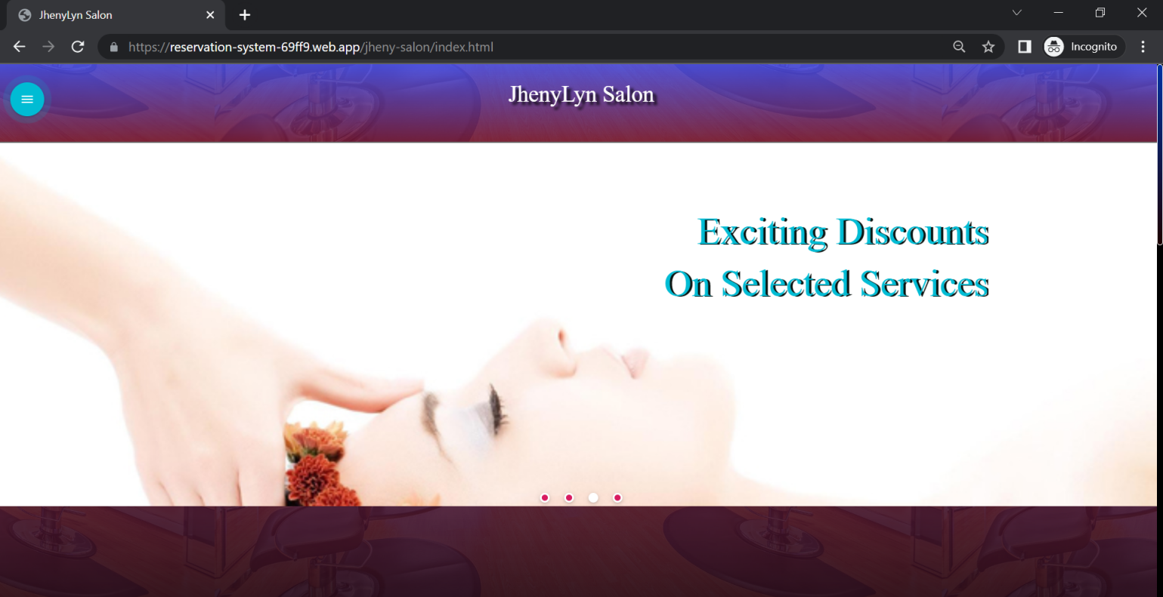

*Figure 23. Customer Sliding image UI*

The User will be redirected on this welcome page

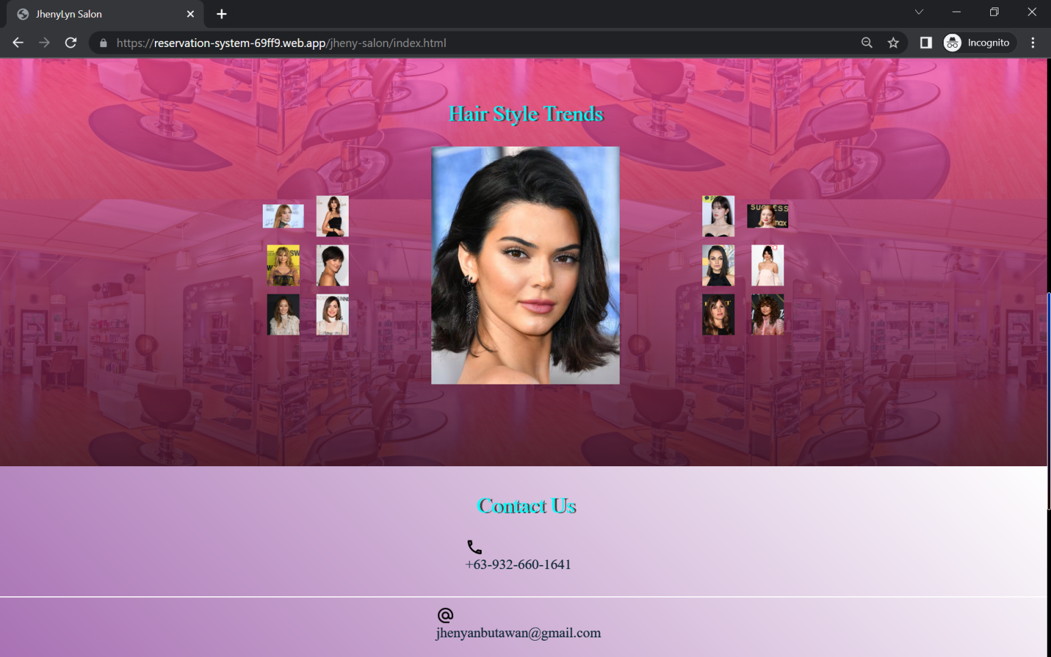

*Figure 24. Contact & Address UI*

The Center content of the welcome page will show the good image layout for Hair style trends etc.

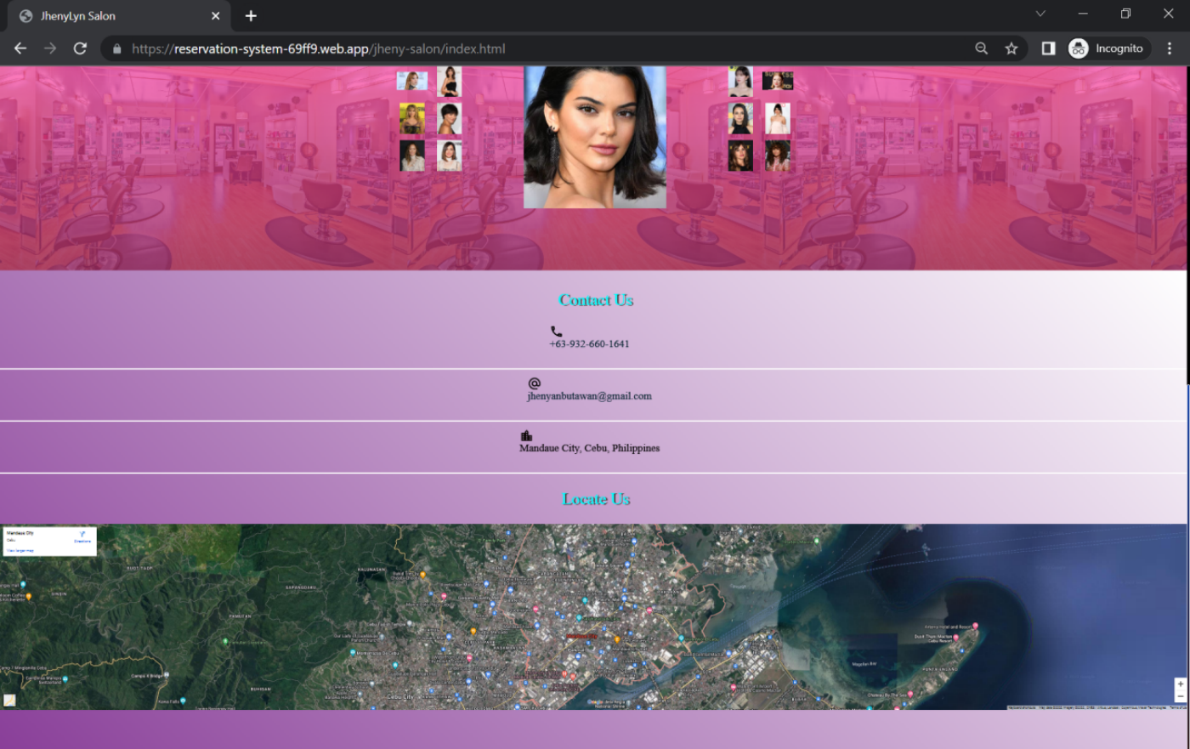

*Figure 25. Google Map Salon Location UI*

The customer will see the salon’s contact and location information.

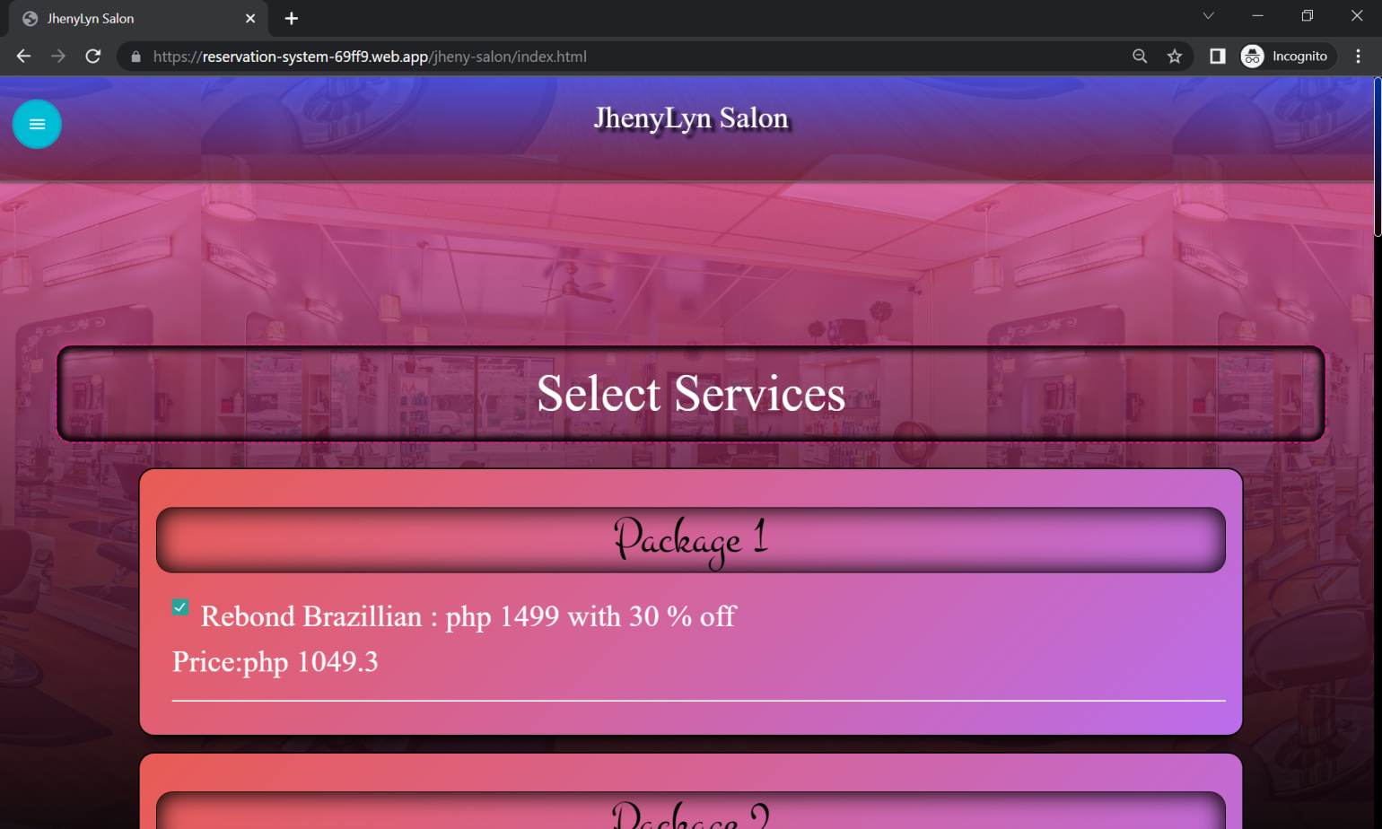

*Figure 26. Selecting Services UI*

Upon clicking the booking option on the sidebar , the user will redirect to the booking side , for them to choose the services offered.

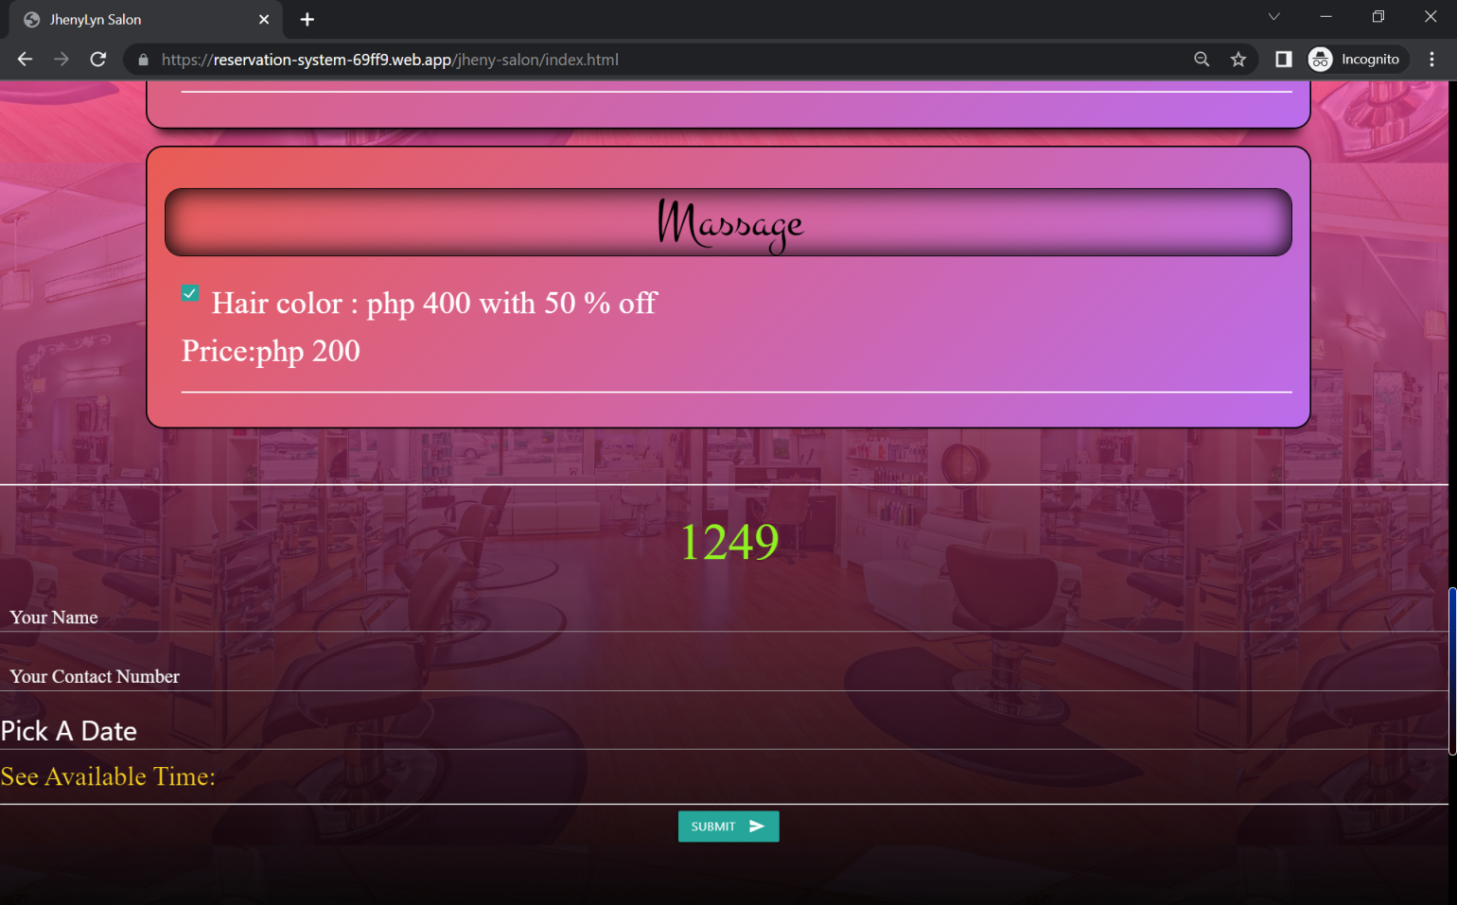

*Figure 27. Send Booking Request UI*

On booking side, there are fields needs to fill.

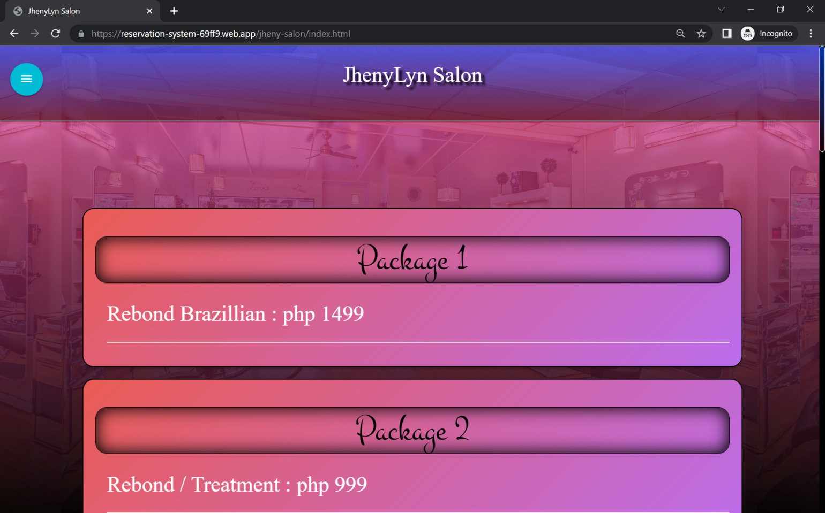

*Figure 28. View Services UI*

In the Services side, the user can view the list of services with price.

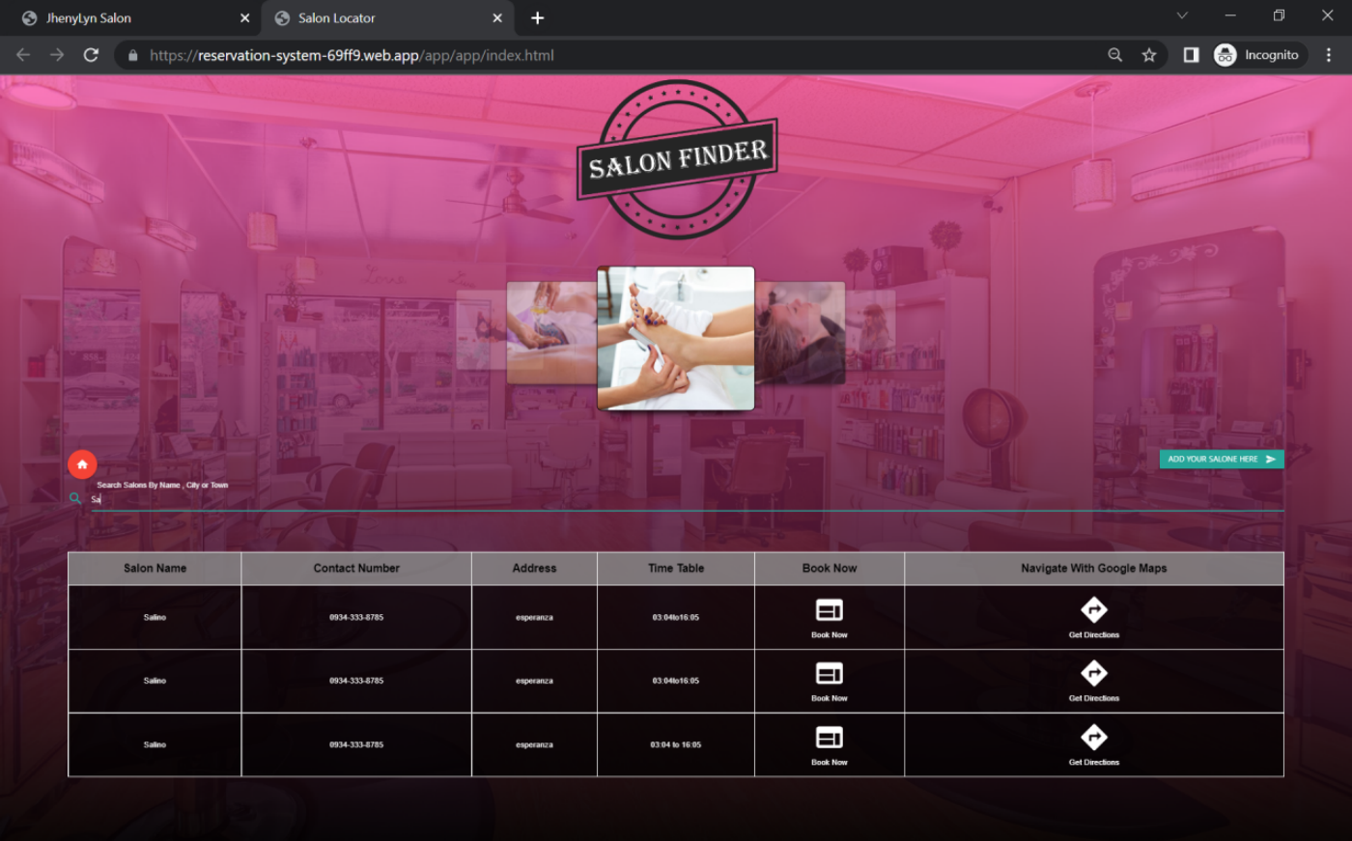

*Figure 29. Salon Request UI*

The Nearby Salon side, will ask user to search the suitable salon.

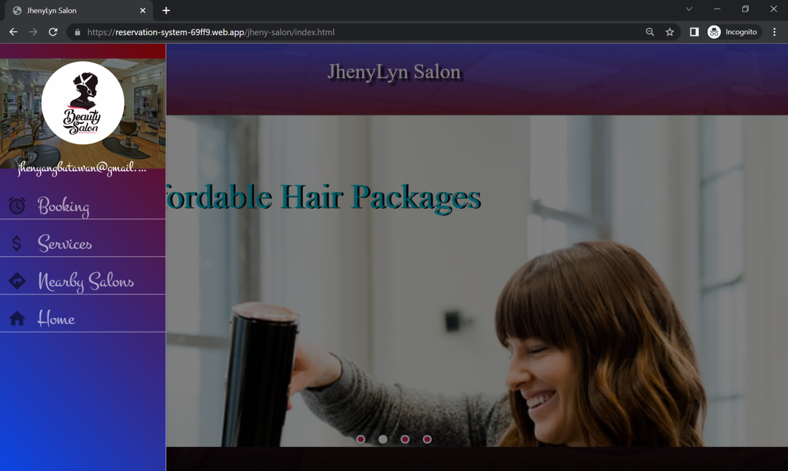

*Figure 30. Salon App Sidebar Menu UI*

The user need to go to the side bar menu for them to select the options.

**Admin/Salon Owner User Interface**

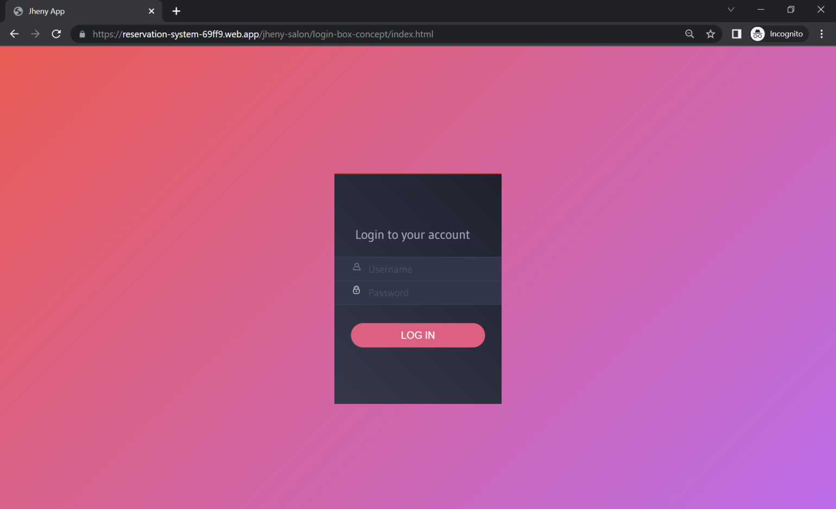*Figure 31. Admin Login UI*

The admin user is required to log a valid credentials.

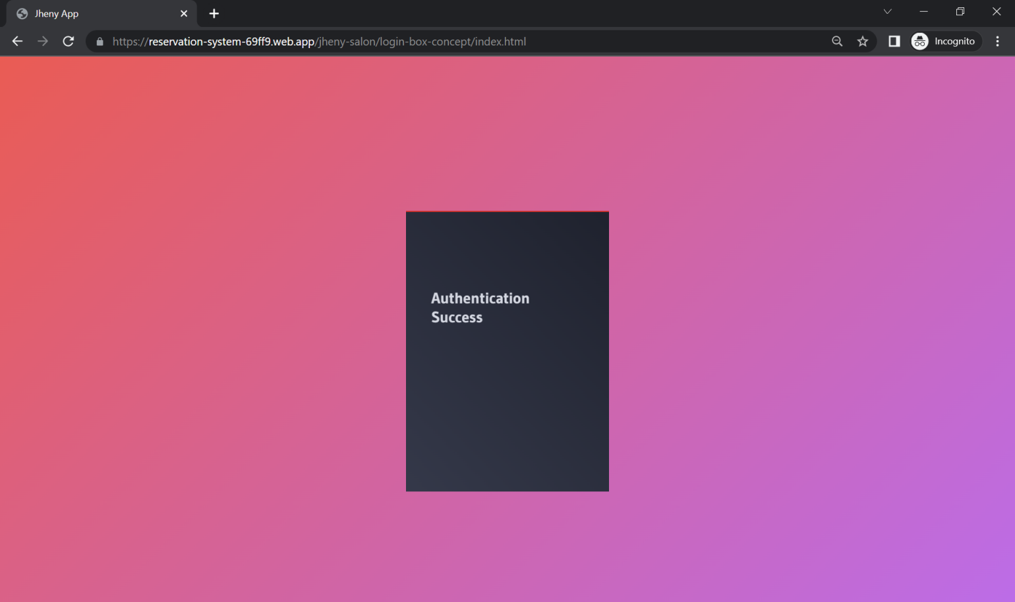

*Figure 32. Authenticated User UI*

If the user has been entered valid username and password then they will be authenticated.

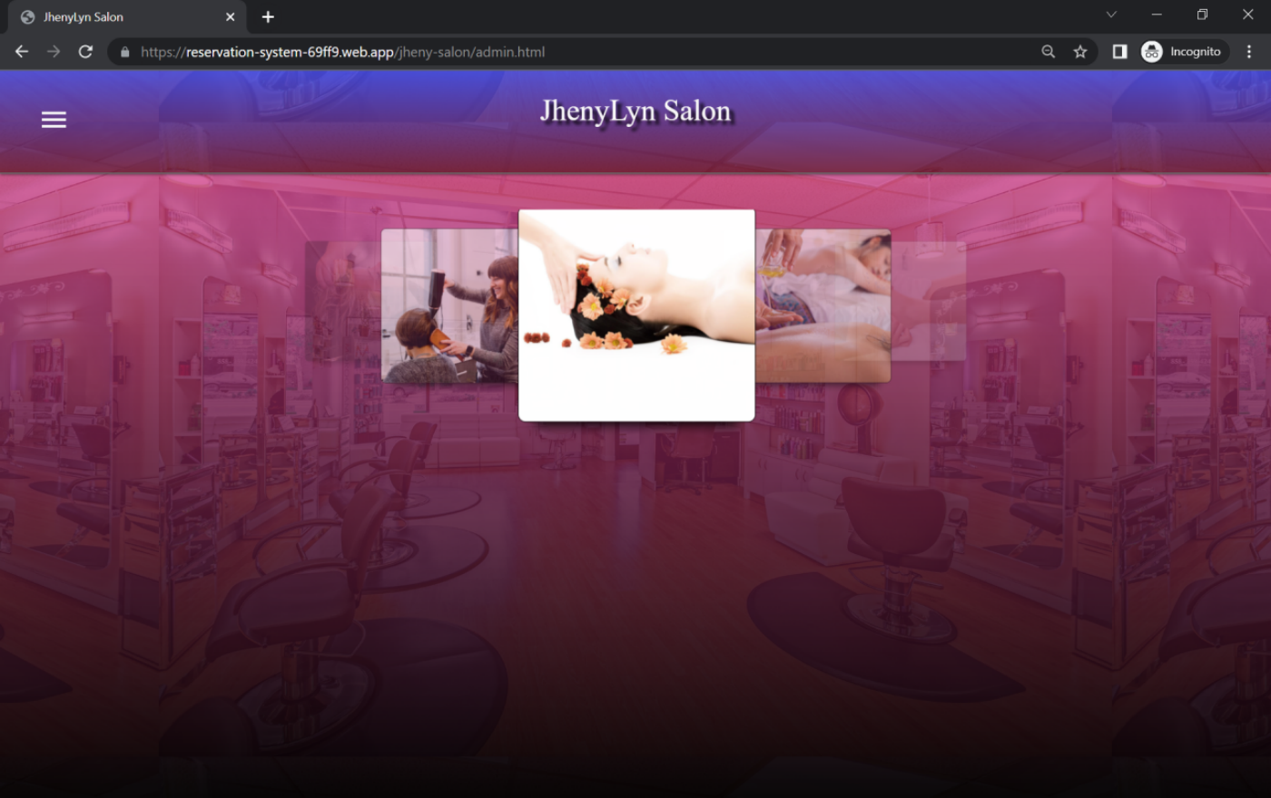

*Figure 33. Admin User Welcome Page*

After successful login, the admin user will redirect to the beautiful home page of the salon system.

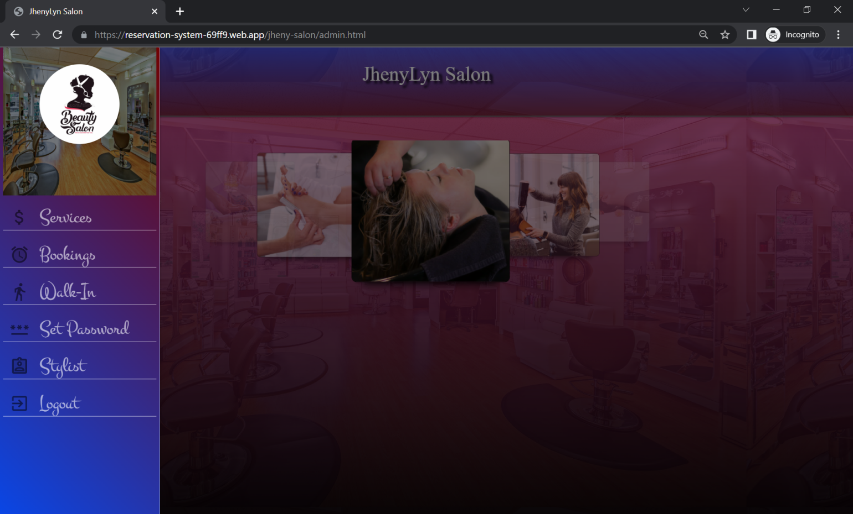

*Figure 34. Admin User Sidebar menu*

The admin user has a sidebar menu.

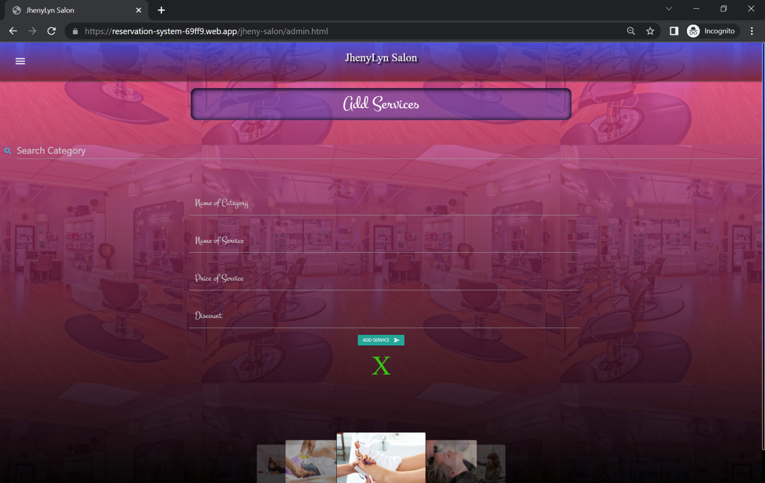

*Figure 35. Add Services UI*

The admin user is required to add services.

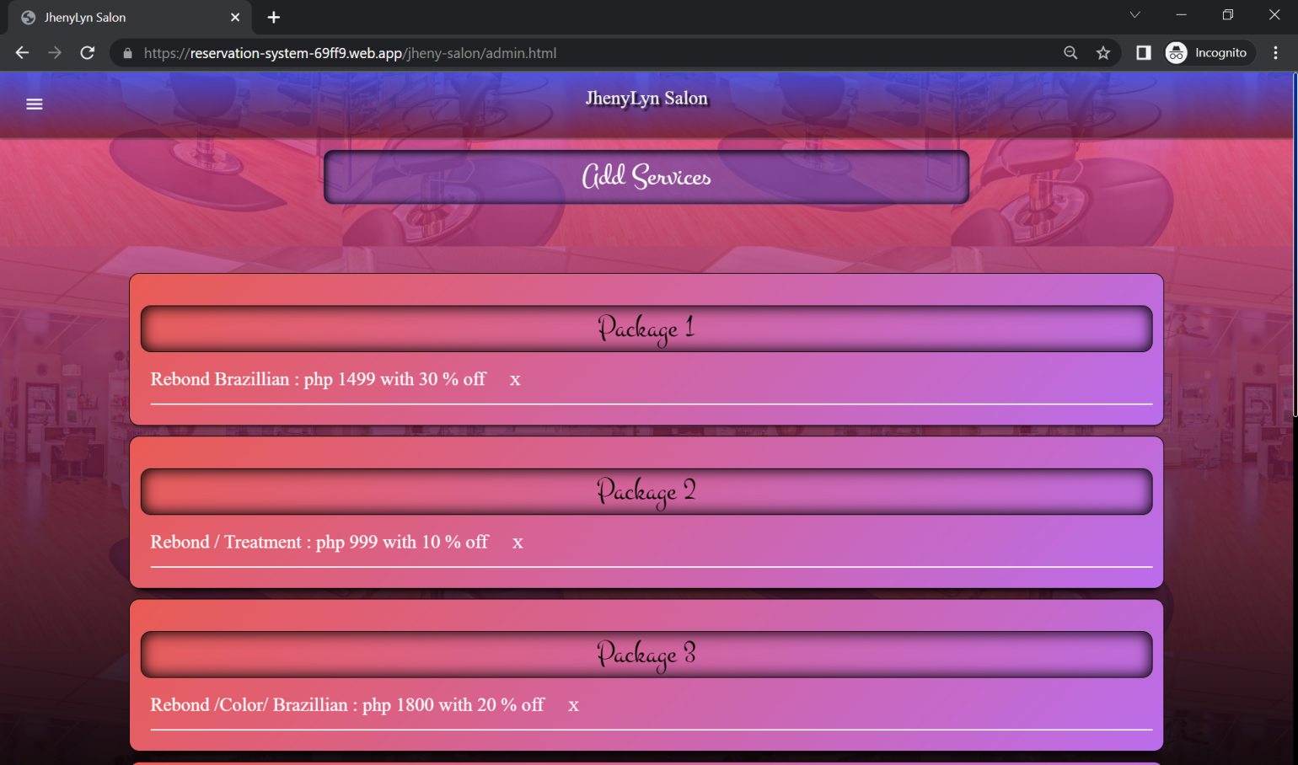

*Figure 36. View Services UI*

After the services data sent to the database then the information will show up.

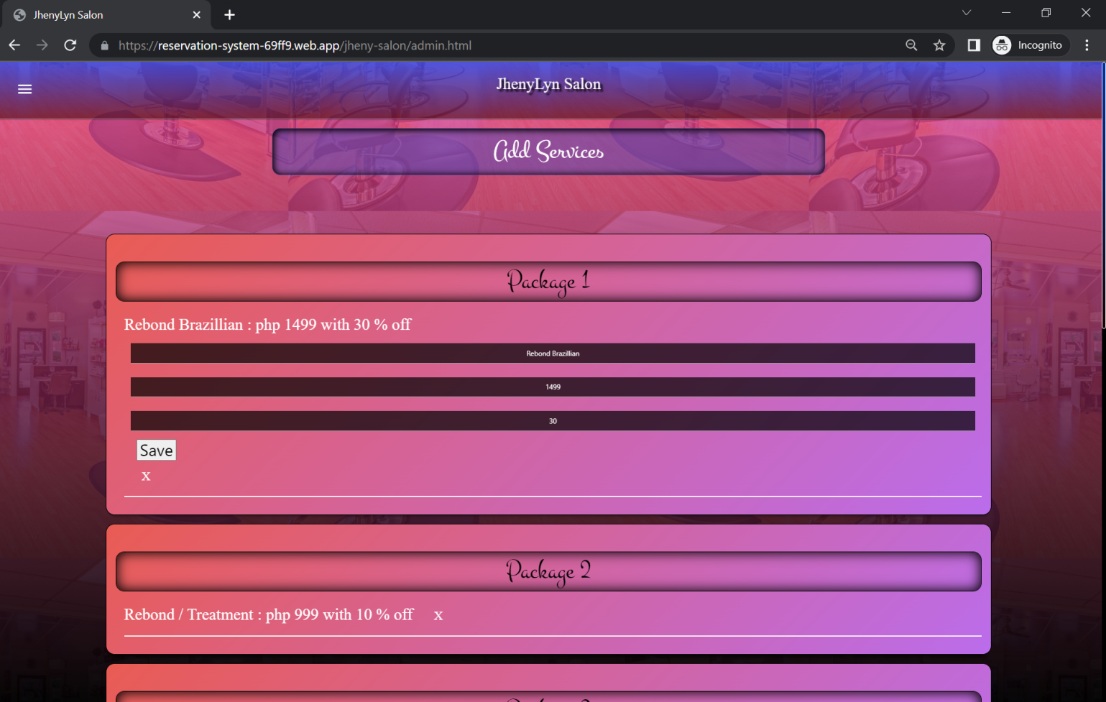

*Figure 37. Edit Services UI*

The admin user has the capability to edit the services.

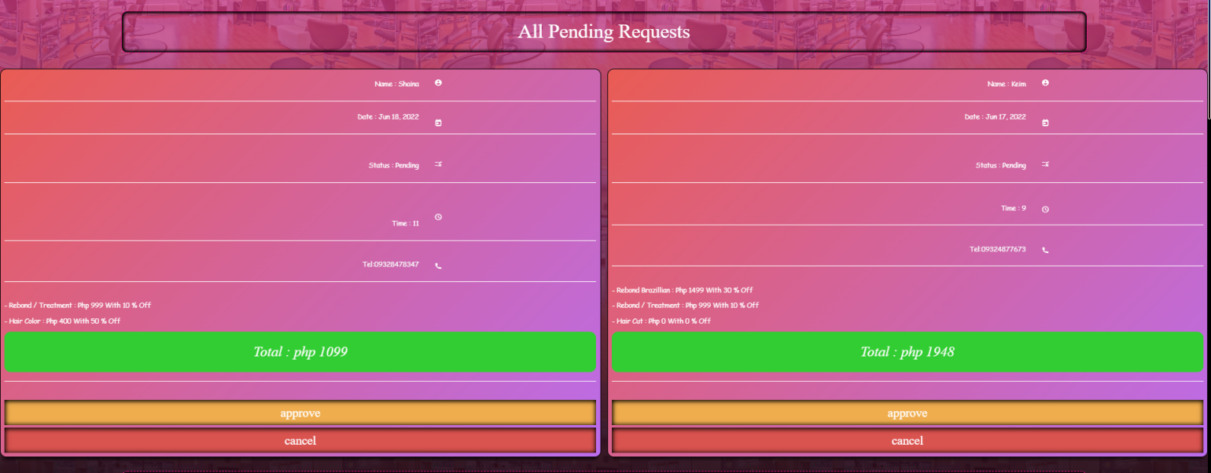*Figure 38. All Pending Request UI*

Once the customer successfully sent the request , the pending request will show up on admin side.

**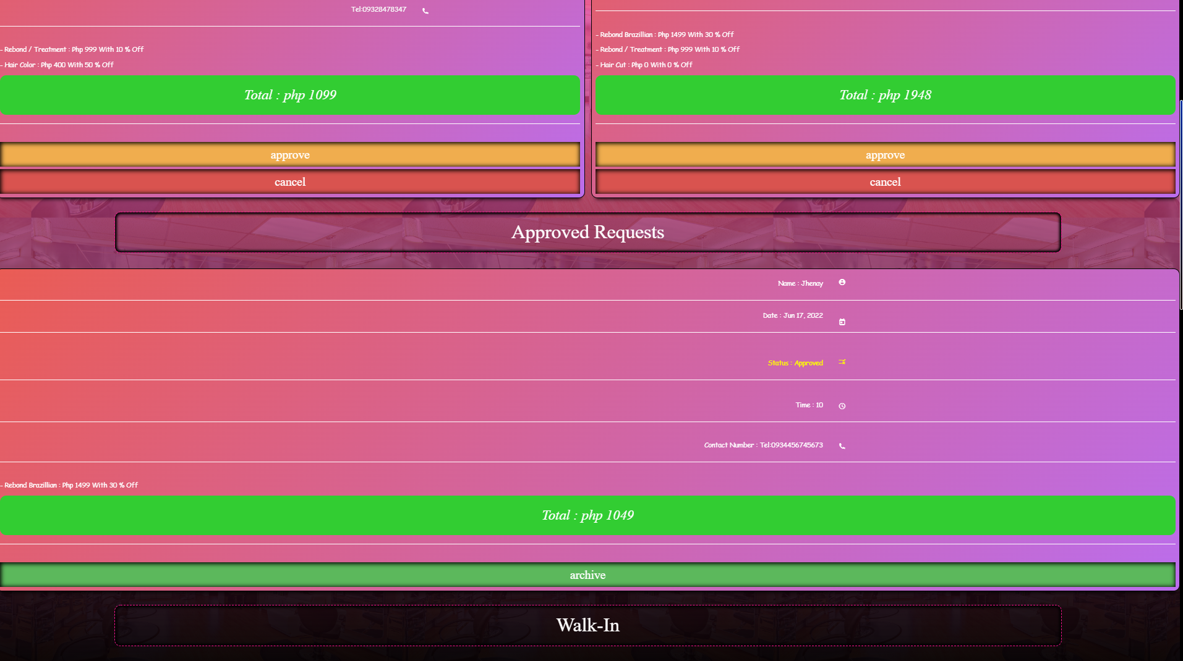***Figure 39. All Approved Request UI*

Once the customer will show up and confirmed his/ her booking then admin can approve.

**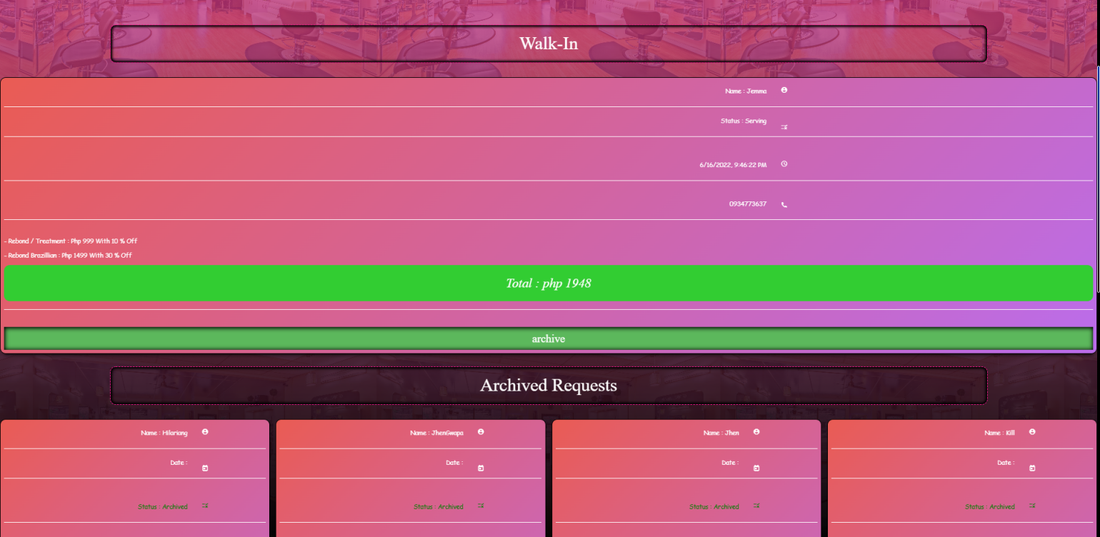***Figure 40. All walk-In Request UI*

The data of the walk-in customer will be shown as per image above.

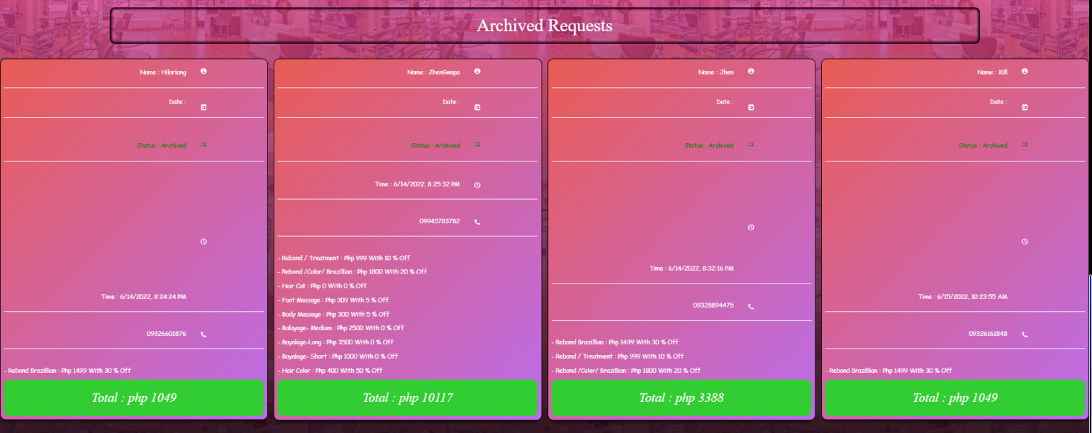

*Figure 41. All archived Request UI*

The approved and walk-in’s data can be archived.

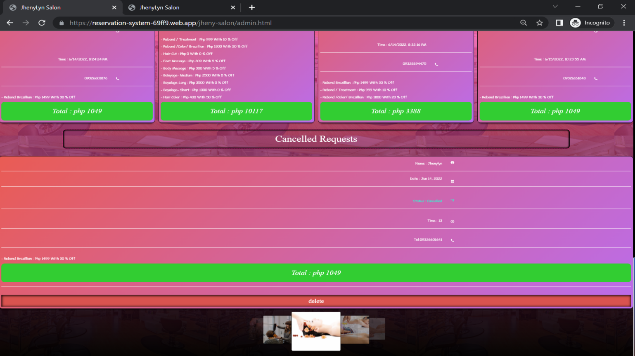

*Figure 42. Canceled Request UI*

The pending requests can be canceled.

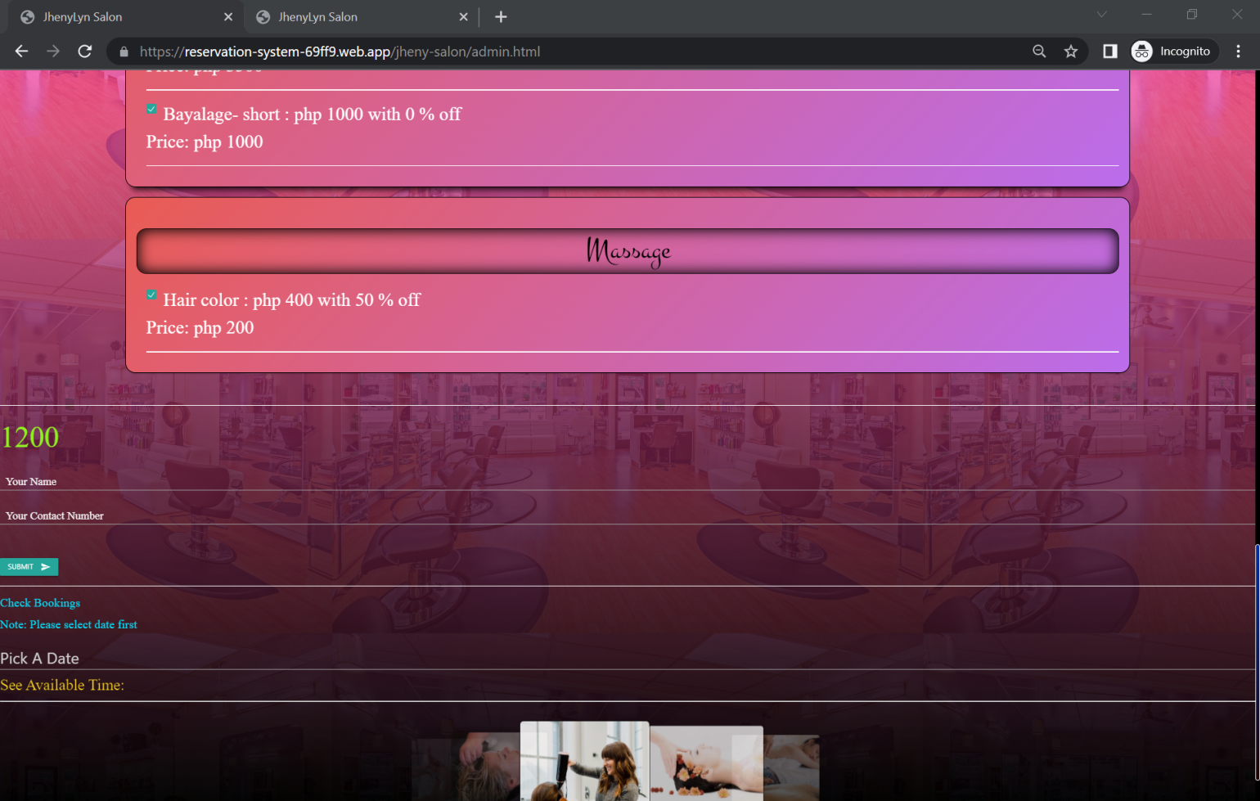

*Figure 43. Send Walk-In Request UI*

The data of the walk-in customer should be filled on the walk-in side.

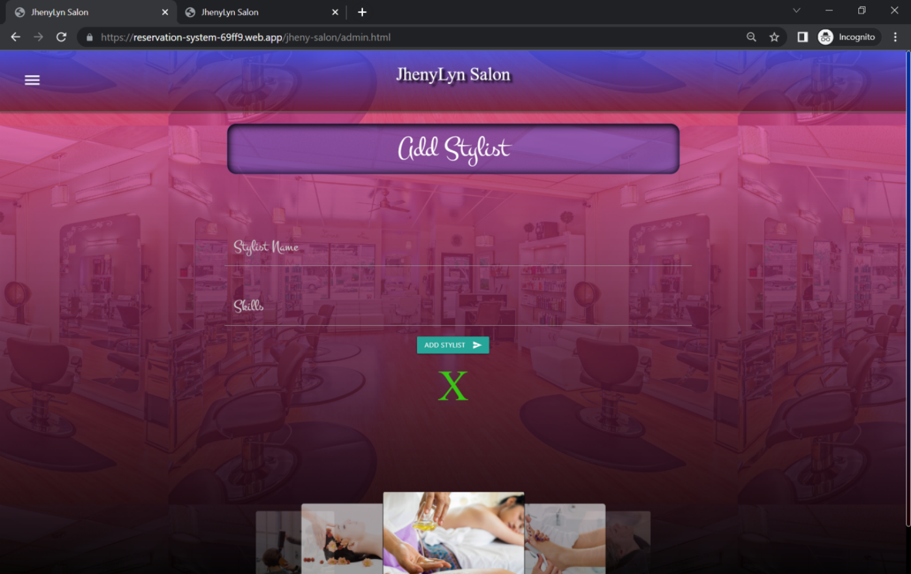

*Figure 44. Add Stylist UI*

The admin can add stylist information.

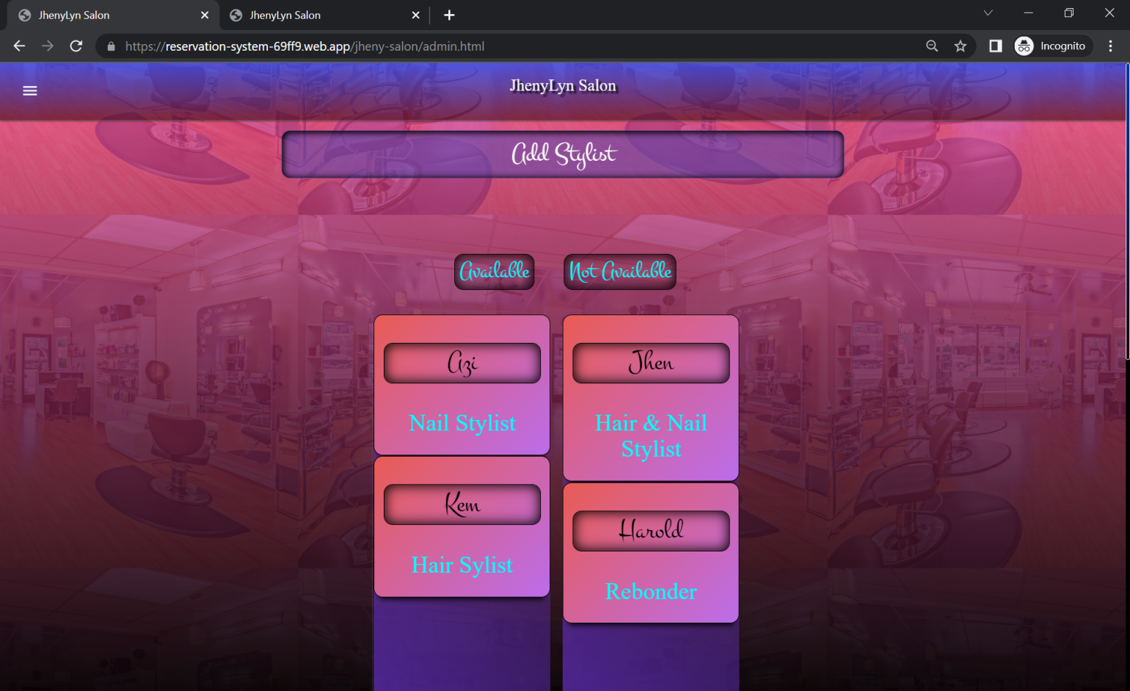

*Figure 45. Available Or Not-Available Stylist*

Admin should use the drag and drop to manage the stylist time availability.

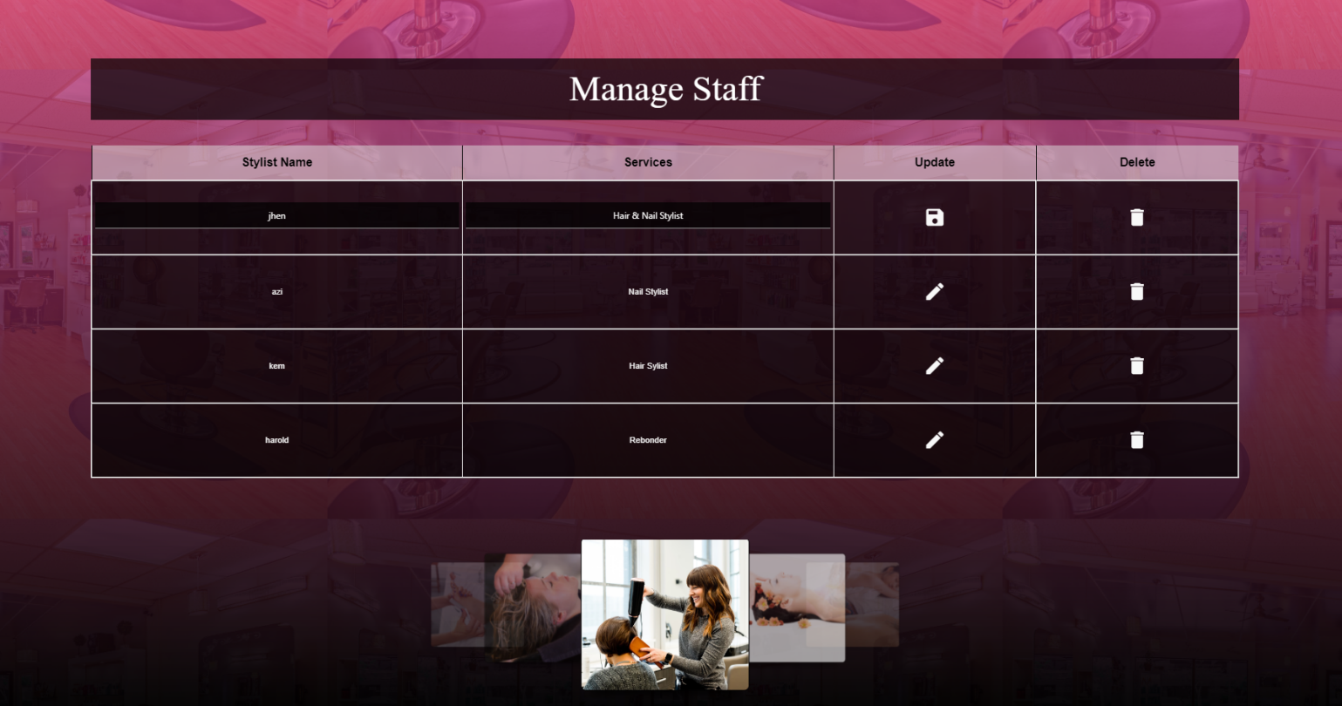

*Figure 46. Manage Staff UI*

The admin can edit and delete stylist data.

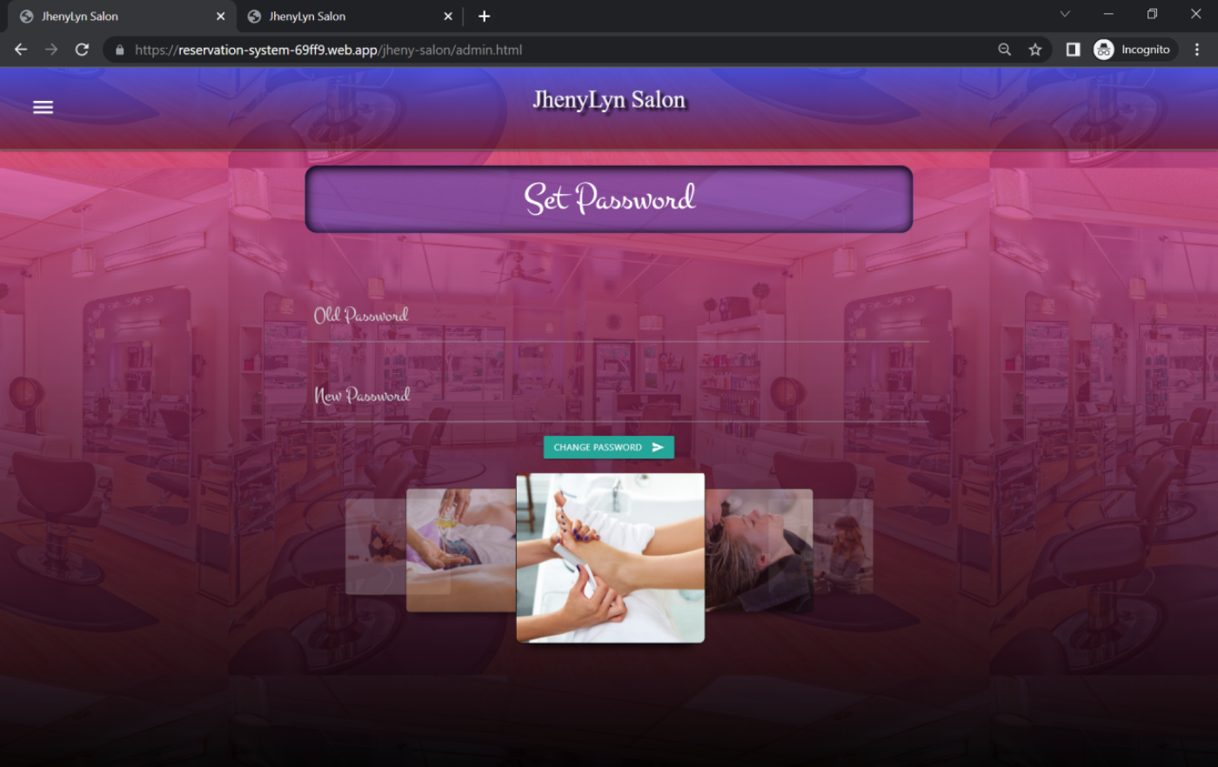

*Figure 47. Set Password UI*

Admin is required to change password.

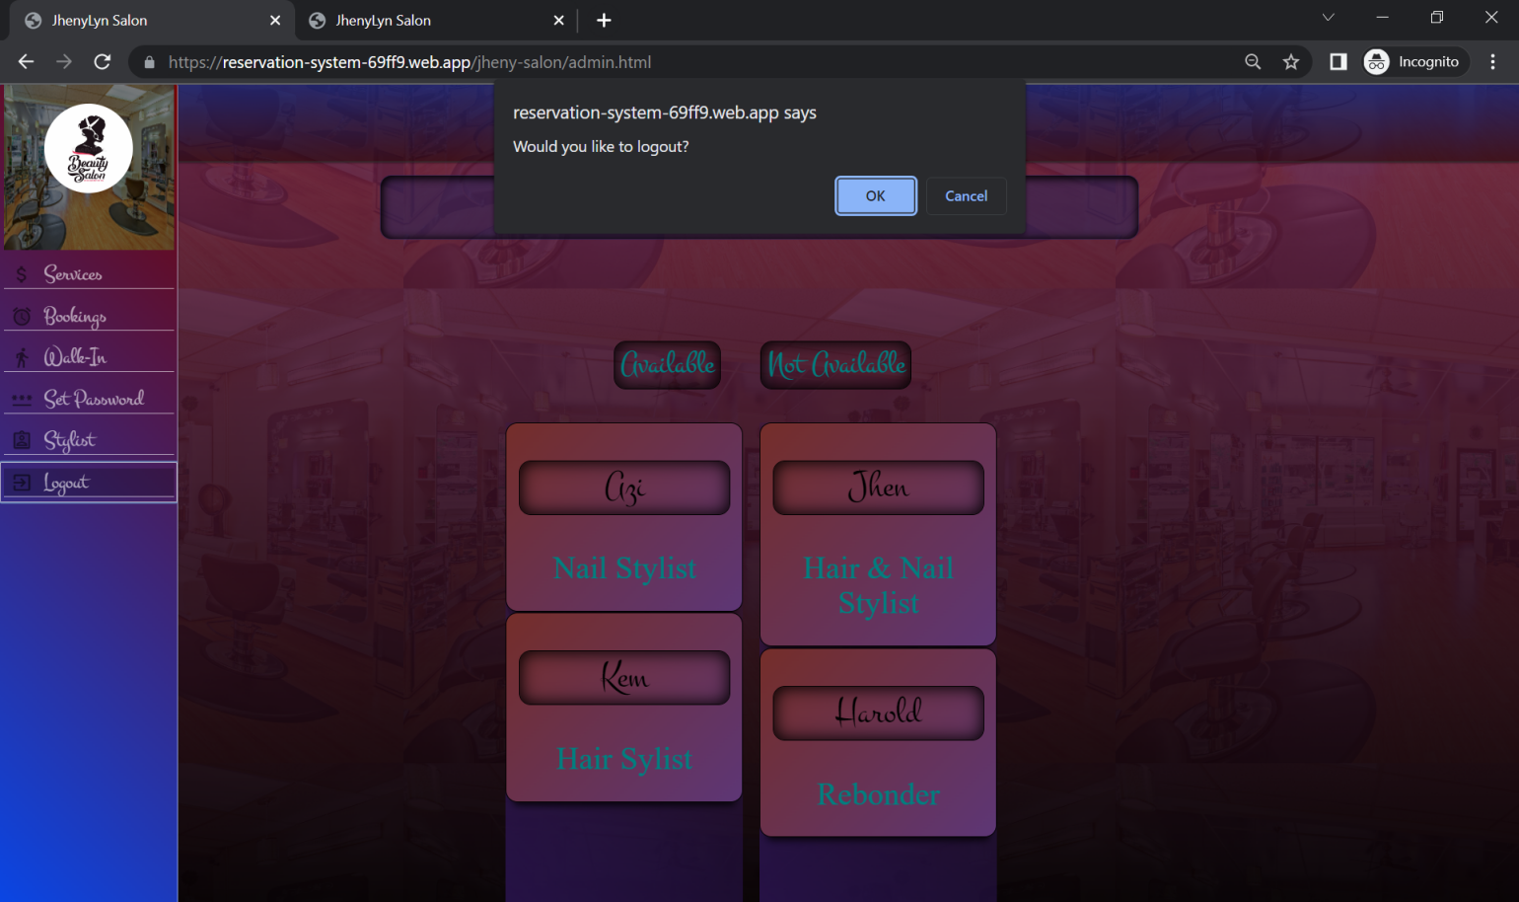

*Figure 48. Log-out UI*

The admin will be prompted to logout or not.

**SUPER ADMIN USER INTERFACE**

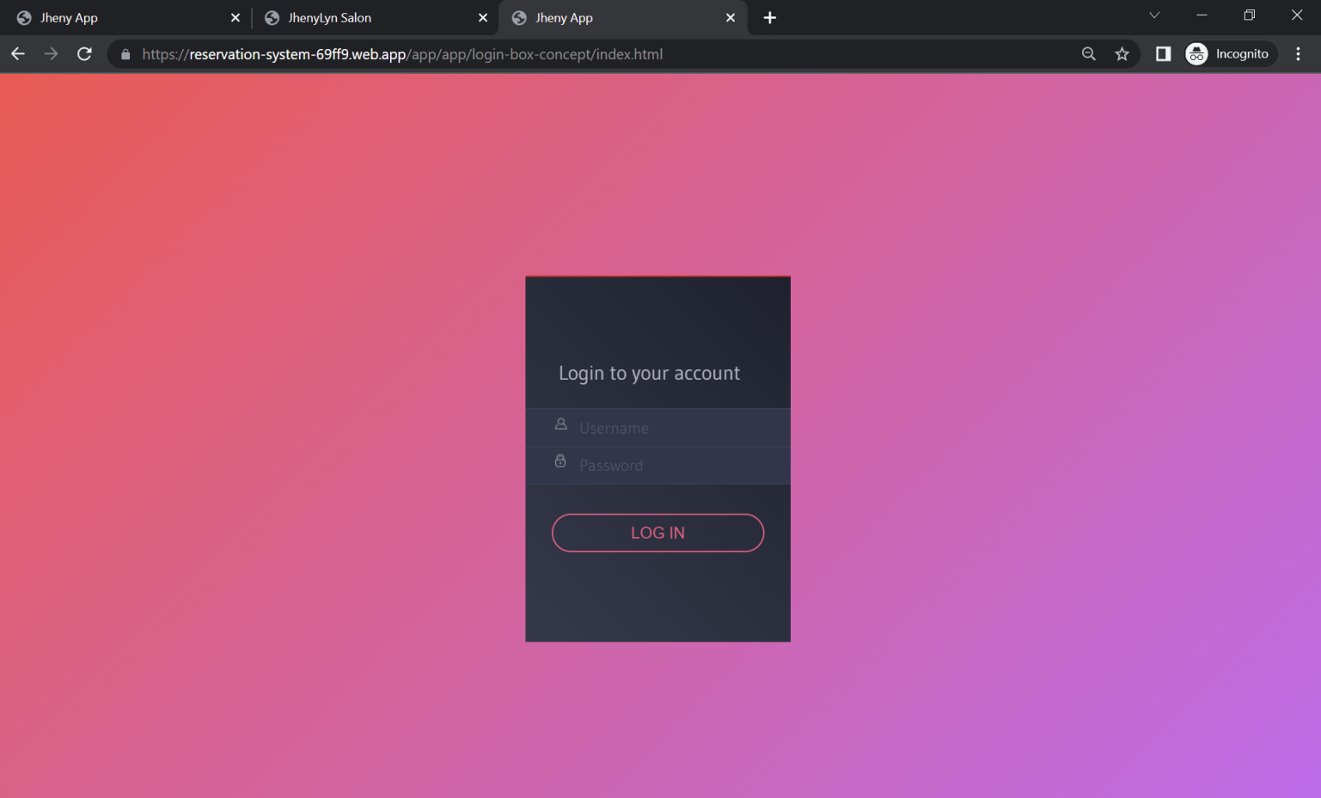

*Figure 49. Super Admin Login UI*

The Super Admin / Developer side login page.

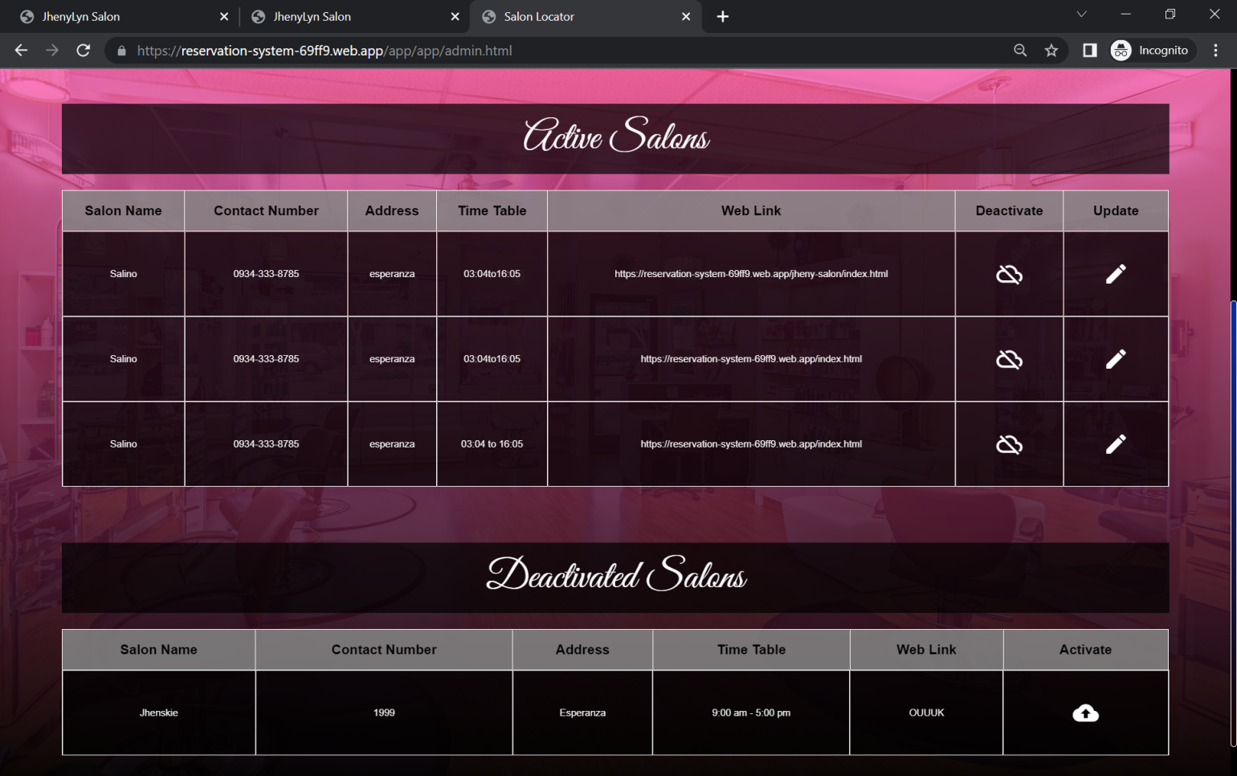

*Figure 50. Activate and Deactivate Salons UI*

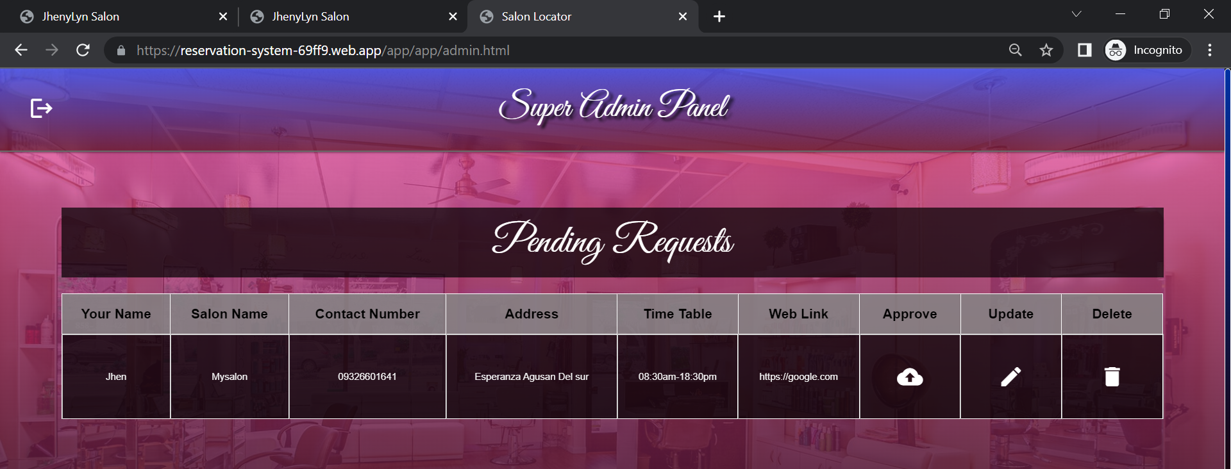The developer can deactivate and activate salons.

*Figure 51. Pending Salon Requests UI*

The developer can activate pending salon request.

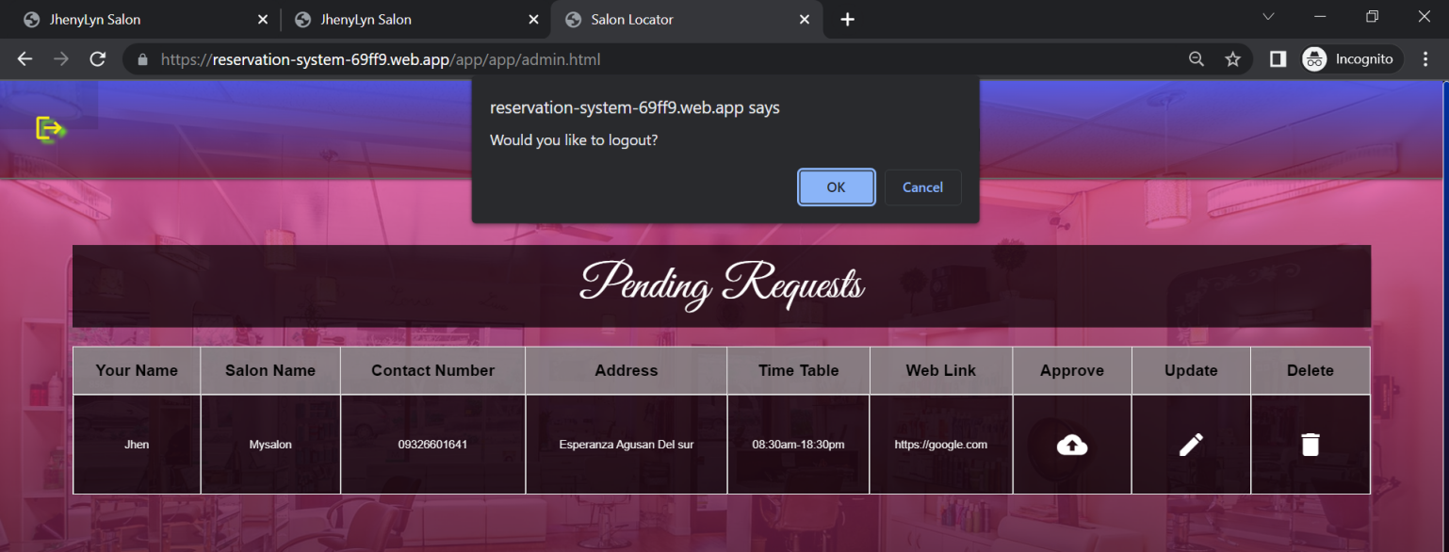

*Figure 52. Log-out Super Admin User UI*

The developer will be prompted to logout or not.

**System Flowchart**



*Figure 53. System Flowchart*

**Hardware Specification and Budget Cost**

**Deployment Cost**

|  |  |
| --- | --- |
| **Description** | **Price** |
| Firebase Free Hosting | **P 0.00** |
| **Total** | ₱ **0.00** |

**Software Specifications**

|  |  |
| --- | --- |
| **Description** | **Price** |
| Visual Studio Code | **Free** |
| Vue Javascript Framework | **Free** |
| **Total** | ₱ **0.00** |

**Development Cost**

|  |  |
| --- | --- |
| **Description** | **Price** |
| Lenovo Touchscreen | **35,000** |
| **Total** | ₱ **35,000.00** |

**SIGNATURES**

|  |  |  |
| --- | --- | --- |
| PROPONENTS | | |
| **Name** | **Signature** | **Date Signed** |
| Jhenylyn Butawan  **Programmer/Tester/Documentation Specialist** |  |  |

|  |  |  |
| --- | --- | --- |
| APPROVER | | |
| **Name** | **Signature** | **Date Signed** |
| Mr. Roy L. Imperial, MSIT  **ACLC College Dean** |  |  |

**User’s Guide**

**Salon Booking and Management System User’s Manual**

**Customer Home Page**

The customer home page consist of sliding images with

animated text, parallax effect, hair style trends images

and a footer that tells the salons contact information

and location that used google map API.

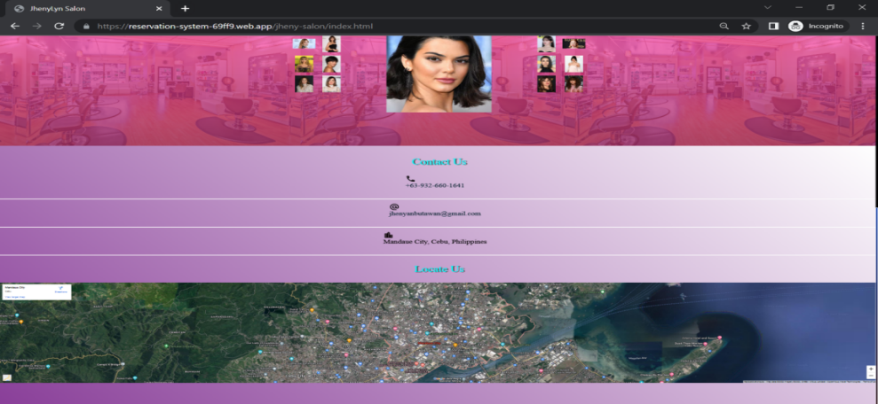

*Figure 54. Generate IP Address to the user*

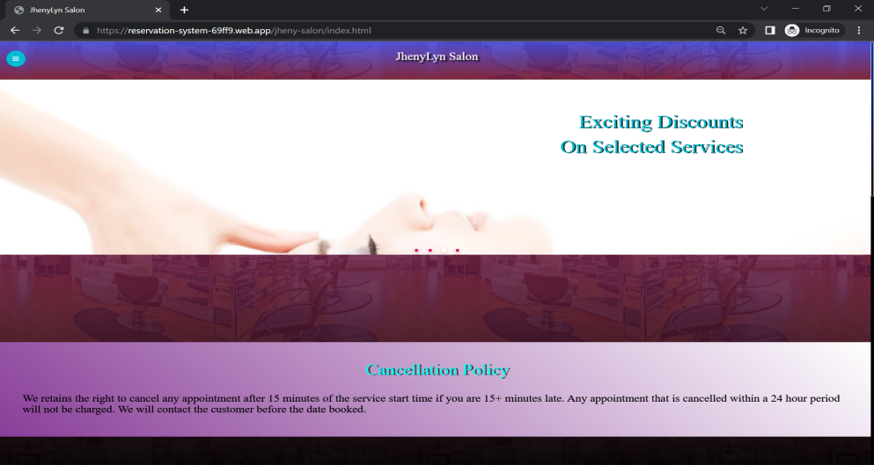

*Figure 55. Generate IP Address to the user*

**Customer Booking Page**

The customer booking page consist of services with its category and service name, price, discounts information that let customers select the services offered. The sum total of the selected services is calculated automatically. The customer cannot send the request without filling all the required fields and not selecting any services. Customer cannot check the time availability without selecting the desired booking date. The submit button should be click once the required information has been filled. There should be a message that will display in every successful entry. If the user encountered unstable or lost the internet connection the data will not be sent but the system will stored the activity information of the user, when the internet is back online then the user can send the request. The system has been designed to let customer still recover the information as far as internet connectivity is concerned.

**Send Booking Request**

1. Click the sidebar button.

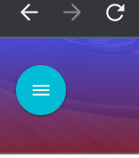

*Figure 56. Customer user menu button*

1. Select the “Booking” text.

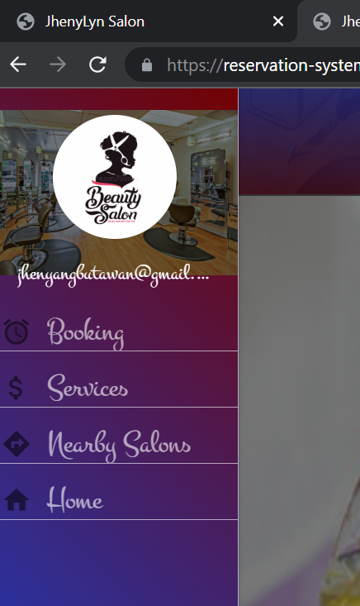

*Figure 57. Customer user sidebar menu with booking text*

1. Check desired services.

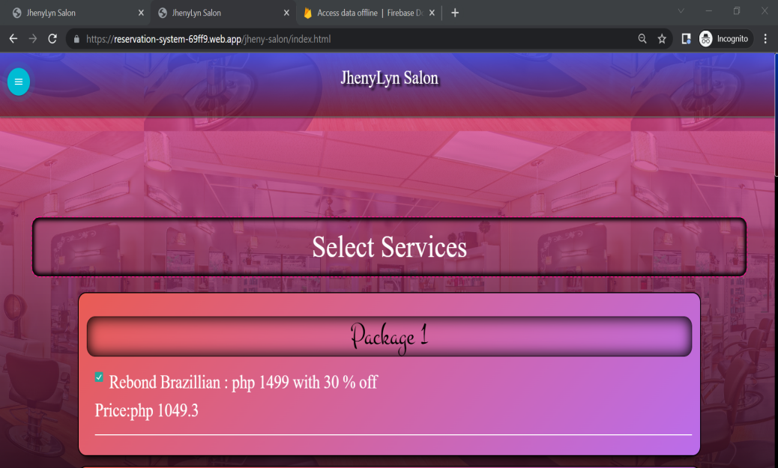

*Figure 58. Customer user services*

1. Enter customer name and contact information.

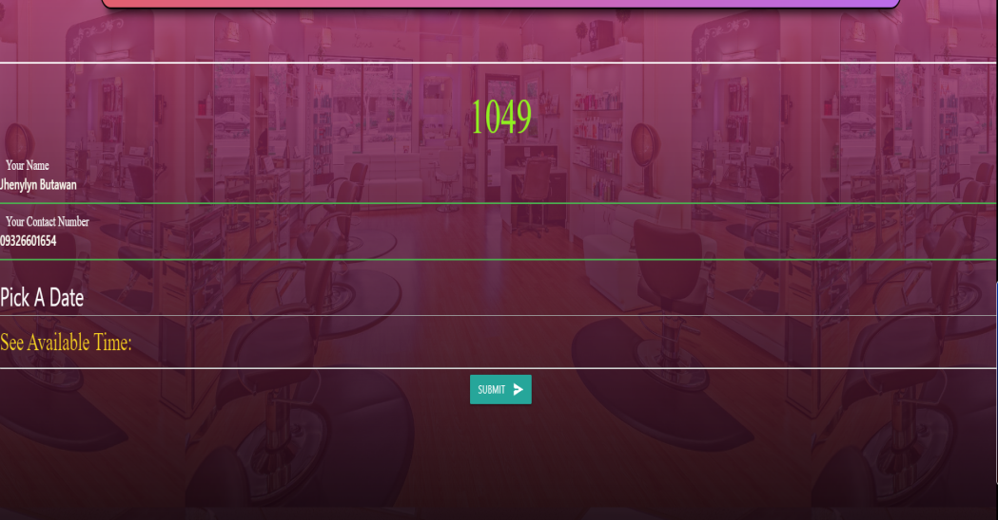

*Figure 59. Customer username and contact number*

1. Click the “Pick A Date” to select a date.

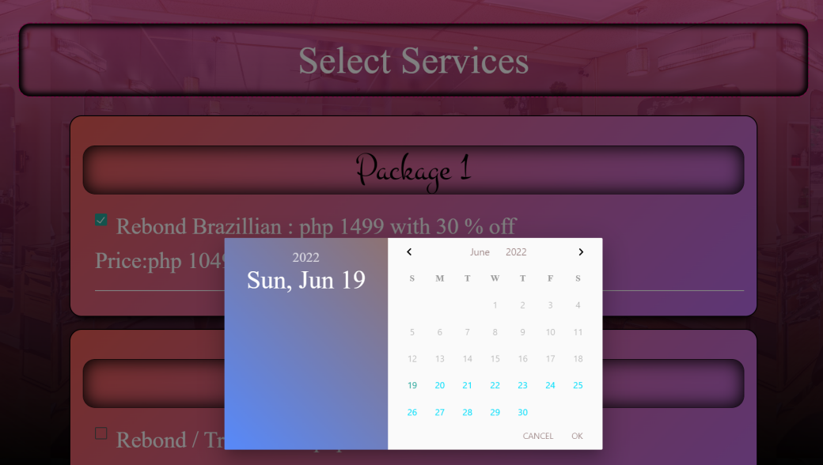

*Figure 60. Customer user pick a date*

1. Click the “See Available Time” to check time availability.

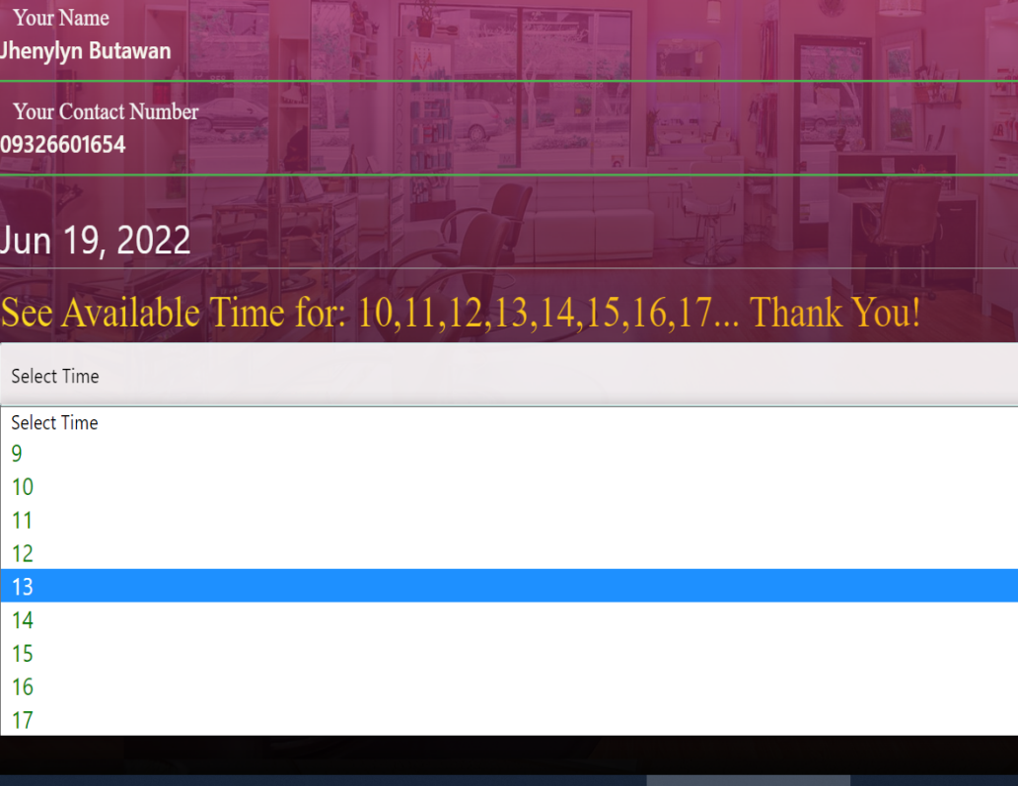

*Figure 61. Customer user time selection*

1. Once the required fields has been filled then click the submit button to send the request.

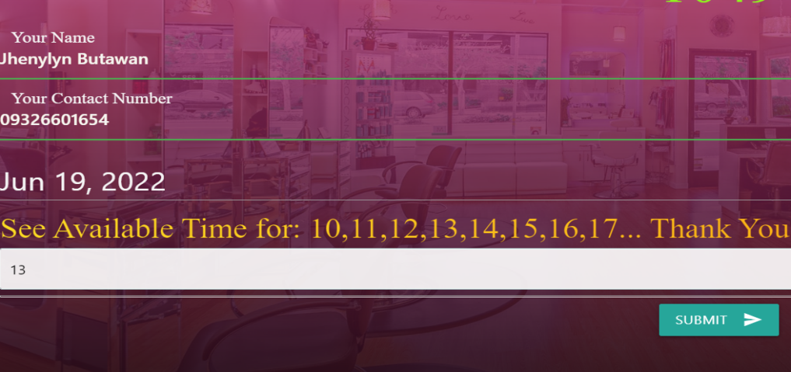

*Figure 62.Customer user submit booking request*

1. Click the “Book Another Appointment” to transact another booking.

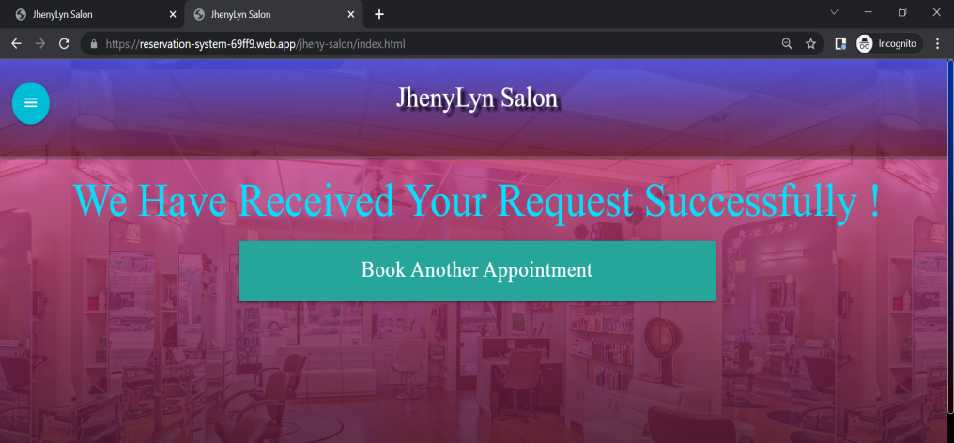

*Figure 63. Customer user book another appointment*

**Services**

The Salon services are all visible to the customer.

1. Click the sidebar button.



*Figure 64. Customer user sidebar menu button*

1. Select the “Booking” text.



*Figure 65. Customer user sidebar menu*

1. View services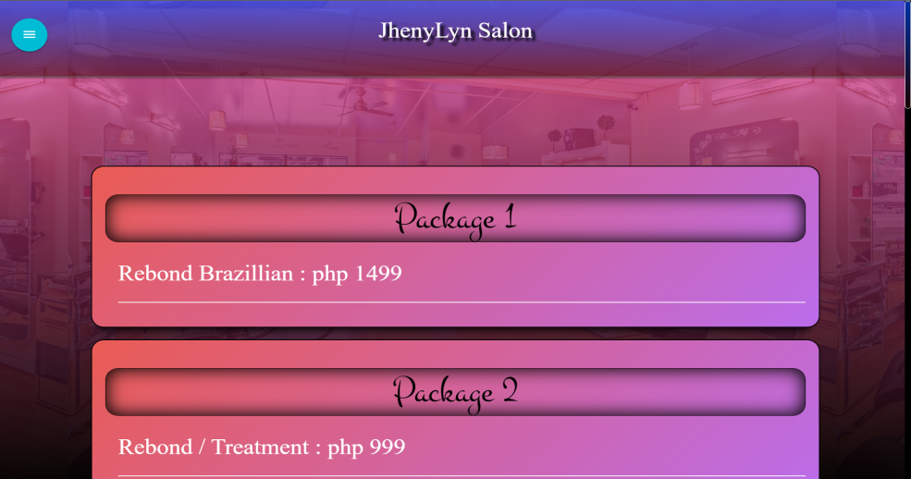

*Figure 66. Customer user services*

**Nearby Salon**

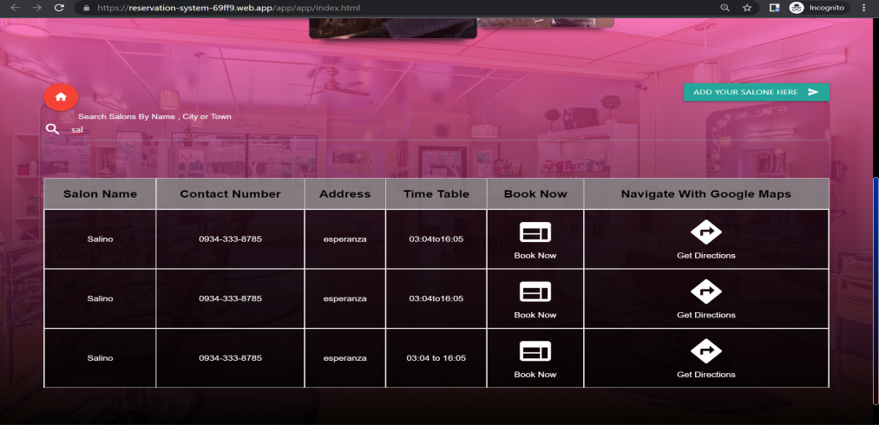Select the “Nearby Salon” from the sidebar menu , once clicked then it should redirect the user to the nearby salon page.

*Figure 67. Customer user find nearby salon*

Only registered salon will be displayed if the salon is not existing

from the list then the user should send a request to include

their salon business on this feature. To do that the user can

click the button “ADD YOUR SALON HERE”. The user should

click the submit button as per image shown below.

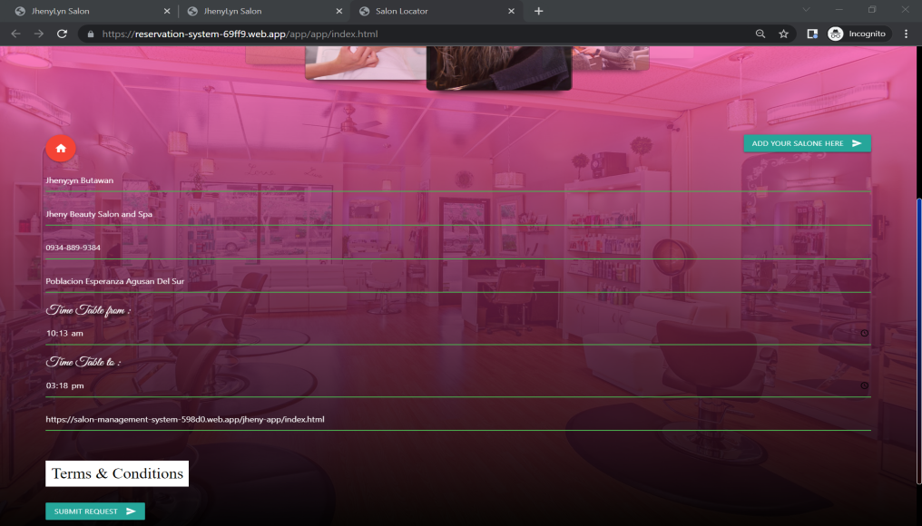

*Figure 68. Customer user register salon*

The user can go back to home page via clicking upon the red

button shown in the picture above.

**Admin User Page**

The admin side of the salon booking and management system

application has the control of all incoming booking request,

staff , services and updating the statuses of the requests. It

has a drag and drop of staff cards to determine the staff

availability throughout the entire activity inside the salon.

To start the entire salon managerial feature. The admin

user should add the salon services.

**Login**

The admin user must enter the valid login credentials.



*Figure 69. Admin user login*

**Services**

1. Select the “Services” option on the sidebar menu

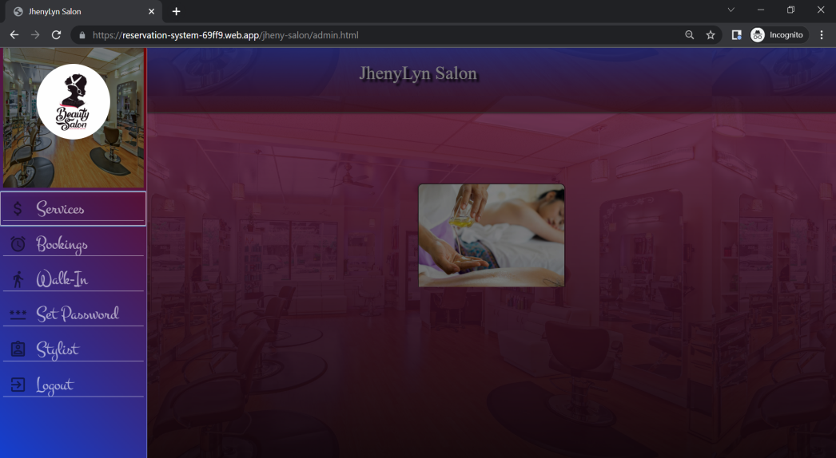

*Figure 70. Admin user navigate services*

1. After selecting the “Services” option. It should redirect to the services page to manage its data. The user must click the “Add Service”button to display all fields that is required.

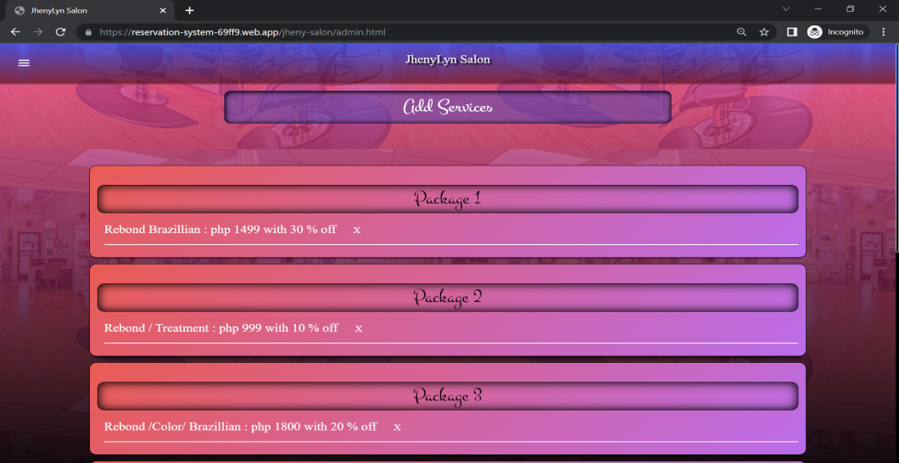

*Figure 71. Admin user add services*

1. Once added the data will be shown as per image below.

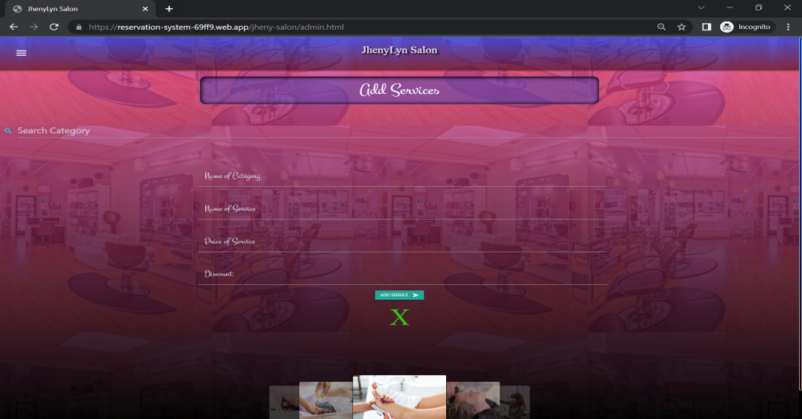

*Figure 72. Admin user view services*

1. The admin user can edit the data of the services via clicking the card, it will enable the edit capability. The edit button must be click to send the updated data. The “X” button corresponds the delete functionality.

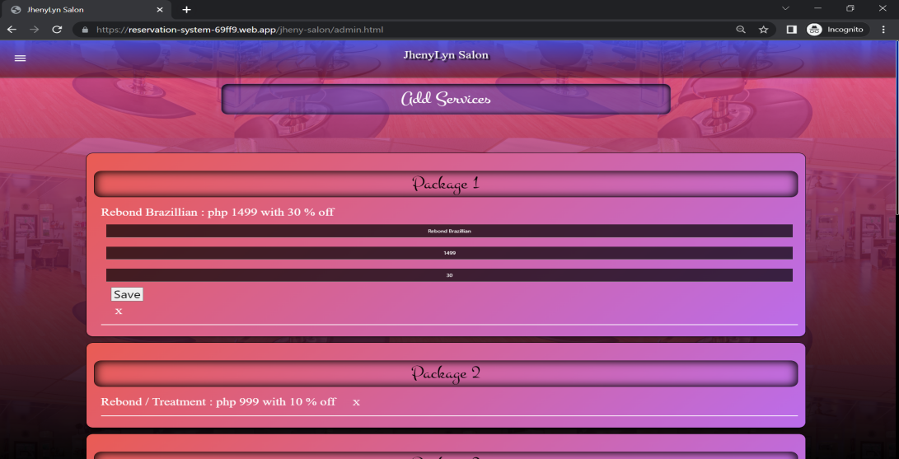

*Figure 73. Admin user edit services*

**Booking**

To check booking request the user must navigate to booking section. Once the customer successfully sent the request , the pending request will show up on admin side.



*Figure 74. customer pending request*

If the customer will show to the salon then admin can approve

his/ her booking.

*Figure 75. customer approved request*

****The data of the walk-in customer.

*Figure 76. Customer Walk-In request*

The approved and walk-in’s data can be archived.



*Figure 77. Customer Archived data*

The pending requests can be canceled.



*Figure 78. Customer canceled request*

**Walk-In**

The data of the walk-in customer should be filled on the walk-in side. The admin user must select the desired services. The required

fields are the customer name and contact information after filling the fields the request is ready to send via clicking the submit button. The date and time of transaction will automatically recorded.



*Figure 79. Walk-In transaction*

**Stylist**

To add stylist the user must navigate to stylist section. The user can add, edit, delete staff data and can drag and drop cards to determine the staff time availability.



*Figure 80. Stylist Availability*

The admin can edit and delete stylist data.



*Figure 81. Manage staff/stylist*

**Set Password**

Admin is required to change password. To set password the

admin should navigate to set password.



*Figure 82. Admin set password*

**Logout**

To logout the admin user must click the logout option on the sidebar menu. The admin will be prompted to logout the system.



*Figure 83. Admin user logout*

**Super Admin**

The super admin has the capability to edit , delete and activate salons.The Super Admin / Developer side login page.



*Figure 84. Super admin login*

The pending request has approve, edit and delete functionality.

To approve salon is to simply click the approve button. To edit is

to simply click the edit button or click the column of the table.

To delete is to simply click the delete button.There is always

a prompt message in every action made.



*Figure 85. Super admin Pending Request*



*Figure 86. Super admin Activate and Deactivate Salons*

To logout is to simply click the left upper side button. The developer will be prompted to logout or not.



*Figure 87. Super admin Logout*

**BIOGRAPHICAL SKETCH**



The author Jhenylyn M. Butawan, was born on October 09, 1999 in Poblacion Esperanza, Agusan Del Sur, Philippines and now currently living in Mandaue City, Cebu as the first daughter of Gemma M. Minerales and Hilario T. Butawan.

She took her primary and secondary education at the Poblacion Esperanza, Agusan Del Sur, where she was a consistent honor student and where she is also a class officers. Jhenylyn is not only academically inclined but she is also good in other fields such as sport. In the four years she spent in high school, she became the class officers and the cadet major for CAT program.

In 2017, she was admitted at the AMA Computer Learning Center, College of Mandaue under the Bachelor of Science in Information Technology. She pursue her Bachelor Degree since she graduated already In Associate of Science in Information Technology in Datamex Institute of Computer Technology by the year 2016.

***JHENYLYN MINERALES BUTAWAN***